**TITLE: Add-on Tests**

**PRINCIPLE:** Providers will often want to add testing to a specimen that has already been collected and is in the lab. It is important for lab staff to be able to determine if the testing can be performed and if so, correctly collect and receive these orders in the Laboratory Information System (LIS) so that these add-on orders can be performed and resulted.

# STEPWISE PROCEDURE:

1. Lab is notified of add-on orders through three different methods of communication.
   1. Phone call from the provider or nurse,
   2. EPIC Add-on Communication from the EPIC add-on printer,
   3. Order comment when labs are entered by providers.
2. Log in to Soft
3. Go to order entry 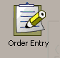
4. Place the cursor in the “MRN” box and scan the barcode at the top of the Add-on Comunication sheet or type the patient’s MRN into the box and press “Enter”

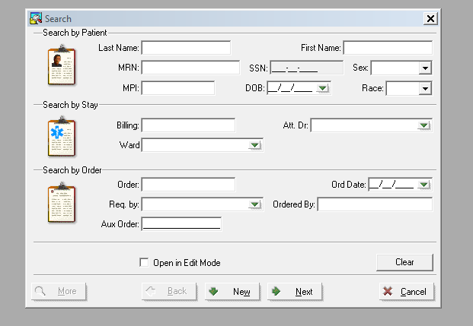

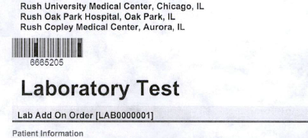

1. Verify the patient information is correct and select the patient.

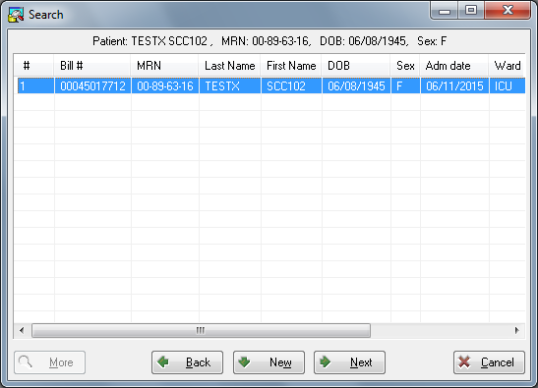

1. Find the correct patient encounter for the add-on orders and review it.

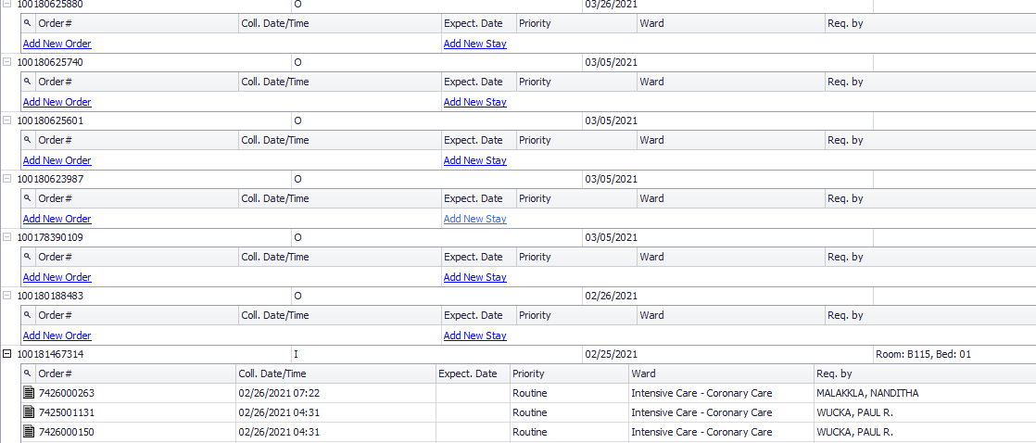

1. The add-on communication sheet or order comment will inform lab what to add and which specimen collection to add the test to. If a provider calls for an add-on, confirm which specimen to add the testing to. Example:

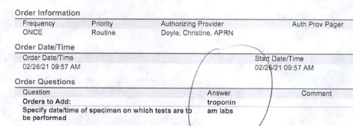

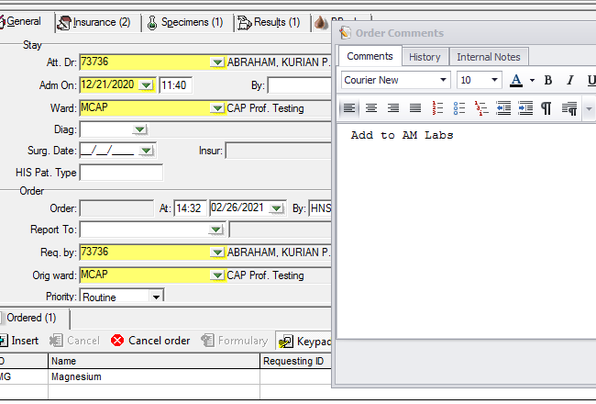

1. Verify that the labs have been collected for the requested time by opening the specified order and checking collection using the “Specimen” tab.

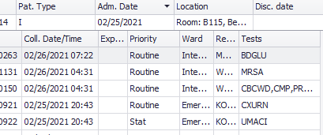

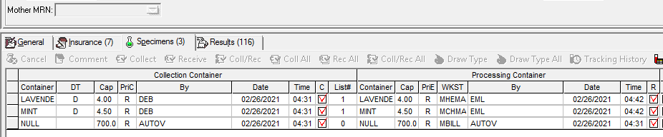

1. For EPIC Add-on Communications:
   1. If the labs have not been collected, contact the patient’s nurse and inform them that the labs have not been collected and that orders need to be placed in the EMR. Document on the add-on communication sheet the nurse’s name and that they were informed of inablility to add testing.
   2. IF the testing cannot be added for any reason (not enough specimen, specimen too old, etc) contact the patient’s nurse and inform them that testing cannot be added and an order must be placed in the EMR so a specimen can be collected.
   3. For any test that cannot be added, document on the add-on communication sheet the nurse’s name that was spoken to and that they were informed of inablility to add testing.
2. Once it has been determined that lab is able to add-on the requested testing, it can be done one of two ways:
   1. The requested add-on order has already been placed by a provider. This is for phone add-on requests, orders already placed, and EPIC add-on communications.
      1. Write down the collector’s initals and collection time of the original specimen order.
      2. Open the add-on order and collect and receive the specimen in the LIS using the original specimen collection information.
      3. Print a specimen label for the add-on test and deliver it to the testing department.
   2. There is no order in the LIS (EPIC Add-on Communications ONLY):
      1. Open the order for the specimen the test is to be added to.



* + 1. Add the test to the requested order by typing in the test code or searching for the test using “Insert”.

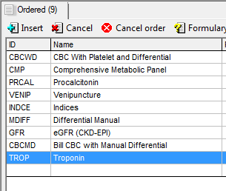

* + 1. Once the test has been entered, there will be a pop-up box that asks if you want to add to the specimen already ordered. Click “yes”.

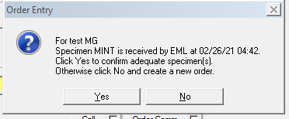

* + - 1. Some tests can be added but will generate a new specimen, such as adding a BNP to a specimen that had a CBC or adding to an order that has an Xtra tube. Be sure to Collect and receive any add-on tests.
    1. When ordering, collecting, and receiving is complete, click on the print button and choose Selected Label

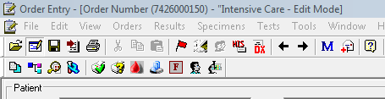

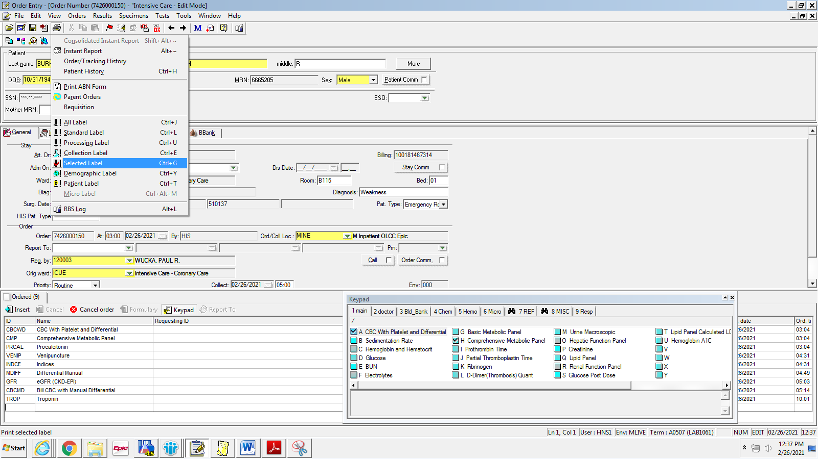

* + 1. Place a check mark next to the label that you need to print and click OK.

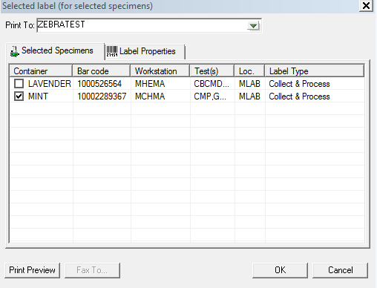

* + 1. Bring the add-on label to the appropriate department and let them know you have an add-on test.
    2. Initial the EPIC add-on communication sheet and place it in the outpatient order bin.

REFERENCE: Super User Training and SOFT Gen Lab Training Guide