Description: RUSH logo for emails

Proc. #4840-CO-0620

**TITLE**: **D-Dimer (ug/mL FEU) Method by Innovance for the Sysmex** **CS-2500**

**PRINCIPLE:**

Coagulation activation results in the cleavage of fibrinogen to fibrin. The fibrin monomers spontaneously aggregate to fibrin and are cross-linked by Factor XIII; this produces a fibrin clot. In response to the coagulation process the fibrinolytic system is activated resulting in the conversion of plasminogen into plasmin, which cleaves fibrin (and fibrinogen) into the fragments D and E. Due to the cross-linkages between the D-domains in the fibrin clot, the action of plasmin releases fibrin degradation products with cross-linked D-domains. The smallest unit is the D-Dimer. Detection of D-Dimers, which specifies cross-linked fibrin degradation products generated by reactive fibrinolysis, is an indicator of coagulation activity.

**CLINICAL SIGNIFICANCE:**

Elevated D-Dimer levels are observed in all diseases and conditions with increased coagulation activation, e.g. thromboembolic disease, disseminated intravascular coagulopathy (DIC), acute aortic dissection, myocardial infarction, malignant diseases, obstetrical complications, third trimester of pregnancy, surgery or polytrauma.1-6

The relevance of the D-Dimer assay is as an aid in the diagnosis of thromboembolic events. Elevated concentrations of D-Dimer are indicative of the presence of a clot and have been reported in deep vein thrombosis, pulmonary embolism and disseminated intravascular coagulation. Innovance D-Dimer assays have been FDA cleared to exclude both PE and DVT as of January 2011.

Polystyrene particles covalently coated with monoclonal antibody (8D3)8 are aggregated when mixed with samples containing D-Dimer. D-Dimer cross-linkage region has a stereosymmetrical structure, i.e. the epitope for the monoclonal occurs twice. Consequently, one antibody suffices in order to trigger and aggregation reaction, which is then detected turbimetrically via the increase in turbidity.

**SPECIMEN COLLECTION:**

**Type:**

Blue top(3.2%) sodium citrate Vacutainer tube. Both the 2 mL or 3 mL tubes are acceptable as long they are filled properly (nine parts of freshly collected blood with one part of 0.11 mol/L (3.2%) sodium citrate).

For proper collection, see policy 4840-CO-0120 Proper Collection & Preparation of Patient Samples.

**Handling Conditions:**

The specimen should be transported at room temperature. Prior to centrifugation, the whole blood specimen is checked for clot formation by gentle inversion and an applicator stick. Centrifuge the capped specimen for a minimum of 3 minutes at 4500 RPMs or at a speed and time that will produce platelet poor plasma. The specimen is stable for 4 hours when stored at 15-25°C. Refrigerated samples are stable for 24 hours or plasma frozen at ≤-18 °C is good for 4 weeks. Frozen plasma samples must be quickly at thawed at 37 °C while gently mixing and avoiding foam formation. Samples must be tested within 2 hours. *Do not refreeze.*

**EQUIPMENT AND MATERAILS:**

**Equipment:**

Sysmex® CA-2500 Instrument

SLD mini cups

Reaction Tubes (only use Cuvette SUC-400A)

**Materials:**

Innovance D-Dimer Kit containing:

Innovance D-Dimer Reagent  
Innovance D-Dimer Buffer   
Innovance D-Dimer Supplement

Innovance D-Dimer Diluent

Innovance D-Dimer Calibrator

Control Material:

Innovance D-Dimer Control 1  
Innovance D-Dimer Control 2

CA Clean I & Clean II

Preservative-free distilled or deionized water

**Preparation:**

All components of a kit are lot-specific. The combination of lots other than those specified for the particular kit lot may lead to incorrect results.

Follow the preparation instructions listed below.

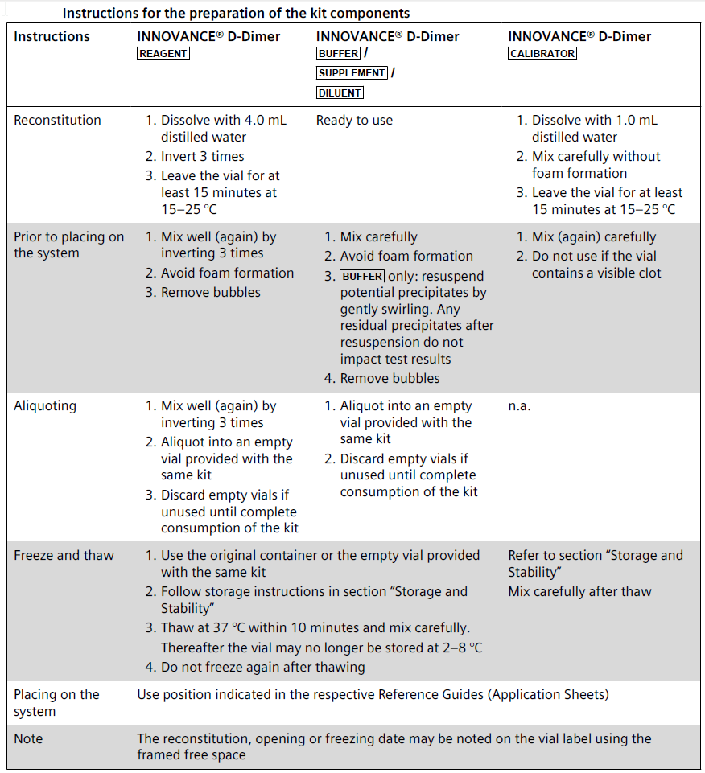

1. **Storage and Stability:**

The kit may be used up to the expiration date indicated on the label if stored unopened at 2 – 8 °C.

**II**. Stability after reconstitution or first opening is listed below

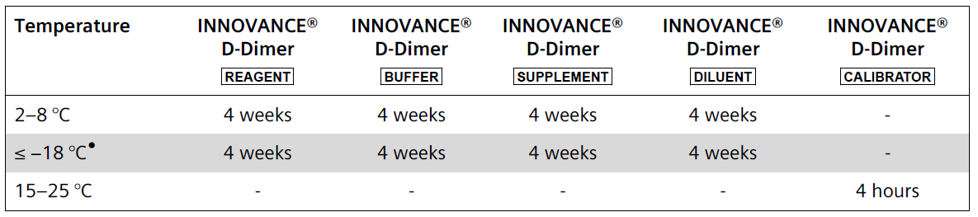

Do not refreeze and thaw. Follow freeze and thaw instructions in section “Preparation of the Reagents”.

**Sysmex® CS-2500 System**

In order to place INNOVANCE® D-Dimer DILUENT on the buffer table, it has to be transferred into conical sample cups. To perform QC it is recommended to transfer controls into SLD Mini Cups.

To perform calibration it is recommended to transfer INNOVANCE® D-Dimer Calibrator into conical sample cups or SLD Mini Cups. As calibrators are intended for immediate use, no on-board stability data has been established.

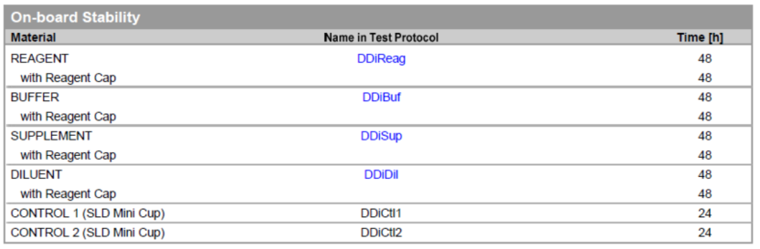

**Innovance D-Dimer Control 1**:   
**Innovance D-Dimer Control 2**:  
Lyophilized human plasma based products containing D-Dimer containing

` 5-chloro-2-methyl-4-isothiazole-3-one

2-methyl-4-isothiazole-3-one (< 1 mg/L)

Sodium azide (< 1 g/L)

Assayed controls used for the assessment of precision and analytical bias in the normal and pathological range for the determination of D-Dimer in the Innovance D-Dimer Kit.

**Reconstitute the Innovance D-Dimer Control 1and 2 with 1.0 mL of sterile water.**

* Re-stopper vial and invert gently to dissolve (without foam formation).
* Let stand at +15 to +25 °C **for at least 15 minutes** before use
* Mix carefully once before using

**Stability after reconstitution:**

On-board stability: 24 hours  
2- 8 °C: 7 days (closed vial)   
≤-18 °C: 4 weeks (do not refreeze)**

**Must be frozen in the original containers. Do not refreeze after thawing.

Innovance D-Dimer Controls 1 and 2 may be frozen in the original contained and thawed once after reconstitution. The previous storage time at 15-25 °C must not have exceeded 4 hours. The plasma must be well sealed and frozen as quickly as possible. Thawing must be completed at 37 °C and within a maximum of 10 minutes. Innovance D-Dimer Control 1 and Innovance D-Dimer Control 2 should not stand for more than 4 hours at 15-25 °C after thawing. Innovance D-Dimer Control 1 and Innovance D-Dimer Control 2 should not be used if they contain visible clots.

**CA Clean I is liquid and ready for use**

On-board stability: 120 hours

Stable unopened at 2-8 °C until expiration date on bottle.

Opened bottle stable for 30 days at 2-8 °C. Do not freeze.

**These products are for in vitro diagnostic use only.**

**WARNING:** Because no known test can offer complete assurance of the absence of infectious agents, all human derived products should be handled with appropriate caution.

**WARNING:** Sodium azide may react with lead and copper plumbing to form highly explosive metal azides. If discarded into a sink, flush with a large volume of water to prevent azide build up.

**Reagent Integrity:**

Indication of deterioration: No evidence of vacuum in vial upon opening, difficulty in reconstituting reagent, control values outside of determined range

**QUALITY CONTROL:**

Innovance D-Dimer Control 1

Innovance D-Dimer Control 2

1. Innovance D-Dimer Controls must be tested **at least every eight hours of testing** and **for each vial of reagent for the respective measurement range to ensure that the system** **is functioning correctly**. Control of the lower measurement range is performed with Innovance D-Dimer Control 1, and for the upper range with Innovance D-Dimer Control 2.
2. The measured values obtained must be within the acceptance ranges given in the respective Table of Assigned Values.
3. If values are obtained outside the acceptance ranges, the measurement must be repeated. If the deviations are confirmed, a new calibration must be performed.
4. **Do not report patient results unless the cause of the deviating control results has been identified and corrected.**

5. Controls should be within the tolerance limits established for the specific lot number of control. If control values are outside of determined range:

* Check controls, reagents and instrument performance.
* Document actions taken to identify and correct the problem before reporting any patient data.
* Corrective action when tolerance limits are exceeded include:

1-Rerun out-of-range control material.

PROCEDURES:

Loading Reagents onto the Reagent table

1. Press **Reagent** icon on the toolbar

2. Highlight a reagent position for removal

3. Press **Change/Add.**

4. Lift the reagent section lid.

5. Verify reagent table cover LED is solid green.

6. Slide the lock lever and remove cover.

7. Lift out rack and remove empty or expired reagents.

8. Add new vial to rack with barcode showing

9. Load rack into the reagent table.

10. Replace cover and slide the lock lever, close the reagent section lid

11. Press **OK** on the screen to read barcode.

12. Wait for the barcode to finish reading.

13. On the reagent screen, **touch reagent position just loaded**, and press **Change** to update date and time.

Loading QC or Calibrator:

Use C-rack and SLD Mini cup

1. Reconstitute vial observing package insert instructions.
2. Aspirate entire contents of vial into a new SLD mini cup, avoid bubbles.
3. Set SLD mini cup into corresponding vial.
4. Carefully check for bubbles and remove if necessary with a small pipette.
5. Remove C-rack and insert vials with SLD mini cups into the rack.
6. Place C-Rack back into the reagent table
7. Lock Lever and press OK to read barcode.
8. On reagent screen, **highlight vial just loaded** and press **Change** to update date and time.

***Note:***  *SLD mini cups are for the C-rack only*

**Buffer Table Loading:**

**Loading barcoded vial**

1. Verify buffer table cover LED is green

2. Open buffer table cove and place reagent in an adaptor with barcode facing out.

3. Place into the STAT/buffer table and close cover.

4. Press OK on the barcode reading screen.

5. On reagent screen, **touch reagent position just loaded**, and press **Change** to update date and time.

**Loading 4ml cup**

1. Verify buffer table is green.

2. Place cup into adaptor and load.

3. Close STAT/buffer table cover and Press **OK** on barcode reading screen.

4. On Reagent screen, see position display as red question mark.

5. Highlight red question mark position.

6. Press **Edit Reagent Info** operator key.

7. Select reagent name, vial type is 4mL cup verify lot number

8. Press **OK** .

9. With cup position highlighted, press **Change** to update date and time.

Loading Consumables and Discarding Waste Material:   
(do the following as necessary)

1. **Replenish Reaction Tubes**   
   Reaction tubes should be replenished as needed. Do not fill cuvettes above the red line. Make sure you use only the Cuvette SUC-400A reaction tube.
2. **Replenish DI water.**

Rinse the DI water tank with 70% isopropyl alcohol followed by DI water before replenishing with

DI water

1. **Dispose of Used Reaction Tubes from the Trash Box.**

Reset the trash counter.

Loading consumables should be done along with the daily maintenance. See procedure “Preventative Maintenance on the CS-2500” for directions on performing maintenance.

**CALIBRATION**

Calibration criteria include: at changes of reagent lot numbers, failure to recover QC within acceptable limits, after major service or maintenance on the CS-2500, at the recommendation of the manufacturer and every 6 months. A minimum of three points must be plotted for the standard curve to be acceptable. Two levels of QC are to be run following the calibration to validate the new curve.

The reference curve is valid for the respective lot of the reagent employed. A new curve should be prepared with a new lot of Innovance D-Dimer using Innovance D-Dimer Calibrator provided in the same kit and if indicated by any change in analytical conditions. The calibration curve can be used as long as the assay-dependent assigned values (i.e. Innovance D-Dimer Control 1 and Innovance D-Dimer Control 2) are within the corresponding acceptance ranges.

In order to generate a standard curve, a calibrator must be loaded onto the CS-2500 analyzer. The calibrator used is: Innovance D-Dimer Calibrator DDi.CAL. **The package insert in the kit has the assigned calibrator value listed in concentration mg/L FEU.**

To calibrate a new lot of reagent:

1. Enter the reagent and calibrator lot information in the **Reagent Lot Master** tab.

2. Reagents, calibrator and buffer should be placed into a SLD mini cup and put inside the vial and placed in the C-Rack

3. Select **Order**

4. Select **Switch Order**.

5. Select **Holder Calib Curve Order**.

6. Select the desired assay to calibrate

7. Select **Change** and select the correct lot number. Select **OK.**

8. Select the correct calibrator lot number from the list.

9. For manual entry of assay values: place the cursor in the **Assay sheet Value**. Select **OK.**

10. Select **Start**.

11. To view the calibration status and progress, press **Joblist**.

PROCESSING QUALITY CONTROL:

**Processing QC from the reagent table: QC files**

1. Load QC onto a C-Rack.

2. Select **Order.**

3. Select **Switch Order.**

4. Select **Holder QC Order**.

5. Press **Order Entry**.

6. Select **QC01-QC20** radio button.

7. Select **QC file** from the list on the right.

8. Select appropriate assays. Press the down arrow to order the next control.

9. Press **OK** once controls have been ordered.

10. Press **Start**.

SAMPLE PROCESSING

After a valid standard curve has been established and QC is performed and found to be acceptable, sample testing can begin.

**Samples can be loaded on the analyzer using sample barcode and the host connection. The CS-2500 has an automatic cap piercer- caps do not have to be removed from the sample tubes.**

Sample ID number (barcoded sample) read by barcode reader /   
 Automatic inquiry of tests (host connection operational)

1. When the host computer is connected using bi-directional communication, host inquiry takes place when the sample ID is read and the analysis parameters are automatically registered
2. Load the barcoded sample tube on the sampler.
3. Check host connection (HC) status, HC status icon must be green or orange.
4. Press **Start** to begin processing.

5. After barcode reading, confirm sample order status and progress on the **Joblist** screen.

**Manual order processing (When no bar-code is available or the LIS is down)**

1. Place rack with sample tubes on sampler.

2. Press **Order**.

3. Enter rack number.

4. Select tube position to input an order.

5. Press **Order Entry**.

6. Press **Ordinary Sample.**

7. Place cursor in sample no. and input sample ID if the sample does not have a barcode label.

8. Select assays to be analyzer.

9. Press the sown arrow to order the next sample.

10. Press **OK.**

11. Press **Start.**

12. Confirm sample order status on the **Joblist**.

**Processing samples in Micro-Mode**

1. Follow steps listed above for manual order processing.

2. Press **Mc** column on **Order screen**.

3. Load **uncapped** tube on to the system.

4. Press **Start**.

**Change to a longer measurement time.**

1. Follow steps listed above for manual order processing.

2. Press **Detailed Settings** button.

3. Click box below **Measurement Time**.

4. Select measurement time

5. Select **OK**

6. Select **Start**.

**REPORTING RESULTS:**

**The D-Dimer concentration in mg/L is calculated automatically by the analyzer based on the reference curve.** The D-Dimer level **is expressed as initial fibrinogen equivalent unit (FEU**). An FEU is the quantity of fibrinogen initially present that leads to the observed D-Dimer level. Increases in D-Dimer concentration observed with thromboembolic events can be variable due to localization, extension and age of the thrombus. Therefore, a thromboembolic event cannot be excluded with certainty solely on the basis of a D-Dimer concentration being within the reference range of ostensibly healthy persons.

Record and report patient and quality control values according to laboratory procedure.

Hemolyzed, lipemic, or icteric samples must be noted with the result.

**Analytical Measuring Range: 0.19 - 35.20 mg/L**

**\*CS-2500 will automatically run high patients on the extended mode.**

**Reference Range:**

Reference Range values determined for D-Dimer are:

**Less than or equal to 0.59mg/L FEU for non ED Patients**

**Less than 0.50 mg/L FEU for ED Patients**

**Cut-off value for D-Dimer is: 0.50mg/L FEU**

**PROCEDURE NOTES:**

Overall performance of D-Dimer testing is dependent on reagent and instrument performance. Acceptable variability (imprecision) should be such, that the total coefficient of variation (CV) of the analytic system is less than 20% on the same lot of control plasma.

A new reference curve must be established with each change of reagent lot, change of instrument or with any deviation from control limits. Recalibration occurs if there are any problems with the curve, or outlier points. One point can be repeated or a new set of reagents/calibrator made up and run. Troubleshoot with the hot line for further issues.

**D-Dimer concentrations** **<3.65 mg/L FEU obtained by re dilution measurement have to be** **confirmed without redilution. When a sample gives a Range Over error on a D-Dimer run the sample on extended mode D-Dimer. If that yields a result it is acceptable to report. If the extended mode D-Dimer gives a <3.65 and a Range Over on D-Dimer, repeat sample on both modes. If results remain the same dilute same with D-Dimer dilute and run on both modes. This results needs to be multiplied by dilution factor.**

The Innovance D-Dimer total measuring range is defined by the concentration of the calibrator used and is approximately 0.19 to 4.40 mg/L FEU. Report a result less than .19 as <0.19. The measuring range can be extended to approximately 33.50 mg/L FEU by automatic redilution of samples above 4.40 mg/L FEU. We report results out as an alpha result of: >34.00mg/L FEU.

All components of the Innovance D-Dimer Kit are lot dependent. Do not mix components of one lot with another-this may lead to incorrect results.

**Instrument Operations**

System Shut-down

1. Verify CA Clean 1 is set on reagent table A.

2. Press **Shutdown**. Select option: **Turn the main unit OFF**.

3. Press **OK.**

4. Press **OK** after shutdown process is completed.

5. Press the **X** in the upper right of the screen.

6. Press **OK**.

7. Select **Windows Start** icon.

8. Select **Shutdown**.

9. Turn the analyzer power **OFF**.

System Start-up:

1. Power **ON** the IPU computer.

2. Windows Logon: Press **CSAdministrator icon**- enter password: CS Admin+2304

3. CS software logon: Press IPU Logon: admin- enter password: admin

4. Turn the analyzer power **ON**.

Emergency Stop:

To be used if the instrument encounters a sudden malfunction or other problem.

1. Press the Mechanical Stop switch on the Main Unit.

2. The operation of the main unit stops and an alarm sounds.

3. The samples already in process become will need to be repeated.

**LIMITATIONS OF THE PROCEDURE:**

Turbidity and particles in plasma may interfere with the determination. Therefore plasmas containing particles must be centrifuged for 3 minutes at approximately 4500 RPM again prior to testing.

**Lipemic samples or samples containing particles that cannot be clarified by centrifuging must be excluded from testing.**

**Higher levels of lipids or turbid samples can lead to falsely elevated or decreased values.**

Patient samples may contain heterophilic antibodies (e.g. human anti-mouse antibodies (HAMA) and rheumatoid factors) that could react with immunoassays to give a falsely elevated or depressed result. This assay has been designed to minimize interference from heterophilic antibodies. Nevertheless, complete elimination from this interference cannot be guaranteed

Results of the D-Dimer test should always be interpreted in conjunction with the patient’s medical history, clinical presentation, and other findings. Clinical diagnosis should not be based on the results of INNOVANCE D-Dimer alone.

Patients with a distal DVT may have a normal INNOVANCE D-Dimer result.

**Interfering Substances**

Levels of the following do not inter­fere with the Innovance D-Dimer assay:

|  |  |
| --- | --- |
| **Analyte** | **Interference Up to** |
| Bilirubin | 15 mg/dL |
| Hemoglobin | 100 mg/dL |
| Triglycerides | 600 mg/dL |

**General Reagent Specificity**

There is no significant effect on the determination of D-Dimer due to levels of the following:

|  |  |
| --- | --- |
| **Analyte** | **Interference Up to** |
| Creatinine | 30 mg/dL |
| Heparin, sodium | 3.0 U/mL |
| Rheumatoid Factors | 1330 IU/mL |
| Albumin | 6 g/L |
| Fibrinogen | 1000 mg/dL |
| Urea | 500 mg/dL |
| Uric Acid | 20 mg/dL |
| Immunoglobulin G (IgG) | 5 g/dL |

**INTERFERENCES:**

No interference up to:

|  |  |
| --- | --- |
| Triglycerides | 330 mg/dL |
| Hemoglobin | 1000 mg/dL |
| Bilirubin unconjugated | 60 mg/dL |
| Bilirubin conjugated | 40 mg/dL |

**REFERENCES**

* + - Innovance D-Dimer package insert. Dade Behring. Marburg, Germany, April 2007
    - Innovance D-Dimer Control package insert. Dade Behring. Marburg, Germany, April 2007.
    - Dade® CA System Buffer package insert. Dade Behring. Marburg, Germany, May 2008
    - Dade® Owrens Veronal Buffer package insert. Dade Behring. Marburg, Germany, May, 2008
    - Clinical Laboratory Standards Institute. Collection, Transport and Processing of Blood Specimens for Testing Plasma-Based Coagulation Assays: Approved Guideline-Fourth Edition.   
      CLSI Publication H21-A5. Wayne, PA, January, 2008
    - Sysmex® Operator’s Manual CS-2500 Automated Coagulation Analyzer.
    - Application Sheet for Innovance D-Dimer on CS-2500 Automated Coagulation Analyzer