**TITLE: Preparing and Receiving Miscellaneous Test Orders in the LIS**

**PRINCIPLE:** When a test is not able to be ordered in the Electronic Medical Record (EMR) or a provider cannot find the the test they want to order, a miscellaneous test will be ordered. It is important to know where to find the information on what test the provider is trying to order so staff can know what type of specimen(s) to collect and what information must be entered in the laboratory information system (LIS) when the specimen(s) is received.

# STEPWISE PROCEDURE:

**Preparing Miscellaneous Orders for Collection:**

1. Miscellaneous labs will appear in the laboratory information system (LIS) as LMISC.
2. The provider entering the order in the electronic medical record (EMR) is required to enter a test name before the system will accept the order. This required information transfers into the LIS under the “Results” tab of Order Entry.

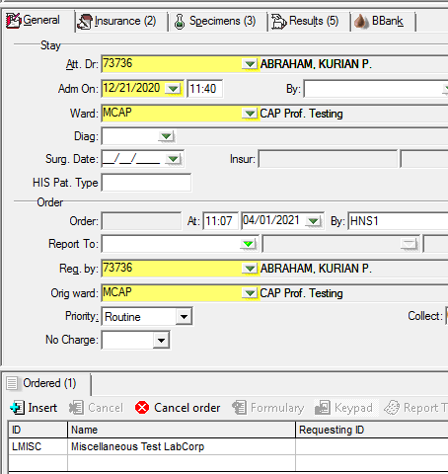

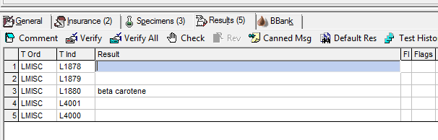

Test Name

1. The test and specimen information needs to be researched before the specimen can be drawn. To research the miscellaneous test:
   1. Search the online LabCorp test directory for the test.
   2. Note the LabCorp test number and specimen requirements. It is highly recommended to print the test information out for reference.
   3. If the test cannot be found in the online LabCorp test directory, call LabCorp customer service at 1-800-399-4461. Our account number is 12070310. Be sure to write down the test number and specimen information to enter into Soft.
   4. If LabCorp does not perform the test, search the Mayo test directory or ARUP test directory for the test and specimen requirements.
      1. For tests being sent to a location other than LabCorp, the LIS test code must be changed to MISC. Have the sendout technologist cancel the LMISC order.
2. Once the test information has been acquired, verify that the test is not orderable in the LIS.
   1. How to check if a test is orderable:
      1. Go to the General tab.
      2. Click “Insert”.



* + 1. Under 2nd ID, enter the 6 digit LabCorp test code and click “Find”.

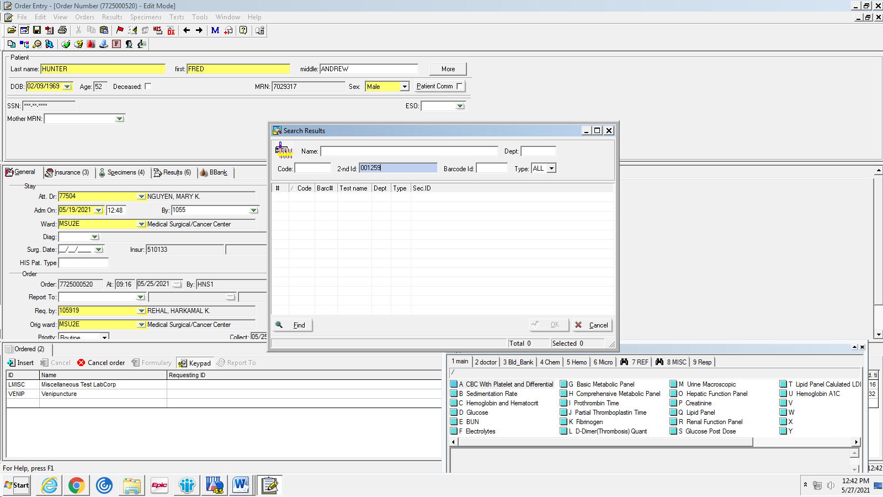

* + 1. If the test is not built in the LIS, you will get an error message stating “You have entered an invalid value.” Continue with the LMISC order.
    2. If the test has been built in the LIS, the correct test code will appear. Select the test and have the sendout technologist cancel the LMISC.

1. Once the specimen information has been found, whether the test is for LabCorp or another lab, enter the Test name, testing lab, test number, and collection information under the “Order Comment” box under the “General” tab. This allows the staff on the floor to see what specimen(s) need to be collected using the handheld devices.
   1. Be sure to enter any special collection information, such as “Protect from Light” or “draw in pre-chilled tube”.

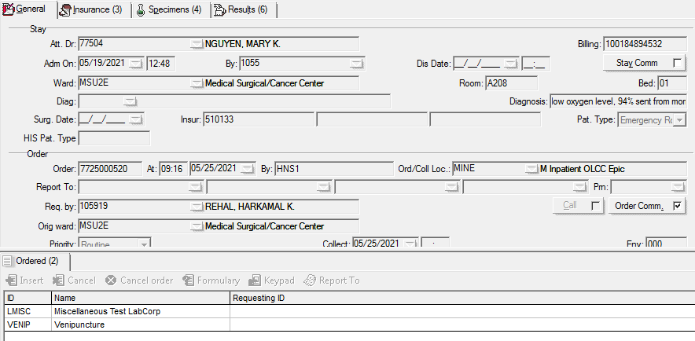

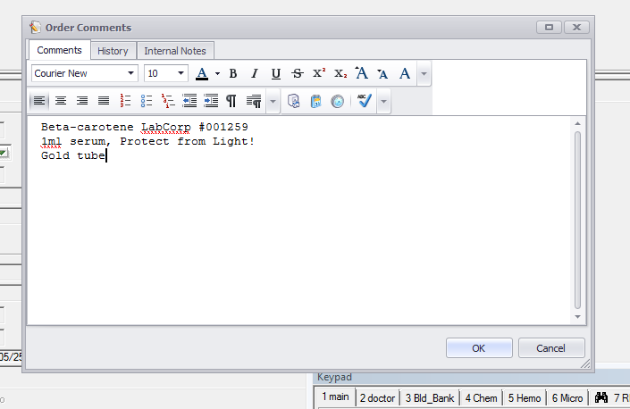

**Receiving LabCorp Miscellaneous Tests:**

1. Upon receiving the LMISC specimen in the LIS, a pop-up box will appear that asks for some, if not all, of the following:
   1. Test Code – You **MUST** enter the **6 digit** LabCorp test code for the test being ordered. If the test code has leading zeros, you must use them.
      1. If the correct test code is not entered, the results will not be transmitted from LabCorp properly.
   2. Total Volume (mL) – Enter the amount of sample being sent for testing.
   3. Source – Enter the specimen type, i.e. serum, plasma, urine, whole blood, etc., transport temperature and any special requirements.

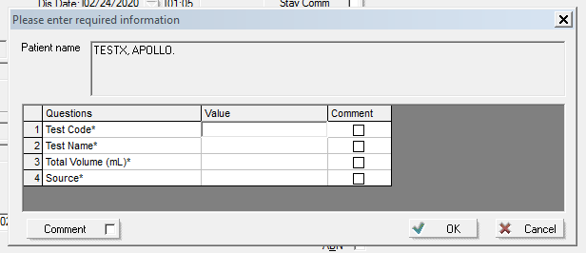

Example:

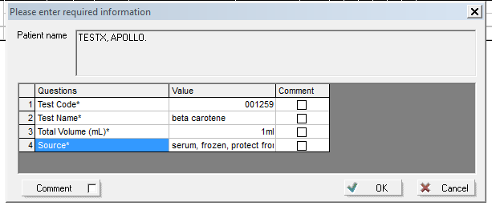

1. Once the specimen(s) is received, it is to be delivered to the sendout department for processing. Forward any printed test information to the sendout department along with the specimen(s).