**TITLE: Products of Conception (Natera Anora) Kit Processing and Resulting**

**Principle:** To successfully process specimens, complete requisitions and package specimens for reference laboratory testing and properly process results when received.

**Personnel:** Phlebotomists and Medical Technologists

**Referred Laboratory:** Natera

**Specimen Requirements:** Natera Anora Kit containing products of conception tissue in saline and blood collected by surgery or emergency department personnel.

**Additional Information:** Requisition must be completely filled out by surgery or emergency department staff, complete with patient and provider signatures.

**LIS Order Code: PRODC**

**Stepwise Procedure:**

**Specimen Processing:**

1. Receive the specimen kit in the laboratory information system (LIS) and print 2 extra labels. One label is to be placed on the Reference Lab Testing Log and one is to keep with the copy of the requisition in the Miscellaneous Laboratory Tests file box.
2. The kit must contain a labeled 6ml EDTA tube of blood from a parent (preferably the mother) and a labeled specimen container containing tissue in saline. Chart labels are acceptable, however, they cannot cover the QR barcodes on the containers.
3. **Each kit has its own specific QR barcode.** Kit contents cannot be interchanged with other kits!

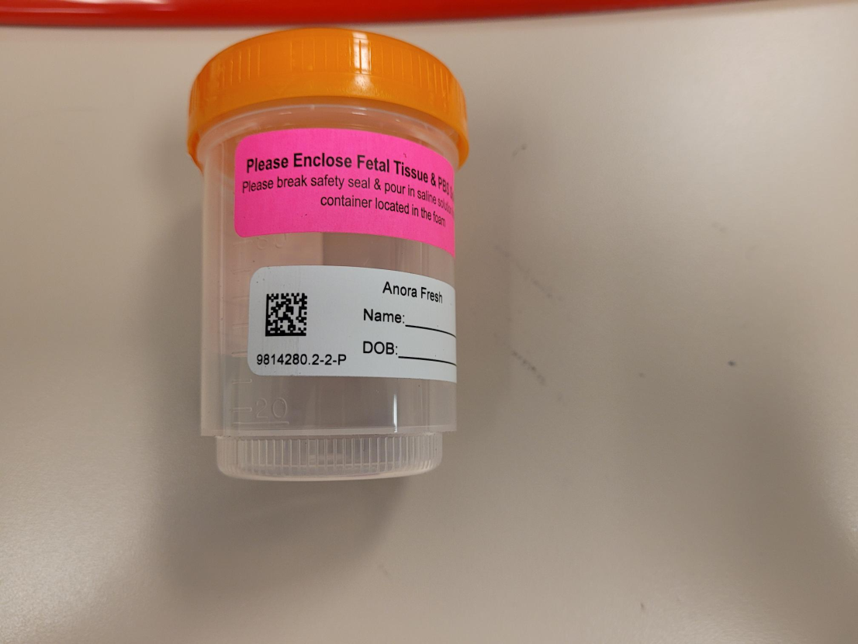 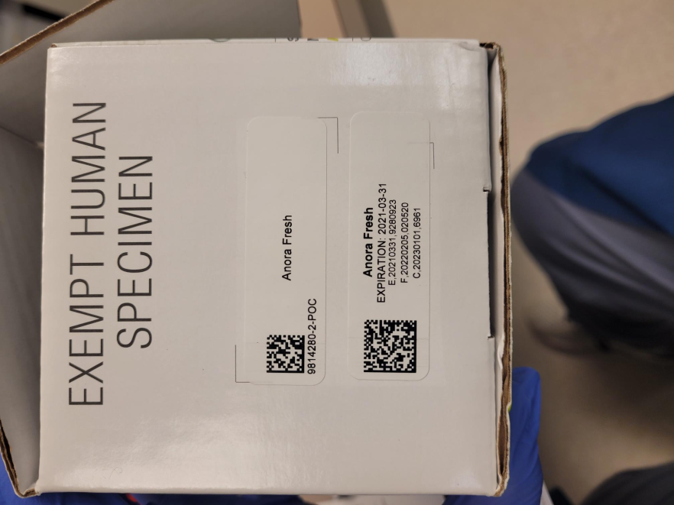

First seven numbers under QR barcode must match!

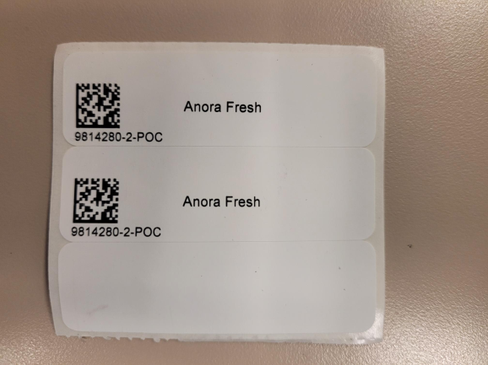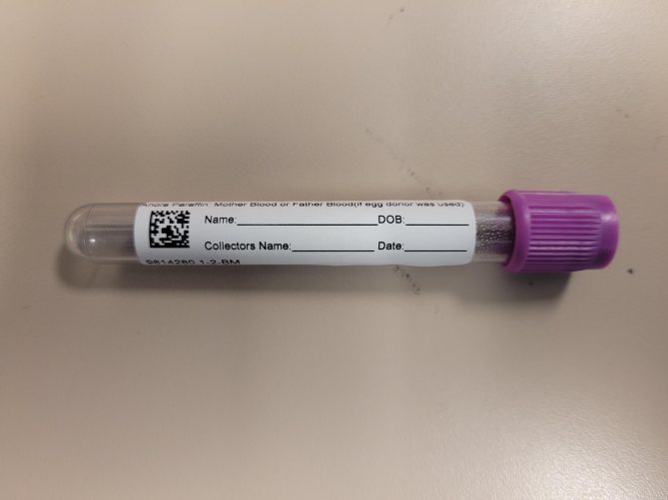

1. Verify patient information is on all containers in the kit, the QR barcodes are visible and match, and that the requisition contains all patient information. All areas in yellow on the requisition must be completed.
2. Parafilm the screw-capped container and return it to the foam holder.
3. Remove the kit QR barcode labels from the specimen bag, make sure the numbers below the barcode match the blood and specimen container labels, and place one at the top of the requisition in the designated location.

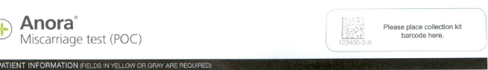

Place label at top of requisition. Numbers under barcode must match blood and tissue containers and kit box!

1. Seal the foam holder containing the specimen container and tube of blood in the specimen bag provided in the kit.
2. Make a copy of the requisition.
3. Place the specimen bag and original requisition into the kit box and close the box.
4. Place the closed box in the pre-labeled FedEx bag that is provided in the kit and seal the shipping bag. If the FedEx bag is missing from the kit, there are extras in the send out requisition drawer under the phone.
5. Write the FedEx tracking number from the label on the shipping bag at the top of the copy of the requisition.
6. Place the sealed FedEx bag on the bookshelf outside the lab manager’s office to be taken to the FedEx pickup location or take the bag to the FedEx pickup location.
7. Place a label on the Reference Lab Testing Log and write the name of the lab and test sent.
8. Place the copy of the requisition, along with the extra LIS label, in the Miscellaneous Laboratory Tests file box under the first letter of the patient’s last name.

**Results Processing:**

1. When results are received, remove the copy of the requisition from the Miscellaneous Laboratory Tests file box.
2. Verify all patient information is correct on the results using the copy of the requisition and LIS label and that the results are final.
3. If all patient information is correct and the results are final, place the LIS label attached to the copy of the requisition on the results and place the results in the “Reports to be Scanned” basket in the LCC area for the LCC phlebotomy staff to scan into the LIS.
4. Preliminary results may be forwarded to the provider, but should not be scanned as it will finalize the results in the LIS. File preliminary results with the copy of the requisition in the Miscellaneous Laboratory Tests file box.
5. If all tests are complete, discard the copy of the requisition in a proper PHI receptacle.