## TITLE: Coroner Drop Off Specimens for Yorkville Lab

### PRINCIPLE

To outline the responsibilities of the Coroner staff and the Laboratory staff to insure timely receipt and assessment of specimen integrity in order to expedite result reporting to the Coroner’s Office.

### PERSONNEL

Phlebotomists, Clinical Associates, Medical Technologists, Senior Medical Technologists, Coroner’s Office

### STEPWISE PROCEDURE

1. **Drawing Supplies**
   1. The Laboratory will supply the following for Phlebotomy and specimen acquisition:
      1. -Needles (not butterflies)
      2. -Biohazard baggies
      3. -Blood Draw Tubes
      4. -Sterile containors
   2. The Coroner will draw the appropriate specimen(s) and label it with the Patient’s name, date of birth, date and time of collection, test requested and initial of collector.
   3. The General Test Requisition must be filled out with patient information, desired tests, Doctor, and a call back and fax number for receiving results. See LAB-0003
2. **Registration of Specimen only done in LIS**
3. The person dropping off specimens will bring the specimen(s) to the Lab to have the order and specimen(s) reviewed by a Medical Technologist for accuracy of specimen labeling and order/tube type, specimen volume and integrity.
4. If specimens for the drop off are deemed unacceptable, the Coroner will be notified during the check in process.
5. If acceptable, then Medical Technologist will register Patient into LIS system. They will **not** be registered in EPIC.
6. Open Order Entry.
7. Enter Patient name.
8. If Patient is already in LIS then select patient and highlight New then New Stay.
9. If the Patient is not found then select “Yes” for Create New.
10. Enter DOB, Sex, Att. Dr. (Dr. Coroner, Doctor ID “COR”) and ward (YLAB). Ord/Coll Loc: should default to YOUTE.
11. Enter tests.
12. Right click on each test that is ordered and highlight Bill—No Charge.
13. Provide reason for No Charge as” Coroner Specimen.”
14. Enter fax number, Kendall Country Coroner’s fax 630-553-4116

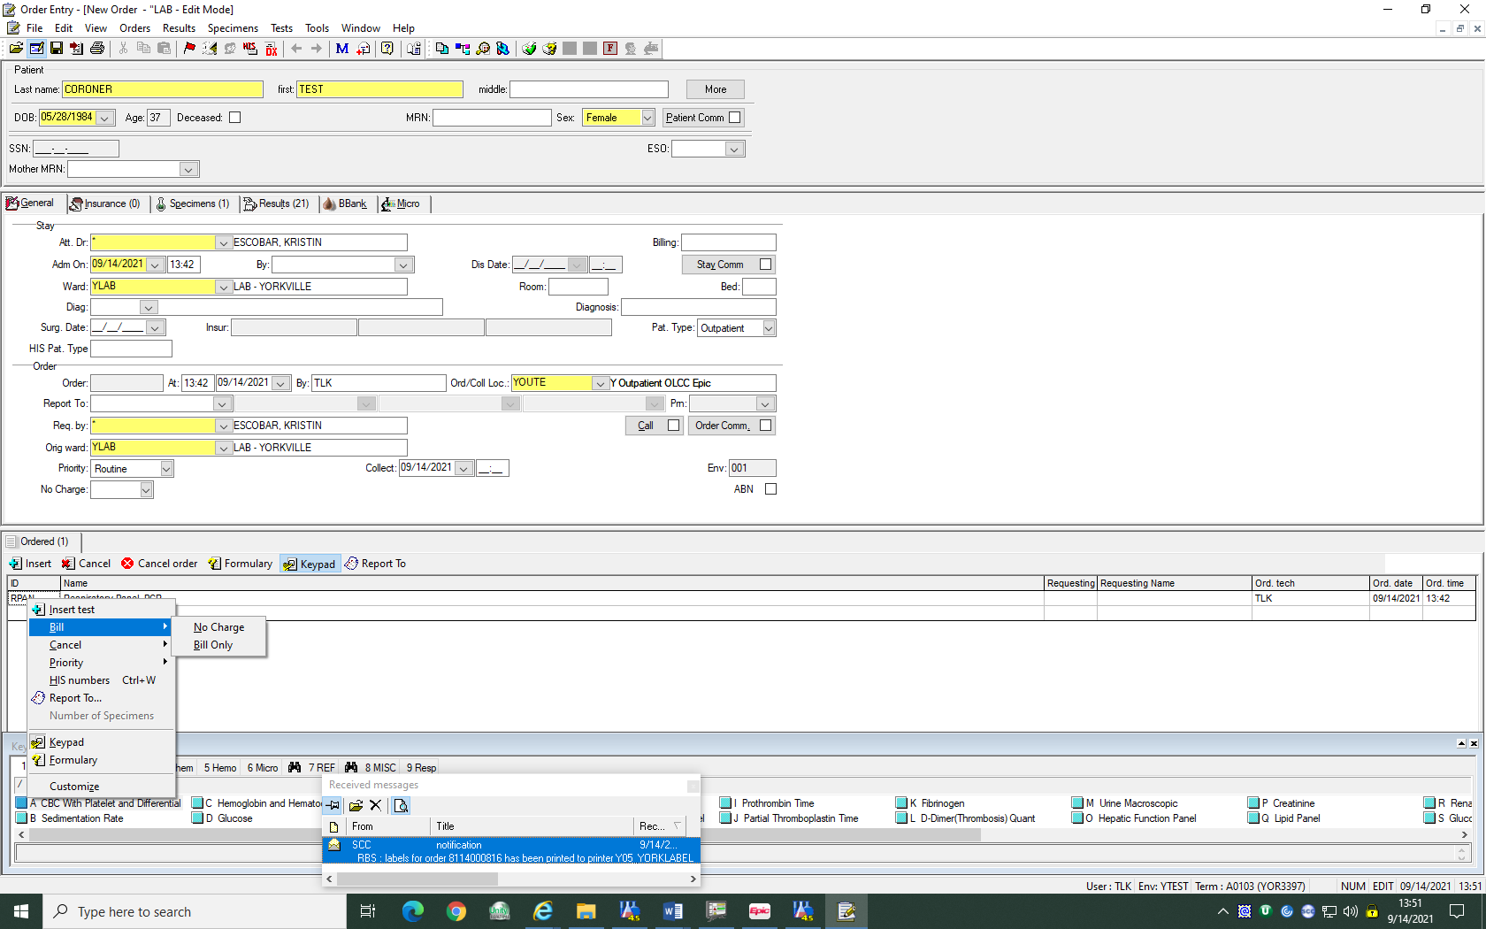

1. Once ordering is complete a Medical Technologist will print labels, receive specimen into the Laboratory LIS system, and deliver the specimens to the proper department.

**C**. **Processing Tests**

* 1. Laboratory personnel will order requested tests in the LIS, print and apply labels to the specimen. The patient’s name on the original hand-written label must remain visible. The comment line contains information regarding faxing and calling results as necessary.
  2. Fax number must be entered on PRN to insure the reports will be sent.
  3. If a specimen is determined to be unacceptable after processing, the Medical Technologist will contact the Coroner’s Office. The order in the LIS will be cancelled with a comment documenting specimen rejection; i.e. Clotted

1. **Test Reporting**
   1. Coroner will receive a faxed report once testing is complete.
   2. Give Director or Manager a final report so an invoice can be sent to the Coroner for payment of testing.
   3. Do not have to call results. Use “Not Indicated” to clear off call list.