**TITLE: Newborn Screen Specimen Receiving**

**PRINCIPLE:**

Newborn screening is recognized as one of the most successful public health accomplishments, and was the first population-based genetic screening program to become an integral component of public health practice. Early detection, diagnosis and treatment of these conditions can prevent death or disability and enable children to reach their full potential. Newborn Screening is typically performed at 24-48 hours of life in order to detect conditions or disorders in newborns soon after birth.  These tests can determine if a newborn has a condition or disease for which early treatment can help improve his/her health outcome. This procedure will establish guidelines to help staff receive newborn screen specimens into the lab and verify all required information is properly completed on the Illinois Department of Public Health (IDPH) Newborn Screen submission form.

**PERSONNEL:**

All Laboratory Personnel

**STEPWISE PROCEDURE**

1. Newborn screen specimens are collected by staff in Mother/Baby, the NICU, and in outpatient. It is extremely important that the forms are correctly completed to ensure accurate resulting.
2. Upon receipt of the newborn screen in the laboratory, immediately remove the newborn screen from the specimen bag. Newborn screen forms need to be reviewed as soon as possible after receipt to ensure that they are complete and properly collected.
3. Newborn screens should not be collected when the baby is less than 24 hours old, unless the infant has been admitted to the neonatal intensive care unit (NICU).
4. First, verify the newborn screen has been properly collected. To verify the newborn screen has been collected properly:
   1. Compare the baby’s date and time of birth and the collection date and time. If less than 24 hours, check to make sure the NICU/Special Care box is filled in under the collection time.
      1. If the baby’s age is less than 24hours, and the NICU box is not marked, contact the collecting department to verify the collection date/time or NICU status. If the baby is not in the NICU, the specimen is to be rejected and recollected when the baby is 24 hours old or older.
   2. Look at the how the circles of blood are filled on both the front and back of the filter paper.
      1. A properly collected newborn screen form should have all the circles filled completely. The blood spot should be visible from both sides of the filter paper. The blood should not significantly extend past the dotted lines on the circles.
         1. Front of Filter Paper:

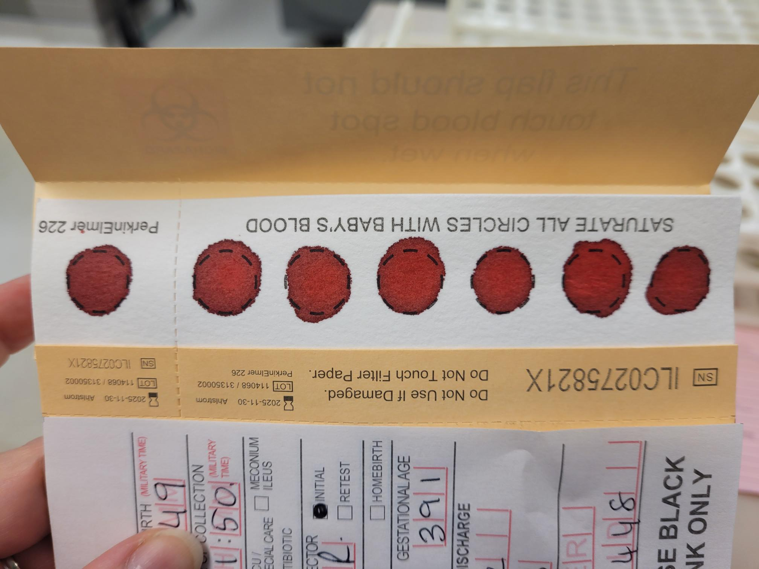

* + - 1. Back of Filter Paper:

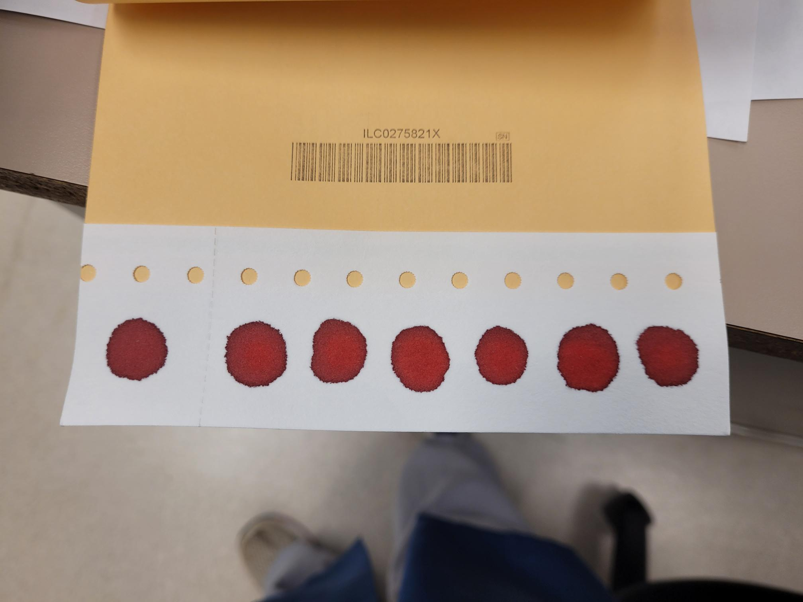

* 1. If the blood spots look like any of the following, the newborn screen is to be rejected and the collector needs to be notified to re-collect the screen due to improper blood collection:
     1. 
        1. Blood was not allowed to soak through the filter paper – Not enough blood for testing.
     2. 
        1. Filter paper looks scratched or torn.
     3. 
        1. Too much blood applied – Overfilled.
     4. 
        1. Squeezing/milking the foot too much resulting in interstitial fluid in the blood.
     5. 
        1. Not wiping away the alcohol before collection, resulting in serum rings.
     6. 
        1. Clotted blood on top of the spots or blood looks layered.

1. If the blood spots are correctly collected, next verify that the form has been completely and correctly filled out. Any missing or incorrect information is required to be completed/corrected by the collector before accepting the specimen into the lab.
   1. Verify the “Baby’s Information” section is complete and correct. Compare the spelling of the baby’s name and medical record number (MRN) to the laboratory information system label on the back of the form. Any discrepancies need to be corrected by the collecting department.

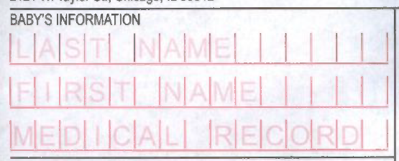

**Baby’s MRN**

**Baby’s gender is their first name** – Should not contain “Baby” or Mom’s first name. Only other acceptable information is a letter or number following the gender in the case of multiples (Girl A, Boy 2, etc).

**Last Name – only 15 characters can be completed.**

1. Verify “Mother’s Information” section is complete. Names, DOB, Last 4 of SSN, phone number, and address, including county of residence is required.

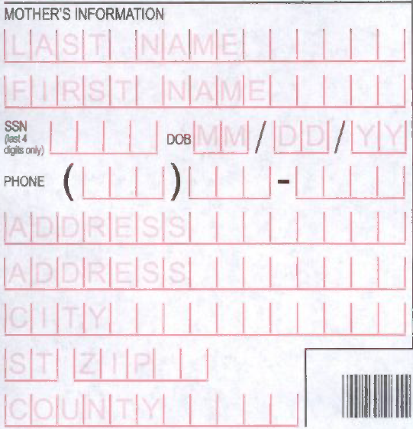

1. Verify all highlighted areas on the right side of the form are completed. These are always required. “Transfused Date” and the boxes under the “Time of Collection” box are completed only if those conditions apply to the infant.

Note: Selection boxes should be completely filled– Not:

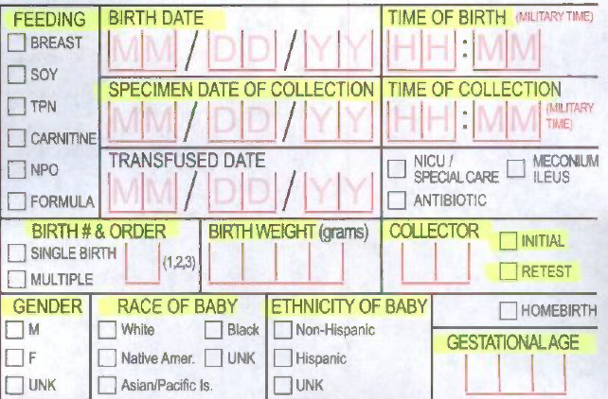

**One must be marked!**

1. The name and phone number of the provider that will care for the baby after discharge and the collecting facility is to be completed.

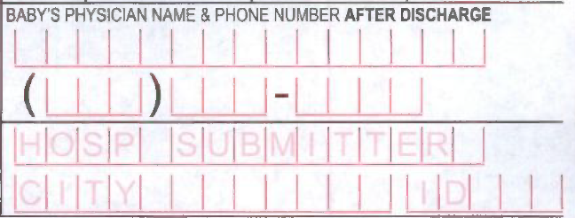

Example of a properly completed form:

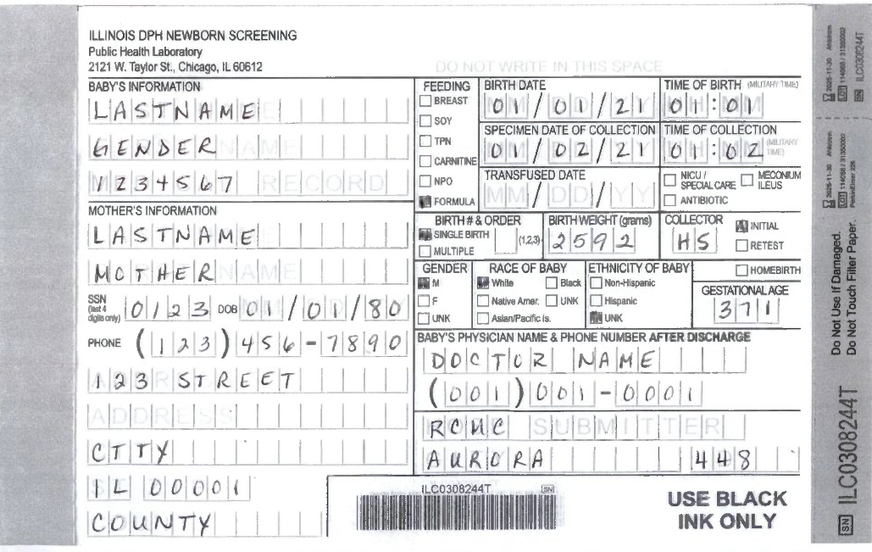

1. If any area of the completed form is incorrect or is missing required information, DO NOT receive the specimen into the lab. Contact the department that collected the newborn screen and inform them of the error on the form. Return the form to that department to have the collector correct the missing or incorrect information or if necessary, recollect the specimen.
2. Once it has been determined that all information is complete and the blood collection has been properly done, scan the LIS label attached to the back of the form into the receiving function of the LIS.
3. Print 2 extra LIS labels and slide the extra labels between the carbon copy and back of the form.
4. Place the newborn screen and extra labels in the drying rack on the island by sendouts.
5. Newborn screens must dry for a minimum of three hours before they can be processed to be shipped to IDPH.

References:

IDPH Instructions for Completing the Newborn Screen Collection Card

Whatman Simple Spot Check Poster, 2007, publication 51676(US)