**TITLE: Newborn Screen Demographic Verification**

**PRINCIPLE:**

Correct demographic information is vital to the proper monitoring of newborn screen results within Illinois Department of Public Health (IDPH), as well as the reporting of results in the laboratory information system. While demographics on the forms are verified before leaving the Rush Copley Lab, the scanning machines at IDPH could potentially misread the completed form. This procedure will establish guidelines to help staff verify newborn screen demographics when the IDPH Submitter Daily Report is received on the fax machine.

**PERSONNEL:**

Phlebotomists and Send Out Technologists

**STEPWISE PROCEDURE**

1. Illinois Department of Public Health sends a Daily Submitter Report via fax for labs that submit newborn screenings. This report contains the MRN, Baby’s name, Mother’s name, Date of Birth, gender, collection date, and date received by IDPH. The header of the report looks as follows:

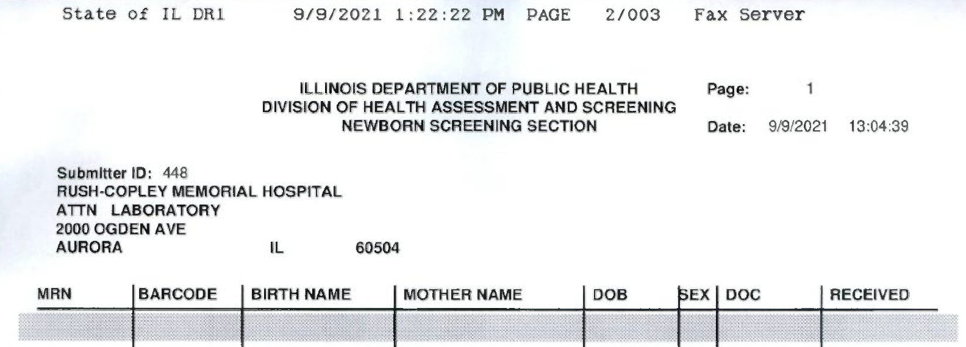

1. When the report is received via fax, it is important that the demographic information on the report is verified against the copies of the newborn screen forms that are kept in the newborn screen accordion file to ensure that when the newborn screen was logged into the state system, the demographic information was logged correctly.
2. Each newborn screen that is logged on the report is to have the MRN, Baby name spelling, mother name spelling, DOB, gender, and date of collection verified using the copy of the newborn screen and LIS label in the newborn screen accordion file.
3. If any discrepancies are found, draw a line through the incorrect information, write the correct information above it, and circle the change.
   1. Example:

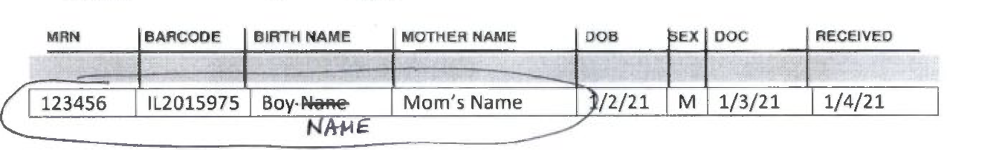

1. Corrections are to be faxed to IDPH in Chicago so that changes can be made before testing is complete.
2. Using the pre-made IDPH Newborn Screening Chicago coversheet, fax the report with marked and circled changes to 312-793-8152.
3. After reviewing the Submitter report and faxing corrections if required, initial and date the bottom of the form.
4. Three-hold punch and place the reviewed Daily Submitter Reports in the “IDPH Daily Submitter Reports” binder next to the scanning computer in the specimen processing area.