TITLE: Culture: Specimen Collection and Transport

PRINCIPLE:
All diagnostic information from the microbiology laboratory is contingent on the quality of specimen received. Consequences of a poorly collected and/or poorly transported specimen include failure to isolate the causative microorganism and recovery of contaminated or normal microbiota, which can lead to improper treatment of the patient. Collection, Transport, and Manipulation of Clinical Specimens guidelines from the Americam Society of Microbiology(ASM) are included for reference.

PERSONNEL
Medical Technologists, Medical Technicians, Clinical Associates and Nursing staff.

SPECIMEN
ACCEPTABLE SPECIMENS:

- Specimens collected using sterile technique.
- Specimens placed in sterile containers.

UNACCEPTABLE SPECIMENS:

- Mislabeled or unlabeled specimens
- Specimens received >24 hours after collected
- Specimens collected using expired culturetts

HANDLING CONDITIONS:

- All specimens must be processed following standard precautions, and under a laminar flow hood.
- All specimens must be transported to the laboratory as soon as they are collected, in order to ensure the survival and isolation of fastidious organisms and to prevent overgrowth by more hardy bacteria.
- If there will be a delay in the processing of specimens they can be stored at room temperature or in refrigeration depending on specimen source. Refer to Table 1 for additional information.

Table 1.
Culture Type | Process Immediately | Refrigerate Immediately | Leave at Room Temperature | Collection Device
AFB Culture |  | X |  | Sterile Container
Abscess/Wound Culture |  |  | X | Stuarts Red Cap Double Swab or Sterile Container
Anaerobe Culture |  |  | X | ESwab
Beta Strep A,B Cultures |  | X |  | Stuarts Red Cap Double Swab
Body Fluid Culture |  | X |  | Sterile Container
Bronchial Culture |  | X |  | Sterile Container
Cath Tip Culture |  | X |  | Sterile Container
C.Difficile |  | X |  | Sterile Container
CSF Cultures | X |  |  | Sterile Container
Ear Cultures |  | X |  | Stuarts Red Cap Double Swab
Eye Cultures |  |  | X | Stuarts Red Cap Double Swab
Fungus Culture |  |  | X | Stuarts Red Cap Double Swab or Sterile Container
*Gastrointestinal Panel, PCR |  |  | X | Orange Top Stool Vial
GC Cultures |  |  | X | Aimes Charcoal Swab
Genital Cultures |  |  | X | Stuarts Red Cap Double Swab or Aimes Charcoal Swab
Influenza PCR | X |  |  | Sterile foam Tipped Applicator or NP swab in Viral Transport Media (VTM)
KOH Preps (Genital) | X |  |  | Swab in Sterile Saline
MRSA Screen |  |  | X | Stuarts Red Cap Double Swab
Occult Blood |  |  | X | Sterile Container
Pertussis PCR |  |  | X | Green Top Viral Transport Media
Pinworm Prep |  |  | X | Pinworm Collection Paddle
Rectal Culture, Urology |  |  | X | Blue cap Amies Gel Swab or  Stuarts Red Cap Double Swab
Respiratory Panel, PCR | X |  |  | NP swab in VTM
RSV PCR | X |  |  | NP swab in VTM
Sputum/Tracheal Cultures |  | X |  | Sterile Container
Strep A/Covid PCR ID NOW | X |  |  | Sterile foam Tipped Applicator
Tissue Cultures |  |  | X | Sterile Container
Trich. Wet Prep | X |  |  | Swab in Sterile Saline
Urine Culture |  | X |  | Gray/Yellow Top Vacutainer
Viral/Chlamydia Culture |  | X |  | Green Top VTM
* Place stool in orange top vial within 2 hours of collection.

EQUIPMENT/REAGENTS

70% alcohol
Povidone iodine or 2% tincture of iodine
Chlorhexidine
Sterile syringe and needle(s)
Liquid Stuarts Double Swab Transport Culturette
Sterile screw capped container
Sterile sputum cup
Tongue depressor
Urine collection kit containing a tube with boric acid preservative
Charcoal swabs (for GC and Genital Cultures)
Anaerobic Collection Kits
Viral Transport Media
BACTEC Blood Bottle(s)

CALIBRATION
Not applicable

QUALITY CONTROL
Not applicable

SPECIMEN COLLECTION
- Collect specimens before administering antimicrobial agents when possible.
- Collect specimen with as little contamination from indigenous flora as possible to ensure that the sample will be representative of the infected site.
- Use appropriate collection devices. Use sterile equipment and aseptic technique to collect specimens to prevent introduction of microorganisms during invasive procedures.
- Label the specimen container with the patient’s name, identification number, date and time specimens was collected, initials of person collecting the specimen, and the specimen source.
- Collect an adequate amount of specimen. Inadequate amounts of specimen may yield false-negative results.
- Identify the specimen source and/or specific site correctly so that proper culture media will be selected during processing in the laboratory.
- Contact Microbiology Laboratory and or Sendouts bench for further collection instruction.

ASM Specimen Collection Guidelines Based on Anatomical Site:

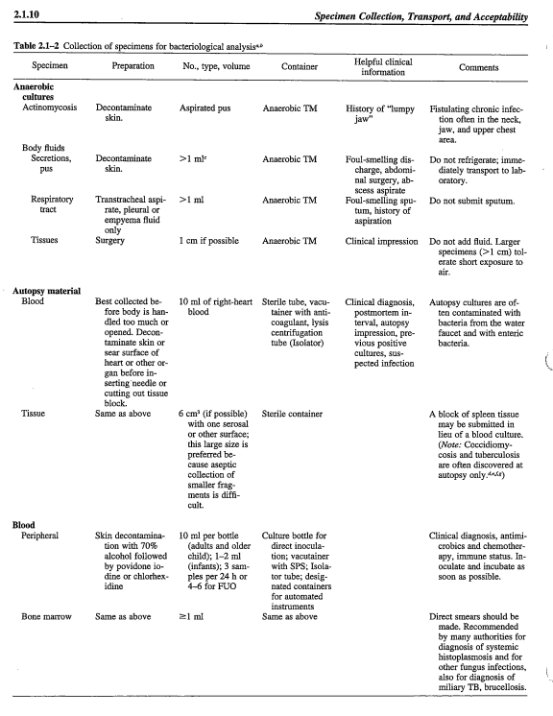

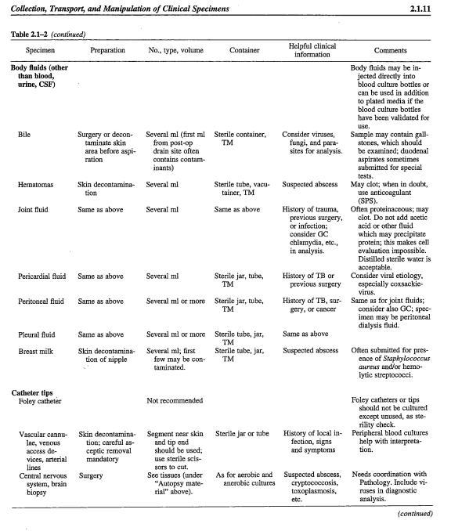

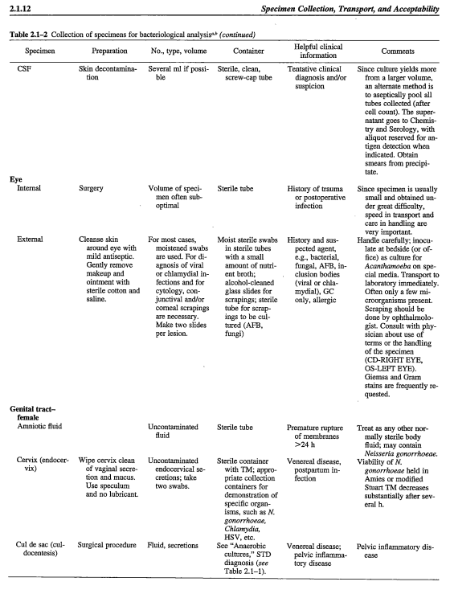

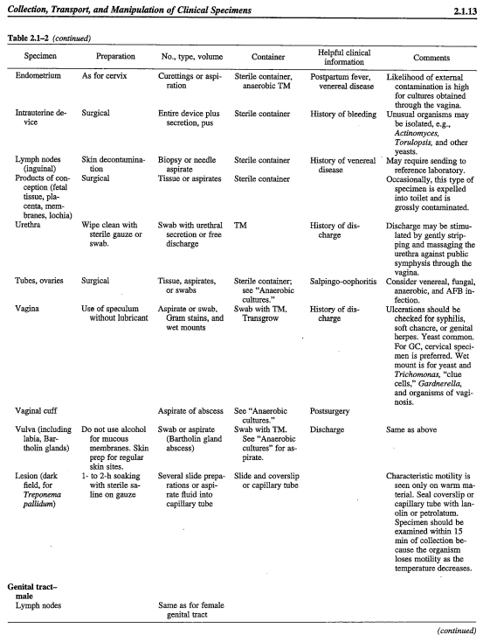

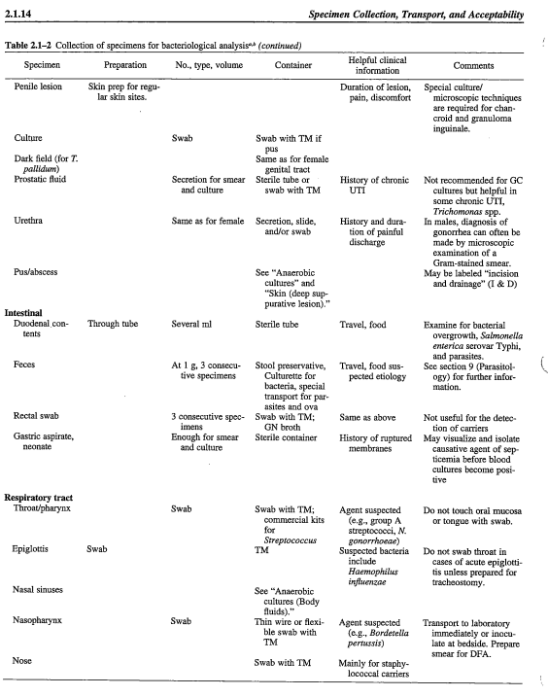

REFERENCES:
Garcia, Lynne S.,Clinical Microbiology Procedure Handbook Third Edition . ASM Press, Washington, D.C. 2010.

Isenberg, Henry D. 1992, Clinical Microbiology Procedures Handbook. American Society for Microbiology, Washington, D.C.

