**TITLE: Sickle Cell Screening Test/Sickledex**

**Principle:**

Sickle cell disease is an inherited condition characterized by the presence of Hemoglobin S (Hb-S). Hb-S exists in a homozygous state (S/S) known as Sickle Cell Anemia or in a heterozygous state (A/S) known as Sickle Cell Trait. Homozygous individuals (S/S) commonly exhibit symptoms of severe hemolytic anemia and/or vascular occlusions. Heterozygous individuals (A/S) are usually asymptomatic. Hb-S may be present with other hemoglobins, such as Hemoglobin A, C or D, or with thalassemia, a condition that interferes with the synthesis of normal hemoglobin. Under conditions of low oxygen tension, the heterozygous (A/S) form can cause erythrocytes to form the characteristic sickle shaped tactoids. The formation of these irreversibly sickled red blood cells causes the onset of the acute symptoms. Detection of both the homozygous and heterozygous condition is important so high-risk individuals can be identified and their symptoms reduced.

Deoxygenated Hb-S is insoluble in the presence of a concentrated phosphate buffer solution and forms a turbid suspension that can be easily visualized. Normal Hemoglobin A and other hemoglobins remain in solution under these conditions. These different qualitative outcomes allow for the detection of sickle cell disease and its traits. SICKLEDEX® uses Saponin to lyse the red blood cells. Sodium Hydrosulfite then reduces the released hemoglobin. Reduced Hb-S is insoluble in the concentrated phosphate buffer and forms a cloudy, turbid suspension. Other sickling hemoglobin subtypes may also give a positive result.

**Personnel:**

Medical Technologists

**Reagents:**

SICKLEDEX Solubility Buffer is a 2.3M potassium phosphate buffer solution. The preservative is 0.1% 2-chloroacetamide. SICKLEDEX Reagent Powder vials contain Saponin and Sodium Hydrosulfite. Warning: Sodium Hydrosulfite is a flammable solid and strong reducing agent. Refer to SDS.

**Reagent Storage and Stability:**

SICKLEDEX is stable throughout the expiration date when stored tightly capped at 2 °C to 30 °C. After opening and reconstituting the buffer solution, the working solubility buffer is stable for 45 days when stored tightly capped at 2 °C to 10 °C. Allowing the bottle of reconstituted buffer to warm to room temperature (18 °C to 30 °C) may reduce its open-vial stability. DO NOT FREEZE. A slight sediment may form during storage. This will not interfere with test results.

**Reagent preparation:**

The working solubility buffer must be prepared before screening can be performed.

1. Bring buffer and reagent powder to room temperature before mixing.

2. Add the contents of one vial of SICKLEDEX Reagent Powder to one bottle of SICKLEDEX Solubility Buffer.

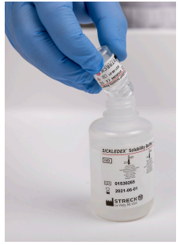

3. Place a white dispenser cap on the bottle of working solubility buffer, ensuring that the dispenser is tightly closed. Dissolve the reagent powder completely with vigorous agitation.

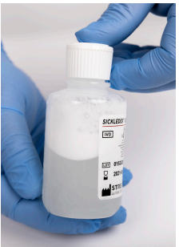

4. Record the reconstitution date in the space provided on the solubility buffer bottle.

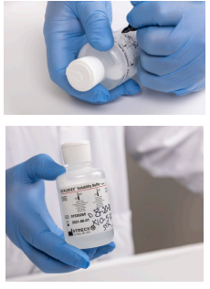

5. Store the working solubility buffer tightly capped at 2 °C to 10 °C when not in use. Reconstituted buffer must be used within 45 days.

**Sample Collection:**

1. Fresh blood samples may be collected from a finger puncture.

2. Use anticoagulated whole blood, packed cells, blood bank segments containing whole blood or packed cells with additive solutions. Never use clotted blood.

3. Blood samples stored at 1 °C to 10 °C for up to 45 days may be used for testing

**Stepwise procedure:**

1. Dispense 2.0 mL of cold working SICKLEDEX Solubility Buffer into a 12 x 75 mm disposable glass or plastic test tube. Return working solubility buffer to 2 °C to 10 °C immediately after use. Allow working solution in test tubes to warm to room temperature (18 °C to 30 °C). The use of reagents below room temperature can give false results.

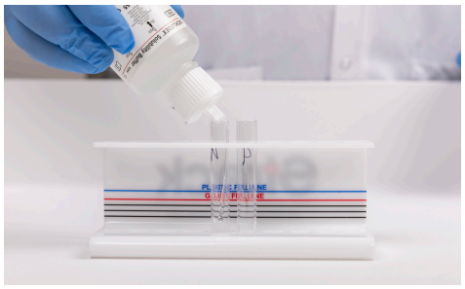

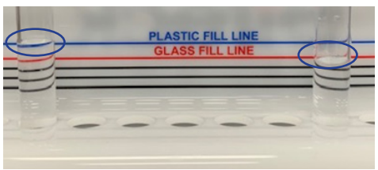

2. Add 20 µL of whole blood or 10 µL of packed red cells to the test tube. When running control samples add 20 µL of control. If the hematocrit is <15%, centrifuge the sample for 5-10 minutes at 1200 rpm. Pipet 10 µL of the packed cell volume from the bottom of the tube and add it to the SICKLEDEX Solubility Buffer test tube

3**.** Mix the contents of the test tube thoroughly by swirling the tube several times. Place the test tube in the test tube rack.

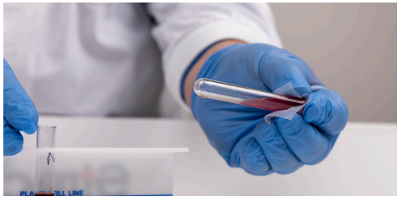

4. Allow the sample to stand at room temperature (18 °C to 30 °C) for at least six minutes. Observe the sample for turbidity. Read results between 6 and 60 minutes

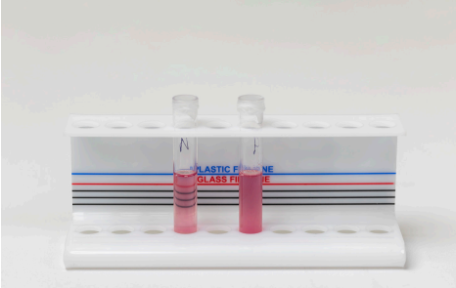

**Quality Control:**

1. QC should be ran each day test is performed (Positive and Negative QC).

2. Mix the positive and negative SickleChex® controls by first rolling the vials between the palms of the hands for 20 seconds (Figure 5a). Then hold the vials between the thumb and finger and rapidly invert the vials 8 to 10 times using a turning motion of the wrist (Figure 5b). See Sickle-Chex IFU for complete mixing instructions. The SICKLEDEX CLIA categorization is Moderately Complex, which requires at least once each day patient specimens are tested, testing must include a negative and positive control material.

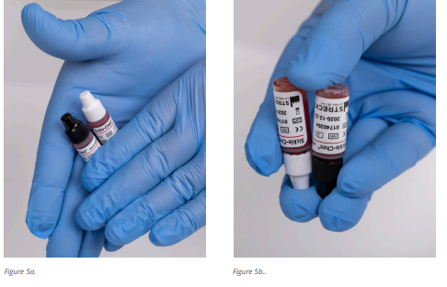

3. Label the Positive and Negative SickleChex control vials with Open and Expiration dates (Figure 6a-b). OVS (open-vial stability) is 100 days after opening when stored at 2 °C to 10 °C. OVS date is not to exceed the lot’s expiration date printed on the control vial.

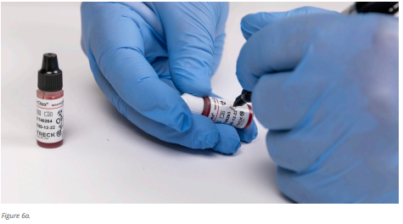

4. To test the controls - label the tube accordingly. Invert the control vial and dispense one drop (20 µL) into a prepared reagent tube (Figure 7a-b). Mix the control sample and reagent by swirling the tube or place a piece of laboratory film over the top and invert the tube to ensure the sample is mixed. 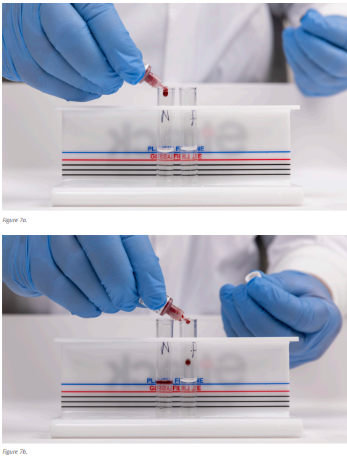

5. Allow the sample to stand at room temperature (18 °C to 30 °C) for at least six minutes. Observe the sample for turbidity. Read results between 6 and 60 minutes

6. Result Appearance:

Negative Sickle-Chex® Control – visible lines

Positive Sickle-Chex Control – turbid

**Reporting Results:**

1. The reaction is read macroscopically by looking through the test tubes at black lines.

2. A **POSITIVE** test for sickling hemoglobin is indicated by a cloudy, turbid suspension through which the black lines are NOT VISIBLE.

3. A **NEGATIVE** test for sickling hemoglobin is indicated by a transparent suspension through which the black lines are CLEARLY VISIBLE.

4. Report all results through the Laboratory Information System. Refer to LIS Procedure Manual for complete instructions on result entry. Positive results have a canned message attached that recommends additional testing be done to confirm the presence of sickling hemoglobin. This canned message is built into the LIS with the positive result in the field, **@SCKL**. The canned message will display in Query and on the Instant Reports. **Verify**, and **Save** your result.

Note: Sickle cell controls are designed to verify the activity of the reagent. Negative patient results may not clear as quickly or as completely as the control.

Note:Inability to obtain expected values may indicate product deterioration. Discoloration of the product may be caused by overheating or freezing during shipping or storage. If the recovered test results are not as expected, check expiration date of the product. Discard outdated product

**Reference ranges:**

Negative

**Limitations:**

1. False positives may occur in patients with erythrocytosis, hyperglobulinemia, extreme leukocytosis or hyperlipidemia. Coarse flocculation may occur in these samples due to elevated levels of total serum protein. These patient samples may be washed in normal physiologic saline and centrifuged to minimize these problems.

2. False positives or false negatives may occur in patients with severe anemia (<15% hematocrit).

3. False negatives may occur in infants under six months of age due to elevated levels of Hemoglobin F.

4. False positives or false negatives may occur in patients with a recent blood transfusion.

5. Positive results may occur in patients with some rare sickling hemoglobin subtypes such as Hemoglobin C Harlem or Hemoglobin C Georgetown.

6. The SICKLEDEX test is a qualitative screening procedure and does not differentiate between Sickle Cell Disease (S/S) and Sickle-Cell Trait (A/S). All positive test results should be further evaluated by hemoglobin electrophoresis, when used for patient testing. This does not apply to blood donor screening tests.

7. SICKLEDEX is compatible with RBC Units that have been glycerolized and frozen, and subsequently thawed and deglycerolized, for the purpose of extending the storage life of an RBC unit. Each laboratory should validate their approved glycerolization protocol with SICKLEDEX prior to implementation.

**References:**

1. McPherson RA, Pincus M.R. Henry’s Clinical Diagnosis and Management by Laboratory Methods-21st Edition. 2007.
2. Miale J.B. Laboratory Medicine Hematology-Fourth Edition. 1972.
3. Streck instructional information sheet for SICKLEDEX