**TITLE: HIT PF4 IgG Assay**

**Intended Use:**

PF4 Enhanced assay is a qualitative solid phase enzyme linked immunosorbent assay (ELISA) designed to detect antibodies in human or sodium citrate plasma reactive with platelet factor 4 (PF4) when it is complexed to polyanionic compounds such as Polyvinyl Sulfonate (PVS). These antibodies are found in some patients undergoing heparin therapy.

**Summary and Explanation:**

Patients receiving heparin treatment for at least a week often develop thrombocytopenia.1,2,3 In some cases the platelet levels are reduced only slightly and return to normal even when heparin treatment is continued. This type of thrombocytopenia is termed “Type I” heparin-induced thrombocytopenia (HIT) and is not antibody-mediated.2

In other patients thrombocytopenia is usually more severe and is antibody-mediated. This condition is designated “Type II” HIT. Type I HIT is generally considered to be a benign condition, whereas patients with Type II HIT are at risk to develop more severe thrombocytopenia as well as arterial or venous thrombosis if heparin therapy is continued. Antibodies associated with Type II HIT can be detected in several ways. The most commonly used techniques are the platelet aggregation test,4 the serotonin release test5 and the platelet factor 4 ELISA. 6,7,8

It is now known that antibodies associated with Type II HIT recognize sites on a platelet protein designated “platelet factor 4” (PFA4) that are created when PF4 is complexed with heparin or another linear polyanionic compound such as polyvinyl sulfonate (PVS).9,10,11

PF4 Enhanced assay Solid Phase ELISA microwells provide immobilized PF4: PVS complexes as a target for the detection of antibodies associated with Type II HIT.

**Principle:**

Patient sample is added to microwells coated with platelet factor 4 (PF4) complexed to polyvinyl sulfonate (PVS). If an antibody recognizing a site on PF4: PVS is present, binding will occur. Unbound antibodies are then washed away. An alkaline phosphatase labeled anti-human globulin reagent (Anti-IgG) is added to the wells and incubated. The unbound Anti-IgG is washed away and the substrate PNPP (p-nitrophenyl phosphate) is added. After a 30-minute incubation period, the reaction is stopped with Stopping Solution. The optical density of the color that develops is measured in a spectrophotometer.

**Personnel:**

All Medical Technologists and Technicians

**Sample Collection:**

Blood should be collected in 3.2% sodium citrate (plasma), using aseptic technique and should be tested while still fresh to minimize the chance of obtaining false positive or false negative reactions due to improper storage or contamination of the specimen. Samples that cannot be tested immediately should be stored at 2 to 8°C for no longer than 48 hours or frozen. Samples frozen at -20°C or below remain in good condition for several years (2-3 years). However, in order to avoid the deleterious effect of repeated freeze/thaw cycles, it is recommended that samples should be aliquoted in small volumes and then stored frozen. Avoid frost-free freezers.

Plasma should be separated from red cells when stored or shipped.

Particulates or aggregates in the sample can cause false positive results or poor duplicate values. Samples containing particulate matter should be clarified by centrifugation prior to testing.

Only whole human serum or plasma is suitable for this assay. Prior dilution of samples in anything other than normal, ELISA negative human serum could affect the results.

Microbially contaminated, hemolyzed, lipemic, icteric, or heat-inactivated serum samples may give inconsistent test results and should be avoided.

**WARNING:** Samples anticoagulated with heparin should not be used in this assay.

**Reagent preparation:**

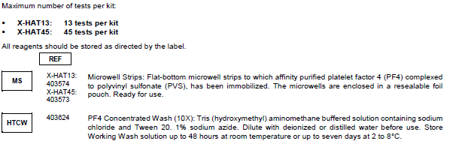

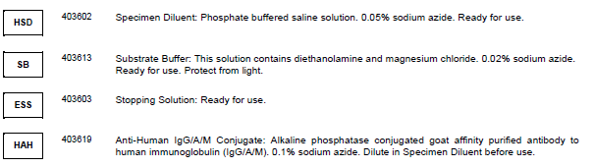

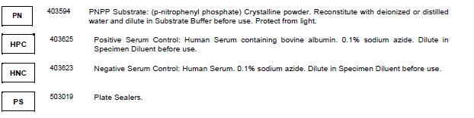

**Cautions:**

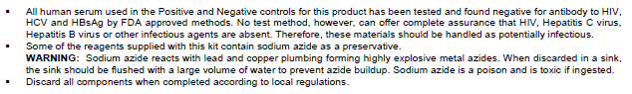

**Precautions:**

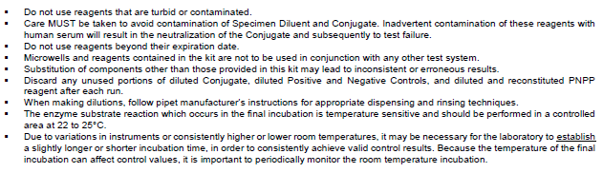

**Procedure:**

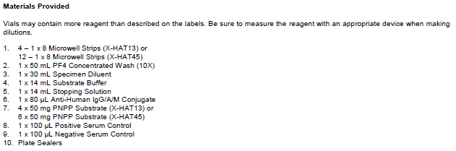

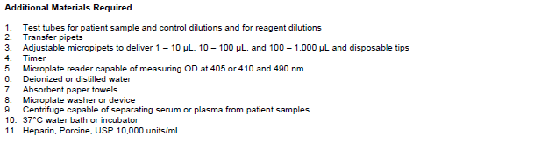

**Test Procedure**

1. Bring all reagents to room temperature
2. Make Working Wash Solution by diluting PF4 Concentrated Wash. Add 1 volume of PF4 Concentrated Wash to 9 volumes of deionized or distilled water. MIX WELL
3. Determine the number of patient samples to be tested. Using the Recording Sheet, assign each sample to a location consisting of two (duplicate) wells. Record the identity of each sample on the Recording Sheet.

**Prepare Samples and Controls**

1. Dilute as follows and mix well:

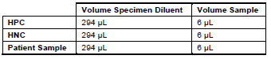

**NOTE:** Precise measurement of patient and control samples is essential for accurate results.

1. Remove microwell frame from pouch. Promptly remove and reseal unneeded strips in the protective pouch.

**NOTE:** Only one frame is provided in the kit. Do not discard until all strips have been used.

**NOTE:** Orient the frame with A1 in the top left corner. Be sure that all strips are properly seated and snapped into their frame. Label or number each strip to avoid errors. Maintain the same plate orientation throughout the assay.

1. Add 300µL of Working Wash Solution to all wells and allow to stand at room temperature for 5-10 minutes.
2. Aspirate or decant forcefully and invert on absorbent toweling to prevent drying.
3. Add 50 µL of the appropriate diluted control or sample to the wells as designated on the Recording Sheet.

**NOTE:** Do not add samples or reagents to the blank wells

**NOTE:** If multiple patient samples are tested at the same time, only one set of controls is required. **LABEL EACH STRIP TO AVOID ERRORS**

1. Seal the microwells with a plate sealer and incubate for 30-35 minutes in a 37°C water bath. If a dry incubator is used instead, increase the time by 10 minutes.
2. Dilute the Conjugate 1 to 1200 in Specimen Diluent. Use a polypropylene container.

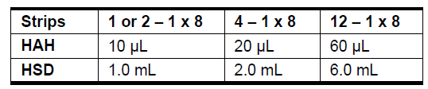

**NOTE:** Conjugate is viscous. Prime tip 2-3 times in Conjugate before dispensing and rinse after addition to Specimen Diluent. Mix well.

1. WASH STEP
2. Aspirate or decant contents of each well and blot on absorbent toweling
3. Add 300µL Working Wash Solution
4. Aspirate or decant
5. Repeat steps B and C for a total of 3 or 4 washes.
6. Vigorously decant to remove all residual wash solution after the final wash solution. Invert on absorbent toweling to prevent drying.

**NOTE:** It is important to completely remove all wash solution after the final wash.

1. Add 50µL of diluted Conjugate (made in the previous step) to all wells EXCEPT those designated as BLANKS.
2. Seal the microwells with a plate sealer and incubate for 30-35 minutes in a 37°C water bath. If a dry incubator is used instead, increase time by 10 minutes.
3. Dissolve PNPP Substrate by adding 0.5mL deionized or distilled water to vial. Replace stopper and mix well. Protect from light until use.
4. Dilute the PNPP 1 to 100 in the Substrate Buffer.

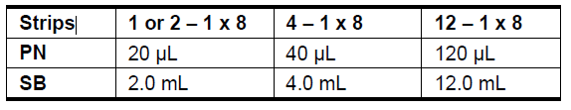

**MIX WELL.** Protect from light until use.

1. WASH STEP
2. Aspirate or decant contents of each well and blot on absorbent toweling
3. Add 300µL Working Wash Solution
4. Aspirate or decant
5. Repeat steps B and C for a total of 3 or 4 washes.
6. Vigorously decant to remove all residual wash solution after the final wash solution. Invert on absorbent toweling to prevent drying.

**Proceed Promptly through the next three steps**

1. Add 100µL of the diluted PNPP solution to all the wells EXCEPT those designated as BLANKS
2. Allow the microwells to stand in the dark for 30 minutes at ROOM TEMPERATURE (22 to 25°C)

**NOTE:** Incubation time and temperature after the addition of PNPP is critical. DO NOT vary the established incubation time or temperature. For consistency, begin timing promptly after addition of the reagent to the first well.

1. Stop the reaction by adding 100µL of Stopping Solution to each well in the same sequence as the addition of substrate. Add 200µL of Stopping Solution to the blank wells.
2. Read the absorbance (OD) of each well at 405 or 410 nm using a reference filter of 490 nm. If the results cannot be read immediately, return the wells to a dark location for up to 30 minutes.
3. Record the results on the Recording Sheet.

**Plate Reader:**

**See attachments for screen shots**

1. Power on analyzer
2. Gen 5 3.11
3. Password admin – ok
4. **Protocols** – PF4 Vertical Assay Rush Copley.prt
5. **Create Experiment and Read Now** (green arrow)
6. Kit lot #, Expiration date, RT – “OK”. Cancel run to add rest of info
7. **Protocol** –Plate layout, verify correct layout, “OK”
8. **Plate--** Sample ID, enter Specimen only “OK”, Close audit trail -- “yes”, “are you sure you don’t want to enter comments – “yes”
9. **Plate—**Information, fill in plate comment **“System Check Passed” -- OK,** close, “are you sure you don’t want to enter comments – “yes”
10. **Place test tray into reader**
11. **Green arrow (Read Now)--** “OK”, pop up box “OK” when ready to run
12. After completed **save** run with date and initials
13. **Print** report using Printer Icon in task bar
14. CV needs to be < 20

**Calibration:**

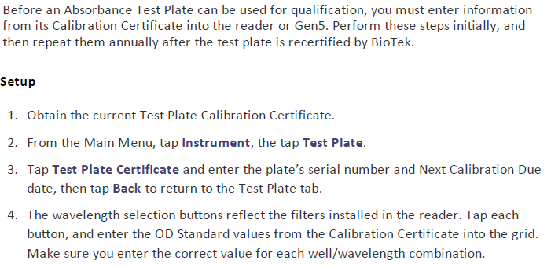

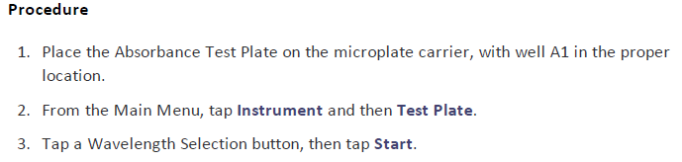

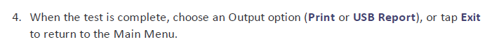

**Quality Control:**

External Quality Control

Quality Control requirements should be established in accordance with local, state and federal regulations or accreditation requirements.

Positive and negative external controls are to be run with each new lot, new untrained operator and with each day that patient testing is performed.

Quality Control of the PF4 Enhanced assay is built into the test system by the inclusion of Positive and Negative Serum Controls. These controls should be included with each test run to help determine if technical errors or reagent failures have occurred.

Criteria for a valid test:

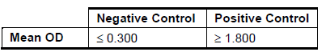

OD readings obtained from duplicate tests should fall within 20% of the mean of the two values. Samples whose results are outside of this limit should be re-tested.

**NOTE:** Poor duplicates can be the result of reagent or sample omission, uneven addition of reagents, uneven temperature during incubations, stray light during the final incubation or cross-well contamination. Failure to test in duplicate may lead to acceptance of erroneous results.

**Reporting Results:**

Report all results through the Laboratory Information System. Refer to the LIS Procedure 4840-LIS-222 for complete instructions on result entry. Test code in Soft is **HIT** (Heparin-Induced Platelet IgG Screen). Go to Resulting Worklist. Result under the YIMMU worklist. Enter the Optical Density (OD) MEAN from the printout in the HIT2 entry field. HIT1 Interpretation has a keypad to select Positive or Negative.

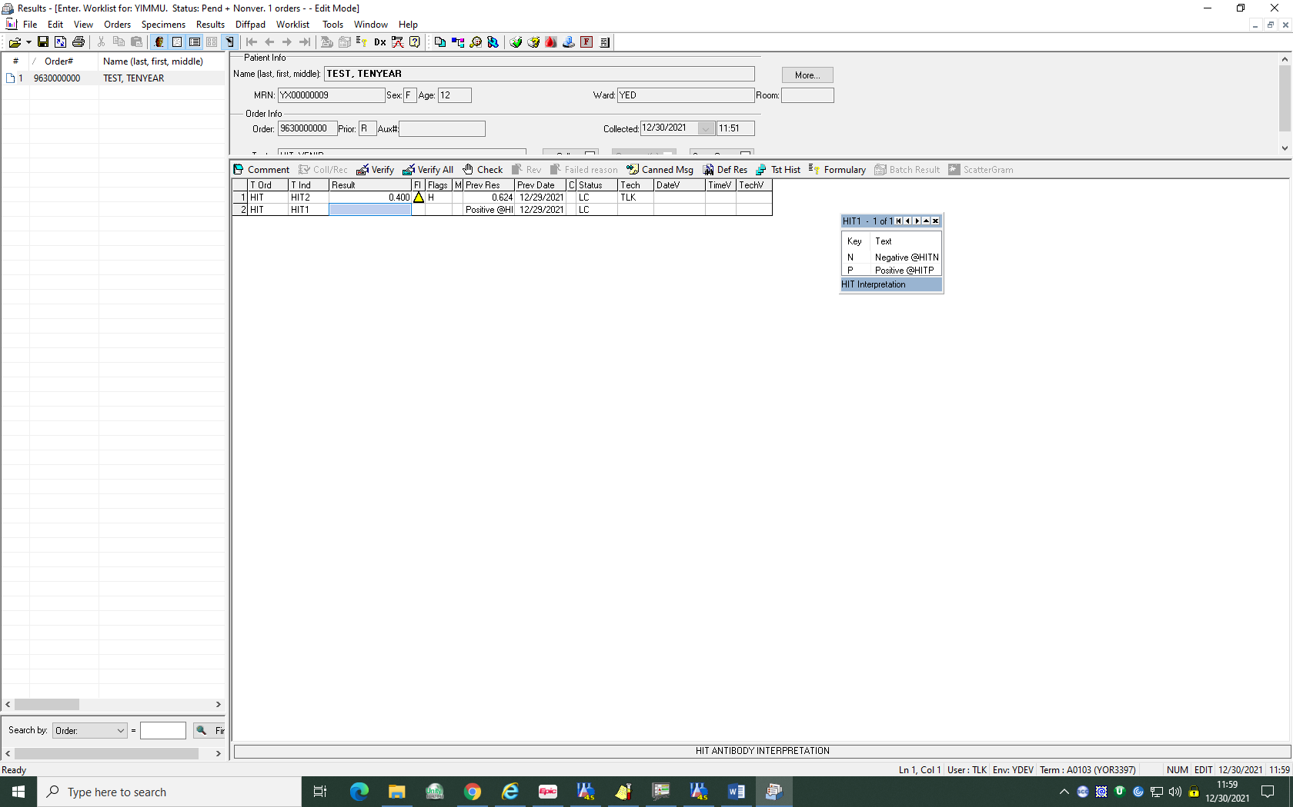

Test results showing OD values equal to or greater than **0.400** are regarded as **positive** results.

The printout from the BioTek plate reader will show you if the result is positive or negative. This is located under the RESULT column on the printout. The CV% needs to be less than 20% in order for the result to be valid. The CV% is listed under the RAW DATA in the far-right column of the result page.

**Calculations:**

Calculations are performed by the GEN 5 software

**Reference Ranges:**

Negative < 0.400

Positive >/= 0.400

This assay is intended to detect IgG antibodies associated with clinically significant Type II HIT.  It will not detect the IgA or IgM antibodies.  Heparin inhibition confirmation not performed.

**Limitations:**

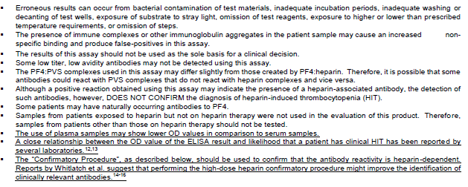

**Notes:** 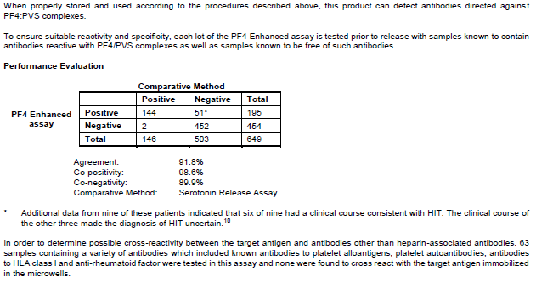

**References:**

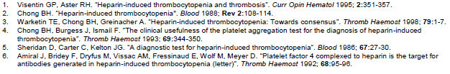

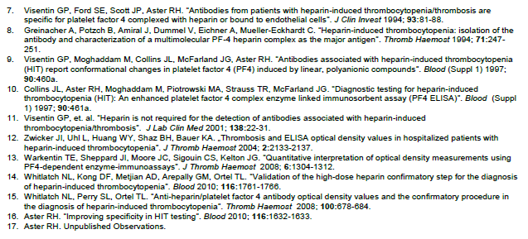

18. 800 TS Microplate reader Operators Manual

