RUSH logo for emails 4840-CH-502

**ARK Levetiracetam Assay (Keppra)**

**Serum/Plasma**

**Abbott Architect**

**PRINCIPLE**

ARK™ Levetiracetam Assay is a homogeneous enzyme immunoassay intended for the quantitative determination of levetiracetam in human serum or plasma on automated clinical chemistry analyzers. Levetiracetam concentrations can be used as an aid in management of patients treated with levetiracetam.

**SUMMARY**

Levetiracetam (KEPPRA®, (S)-α-ethyl-2-oxo-1-pyrrolidine acetamide) is an anti-convulsant drug approved for use as adjunctive therapy in the treatment of epilepsy.

**PRINCIPLES OF THE PROCEDURE**

ARK Levetiracetam Assay is a homogeneous immunoassay based on competition between drug in the specimen and levetiracetam labeled with the enzyme glucose-6-phosphate dehydrogenase (G6PDH) for binding to the antibody reagent. As the latter binds antibody, enzyme activity decreases. In the presence of drug from the specimen, enzyme activity increases and is directly proportional to the drug concentration. Active enzyme converts the coenzyme nicotinamide adenine dinucleotide (NAD) to NADH that is measured spectrophotometrically as a rate of change in absorbance. Endogenous serum G6PDH does not interfere with the results because the co-enyzme NAD functions only with the bacterial enzyme used in the assay.

**REAGENTS**

**ARK Levetiracetam Assay Reagent R1 – Antibody/Substrate:** rabbit polyclonal antibodies to levetiracetam, glucose-6-phosphate, nicotinamide adenine dinucleotide, bovine serum albumin, preservatives, and stabilizers

**Reagent R2** – **Enzyme:** Levetiracetam labeled with bacterial G6PDH, buffer, bovine serum albumin, preservatives, and stabilizers

**REAGENT HANDLING AND STORAGE**

ARK Levetiracetam Assay reagents are provided liquid, ready to use and may be used directly from the refrigerator. When not in use, reagents must be stored at 2–8°C (36–46°F), upright and with screw caps tightly closed. If stored as directed, reagents are stable until the expiration date printed on the label. Do not freeze reagents. Avoid prolonged exposure to temperatures above 32°C (90°F). Improper storage of reagents can affect assay performance.

**Reagents on-board the analyzer are stable for 90 days.**

**WARNINGS AND PRECAUTIONS** • For In Vitro Diagnostic Use. For prescription use only. • Reagents and are provided as a matched set and should not be interchanged with reagents from different lot numbers.

**SPECIMEN COLLECTION AND PREPARATION FOR ANALYSIS**

• Serum or plasma is required. For consistency, using the same specimen matrix for individual patients is a good practice. A steady state, trough (pre-dose) sample is generally accepted as most consistent for therapeutic drug monitoring of levetiracetam.

• Whole blood cannot be used. **Samples containing gel separators cannot be used**.

The following anticoagulants may be used with this assay.

• Sodium heparin

• Lithium heparin without gel

• Potassium EDTA

• Process the blood as soon as possible after collection to prepare serum or plasma, since hydrolysis of levetiracetam may occur in the prolonged presence of whole blood.2-3

• DO NOT USE GEL SEPARATORS.

• Do not induce foaming and avoid repeated freezing and thawing to preserve the integrity of the specimen from the time it is collected until the time it is assayed.

• Fibrin, red blood cells, and other particulate matter may cause an erroneous result. Ensure adequate centrifugation.

• Clarified specimens may be stored up to one week at 2 to 8°C. If testing will be delayed more than one week, specimens should be stored frozen (≤ -10°C) up to four weeks prior to being tested. Care should be taken to limit the number of freeze-thaw cycles.

• Handle all patient specimens as if they were potentially infectious.

**PROCEDURE**

Materials Provided ARK Levetiracetam Assay

Materials Required – Provided Separately

* ARK Levetiracetam Calibrator – (#5024-0002-00)
* Quality Controls – ARK Levetiracetam Control – (#5024-0003-00)

**Instruments**

Reagents need to be transferred a clean empty 20 mL wedge pack. Label pack with R1 or R2, lot number and expiration date. Avoid cross-contamination of R1 and R2.

**Assay Sequence**

For further instructions on calibrating, running QC or patient testing refer to the Abbott Architect operator’s manual.

**Calibration**

Perform a full calibration (6- point) procedure using the ARK Levetiracetam Calibrators A, B, C, D, E, and F; test calibrators in duplicate. Calibration is required with each new reagent kit lot number. Verify the calibration curve with at least two levels of quality controls according to the established laboratory quality assurance plan. CAL A is the calibration blank.

**When to Re-Calibrate**

* Calibrate every 40 days
* Whenever a new lot of reagents is used
* Whenever indicated by quality control results
* After instrument issues or troubleshooting
* Whenever required by standard laboratory protocols

**Quality Control (QC)**

**Ark Levetiracetam QC Levels Low, Mid, High** (refer to QC package insert for acceptable QC ranges)

Controls are stable until the manufacturer’s expiration date when stored at 2-8⸰C.

Laboratories should establish QC procedures for the ARK Levetiracetam Assay. All quality control requirements and testing should be performed in conformance with local, state and/or federal regulations or accreditation requirements.

Good laboratory practice suggests that at least two levels (low and high medical decision points) of quality control be tested each day patient samples are assayed and each time a calibration is performed. Monitor the control values for any trends or shifts. If any trends or shifts are detected, or if the control does not recover within the specified range, review all operating parameters according to your clinical laboratory quality procedures. Contact Customer Service for further assistance.

**Manual Dilution Protocol** To estimate drug levels in specimens exceeding the upper limit of quantitation, manually dilute the specimen with zero calibrator (CAL A). Follow manufacturer’s instructions when performing a manual dilution.

**RESULTS**

Report result units as μg/mL. (To convert results from μg/mL levetiracetam to μmol/L levetiracetam, multiply μg/mL by 5.88. The levetiracetam value from this assay should be used in conjunction with other clinical information. Refer to the instrument specific operator’s manual for any result error codes.

**The therapeutic range for Levetiracetam (Keppra) is: 12 – 46 ug/mL**

**LIMITATIONS OF PROCEDURE**

This assay is designed for use with serum or plasma only; refer to the sections Specimen Collection and Preparation for Analysis. It is generally good practice to use the same method (as well as matrix) consistently for individual patient care due to the potential for method-to-method variabilities. See the section Expected Values below.

*Brivaracetam (Briviact®)4 interferes with measurements of levetiracetam (Keppra®) in the ARK Levetiracetam Assay. Patients undergoing a switch in drug therapy involving Keppra and Briviact should not be monitored for levetiracetam using this assay. Serum levels of Levetiracetam and/or Brivaracetam should be confirmed by LC/MS-MS test method if there is a possibility of both drugs being present.*

**EXPECTED VALUES**

A reference range for levetiracetam has not been well established. Tentative reference ranges for seizure control have been proposed, which include concentrations from 6 to 46 µg/mL (35 to 270 µmol/L; trough samples). However, these ranges have not been validated by adequate controlled trials, and in general the relationship between these serum concentrations and clinical effect has not been well-defined. Levetiracetam drug concentrations should be used in conjunction with information available from clinical evaluations and other diagnostic procedures. Circulating levels of levetiracetam (serum blood concentrations) may be affected by compliance, renal function, pregnancy, drug-drug interactions and timing of the sample draw. Furthermore, the clinical effect of these serum blood concentrations may be further altered by changes in progression in the severity of the disease and the addition or withdrawal of concomitant drugs which may interact pharmacodynamically with circulating levels of levetiracetam. The reference range of drug concentrations which is quoted should only imply a lower limit below which a therapeutic response is relatively unlikely to occur, and an upper limit above which toxicity is relatively likely to occur in the specific patient populations studied. Generally, clinicians using reference ranges such as these should be aware that, because of individual variation, patients may achieve therapeutic benefit with serum drug concentrations outside of these ranges and may experience toxicity with levels below the lower limit of the reference range. Sampling time should be standardized such that trough serum concentrations are measured just before the next dosage, preferably in the morning.

**SPECIFIC PERFORMANCE CHARACTERISTICS**

Each laboratory is responsible for verification of performance using instrument parameters established for their analyzer. The following performance characteristics were obtained on the Roche/Hitachi 917 System.

**Sensitivity**

Limit of Quantitation (LoQ) The LOQ of the ARK Levetiracetam Assay was determined according to CLSI EP17-A and is defined as the lowest concentration for which acceptable inter-assay precision and recovery is observed (≤20% CV with ±15% recovery). The LOQ was determined to be 2.0 μg/mL, and may depend on analyzer-specific performance.

**Assay Range**

The range of the assay is 2.0 to 100.0 µg/mL. Report results below this range as 100.0 µg/mL or above the analyzer-specific upper LOQ established in your laboratory.

**Recovery**

Accuracy (analytical recovery) was performed by adding concentrated levetiracetam drug into human serum negative for levetiracetam. A stock concentrate of highly pure levetiracetam was added volumetrically to human serum negative for levetiracetam, representing drug concentrations across the assay range. Six replicates of each sample were assayed on an automated clinical chemistry analyzer. The results were averaged and compared to the target concentration and percent recovery calculated.

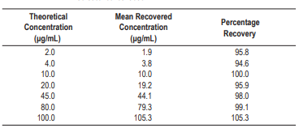

**LINEARITY**

Linearity studies were performed as suggested in CLSI/NCCLS Protocol EP6-A. A 100.0 μg/ mL serum sample was prepared and dilutions were made proportionally with human serum negative for levetiracetam. Levetiracetam concentrations ranged from 1.0 to 100.0 μg/mL. Linearity at specific dilutions was considered acceptable if the percent difference was ±10% between the predicted 1st and 2nd order regressed values or ±15% below 3.0 μg/mL. A linear relationship was demonstrated between 2.0 and 100.0 μg/mL. Results are shown below

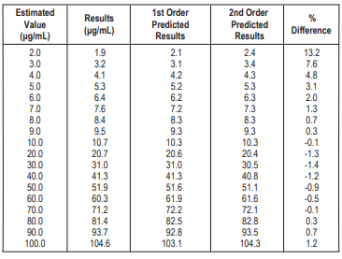

**METHOD COMPARISON**

Correlation studies were performed using CLSI/NCCLS Protocol EP9-A2. Results from the ARK Levetiracetam Assay were compared with results from LC/MS/MS. The levetiracetam concentrations ranged from 2.0 μg/mL to 86.4 μg/mL. Results of the Passing-Bablok10 regression analysis for the study are shown below (with 95% confidence limits)

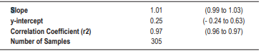

**Precision**

Precision was determined as described in CLSI/NCCLS Protocol EP5-A2. Tri-level controls and three human serum pooled specimens containing levetiracetam were used in the study. Each level was assayed in quadruplicate twice a day for 20 days. Each of the runs per day was separated by at least two hours. The within run, between day, total SD, and percent CVs were calculated. Results are shown below. Acceptance criteria: <10% total CV.

**INTERFERING SUBSTANCES**

Interference studies were conducted using CLSI/NCCLS Protocol EP7-A2 as a guideline. Clinically high concentrations of the following potentially interfering substances in serum with known levels of levetiracetam (approximately 15 and 50 μg/mL) were evaluated. Each sample was assayed using the ARK Levetiracetam Assay, along with a serum control of levetiracetam. Measurement of levetiracetam resulted in ≤10% error in the presence of interfering substances at the levels tested.

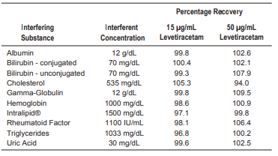

**SPECIFICITY**

Levetiracetam is hydrolyzed to its major metabolite 2-pyrrolidone-N-butyric acid (ucb L057) and two minor metabolites.3 Other medications routinely administered with levetiracetam and anti-epileptic drugs were also tested to determine whether these compounds affect the quantitation of levetiracetam concentrations using the ARK Levetiracetam Assay. High levels of these compounds were spiked into serum pools containing low (15 μg/mL) and high (50 μg/ mL) therapeutic levels of levetiracetam. The samples were analyzed and the levetiracetam concentrations of samples containing interferent were compared to the control serum.

**Metabolites**

The metabolite ucb L057 was tested for cross-reactivity

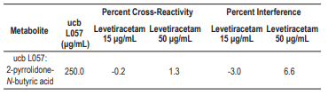

**Drug Interference**

Due to structural similarities, brivaracetam (Briviact®) crossreacts substantially in the ARK Levetiracetam Assay. Measurements of levetiracetam should not be made with the ARK assay when both drugs are present in circulation. Levetiracetam-selective antibody did not crossreact with other anti-epileptic or coadministered drugs tested. A high concentration of each compound was spiked into normal human serum with known levels of levetiracetam (approximately 15 and 50 μg/mL) and assayed along with a serum control of levetiracetam. Measurement of levetiracetam resulted in ≤10% error in the presence of drug compounds at the levels tested.

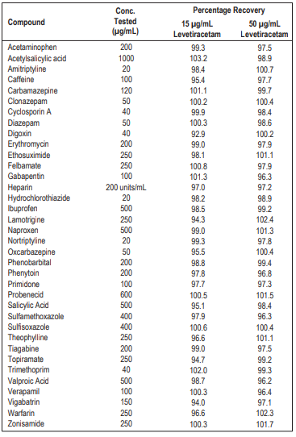

**REFERENCES**

1.KEPPRA®. Prescribing Information (KEPPRA Tablets, KEPPRA XR™, KEPPRA Oral Solution and KEPPRA Injection), UCB, Inc., Smyrna, GA ([www.keppra.com](http://www.keppra.com)).

2. Patsalos, P. N. et al. 2006. In situ metabolism of levetiracetam in blood of patients with epilepsy. Epilepsia 47:1818-1821.

3.Benedetti, M. S. et al. 2003. Pharmoacokinteics and metabolism of 14C-levetiracetam, a new antiepileptic agent, in health volunteers. Eur J Clin Pharmacol. 59:621-630.

4.Briviact®. 2016. Prescribing Information. UCB, Inc. (Smyrna, GA).

5. Leppik, I. E. et al. 2002. Effective levetiracetam doses and serum concentrations: Age effects. Epilepsia 43 (Suppl 7):240.

6. Johannessen, S. I. et al. 2003. Therapeutic drug monitoring of the newer antiepileptic drugs. Ther Drug Monit. 25:347-363.

7. Splinter, M. Y. 2005. Pharmacokinetic properties of new antiepileptic drugs. Journal Of Pharmacy Practice 18:444–460.

8. Lancelin, F. et al. 2007. Therapeutic drug monitoring of levetiracetam by high-performance liquid chromatography with photodiode array ultraviolet detection: Preliminary observations on correlation between plasma concentration and clinical response in patients with refractory epilepsy. Ther Drug Monit. 29:576-583.

9. Patsalos, P. N. et al. 2008. Antiepileptic drugs – best practice guidelines for therapeutic drug monitoring: A position paper by the subcommission on therapeutic drug monitoring, ILAE Commission on Therapeutic Strategies. Epilepsia 49:1239-1276.

10. Bablok W, Passing H, Bender R, Schneider B. 1988. A general regression procedure for method transformation. Application of linear regression procedures for method comparison studies in clinical chemistry. Part III. J. Clin Chem Clin Biochem. 26(11):783-790.

TRADEMARKS

ARKTM is a trademark of ARK Diagnostics, Inc.