## TITLE: Yorkville Administration of Rhogam

## PRINCIPLE:

RhoGam is used to prevent the formation of antibodies in the Rh negative woman who has delivered an infant with Rh positive blood, or in a woman who has a pregnancy outcome with undetermined blood type; abortion, miscarriage, hydatidiform mole, ectopic pregnancy, or other nonviable pregnancy outcome. RhoGam is also indicated when a woman undergoes exposure to Rh positive cells, such as abruption, or amniocentesis. RhoGam is given to Rh negative women prophylactically at 28 weeks as part of the prenatal care process.

**CLINICAL SIGNIFICANCE:**

With an injection of passive RhO (D) antibody (RhoGam) to the post-partum mother or to the recipient of a transfusion accident the person’s antibody response to the foreign RhO (D) positive cells is suppressed.

## POLICY:

1. Physician/CNM order is necessary. All Rh negative women who meet the laboratory criteria shall receive the RhoGam injection.
2. RhoGam may be used prophylactically in the unsensitized Rh negative mother at the 28th week of normal pregnancy.

**PERSONNEL**:

### Medical Technologists

Nursing Staff

**SPECIMEN:**

Do not need two different blood draws to verify an unknown patient’s blood type prior to issue of Rhogam.

One pink top tube needs to be collected before any Rhogam is given to the patient.

No special preparation of the patient is required prior to specimen collection. The blood sample should be tested as soon as possible after collection. If a delay occurs, store sample at 2 C to 8 C. Sample can only be used for 3 days from collection time.

## STEPWISE PROCEDURE:

1. Yorkville Emergency Department will order a Type and Screen (TS) on the Patient.
2. Yorkville Lab will receive the blood into the lab and transfer the specimen to the Main Lab. Send the blood bank specimen over stat via a courier or ambulance.
3. The Main Lab will perform the testing on the patient specimen.
4. Yorkville Lab will issue Rhogam to YED if appropriate. Confirm with Blood Bank that it is ok issue.
5. If there is a known type in Soft Bank, Yorkville Lab can issue Rhogam on RH NEGATIVE Patient’s as long as the pink top tube is collected.
6. An order needs to be placed by the Doctor for Rhogam Vial (RHG)
7. When the RhoGam is ready call the Emergency Room to have them come pickup.

To look up Patient History

1. Patient>Reports>History
2. Enter Name or MRN and select correct one
3. Box opens with blood type if one is avaliable

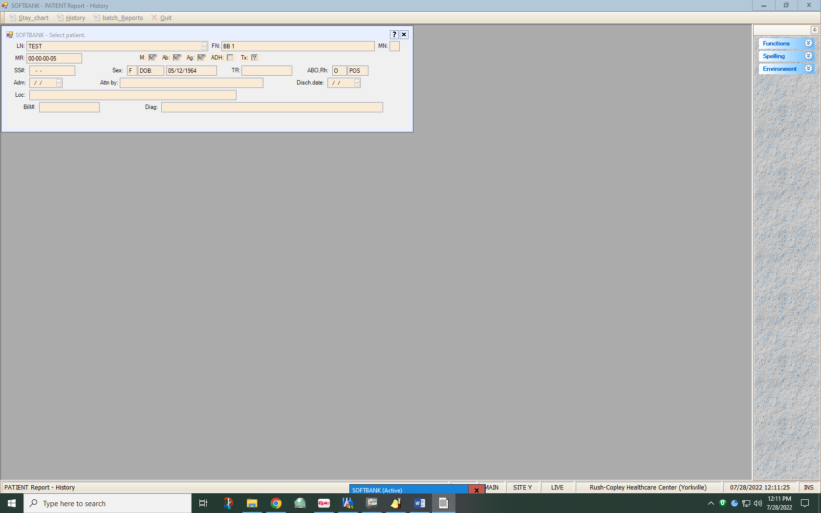

For Issuing Rhogam:

1. Patient>Orders>Actions

2. Enter patient information

3. F-12

4. History appears – ESC-Quit

5. Rhogam request appears, double click on request

6. Patient history not reviewed – Review it? Yes

7. F 12

8. History reviewed? Yes

9. Enter “I” for Issued from drop down box for St (Status)

10. User defaults to 1 – leave, if one vial of rhogam is being issued

11. Received by – choose Yorkville Emergency Department (YED) from drop down box

12. Enter lot number from drop down box and issued amount as 1 from drop down box

13. “How many slips” defaults to 1 - check box “For each unit separately” (double click)

14. “How many labels” defaults to 1 - check box “For each unit separately” (double click)

15. F 12

16. Save changes? Yes

17. Choose printer for slip (Y01_HP) - Rx Product slip will print

18. Chose printer for label (Y05_YorkLabel)-RHG label will print

19. ESC – twice

NOTE: Include the patient card from the Rhogam insert with the RHG label affixed to card and the insert the Rhogam Product Slip into biobag to give to YED.

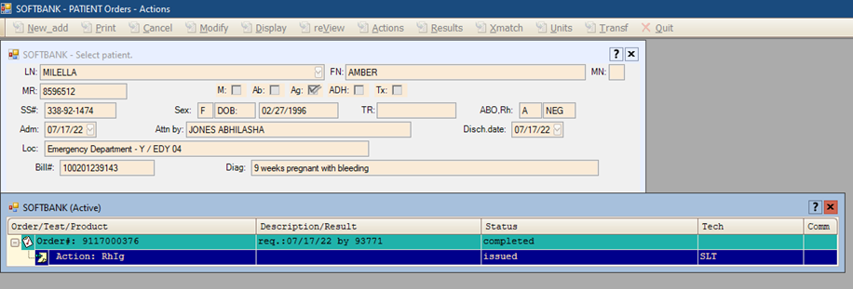

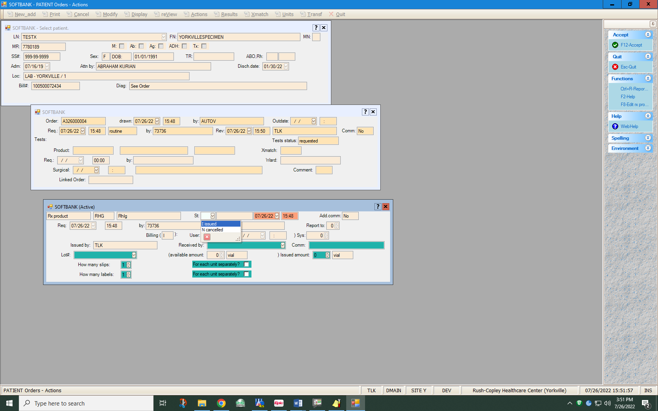

**INTERPRETATION:**

Rh positive patients are not candidates for RhoGam.

Previously known Rh negative patients can be given rhogam after the pink top tube has been drawn.

If any questions call to confirm with RCMC blood bank

MISCARRIAGES

It has been suggested that a miscarriage, abortion or ectopic pregnancy can serve as a primary immunizing stimulus by virtue of the entry of a small amount of RhO (D) positive fetal cells into the RhO (D) negative mother’s bloodstream. Therefore, if a RhO (D) negative mother has a miscarriage abortion or ectopic pregnancy, she should be considered as a candidate for protective treatment with RhoGam. The administration procedure should be followed as described. Since the fetus blood type may not be known, one should assume that it was RhO (D) positive and extend RhoGam to the mother within 72 hours after the spontaneous passage or surgical removal of the products of conception.

**NOTE: THE FETAL SCREEN DOES NOT NEED TO BE DONE ON WOMEN LESS THAN 20 WEEKS GESTATION UNLESS REQUESTED BY THE DOCTOR. 1 VIAL OF RHOGAM IS SUFFICIENT.**

For Entering New Lot into Inventory for Rhogam:

1. Open SoftBank
2. INVENTORY > Supplies > Delivery
3. In Supply drop down, select RhIg
4. Input Lot #
5. Increase Total amount to number of individual RhIg vials received
6. Input Exp. Date
7. Review Pkg. insert and check box
8. Review receipt criteria and check box
9. For items 7 and 8, if these boxes are not checked properly, the supply status will changed to quarantine.  So, be sure to check these boxes.
10. Hit F12 to SAVE

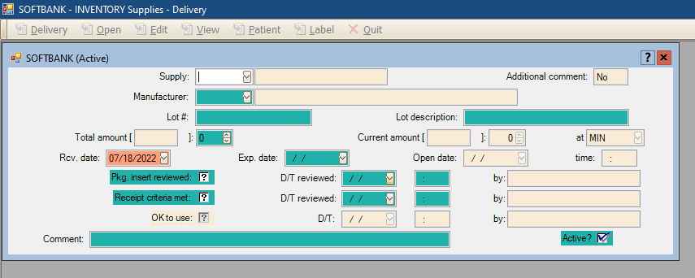

Need to Open the Lot for Use

1. Open Softbank
2. INVENTORY > Supplies > Open
3. In supply drop down, select RhIg
4. Enter Lot number
5. Information populates with current day in the open date
6. Hit F12 to save
7. Save changes-Yes

**REFERENCE:**

###### RhO (D) Immune Globulin (Human) – Direction for use ORTHO DIAGNOSTICS

Bayer Corporation, Elkhart, IN. 46515

##### AABB Technical Manual, 18th Edition, 2014

##### AABB Standards, 30th Edition, 2015