TITLE: Automated Body Fluid Analysis

PRINCIPLE:
The Automated Body Fluid Analysis procedure is for obtaining in vitro quantitative determinations of total nucleated cells (TNC) and erythrocytes (RBC) in serous fluids and synovial fluids, using the Sysmex XN-9100 Analyzer. The analyzer performs hematology analysis according to the hydrodynamic focusing (DC Detection), flow cytometry method (semiconductor laser), and SLS-hemoglobin method. The device counts and sizes red blood cells (RBC) using electronic resistance detection. The white blood cell, total nucleated cell (WBC and TNC) count and differential (DIFF) are all evaluated using flow cytometry with a semiconductor laser exploiting the differences in cell size, complexity and RNA/DNA content. Forward scattered light provides information on blood cell size and Lateral Scattered Light provides information on the cell interior such as the size of the nucleus. Lateral fluorescent light intensity increases as the concentration of the stain becomes higher. By measuring the intensity of the fluorescence emitted, information is obtained on the degree of blood cell staining. Fluorescent light is emitted in all directions. The XN detects the fluorescent light that is emitted sideways.

The body fluid is aspirated into the XN-9100 via the Manual Mode.

All Body Fluid samples and Body Fluid Controls must be run in Manual mode. *ALL CSF cell counts that are clear and colorless will be performed manually.

The TNC (total nucleated cell) count generated by the XN-9100 represents the WBC count and the non-Hematology cells in the analysis of body fluids. This count differs from the manual count as it includes macrophages and mesothelial cells.

PERSONNEL:
Medical Technologists and Technicians

PATIENT PREPARATION:
No patient preparation by Laboratory Personnel

SPECIMEN:
Type of Specimen:
- Serous Fluids (pleural, pericardial, peritoneal)
- Synovial Fluid.
- Unclotted, preferably anticoagulated with EDTA. If any specimen contains clots, cellular clumps or debris, note in the LIS system: “Specimen contains clots, cell count may be inaccurate”. Remove clots prior to running on instrument as this will clog the apertures.
- Minimum volume is 1 mL
- To reduce viscosity, synovial fluids should be pre-treated with hyaluronidase before running on an instrument. Using 2 wooden sticks, take a couple of flakes of the hyaluronidase, mix with 1 ml synovial fluid and let stand for approximately 5 to 30 minutes. Fluids must drop freely using a plastic pipette. Be sure to mix well before aspirating into the Sysmex XN-9100.
- Bronchial wash
- CSF if all tubes are reddish and there is at least 2 mL in the tube to be sampled. If the RBC counts are >1000/µL then report the total WBC and RBC counts. If CSF is clear fluid then perform a manual chamber count.

Handling Precautions:
Handle all specimens using Standard Precautions

In cases of suspected Creutzfeldt-Jacob disease, refer to the Manual Body Fluid Cell Count procedure Proc. #4840-HE-0340. These samples are not to be run in Automation.

Reagents:
XN-9100 Series Cellpack DCL Diluent
Hyaluronidase, frozen (in the back of the Chemistry freezer)
XN-9100 XN Check BF Body Fluid Controls

EQUIPMENT:
XN-9100
Wooden Sticks
Blood Collection tube purple (lavender) black 4mL K2EDTA
Blood collection tube white- 3 mL no additive
Plastic pipettes

QUALITY CONTROL:
- A minimum of two levels XN Check BF controls are run once every 24 hours when there are patient samples for Body Fluid counts.
- Controls will be run on Instrument 1 on odd number days
- Controls will be run on Instrument 2 on even number days
- Prior to performing the Body Fluid counts, the tech is required to check the QC files on the XN-9100 to verify the date and time that the body fluid QC was performed and if it was within range.
- If QC was not performed within the last 24 hours, run the Body Fluid QC first followed by the patient specimen.
- A background count of the diluent must be performed and found acceptable prior to analyzing body fluid specimens. The XN will automatically run a background check when the instrument is put in Body Fluid Mode.
- Analyzing Sysmex XN Body Fluid Cell Controls:
- Store Body Fluid Cell Controls refrigerated at 2-8ºC.
- Sealed control vials are stable until the expiration date.
- Open Body Fluid Control Vials are stable for 30 days when promptly refrigerated after each use. When opening a Body Fluid Control ensure open and expiration dates are marked on the vial.
- QC vials should be brought to room temperature (15.5 to 32ºC) for 10-15 minutes.
- Roll the tube slowly between the palms of the hand for 15-20 seconds in an upright position. Continue to mix by holding the vial by the ends between the thumb and finger, rapidly inverting the vial 20 times end-over-end using a very quick turning motion of the wrist. Note: Do not place controls on mechanical rocker.
- Analyze immediately after mixing. Subsequent analyses during this test period may be performed by inverting the vial 5 times prior to instrument analysis.
- Check the Status indicator LED on the analyzer to confirm analyzer is in ready state.
- If the tube holder is not ejected, press the mode switch. Tube holder will slide out.
- Select the Change Analysis Mode button on the control menu.
- Select [Body Fluid] mode. The analyzer will automatically perform an Autorinse and background count.
- Select [OK]
- Select Manual Analysis button on the control menu.
- Select Read ID [the QC Barcode will be scanned by the analyzer]
(Make sure [CAP OPEN] is NOT selected).
- Place thoroughly mixed vial in tube holder, press start switch.
- If vial barcode is unreadable, select the analyzer menu button on the control menu.
- Select [QC Analysis]
- From the list of QC files, select the file to be analyzed and click OK. Judgement dialog box will open automatically.
- Place thoroughly mixed vial in tube holder, press start switch.
- When analysis is complete, analysis results are displayed. User should review results and either accept or cancel the run. Accepting the run will transfer the results to the Insight and BCQM programs, be plotted on the L-J Chart and the Radar Chart for review.

STEPWISE PROCEDURE:

Refer to 4840-HE-0340 Manual Body Fluid Cell Counts for order verification, distribution of fluids, etc.

- Analyzing the patient body fluid specimen:
- Automated body fluid analysis must be performed in purple top EDTA blood collection tubes.
- All patient body fluids are checked macroscopically for clumps of cells that may give spuriously low cell counts by the instrument, or debris that may give spuriously high cell counts. If marked clumping or clots are present, this may preclude reporting a formal automated count. Check the specimen for clots with the use of wooden sticks. Specimen for analysis on the Sysmex XN-9100 must be clot free.
- If clots are able to be removed, remove the clots, run the sample and include a comment: “specimen is clotted – results may be inaccurate.” The limited accuracy of cell counts in these situations must be included in the laboratory report, with a description of the specimen problem.
- Instrument generated flags and findings on microscopic examination that suggest the presence of debris, may require a manual count.
- Viscous Fluids: To reduce body fluid sample viscosity, use hyaluronidase to treat synovial fluids prior to analysis. A ratio of 5mg hyaluronidase to 1mL of synovial fluid. Pre-treatment of the viscous fluid prior to running the fluid on the analyzer will be required.

- Hyaluronidase is used to treat synovial fluids, a small amount (5mg) should work, use 2 clean, dry applicator sticks dipped in the hyaluronidase and mix well, let the tube set for approximately 5-30 minutes. Mix the tube again prior to use. Check periodically to ensure the fluid flows freely using a pipette (one unobstructed drop at a time)

- A “WBC Abnormal Scattergram message, Dashes (- -) in place of numeric data, or an Asterisk (*) next to results for both the TNC and RBC will require additional action to be taken. Possible actions include:
- Repeating the sample
- Diluting the sample with CELLPACK DCL diluent to minimize interference.
- Performing a manual cell count
- If the WBC ABN Scattergram IP Message is present due to HF-BF results exceeding the HF-BF user defined limits – scan the slide for the presence of mesothelial cells, clusters of cells and/or abnormal cells. Report results or hold for review depending on cells observed.
- If no abnormalities are found when reviewing the smear and the WBC and TNC estimates are consistent with the analyzer reported WBC-BF and TNC-BF, the results with astericks (*) may be reported.
- Refer to Proc. #4840-HE-0340 Manual Body Fluid Cell Counts.
To Start Analysis on Analyzer:
- At the XN-9100 workstation, Confirm the analyzer is in Ready state.
- Press the mode switch to eject the tube holder.
- Select the Change Analysis Mode button on the control menu.
- Select [Body Fluid]
- Select [OK].
- The analyzer will automatically perform a background check up to three times if the first two fail.
- Select the [Manual Analysis] button on the control menu. (Picture of hand holding tube)
- Input the sample ID or select [Read ID].
- Select [OK]
NOTE: BF mode will automatically select state of [Cap Open]. Remove check if using a regular sample tube with the cap on.
- Properly mix the specimen and place in tube holder.
- Press the start switch on the analyzer.
- The tube holder will slide in and the sample will be aspirated.
- When the analysis is complete, the tube holder slides out.
- Remove the sample.
- Background check is required prior to running additional samples if the analyzer alerts you with the error message “Analysis result is high”. The following values trigger this message:
- WBC-BF and TC-BF# > 100x10 2/µL
- RBC-BF > 100.0 x 10 4/µL
Sample will be displayed with Red background in Sample Explorer.
NOTE: If you have two patient body fluid specimens to run at the same time, they can be run consecutively. If a background is necessary between specimens, the XN will prompt you to do one.
- Return analyzer to Whole Blood mode prior to running whole blood samples.
RESULTING IN CARESPHERE: SAMPLES RUN ON INSTRUMENT
- Go to the Fluids section of the home screen.
- TNC and RBC will cross from the instrument and populate the appropriate fields.
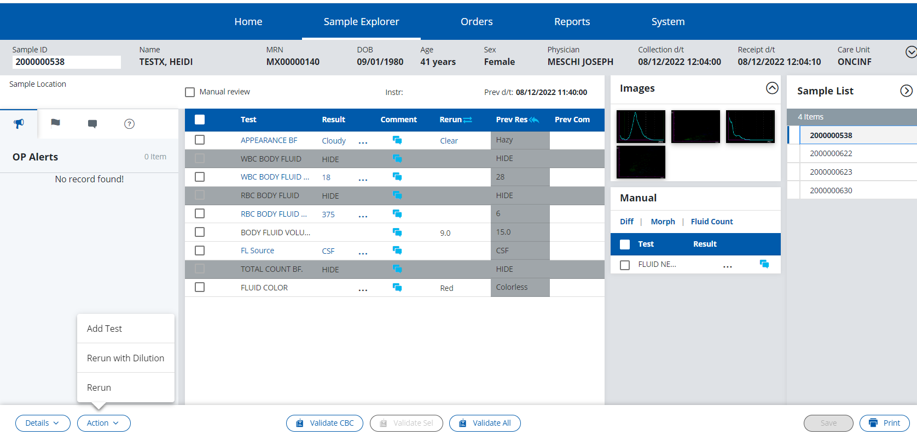
- If a dilution in needed click the Action button at the bottom left of the Fluid Screen.From the pop-up box click Rerun with Dilution.
A new box will pop-up asking for the Dilution Factor.
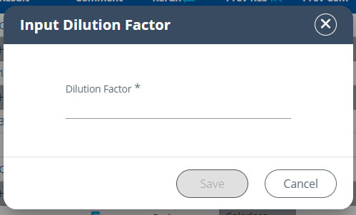
Enter the dilution factor and Save. Now you can rerun your dilution and Caresphere will do your dilution calculations for you.
- If you need to choose between two runs, click on the arrows next to rerun on the blue bar above the instrument test results.
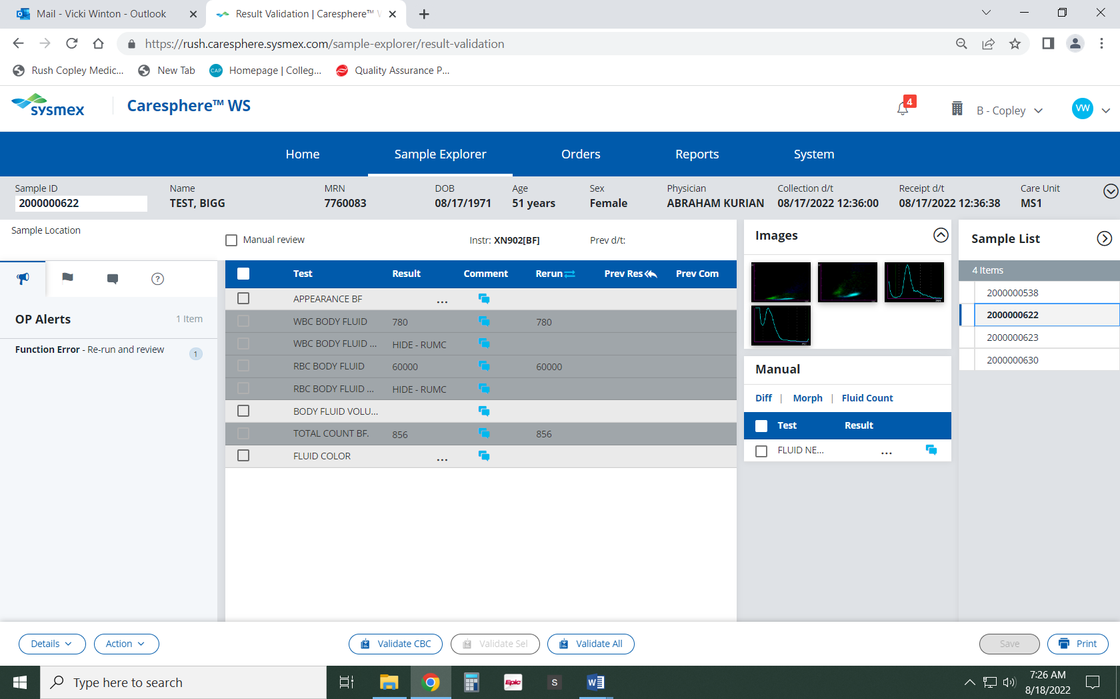
This will open the Rerun box. Click on the box next to Data Mark above the run you would like to use and click OK. This will move the results you have chosen to the main Fluid Screen.

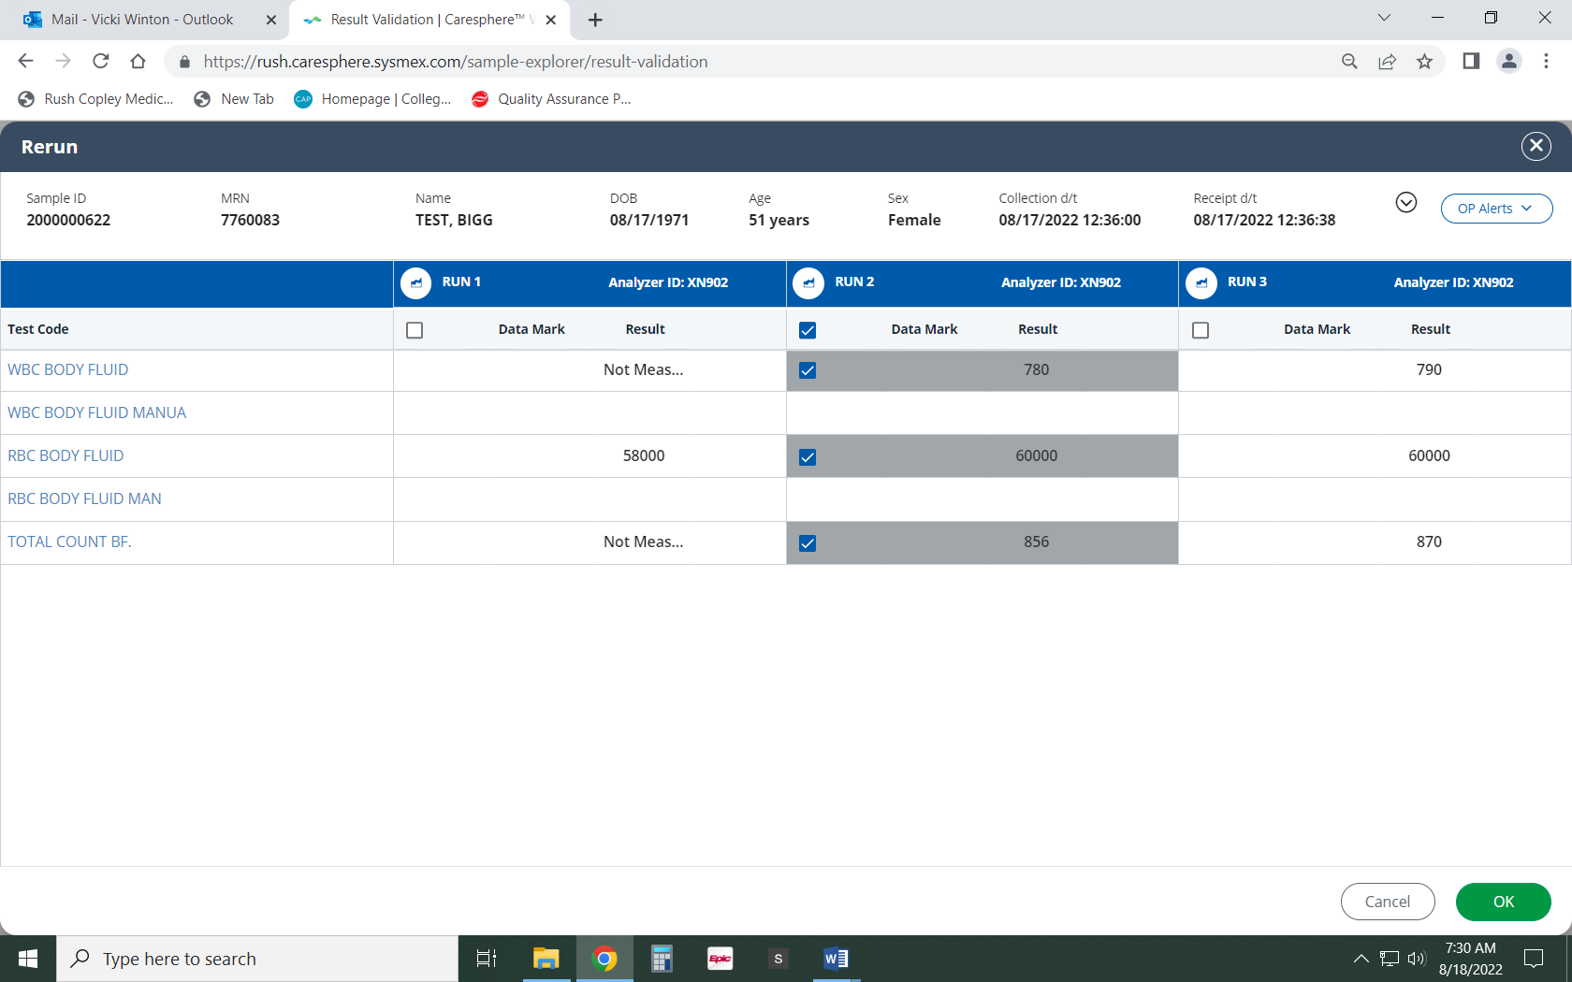
- Fill in Fluid Appearance, Color, Volume and Source.
- If less than or equal to 10 WBC’s are present no manual differential is required. On the main fluid screen you will need to result the FLUID NEUTROPHIL in the manual box. Click on the ellipsis next to FLUID NEUTROPHIL and click Not Indicated. Click Save. When results are validated, not indicated will cross to Soft.
- Click on Diff tab. Change diff counter from MDIFF to FDIFF at bottom left of screen.
- Perform manual differential. If non-hematopoietic cells are observed while performing manual differential:
- Click the Actions button. From the pop-up screen click Add Test.
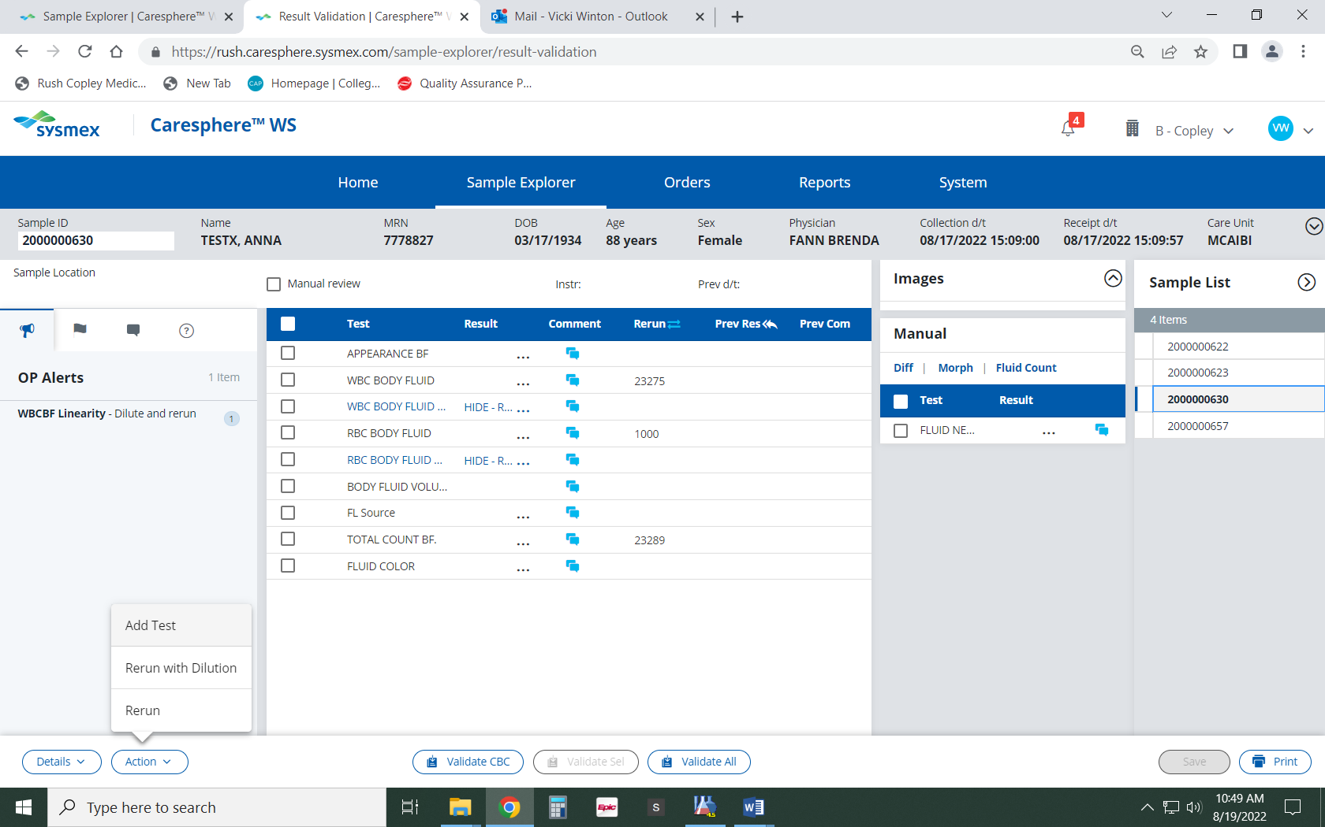
- Scroll to FLOTHER -Fluid Other. Click box in front of FLOTHER. Click Save.
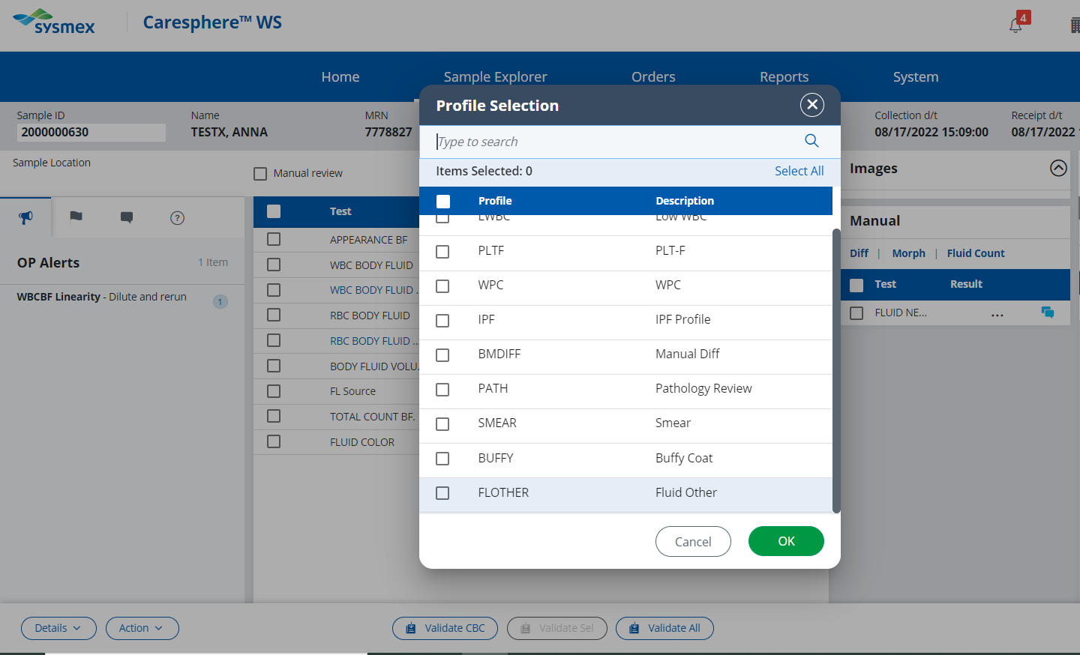
- Fluid Other will be in the Manual box under your manual diff.
- Answer the Fluid Other by clicking on the ellipsis and clicking Few, Moderate or Many.
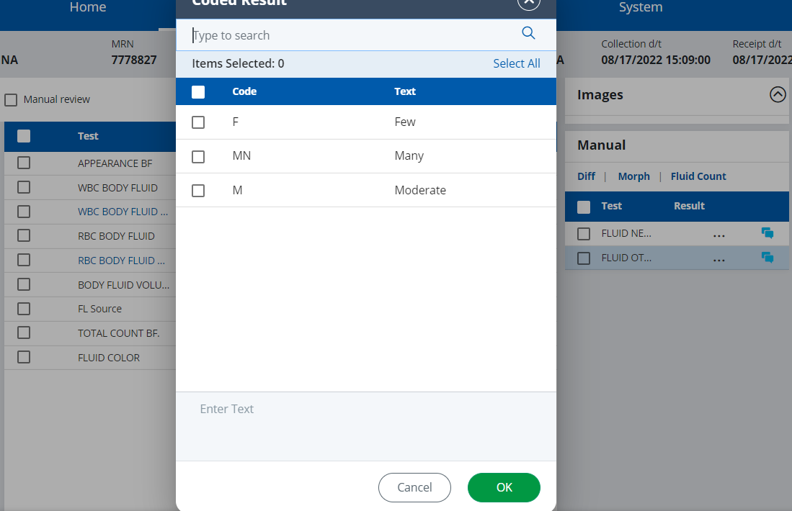
- To standardize how we enumerate Non-heme cells we will use the 30% rule.
Count how many WBCs you see in a 50x oil field. Now count how many non-heme cells
are in that same field.
- If the number of non-heme cells are less then 30% of the number of white cells you count then non-heme will be qualitated as Few.
- If the number of non-heme cells are between 30-60% of the number of white cells counted non-heme will be moderate.
- If the number of non-heme cells are greater than 60% of the number of white cells counted non-heme will be many.
Example: If you count 10 WBC and you count 1-3 non-heme cells per 50x oil field, non- heme
are few
If you count 10 WBC and you count 4-6 non-heme cells per 50x oil field, non-heme are moderate
If you count 10 WBC and you count 7 or more non-heme cells per 50x oil field, non- heme are many
- If you feel a second differential count is warranted you can change your diff pad from count 1 to count 2 and perform a second differential. Press the save button and a box will pop up asking you to choose which count you want reported. Choose the appropriate differential count and click save.
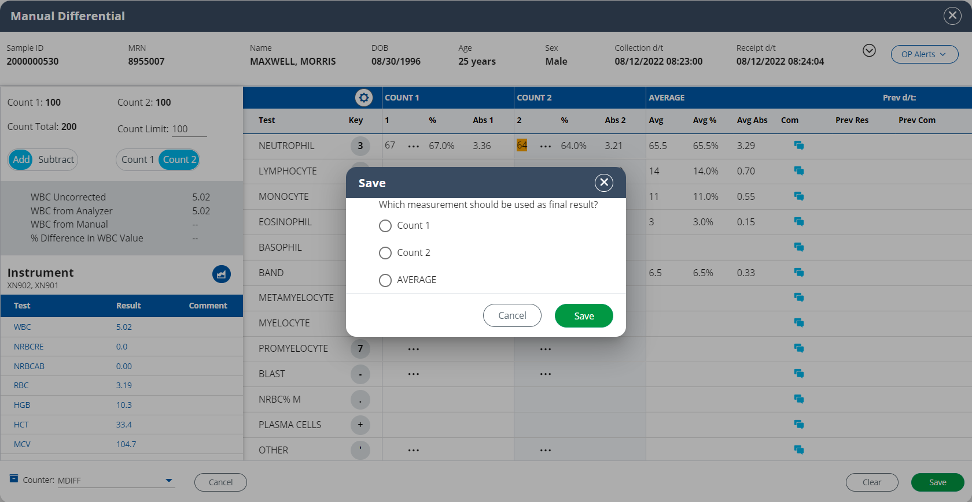
- On the main Fluid screen double check that all results are there. Your differential result should be on the main screen under the manual box. If everything looks good Validate all. This should remove the fluid from your Sample List.

RESULTING MANUAL BODY FLUID SAMPLES:
Refer to Hematology Procedure #4840-HE-0340

INTERPRETATION/RESULTS/ALERT VALUE
- Results:
- Equivalent units: cmm (cubic millimeters) = mm³ = uL (microliters)
- Measuring and Operating Ranges:
- RBC linearity – 0.002 -5.000 x 10⁶/µL
- TNC and WBC linearity – 0.003 – 10.000 x 10³/µL
- Any results that are greater than the linearity will give a - - or * error and should be diluted with Cellpack DCL diluent.

- Cerebrospinal Fluid (CSF)
- CSF is a clear, colorless, non-cellular fluid that circulates over the brain and spinal cord. Cell enumeration is indicated to aid in the diagnosis and treatment of meningeal infections, subarachnoid hemorrhage, and central nervous system malignancies.

- Cell counts will be performed manually on ALL CLEAR AND COLORLESS CSFs. Refer to Proc. #4840-HE-0340 Manual Body Fluid Cell Counts.

- Serous Fluids
- The pericardial, peritoneal, and pleural cavities are formed by double-layered serous membranes that separate the heart, abdomen, and lung respectively from their surrounding environment. In the absence of disease, these serous membranes are separated by a minute amount of fluid that allows for movement.

- An accumulation of fluid between the membranes is an indication of disease.

- Synovial Fluid
- Synovial Fluid occupies the synovial cavity to lubricate the joint space and provide nutrients to the cartilage.

- Cell enumeration is indicated to aid in the diagnosis and treatment of joint disease, as well as the classification of the disease as septic, inflammatory, or non-inflammatory.

- Bronchiolar Lavage
Bronchiolar lavage (BAL) is a safe and simple tool to sample cells from the lower respiratory tract. The specimen is obtained by the physician, usually under local anesthesia. Aliquots of normal saline solution are instilled and aspirated with a syring via a bronchoscope channel, the bronchoscope wedged in a segmental or subsegmental bronchus. The specimen should be sterilely collected and placed in a sterile bronch-wash tube or sterile cup.
- Due to the often mucoid nature of Bronchoalveolar lavage, it can be difficult to attain accurate results because of leukocytes and erythrocytes being caught in mucus strands and not evenly distributing amongst the specimen. If this is the case, we will amend what we report out from a quantitative number to a qualitative estimate.
- On the Caresphere home screen click on Sample explorer
- Type in order number under Sample ID, when order number appears under number you just typed in click on order number. Order number is now under Search Result. Double click on Order number.
- Make a wet prep slide by placing a well mixed drop of specimen on a glass slide and covering with a cover slip. Examine using High Dry objective.
- Quantitate number of WBC present (Few, Moderate or Many). Also note if RBCs are present or absent.
- Enter Fluid appearance, Body Fluid volume, Fluid Source and Fluid Color. Save.
- Next to WBC Body Fluid click the ellipsis. Select SETX (See Text).
- Now click the blue comment box on the WBC Body Fluid line. Click the Add Coded Comment at bottom of comment box. Click BAL (Unable to quantitate WBC count due to mucoid nature of specimen provided. WBC estimate is _____________. At bottom of Add Coded comment box click cursor at the end of the sentence and add Few, Moderate or Many. Now Click Save.
- Now a Add New Comment for Body Fluid box will be on the screen. Check that your comment is there and correct. Click Save.
- If RBCs were present on wet prep slide, on the RBC Body Fluid line click on the result line and type in the number 1. If RBCs were absent type in a 0. Click Save. This will automatically trigger Caresphere to Hide the RBC Manual result.
- At the WBC Body Fluid Manual line and Total Count Body Fluid lines click the ellipsis and click Hide. Click OK. Click Save.
- Make a cytospin slide and perform manual differential (Refer to step 7-11 of this procedure)

REFERENCE VALUES

- Synovial Fluid:
- Appearance – clear, yellow
- RBCs: 0 RBC/mm³
- TNCs: 0-200/mm³

- CSF
- Appearance – clear, colorless
- RBCs: 0 RBC/mm³
- TNCs – Adults: 0-5/mm³
- TNCs – Neonate: 0-30/mm³

- No Known Normals:
- Pericardial Fluid
- Peritoneal lavage
- Pleural fluid/Thoracentesis
- Bronchiolar Lavage

Differentials: A differential should be performed on WBC cell counts over 10 cells/cmm on a Wright-Giemsa stained smear. Refer to Proc. #4840-HE-0340 Manual Body Fluid Cell Counts.

METHOD PERFORMANCE SPECIFICATIONS/LIMITATIONS:
- WBC Limitations: nRBC’s, giant platelets, platelet clumps, malarial parasites, precipitated elevated proteins, microlymphoblasts, very small lymphocytes, fragmented WBC’s, cryoglobulins, agglutinated WBC’s, lyse resistant RBC’s, unlysed particles >35 fL in size may affect the accuracy of the WBC count.
- RBC Limitations: Very high WBC count, high concentration of very large platelets and auto agglutination may affect the accuracy of the RBC count.
- All Fluids:
- Clotted specimens may lead to misleading or erroneous results. Follow standard laboratory operating procedure for inspecting specimens for clots.
- Improperly mixed specimens may lead to misleading or erroneous results.
- Cellular debris may lead to misleading or erroneous results.
- Delays in processing may lead to misleading or erroneous results.
- Results should be interpreted in light of the total clinical presentation of the patient, including clinical history, data from additional tests, smear review, and other appropriate information.
- Synovial Fluids
- Fat globules may lead to misleading or erroneous results.
- Crystals may lead to misleading or erroneous results.
- Highly viscous synovial fluids may trap cells leading to misleading or erroneous results.

REFERENCES:
- Sysmex XN-9100 Instructions for Use( North American Edition), Sysmex Corporation, Kobe, Japan.
- Clinical and Laboratory Standards Institute (CLSI). Laboratory Documents: Development and Control; Approved Guideline; Fifth Edition. (GP2-A5, 2006).
- Sysmex America Inc., Lincolnshire, IL. XN CHECK Hematology Control for Sysmex XN-Series Analyzers package insert.
- Sysmex XN series Administrator’s Guide (North American Edition), Sysmex Corporation, Kobe Japan.
- College of American Pathologists. Laboratory Accreditation Checklists, www.cap.org, retrieved January 2020.

