TITLE: Completing a Quality Assessment/Improvement form

PRINCIPLE/PURPOSE:
Occurrence Event Management Provides direction for the laboratory’s processes and procedures to capture events to identify systemic problems and commit to removing the cause and thus reduce risk. The organization supports a “just culture” environment, promoting a non-punitive approach in which personnel at every level feel free and comfortable reporting issues or events.
  - Laboratory staff use the Lab’s Quality Assessment/Improvement form “Attachment A” and “Attachment B” to record events within the laboratory in addition to the hospital’s onlineoccurrence report.
  - The below criteria warrant occurrence completion but are not limited to these options. When in doubt fill out both the Lab’s Quality Assessment/Improvement form and the hospitals occurrence report.
      - Lost specimen
      - Wrong patient/test/result
      - Mislabeled or unlabeled specimen
      - Contaminated specimen
      - Wrong patient/site/test
      - Incorrect result (corrected report)
      - Significant delay in testing
      - Affect patient care or safety

  - Laboratory staff should self-report if they participate in, witness or discover an event that potentially jeopardizes quality of care and patient outcomes. When in doubt report it out using both the Lab’s Quality Assessment/Improvement form and the hospitals online occurrence reporting.

PERSONNEL:
All Laboratory Personnel

STEPWISE PROCEDURE:
- Access a blank form from the S drive
- Complete the fields below.
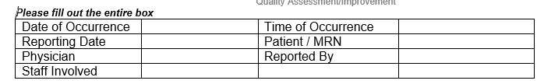

- Categorize the event based on the fields below
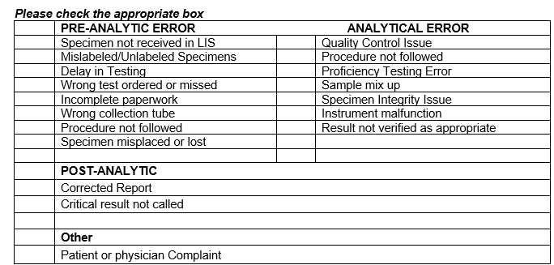

- Briefly describe what happened. State the facts and not opinions, emotion or judgements.

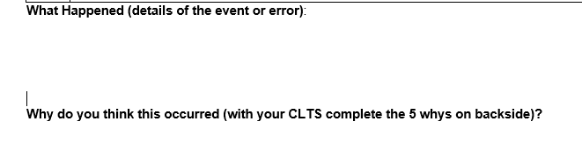

- On the reverse side, answer the 5 whys
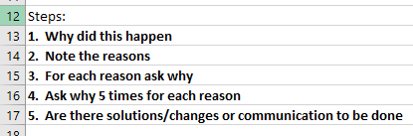

- If you need help with this form, contact the CLTS or Lead phlebotomist in that area.
- If you also filled out the hospital’s online occurrence report, circle “Y”. If not circle “N”.
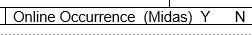
- Sign the form and forward to the Lab manager.

