## TITLE: Transfusion Reaction Workup

PRINCIPLE:

Having a system for detecting, reporting and evaluating any adverse reaction or complication of transfusion is required of every Blood Bank and Transfusion Service. The system must include a method for reporting and recording cases of suspected post transfusion disease.

Suspect a transfusion reaction when there are significant changes in the patient’s vital signs such as:

* 2-degree F increase in temperature compared to the pre-transfusion assessment temperature
* hypoxemia with SpO2 <90%,
* hypertension ≥ 30 mmHg increase,
* hypotension ≥ 30 mmHg drop in systolic BP and ≤ 80 mmHg and/or other signs and symptoms.

Examples of transfusion reactions by incidence include:

* Allergic transfusion reaction (92 in 100,000 transfusion events),
* Febrile, Non-hemolytic transfusion reaction (91 in 100,000),
* Transfusion-Associated Circulatory Overload (TACO) (11 in 100,000),
* Hypotensive transfusion reaction (3 in 100,000),
* Transfusion-Related Acute Lung Injury (TRALI) (1 in 100,000),
* Acute Hemolytic Transfusion reaction (1 in 100,000)
* Transfusion-transmitted infection/sepsis (<1 in 100,000).

There must be a thorough investigation and a report in each case. To assure adequate care of the patient, to prevent subsequent errors, and for medicolegal eventualities, it is imperative that very careful and complete records be made and retained indefinitely.

The records must include type of reaction, extent and results of investigation, conclusions, follow-up and report made to physician, patient’s chart, and collection facility or manufacturer if the fault is determined to be the product transfused. Signatures of each person involved in the investigation must be part of these records.

A hospital’s occurrence report along with the Lab’s quality assessment/improvement form must be filled out.

Further transfusion must not be initiated until consent from physician as well as approval from the Pathologist on call has been obtained.

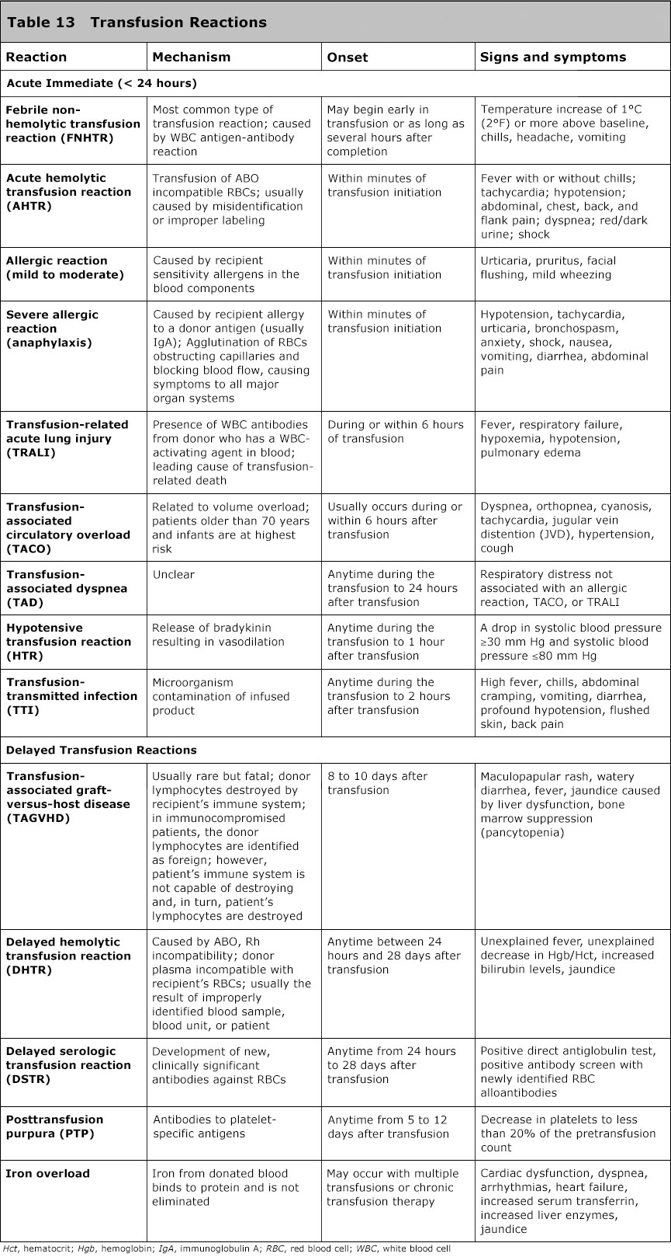

**CLINICAL SIGNIFICANCE:**

The classic hemolytic transfusion reaction may begin with chills, headache, chest or back pain, nausea, vomiting and/or a sudden rise in temperature. The initial reaction generally is NOT fatal. A blood sample collected at the time of the earliest symptoms may have hemoglobin in the serum. The first urine sample may contain hemoglobin, red cells, or pigmented casts. After the initial reaction there may be no further signs, but some cases may show a lessened output of urine. Severely affected patients may have renal shutdown and subsequently die. Other types of transfusion reactions that should be reported are:

* Febrile
* Non-hemolytic reactions
* TRALI (Transfusion Related Acute Lung Injury)- seen within 6 hours of transfusion
* TACO (Transfusion Associated Circulatory Overload)- previously known as fluid overload
* Allergic- Hives, rash, etc.
* Delayed Hemolytic Transfusion Reactions- identification of a new clinically significant antibody within 28 days of transfusion.

### PERSONNEL:

Medical Technologists

**SPECIMEN COLLECTION:**

Draw one Blood Bank tubes (Pink EDTA) from the patient using the SoftID protocol

THESE ARE STAT SAMPLES AND MUST BE TAKEN TO THE BLOOD BANK IMMEDIATELY.

**REAGENTS AND EQUIPMENT:**

See individual procedures.

### QUALITY CONTROL:

See individual procedures

*NOTE: All transfusion workups are STAT.*

**ORDERING TRANSFUSION REACTIONS IN SOFTBANK**

1. Upon receiving notification that a patient is having a transfusion reaction, request that the physician/RN order a POST1 in EPIC.
2. RN or phlebotomist should draw the POST1 pink top using SoftID.
3. Go into EPIC and print the transfusion vitals for the transfused unit(s). This can be found in the blood bank administration flowsheet/blood bank snapshot. This printout should contain the previtals, vitals during reaction and what reactions the patient had.

* Transfusion reactions should be documented by the nurse in the patient’s EHR under reactions in the blood administration flowsheet.
* Include the printout with your other printouts for pathologist review

1. In SoftBank go to patient > Transfusions > Confirm, this will put units in “transfused” status. Select the unit(s) involved in the transfusion reaction, F12 to save:

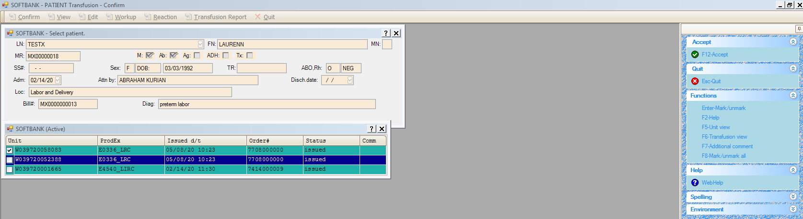

1. Enter start and stop times from the EPIC vitals’ printout along with nurse observations. If the observations are not listed on the EPIC printout, obtain them from the nurse (fever, chills, hives, etc.) F12 to save:

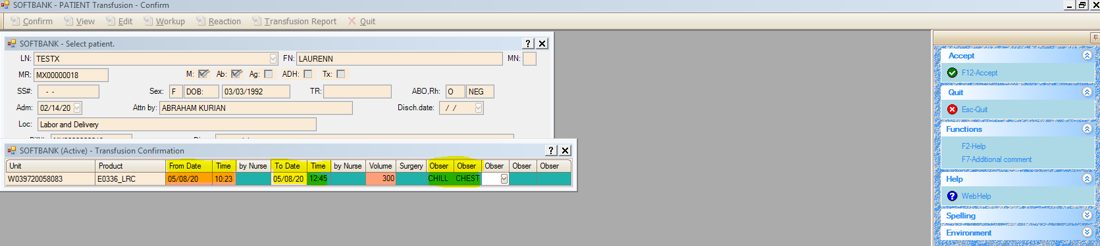

1. Add comment from canned messages, “Investigating a transfusion reaction” to the exception box that pops up, F12 to save

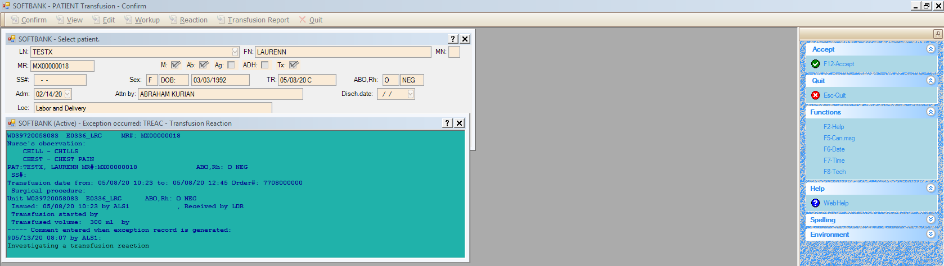

Now you may continue on with the Stepwise Procedure for the transfusion reaction.

## STEPWISE PROCEDURE:

A. Transfusion Reaction Work-Up

1. Check all clerical work involved in the initial crossmatch. This includes patient identification, blood unit labels and all pre-reaction records for possible errors in patient or blood identification at the bedside or in the laboratory. Make sure that there is agreement between all orders, tubes and computer entries.
2. NOTE THE APPEARANCE OF THE PATIENT’S SERUM (COMPARE THE PRE AND POST TUBES) AND THE DONOR BLOOD, note any hemolysis or icterus.
3. Do a Direct Coombs on the patient’s pre- and post-specimens using Poly Coombs in test tube.
4. Retype the patient’s ABORH (pre and post samples).
5. NEGATIVE AND/OR COMPATIBLE RESULTS ON THE ABOVE INVESTIGATIONS MEAN THAT THERE HAS NOT BEEN A HEMOLYTIC REACTION, AND IT IS NOT NECESSARY TO CONTINUE WITH PHASE II OF THE WORKUP.
6. Enter the results in the LIS using the stepwise procedure listed below, DO NOT ENTER TRANSFUSION REACTION RESULTS UNDER PATIENT > ORDERS> RESULTS
7. Give the investigation to the pathologist for their remarks.
8. Transfusion reaction workups must be initiated within 24 hours. All reactions are treated as STAT. Completion of workup will be dependent on reaction type and severity. For example, workups sent to Versiti to rule out TRALI will take longer.
9. Place pre and post transfusion samples in the daily rack, allowing for 21 days post transfusion storage.

**NOTE: TRANSFUSION REACTION WORK UPS WILL OCCUR ON ALL TRANSFUSED BLOOD PRODUCTS (i.e., RBC, Frozen Plasma, Platelets, ECT), AS THE CARE GIVER DEEMS APPROPRIATE. IN CASES OF A TRANSFUSION REACTION BEING CALLED ON FFP OR PLATELETS THERE MAY NOT BE A PRE-TRANSFUSION SPECIMEN, IT IS OK TO ONLY REPORT THE RESULTS ON THE POST-REACTION SPECIMEN. PLEASE MAKE NOTE IN SOFTBANK AND ON THE REPORT THAT “NO PRE-TRANSFUSION SAMPLE AVAILABLE”.**

B. **PHASE II OF WORK UP**:

IF THE PATIENT’S CLINICAL CONDITION STRONGLY SUGGESTS A

HEMOLYTIC REACTION, FURTHER INVESTIGATION IS WARRANTED

DESPITE A NEGATIVE PRELIMINARY RESULT. IF ANY FINDINGS ARE

POSITIVE, DOUBTFUL OR INCOMPATIBLE, THE FOLLOWING TESTS

MUST BE DONE AND THE RESULTS RECORDED. BE SURE TO

NOTIFY A PATHOLOGIST AND BLOOD BANK CLINICAL LABORATORY

TECHNICAL SPECIALIST.

NOTE: ANY OF THE FOLLOWING TESTING WILL BE PERFORMED AT THE

REQUEST OF THE PHYSICIAN OR A PATHOLOGIST.

1. Order a POST2, do an antibody screen on both the pre and post specimens. Put these results in with the rest of the transfusion workup. Also do an antibody screen on the donor(s), if possible. A positive antibody screening indicates the presence of an antibody which must be identified.
2. Recrossmatch both the pre and post specimens with the donor(s) according to

Procedure 4840-BB-308, including the AHG phase.

1. Place order in Laboratory Information System for a bilirubin to be drawn six (6)

hours after the transfusion was stopped. Omit the charge on these orders in order

entry with the comment “Transfusion Reaction”.

1. Place an order for a UMAC; notify patient’s nurse that it needs to be collected.

Check at least one post-transfusion urine for hemoglobin.

5. Send bag and remaining blood to Microbiology for a gram stain and

culture.

6. Record all results of the tests in SoftBank under Patient > Transfusion > Workup;

record all the results for extra blood bank testing, chemistries, urine and prelim micro under Shift + F7 Comment. These comments will show up on the Transfusion reaction report.

7. When all chemistries, urine results and preliminary bacteriology results (gram

stain) are back and the blood bank investigation is done, give the

investigation to the pathologist for their remark.

1. Place pre and post transfusion samples in the daily rack, allowing for 21 days

post transfusion storage.

9. ALL TRANSFUSION WORK-UPS ARE STAT and should be reviewed

by the Pathologist on call.

10. NOTE: IF ANY OF THE ABOVE TESTS INDICATES OR STRONGLY

SUGGESTS A HEMOLYTIC REACTION, BACTERIAL CONTAM-

INATION, AND/ OR OTHER SERIOUS REACTIONS NOTIFY THE

PATHOLOGIST AND ATTENDING PHYSICIAN

IMMEDIATELY.

### REPORTING RESULTS IN THE LIS

**Transfusion Reaction Workup (Phase I)**

1. Receive post-transfusion sample in lab
2. Open Soft Bank
3. Open Patient>Transfusion>Workup
4. Enter patient information – F 12
5. Caution Screen appears, Esc to close
6. Choose Transfused Unit, Click Enter-Reaction from side menu
7. Screen opens with Transfusion Reaction Data, leave both boxes checked, F12 to save

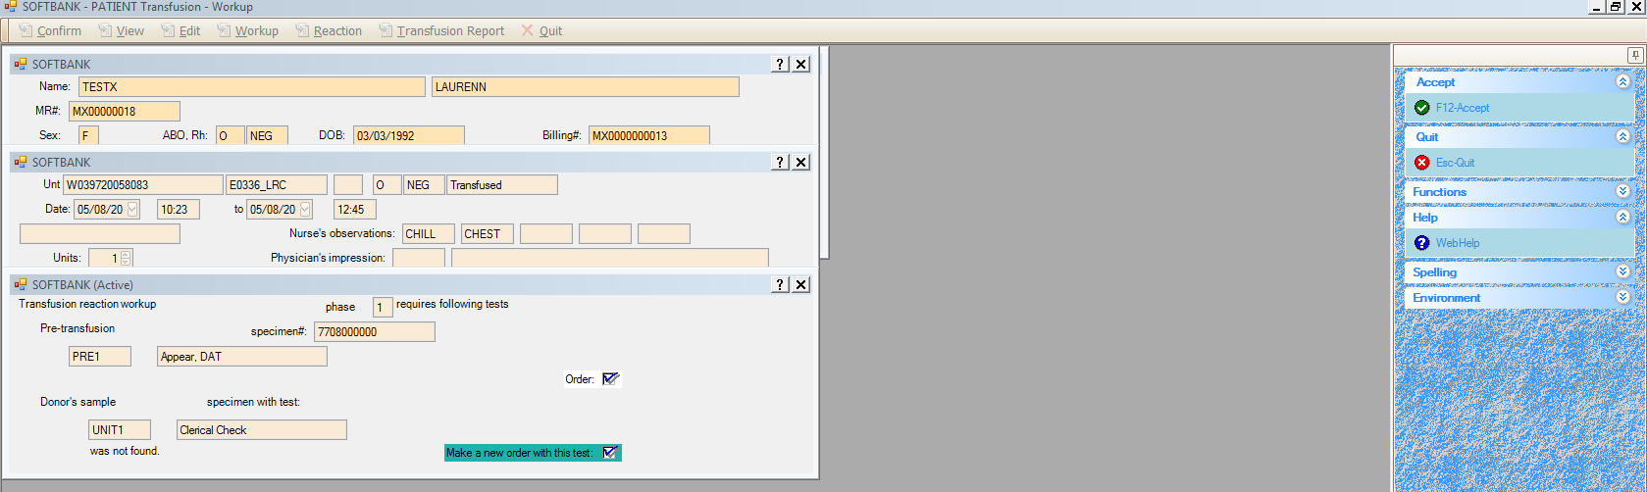

1. Select reaction box and click F7-Results
2. Enter results
3. F-12 Save changes
4. Continue to next result box, **repeat from step 8 until ALL boxes are complete.**

STOP: If further workup is indicated, continue to Phase 2 procedures now

1. Print report by selecting Cont+P-Report, select printer
2. Take report to Pathologist for comment
3. Open Patient>Transfusion>Reaction
4. Enter Patients name
5. Caution box appears, Esc to close
6. Choose Unit and press Enter
7. Enter pathologist’s impression from dropdown menu
8. Enter pathologist’s name
9. F-12 Accept, “Save Changes?” Yes
10. Choose printer

**Transfusion Reaction Workup (Phase 2)**

1. Patient>Transfusion>Workup
2. Enter patient’s name
3. Select Unit, choose Enter Reaction from side menu
4. Choose Ctrl+T-Phase 2, screen opens with Phase 2 data
5. F12-Accept, Save changes
6. Move to a result box, select F7-Results, enter results, F-12 Save changes, until resulting completed
7. Print report using Control-P, select printer
8. Give to pathologist for review
9. Open Patient>Transfusion>Reaction
10. Enter pathologist’s impressions
11. Enter pathologist name
12. Print report

**INTERPRETING RESULTS**

Since compatibility testing is performed for the detection of antibodies to the red cells antigens, adverse effects of transfusion are most commonly caused by leukocytes, platelets, and/or plasma proteins. In addition, every transfusion carries a risk of alloimmunization as well as transmission of disease. All the care in crossmatching blood in the laboratory can be negated by the administration of blood to the wrong patient.

Suspected TRALI reactions may need to be sent to Versiti for further workup. TRALI is a reaction noted to have acute respiratory distress, hypo- or hypertension and non-cardiogenic pulmonary edema occurring within 6 hours of blood component transfusion. Causative antibodies are most often found in the plasma of blood donors (HLA & HNA). An example of the request for workup from Versiti can be found in the form’s drawer or at the end of this procedure.

A delayed hemolytic transfusion reaction can be suspected when a patient has a type and screen with a positive antibody screen result and a **NEW** clinically significant antibody present, within 24 hours to 28 days post receiving a red blood cell transfusion. In this case the technologist will need to initiate the transfusion reaction workup and notify the patient’s physician and the senior technologist. The technologist will place a new order for POST1 and a POST2 on the same sample the type and screen was just performed on. You may not be able to compare post transfusion testing with pre-transfusion testing if the sample is not available or QNS. It is acceptable to only result the post transfusion portion of the workup. You also will not be able to do any clerical check on the unit. Segments from the unit(s) transfused can be pulled from the segment bag and antigen typed for the new antibody and AHG crossmatched. Any units antigen positive for the new antibody will automatically be implicated in the transfusion reaction.

All transfusion reactions should be reported to the blood bank and evaluated to the extent considered appropriately by its Medical Director. A hospital’s occurrence report along with the Lab’s quality assessment/improvement form must be filled out.

In the event of a fatal reaction, lab leadership will notify Legal, Risk and Quality departments per procedure 4840-BB-808.

### REFERENCE

Soft Computer Company, Clearwater, Florida

AABB Technical Manual, 18th Edition, 2014.

Standards for Blood Banks & Transfusion Service, 30th edition, 2015

Current CAP checklist

