## TITLE: Blood Gases – LIS Resulting

**PURPOSE:**

To provide instruction to staff for resulting Blood Gas analysis tests in SoftLab.

**PERSONNEL**

###### Medical Technologists, Medical Technicians

### STEPWISE PROCEDURE:

ABL90 Flex Plus is interfaced to the LIS and results will auto verify if appropriate. Result reporting is accomplished via the interface.

* 1. Log into the SoftLab system using your username and password.
  2. Go to **‘Resulting Worklist’**

-Choose **“YRESP”,** Choose **“All”** or **“Pending & Not Posted** and then **OK.**

-Choose correct patient to review results.

- Reportable parameters will have a numerical value, non-reportable parameters will have a **“.”**

-Any non-interfaced results (i.e. ALLEN) may be entered here. A result may be

changed here and result level comments can be added.

-Click on **“Verify All”**, **“Save”**

-If the test needs to be repeated then go to **‘Order Entry’** and place another order for the patient. See 4840-LIS-213 (Order Entry - LIS) for more information. Select which result and Verify. Cancel other order in **‘Order Entry’**.

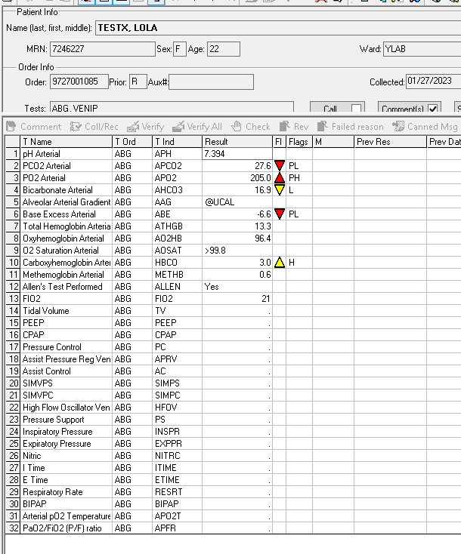

Add @UCAL or @NA when no results for

* 1. Review the displayed results. (See chart below for LIS pneumonic vs. ABL90 printout vs. SCM/Reports identifiers)  
       
     **LIS ABL90 Flex Plus** **SCM/Reports**

ABE ABEc Base Excess Arterial

AAG *p*O2(A-a)e Alveolar Arterial Gradient

HBCO *F*COHb Carboxyhemoglobin Arterial

FIO2 Input from Staff *F*O2 (I) FIO2

AHCO3 cHCO3¯(P)c Bicarbonate Arterial

METHB *F*MetHb Methemoglobin Arterial

AO2HB *F*O2Hb Oxyhemoglobin Arterial

ATHGB *c*tHb Total Hemoglobin Arterial

APCO2 *p*CO2 PCO2 Arterial

APH *p*H pH Arterial

APO2 *p*O2 pO2 Arterial

AOSAT *s*O2 O2 Saturation Arterial

ALLEN enter result manually Allen’s Test Performed

VPH pH pH venous blood

VHBCO *F*COHb Carboxyhemoglobin, Venous

VPCO2 *p*CO2 PCO2 Venous

VHCO3 cHCO3¯(P)c Bicarbonate Venous

VBE ABEc Base Excess Venous

VPO2 *p*O2 pO2 Venous

VTHGB *c*tHb Total Hemoglobin Venous

VO2HB *F*O2Hb Oxyhemoglobin Venous

VOSAT *s*O2 O2 Saturation Venous

VMTHB *F*MetHb Methemoglobin Venous