**OHSA revised Hazard Communication Standard**

OSHA revised its Hazard Communication Standard (HCS) to align with the United Nations’ Globally Harmonized System of Classification and Labeling of Chemicals (GHS) and published it in the Federal Register in March 2012 (77 FR 17574).

Two significant changes contained in the revised standard require the use of:

* new labeling elements
* standardized format for Safety Data Sheets (SDSs), formerly known as, Material Safety Data Sheets (MSDSs)

The new label elements and SDS requirements will improve worker understanding of the hazards associated with the chemicals in their workplace.

**Type of information expected to see on the labels including:**

* **Product identifier**: How the hazardous chemical is identified, example, Chemical name, code number or batch number.
* **Signal word**: Indicate the relative level of severity of hazard and the alert the reader to a potential hazard.
* **Pictogram**: OSHA has designated eight pictograms under this standard for application to a hazard category.
* **Hazard statement**: Describe the nature of the hazard(s) of a chemical, including, where appropriate, the degree of hazard.
* **Precautionary statement(s):** a phrase that describes recommended measures that should be taken to minimize or prevent adverse effects resulting from exposure to a hazardous chemical or improper storage or handling.
* **Supplier Identification**: Name, address and phone number of the chemical manufacturer, distributor, or importer

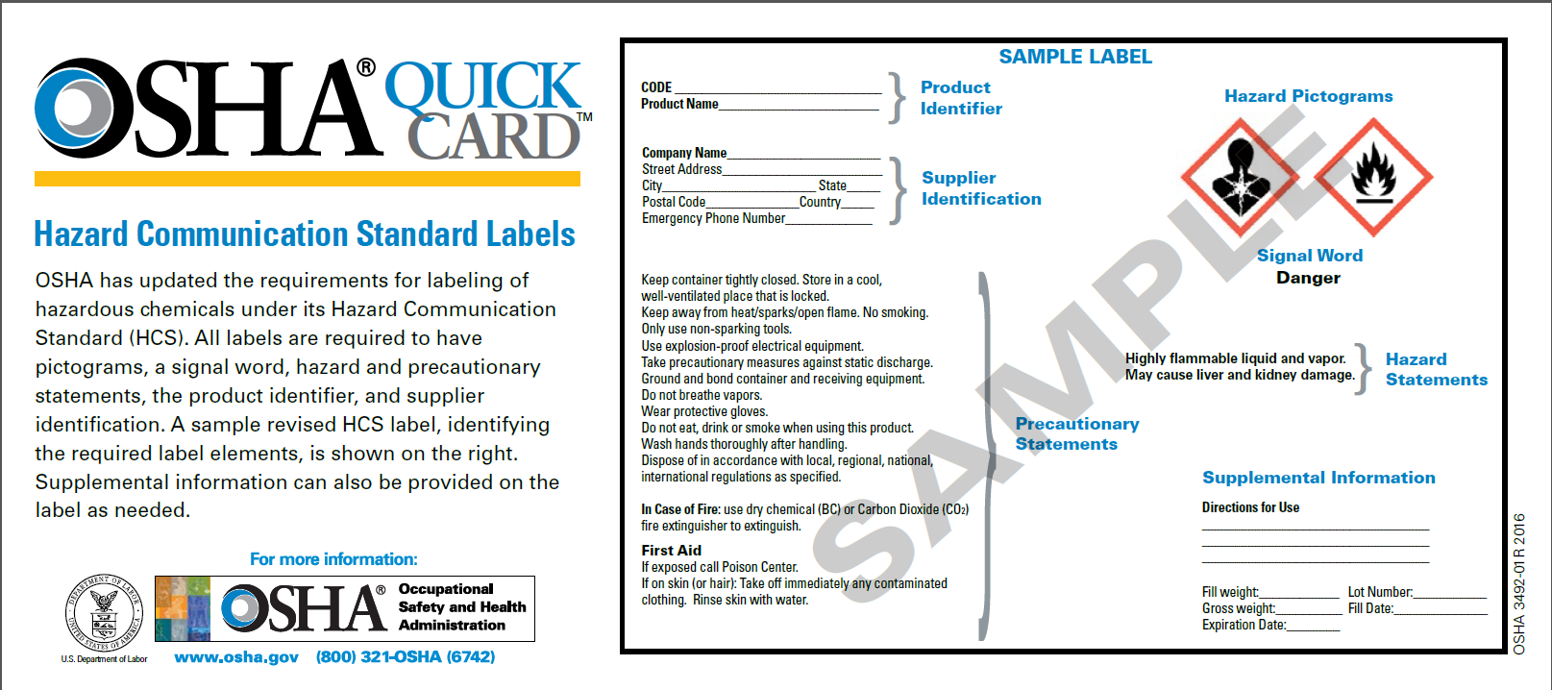

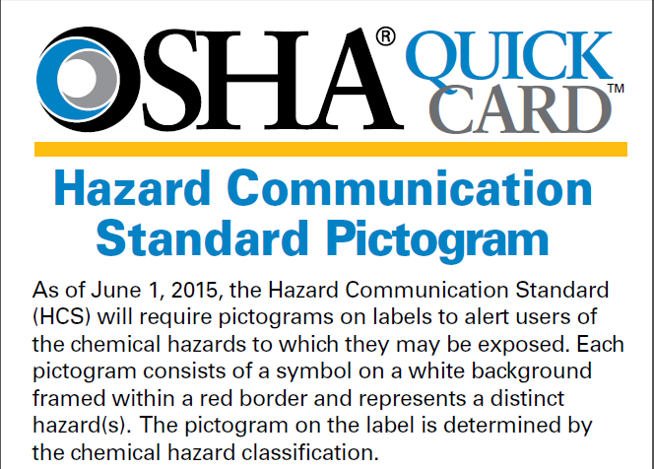

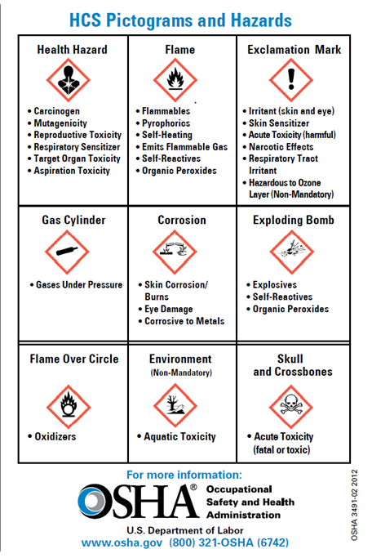

**OSHA designated 8 pictograms:**

|  |  |
| --- | --- |
| **Pictogram** | **Example of hazard** |
| Health Hazard | Carcinogen |
| Flame | Flammables |
| Exclamation Mark | Irritant |
| Gas Cylinder | Gases under pressure |
| Corrosion | Skin corrosion/burns |
| Exploding Bomb | Explosives |
| Flame Over Circle | Oxidizers |
| Skull and Crossbones | Acute Toxicity |
| Environment (Non Mandatory) | Aquatic Toxicity |

Precautionary statements will be the same on SDS and on the label.

{

**Section 8** will always contain information about exposure limits, engineering controls and ways to protect you, including PPE.

