Maine Medical Center POCT Program

POCT SKILLS ASSESSMENT FOR OBGYN RESIDENTS AND ATTENDINGS

Name (please print): __________________ Date: __________________ Initials: ___________

**(1) SLIDE 1:**

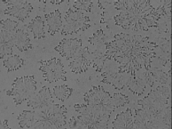

Indicate whether ferning is present or absent in this unstained vaginal sample.

___ Ferning is present ___ Ferning is not present

**(2) SLIDE 2:**

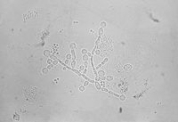

Indicate whether spermatozoa and/or trichomonas are present or absent in this unstained vaginal wet prep sample.

___ Spermatozoa are present ___ Spermatozoa are absent

___ Trichomonas are present ___ Trichomonas are absent

**(3) SLIDE 3:**

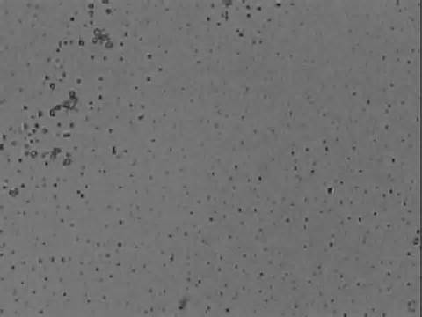

Indicate whether ferning is present or absent in this unstained vaginal sample.

___ Ferning is present ___ Ferning is not present

**(4) SLIDE 4:**



Indicate whether yeast/fungi are present or absent in this KOH, unstained vaginal sample.

___ Yeast/fungi are present ___ Yeast/fungi are absent

**(5) SLIDE 5:**

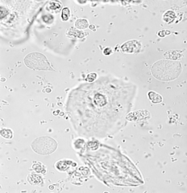

Indicate whether spermatozoa and/or trichomonas are present or absent in this unstained vaginal wet prep sample.

___ Spermatozoa are present ___ Spermatozoa are absent

___ Trichomonas are present ___ Trichomonas are absent

**(6) SLIDE 6:**

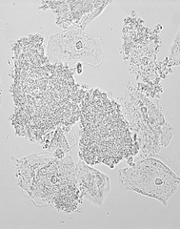

Indicate whether yeast/fungi are present or absent in this KOH, unstained vaginal sample.

___ Yeast/fungi are present ___ Yeast/fungi are absent

**(7) SLIDE 7:**

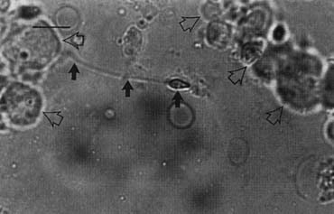

Indicate whether trichomonas/spermatozoa are present or absent in this unstained vaginal wet prep sample.

___ Trichomonas are present ___ Trichomonas are absent

___ Spermatozoa are present ___ Spermatozoa are absent

**(8) SLIDE 8:**

Indicate whether spermatozoa are present or absent in this unstained vaginal wet prep sample.

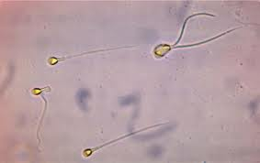

___ Spermatozoa are present ___ Spermatozoa are absent absent

**(9) SLIDE 9:**

Indicate whether trichomonas are present or absent in this unstained vaginal wet prep sample.

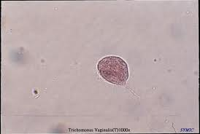

___ Trichomonas are present ___ Trichomonas are absent

**(10) When you have finished, please give your completed forms to your preceptor.**