Maternity Point of Care Competency  
Providers

2015

The Point of Care manual is found in DocuShare under “Policies and Procedures”,. “Point of Care”. Please review the following procedures for the Point of Care testing performed in Maternity.

Urine Protein using Albustix

Urine Ketone using Ketostix

Vaginal pH using Nitrazine Paper

Fern Test

Vaginal Wet Prep

After you have reviewed the procedures, complete the quiz. Passing score is 85%.

Multiple Choice

1. After dipping urine for urine protein, the test area on the strip should be read:

a. after 2 minutes

b. after 1 minute

c. immediately

d. after 15 seconds

2. After dipping urine for ketones, the test area on the strip should be read:

a. after 2 minutes

b. after 1 minute

c. immediately

d. after 15 seconds

3. QC controls for urine testing performed for Albustix, Ketostix and pH must be run:

a. each shift

b. daily

c. using both levels of KovaTrol

d. both b and c

e. both a and c

4. Urines contaminated with skin cleaners containing chlorhexadine may cause a false positive result when testing for:

a. Protein

b. Ketones

c. Both a and b

d. None of the above

5. Fern tests slide must be:

a. dried at least 10 minutes before reading

b. read using the 10X objective of the microscope

c. labeled with patient name, date of birth and time collected

d. all of the above

6. Is ferning present or absent? Check the appropriate box below the picture.

**Slide A**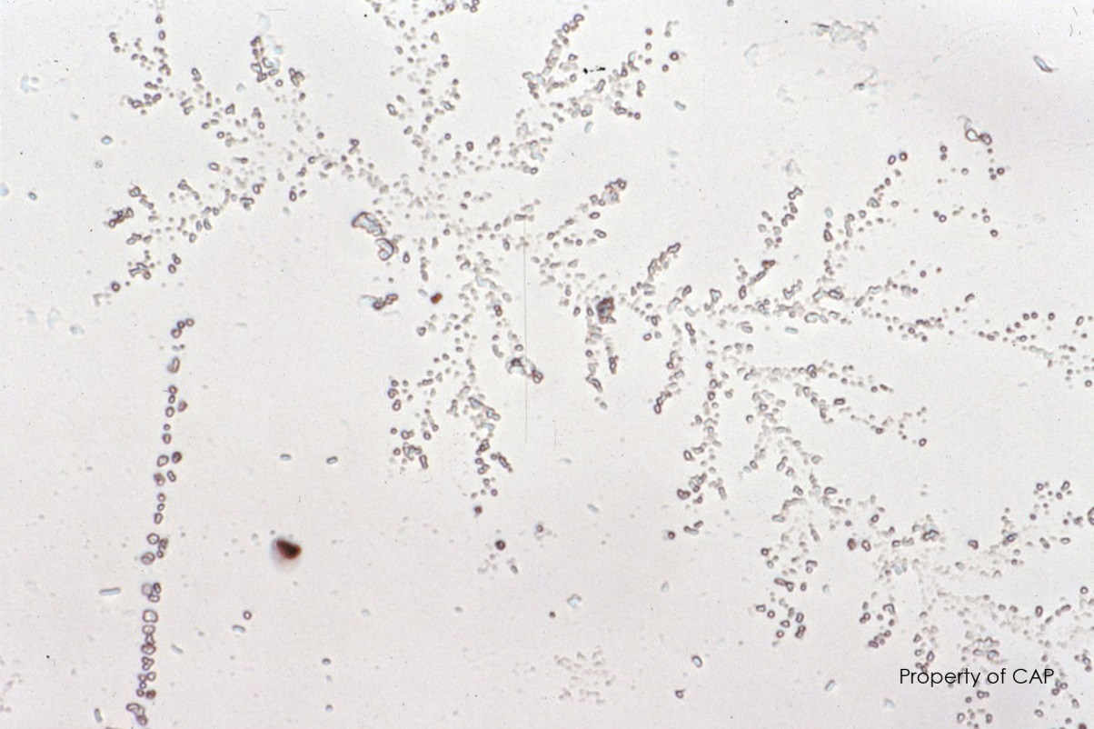

**Ferns present**

**No ferns seen**

**7.** Is ferning present or absent? Check the appropriate box below the picture

**Slide B** 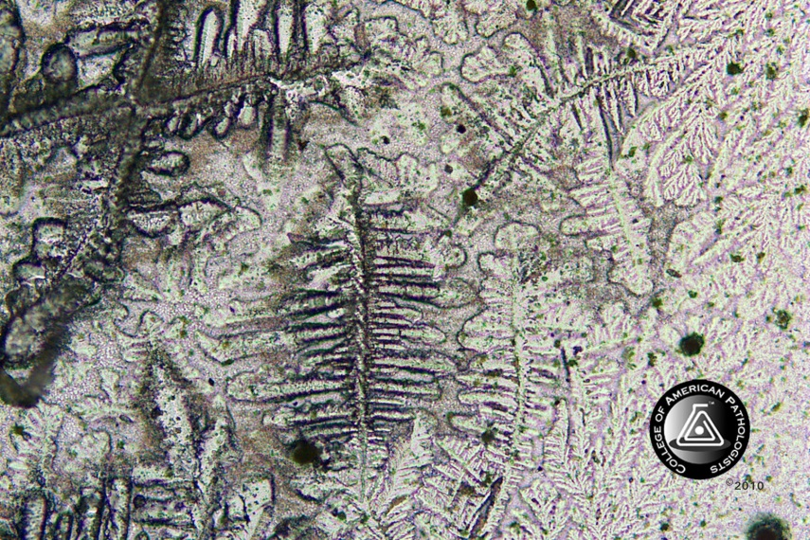

**Ferns present**

**No ferns seen**

8. What cell is present in this picture? Check the appropriate box below the picture.

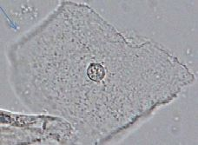

Clue cell

Normal vaginal epithial cell

9. Identify the cells indicated by the arrows in the following picture. Check the appropriate box below the picture.

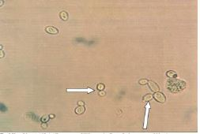

Trichomonas present

Yeast present