SCOPE:

This procedure applies to UPMC – Hanover.

PURPOSE:
Downtime is any occasion when normal access to the EPIC system is disrupted for an extended period-of-time for planned or unplanned reasons. EPIC can support your laboratory’s ability to provide consistent and uninterrupted patient care through BCA (Business Continuity Access) functionality- combination of reporting, specialized labeling, and specimen linking features.

Considerations to make for planned system outages.
Short-term planned downtime (less than 2 hours)
    - Choose off-peak hours, when the lab receives its lowest specimen volume
    - Prioritize running all STAT and other high-priority tests prior to the downtime, hold all routines. Your lab may not receive many STAT or high priority tests during a two-hour period, especially during off-peak hours.
    - Run all routine tests after the system has recovered.

For Long-Term planned downtime (greater than 2 hours)
    - Alert the appropriate members of your organization and support team that a significant downtime will occur. Plan this event for times when the lab receives the lowest number of specimens. Otherwise, follow the same downtime procedure described in the short-term section above.

PROCEDURE:

- REVIEW ORDER REQUESITION AND PLACE INFORMATION ON DOWNTIME LABELS

Step | Action
1 | Planned or Unplanned Downtime Event:  - Perform tests and analyze specimens as usual.  - Apply a unique downtime label to each specimen, not one for each test.  - Beaker will allow more than one test to be associated with 1 downtime specimen. For example: A BMP and a Magnesium may share a tube/specimen, so only one downtime label is needed for both tests.  Up to 6 tests may share one label/ specimen type.
2 | Review physician’s request for testing  - The receptionist receives request and registration slip from the floor or the patient if outpatient.  - Document date and time, of receipt of requisition, and initials of person receiving on the paper.  - If patient is available, verify patient’s information and ask any questions that pertain to their blood draw (i.e. Last dose, fasting status, etc.).  - Highlight ordered tests and circle the lab site on the request.
3 | Document on the Requisition Form with orders from physician:  - Highlight or circle test- place a footie or aliquot label beside test- to link-up barcode numbers after computer downtime completed.  - On Footie or aliquot label write the name of the test associated with specimen ID.  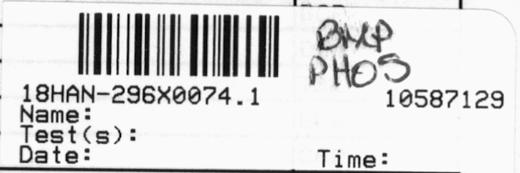  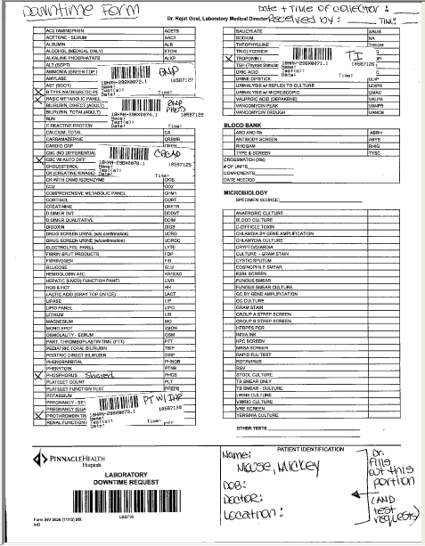
4 | Place the following information on the labels:  - Name of patient / Date of Birth/ Sex/ Location or Doctor  - MRN  - Test names  - Date and Time of collection/ collector’s name  [Must have bold/ if available]  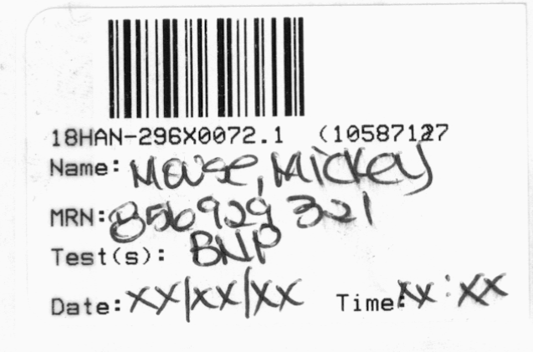
5 | Specimen Collection  - Verify the patient’s name and date of birth.  - Collect the specimens required for tests marked on the requisition. – Requisition may be either normal outpatient requisition, or downtime requisition used for E.D. and inpatients.  - Label specimens upon collection with patient’s name, date of birth, date and time of collection, collector’s initials and patient location.  - Mark date and time of collection and collector’s initials on requisition.  - Write the count of each tube type drawn at the top of the requisition.  - Spin specimens as needed and organize tubes in rack by patient and in same order as the requisitions.  - Offsite collections should be packaged one patient per bag along with its requisition.
6 | Procedure for filling out Downtime labels:
7 | The request is placed in a folder, and copies of the results from the analyzer are attached to the request.  Once the computer system is back in service, the technologist can link the results and orders.  See EPIC Computer Downtime 2- Instrument Programming and Result Reporting  by Technologist.

Document History
Date of Origination and Document Control Number | LIS 0159.0 P  7/30/2019
 |  | Prepared by: Marilee Klunk, MT (ASCLS)
Revision History/ Biannual Review:
Revision History/ Biannual Review:
Revision History/ Biannual Review:
Revision History/ Biannual Review:
Revision History/ Biannual Review:

Keywords:

Downtime, Collection, Accessioning

