# PURPOSE:

This document establishes a policy and procedure for the collection of whole blood samples for Chain of Custody – Alcohol and / or Drugs of Abuse testing at the request of a YORK or ADAMS County police officer or Pennsylvania State Police trooperoperating out of theYORK/ADAMS County Barracks as authorized under the Pennsylvania Motor Vehicle Code.

**SCOPE:** This procedure applies to UPMC Hanover laboratory.

**POLICY:**

* The following procedure applies ONLY to Chain of Custody Alcohol and / or Drugs of Abuse testing requested by officers of police departments located in **YORK and ADAMS County**, Pennsylvania.
* UPMC Hanover Laboratory will collect whole blood samples for Chain of Custody – Alcohol and / or Drugs of Abuse testing at the request of a police officer as authorized under the Pennsylvania Motor Vehicle Code.
* The YORK and ADAMS County District Attorney’s Office have established individual accounts with National Medical Services, Inc (NMS) of Horsham, Pennsylvania to provide chain of custody alcohol and / or drugs of abuse testing as permitted under the Pennsylvania Motor Vehicle Code.
* UPMC Hanover Laboratory will serve solely as the sample collection agent. NMS test results will be sent directly to the York and Adams County District Attorney’s Office or the requesting police department.
* UPMC Hanover will NOT have access or receive a copy of or retain any test results.

**REAGENTS/SUPPLIES:**

* Sealed NMS biological specimen collection kit, containing:

1 blood tube holder/box

2 10mL Grey Top tubes

1 each needle and adapter (see note below)

1 iodine prep pad

1 plastic zip lock bag with absorbent pad.

2 specimen seals

1 Investigating officer’s report card

1 kit box shipping seal

3 % Hydrogen Peroxide (approved to use instead of iodine prep pad)

* NMS Chain of Custody Form
* See sample of Chain of Custody/requisition form and instructions on pages 6 & 7.
* See-example of completed form that officer fills out, blood tube holder box label & labeled blood tubes on page 8.

**PROCEDURE:**

The procedure consists of four subsections:

* ER Registration and Test Ordering
* Sample Collection
* Completing the Chain of Custody
* Packaging, Shipment, and Record Retention

**ED Registration**

|  |  |  |
| --- | --- | --- |
| **Step** | **Action** | |
| **1** | The requesting police officer will present with the patient in the Emergency Department (or in an ER room if the patient also requires medical evaluation). | |
| **2** | The Emergency Room Registrar will register the patient in EPIC. | |
| **3** | The Registrar will notify the Laboratory to send a phlebotomist and relay whether it is a York or Adams county officer requesting the test. | |
| Sample Collection | |
| Step | Action | |
| 1 | Take a NMS collection kit and chain of custody form (for the appropriate jurisdiction, York or Adams County) to the patient's location.   * Check Expiration date on the side panel of the sealed test kit prior to proceeding to the Emergency Department. | |
| 2 | Open the collection kit and remove all components. | |
| 3 | Cleanse the blood withdrawal site with the ***non-alcohol prep pad*** provided in the kit. (Hydrogen peroxide - H2O2 – may be used). | |
| 4 | Draw the patient's blood using standard phlebotomy technique.   * ***Blood tubes must be inverted at least five (5) times immediately after collection to assure proper mixing of the anticoagulant powder. DO NOT shake vigorously*** | |
| 5 | Fill out the two (2) "Specimen Seals:"  A. Phlebotomist fills out “ID # or SS#, "date collected" and "collected by" lines.  B. Patient fills out "Donors initials" line. | |
| 6 | Remove backing and affix center of the specimen seals on the blood tube stoppers, then press the ends of the seals down the sides of the blood tubes as shown in example on page 8. | |
| 7 | Return the filled and sealed blood tubes to the blood tube holder/box. *Proceed to Chain of Custody section.* | |

|  |  |
| --- | --- |
| Chain of Custody | |
| Step | Action | |
| 1 | Initial the *police evidence seal* and place the evidence seal on the blood tube box in the area indicated. | |
| 2 | The phlebotomist and investigating officer fill out the appropriate portions of the Chain of Custody as demonstrated in example on page 6.   * Officer completes sections 1,5-8 (7 if indicated) * Phlebotomist completes sections 2-4 & 9   NMS instructions for completing each section are located on page 7. | |
| 3 | The phlebotomist and investigating officer fill out the appropriate portions of the blood tube holder/box as shown in example on page 8. | |
| 4 | The phlebotomist will make a photocopy of the completed NMS Chain of Custody form to keep as the *File Copy* for laboratory records and to be placed in the folder in the lock box for Chain of Custody records. | |
| 5 | * Place the *NMS Copy* of the chain of custody form in the collection box for transport with specimens. * Give the *Client Copy* of the chain of custody to the requesting officer. * Retain the copy made (*File Copy*) and transport back to laboratory to be placed in the *manila folder in the lock box for laboratory records* (Chain of Custody). *Proceed to Packaging/Shipment/Record Retention section.* | |
| Packaging/Shipment/Record Retention | |
| Step | Action | |
| 1 | Place the blood tube box (with filled and sealed blood tubes) in the provided zip lock bag. NOTE: ***do not remove liquid absorbent sheet from the bag.*** | |
| 2 | Squeeze out excess air, then zip-seal bag. | |
| 3 | Place sealed bag in kit along with the NMS Chain of Custody form. | |
| 4 | Sign and date, as collector, the "Kit Box Shipping Seal." | |
| 5 | Reassemble the kit box, then seal kit by affixing the "Kit Box Shipping Seal" to the kit box where indicated. | |
| 6 | Transport the sealed kit to Specimen Processing area and place the sealed kit in the designated Chain of Custody lock box. **Lock the box with the key.** *The key is labeled “COC Key” and is located inside of the top filing cabinet (left hand side of cabinet on a magnet) under the QUEST Printer in the SPA area.* Place a copy of the Chain of Custody form in the folder located in the lock box. Remove the “KITS IN LOCK BOX” sign that is in the lock box and place it on the outside of the lock box. | |
| 7 | This will let Specimen Processing staff know that there is a Chain of Custody kit (s) in the lock box to be sent out via Fed Ex. | |
| 8 | Specimen processing staff and/or phlebotomist (trained and competent in Chain of Custody) will prepare the sealed kit(s) for shipment to NMS laboratory via FedEx.   * Up to four kits may be placed in a single FedEx bag. Use the prepaid air bills provided by NMS. * Record the air bill number and date of shipment in the “Case History” section of the *File Copy* of the NMS requisition. On the bottom of the Chain of Custody form; fill out the date and sign your name. Take the *File Copy* to the Storeroom with sealed FED EX bags. Storeroom staff must sign “received by” and the Purpose of Transfer will be FED EX. Return to the laboratory with filled out form and place the *File Copy* in the NMS Referral binder. On a monthly basis, remove requisitions greater than one-month past collection date and give to the Laboratory Secretaries to file. * IF the testing laboratory (NMS) deems the specimen (s) to be unacceptable for testing and/or requires information needed for testing to proceed; NMS staff will contact UPMC Hanover laboratory via phone. Staff must record events on the Specimen Rejection record form located in the *NMS KIT REFERRALS* binder. | |

**NOTES/ LIMITATIONS:**

* ***Blood tubes must be inverted at least five (5) times immediately after collection to assure proper mixing of the anticoagulant powder. DO NOT shake vigorously***
* If the patient is allergic to iodine, hydrogen peroxide may be used for cleaning the blood withdrawal site.
* Sealed kits must be locked in the Chain of Custody designated lock box until they are shipped via FED EX to NMS laboratories.
* If an officer requests that the blood sample be screened for additional drugs (i.e. prescription drugs), he may write the name of the drug(s) in the area on the form labeled “Other Testing”. It is preferred to enter a test name and test code to avoid processing delays per NMS.
* All communications from NMS pertaining to specimens and additional information needed for cases must be recorded on the Specimen Rejection Record form located in the NMS KIT REFERRALS binder.
* All test results and charges are sent by NMS directly to the York County District Attorney’s Office.UPMC Hanover hospital has no access to test results. Direct all inquiries concerning test results to the York County District Attorney’s Office
* The Chain of Custody records are filed and kept in a locked filing cabinet and retained for two years.
* **Specimen stability**

Room Temperature: 7 day (s)

Refrigerated: 1 month (s)

Frozen (-20 degrees C): 8 month (s)

**REFERENCES:**

* Example of completed NMS kit components (page 8).
* Example of NMS test requisition and chain of custody form (page 6)
* Instructions for filling out form (page 7)
* NMS laboratory website (nmslabs.com)
* “Instructions for Blood Specimen Collection”, National Medical Services, Inc INTEGRIKIT package insert BA3NMS:INS1.2 12/006.
* Analysis Requisition and Chain of Custody form, FR-Req (v.2) (12/2016)
* Administrative Laboratory Policy: Retention of Records and Specimens in the Laboratory

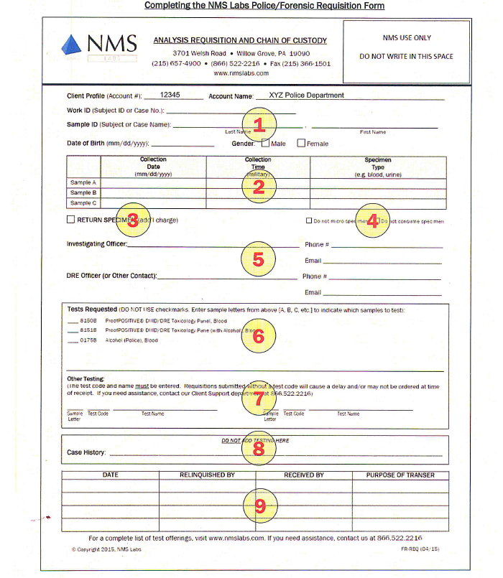

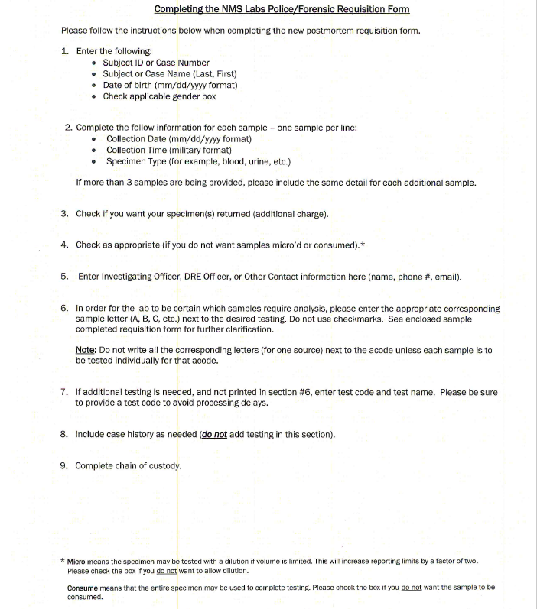

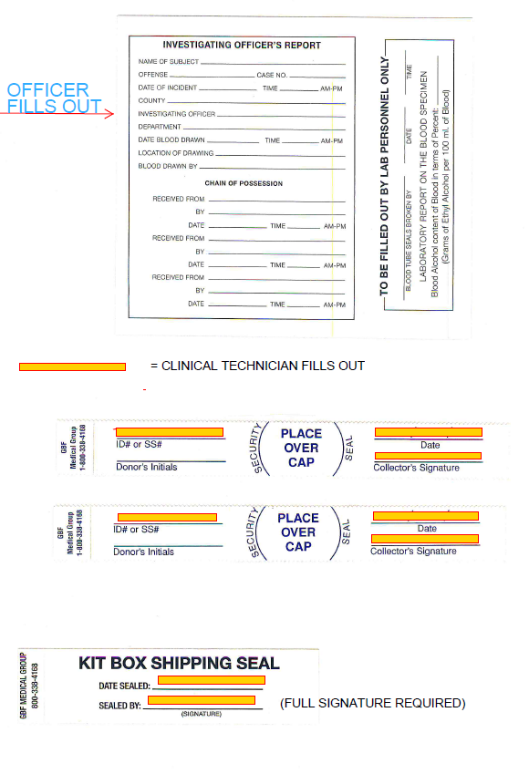

Phlebotomist fills out

**Document History**

|  |  |  |
| --- | --- | --- |
| Date of Origination and Document Control Number | 09/12/13  PHLB1550.1 |  |
| Prepared by: J. Laughman |
| Revision History/ Biannual Review: | 9/12/14  PHLB1550.2 | Prepared by: J. Laughman |
| Revision History/ Biannual Review: | 4/20/17  PHLB1550.3 | PHLB1550.2 revised and published as PHLB1550.3.  Prepared by Monica Salisbury MLT(ASCP), Laboratory Support Services Supervisor   1. Reformatted to approved hospital template. 2. Added instructions and examples of new NMS analysis requisition and chain of custody form (FR-Req (v.2) (12/2016) 3. Retired PHLB1550.2 |
| Revision History/ Biannual Review: | 5/20/19, 8/15/19 | Monica Salisbury, MLT (ASCP), POCS |
| Revision History/ Biannual Review: | 9/26/19 | Monica Salisbury, MLT (ASCP), POCS |
| Revision History/ Biannual Review: |  |  |