Finding an Electronic Laboratory Policy/Procedure  
MCN Policy Manager

Electronic laboratory policies and procedures are located in MCN Policy Manager. MCN is accessed through the Infonet or Citrix.

Navigate to the MCN website and click on the MCN Navigation Video for instructions in locating a document. Ask your supervisor if you have any questions.

MCN Policy Manager Access

Infonet access: In the search field type in "MCN". The links for navigation to MCN will appear on the screen. Follow those links to MCN.

Citrix access: Click on the Citrix Access icon on your computer desk top. At the top of the Citrix home screen, click on APPS, then click on MCN POLICY MANAGER.

After the automatic log in, the screen below will appear. Click on the MCN Navigation Video for instructions.

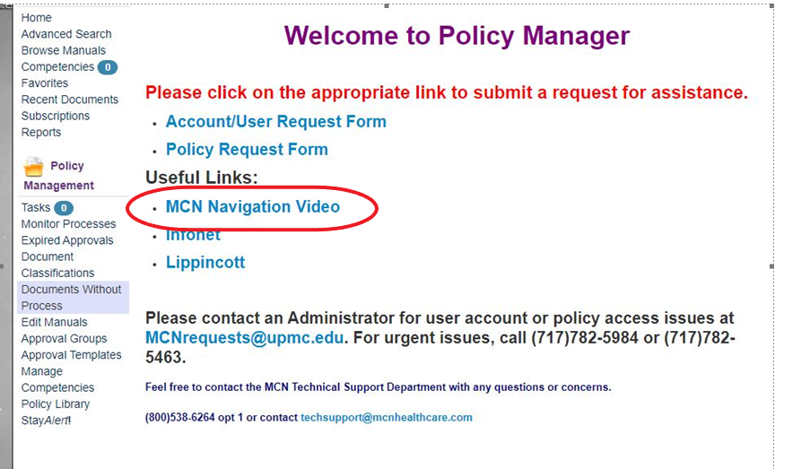

Once you are familiar with MCN, click on "Browse Manuals" then "UPMC Hanover Manuals" to see a listing of UPMC Hanover manuals. Choose " Laboratory-Hanover (HAN)". Click on the manual you wish to view to find a listing of policies and procedures.

For any questions you may have, contact your supervisor.