**PURPOSE:**

To provide the process for terminating the work up of any pending blood cultures on comfort measures only (CMO) or expired patients as requested by Infection Prevention.

**SCOPE:**

This policy applies to UPMC hospital facilities.

**PROCEDURE:**

* Patient has expired or is made CMO (notification goes to Infection Prevention via EPIC mailbox Best Practice)
* Infection Prevention reviews chart to see if patient has blood cultures pending and if they meet criteria (no autopsy, not a coroner case, not for organ donation).
* Infection Prevention reviews the case with Infectious Disease and If in agreement, Infection Prevention will contact the ordering physician to cancel the blood cultures.
* If the ordering physician is in agreement, Infection Prevention will call the microbiology lab to stop the work-up.
* The physician and the laboratory have the right to continue to process the blood culture for any justifiable reason. This may include:
  + Laboratory – the blood culture has been already partially reported.
  + Clinical – an investigation is pending, especially if an autopsy is planned, a coroner case, or patient is for organ donation.

**INTERPRETATION OF RESULTS AND REPORTING:**

Comments will be added by the lab to results currently on the culture, after which the culture will be finalized. Comments and mnemonics follow.

* COMFORT/PALLIATIVE CARE (554) -**The patient is palliative care for comfort measures. No further work up is indicated.**
* 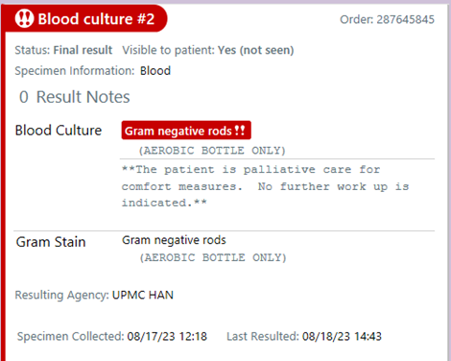
* PATIENT EXPIRED (555)** The patient expired. No further work up is indicated.**

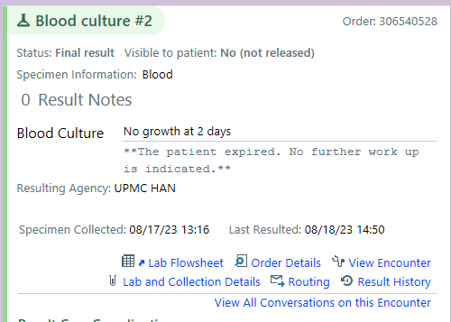

If no results have been entered.

