**PURPOSE/PRINCIPLE:**

The C. DIFF QUIK CHEK COMPLETE® test is a rapid membrane enzyme immunoassay for the simultaneous detection of Clostridium difficile glutamate dehydrogenase antigen and toxins A and B in a single reaction well. The test detects C. difficile antigen, glutamate dehydrogenase, as a screen for the presence of C. difficile and confirms the presence of toxigenic C. difficile by detecting toxins A and B in fecal specimens from persons suspected of having C. difficile disease. The test is to be used as an aid in the diagnosis of C. difficile disease. As with other C. difficile tests, results should be considered in conjunction with the patient history.

**SCOPE:**

This policy applies to UPMC Hanover Hospital.

**SPECIMEN TYPE**:

Acceptable Specimen Types:

1. Fresh untreated stool specimens (soft or liquid), stored at 2°C – 8°C and less than 72 hours old. If the test cannot be performed within 72 hours of collection the specimen must be frozen.
2. Frozen fecal samples. Freezing is only recommended if testing cannot be completed within 72 hours. Specimens that are frozen may lose activity due to freezing and thawing.

Unacceptable Specimen Types:

1. Formed stool specimens
2. Stool in Cary-Blair or ParaPaks C&S preservative
3. Rectal swabs
4. Fecal specimens received in ParaPaks formalin or PVA
5. Patients with a previously negative test within 5 days
6. Patient with a previously positive test within 30 days
7. Duodenal, colostomy and ileostomy aspirates, drainages or collections

**Reagents/Supplies:**

A. Materials Provided:

1. Membrane Devices – each pouch contains 1 device (25 pouches per kit)
2. Diluent (22 mL per bottle) – Buffered protein solution with graduated dropper assembly
3. REAGWASH Wash Buffer (12 mL per bottle) – Buffered solution with graduated dropper assembly.
4. REAGSUB S Substrate (3.5 mL per bottle) – Solution containing tetramethylbenzidine
5. ENZCONJ Conjugate (2.5 mL per bottle) – Mouse monoclonal antibody specific for glutamate dehydrogenase coupled to horseradish peroxidase and goat polyclonal antibodies specific for toxins A and B coupled to horseradish peroxidase in a buffered protein solution
6. Positive Control (2 mL) – Antigen in a buffered protein solution
7. Disposable plastic transfer pipettes – graduated at 25 μL, 400 μL and 500 μL IVD For in vitro diagnostic use

B. Materials and Equipment Required but Not Provided:

1. Small test tube (e.g., plastic tubes or glass tubes)
2. Applicator sticks
3. Timer
4. Vortex mixer
5. Disposable gloves for handling fecal samples
6. Pipettor and tips

**HAZARDS/PRECAUTIONS:**

1. Reagents from different kits should not be mixed or interchanged. Do not use a kit past the expiration date.
2. Each component in the kit should be inspected for any signs of leakage. Upon arrival, inspect the kit to ensure that components are not frozen or warm to the touch due to improper shipping conditions.
3. Bring all components to ROOM TEMPERATURE BEFORE USE!
4. Caps, tips and dropper assemblies are color-coded; do NOT mix or interchange!
5. Do not freeze the reagents. The kit should be stored between 2°C and 8°C.
6. The pouch containing the Membrane Device should be at room temperature before opening. Keep the membrane devices dry before use.
7. Use fecal specimens within 72 hours of collection to obtain optimal results. Specimens that are frozen may lose activity due to freezing and thawing. If using frozen specimens, thaw at room temperature.
8. Hold reagent bottles vertically to dispense reagents to ensure consistent drop size and correct volume.
9. Specimens and membrane devices should be handled and disposed of as potential biohazards after use.
10. Membrane devices cannot be reused.
11. The test has been optimized for sensitivity and specificity. Alterations of the specified procedure and/or test conditions may affect the sensitivity and specificity of the test. Do not deviate from the specified procedure.
12. Be attentive to the total assay time when testing more than one fecal specimen. Add Diluent first, and then add the Conjugate to each tube of Diluent. Then add specimen to the tube of Diluent/Conjugate. Thoroughly mix all of the diluted specimens, and transfer to the Membrane Device. The 15-minute incubation step begins after the last diluted sample-conjugate mixture has been transferred to the final Membrane Device.
13. If the Substrate reagent changes to a dark blue/violet color call technical services for replacement.
14. Fecal specimens may contain potentially infectious agents and should be handled at “Biosafety Level 2” as recommended in the CDC/NIH Manual “Biosafety in Microbiological and Biomedical Laboratories.”
15. Wear disposable gloves when doing the test.
16. The Conjugate, Diluent and Wash Buffer reagents contain 0.05% ProClin® 300 as a preservative. Although the concentration is low, ProClin® 300 is known to be harmful. If skin irritation or rash occurs, get medical advice/attention. Take off contaminated clothing and wash it before reuse. Handle reagents according to existing regulations for laboratory safety and good laboratory practice. Safety Data Sheets for this product are available upon request, contact technical support.
17. Follow your national, regional, and local ordinances accordingly for waste disposal regulations.

**QUALITY CONTROL POLICY:**

**Frequency**: QC is performed every 30 days and each new shipment and lot number NOTE: Do not use the kit if controls have not yielded the appropriate results. Contact the laboratory supervisor. Document QC results on the appropriate log sheet.

**Internal**: A blue control line must be visible on the “C” side of the Reaction Window on every Membrane Device that is tested. The appearance of the blue control line confirms that the sample and reagents were added correctly, that the reagents were active at the time of performing the assay, and that the sample migrated properly through the Membrane Device. A clear background in the result area is considered an internal negative control. If the test has been performed correctly and reagents are working properly, the background will be clear to give a discernible result.

**External**: The reactivity of the C. DIFF QUIK CHEK® test should be verified on receipt using the Positive Control and negative control (Diluent). The Positive Control is supplied with the kit (gray-capped bottle). The Positive Control confirms the reactivity of the other reagents associated with the assay, and is not intended to ensure precision at the analytical assay cut-off. Diluent is used for the negative control. Additional tests can be performed with the controls to meet the requirements of local, state and/or federal regulations and/or accrediting organizations.

Any QC discrepancies are documented in the microbiology problem log.

**PROCEDURE:**

Samples will be batched and run as workload permits.

**ANY stool received from a patient <1 year of age will automatically be ordered as the C diff Real time PCR. If it is positive it will automatically reflex to the Quest cytotoxicity test.**

A. Sample Preparation

1. Bring all reagents and the required number of devices to room temperature before use.
2. Set up and label one small test tube for each fecal specimen and external controls if necessary.
3. Using the black graduated dropper assembly, add the appropriate volume of diluent for the sample received, see Table 1 below.

|  |  |
| --- | --- |
| **Sample Type** | **Volume of Diluent** |
| Fresh Fecal Specimens | 750 ul (2nd graduation from the tip) |
| Frozen Fecal Specimens | 650 ul (1st graduation from the tip) |
| External Controls (Positive and Negative) | 750 ul (2nd graduation from the tip) |

1. Add one drop of conjugate to each tube.
2. Obtain one disposable plastic transfer pipette (supplied with the kit) for each sample - the pipettes have raised graduations at 25uL, 400uL and 500uL.

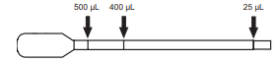

1. Mix all specimens thoroughly regardless of consistency. It is essential that the specimens be evenly suspended before transferring.
   1. Liquid/semi-solid specimens – Pipette 25uL of specimen with a transfer pipette and dispense into the diluents/conjugate mixture. Use the same transfer pipette to mix the diluted specimens.
   2. External Controls – Add one drop of Positive control to the appropriate test tube containing diluent and conjugate. Add 25 uL of diluent for the Negative control, and pipette into the appropriate test tube containing diluent and conjugate.

**NOTE: Transferring too little specimen, or failure to mix and completely suspend the specimen in the Diluent mixture, may result in a false-negative test result. The addition of too much fecal specimen may cause invalid results due to restricted sample flow.**

B. Test Procedure

1. Obtain and label one membrane device per specimen, and one Membrane device per external positive or negative control as necessary. The foil bag should be brought to room temperature before opening and used immediately after opening. Label each device appropriately and orient it on a flat surface so the “**C. Diff Complete**” print is located at the bottom of the device, and the small sample well is located in the top right corner of the device.
2. Close each tube of diluted specimen and mix thoroughly. Proper mixing can be achieved by vortexing or inverting the tube. Once a patient sample or positive control has been diluted in the diluent/conjugate mixture, it may be incubated at room temperature for any period of time up to 24 hours prior to addition to the membrane device.
3. Using a new transfer pipette, transfer 500uL of the diluted sample-conjugate mixture in the **Sample Well** (smaller hole in the upper right corner of the device). Make certain that the liquid sample is expelled onto the wicking pad inside of the membrane device. Also, when loading sample into the sample well make sure that the tip of the transfer pipette is angled towards the **Reaction Window** (larger hole in the middle of device).

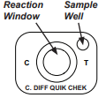

1. Incubate the device at room temperature for 15 minutes – the sample will wick through the device and a wet area will spread across the Reaction Window.
   1. **NOTE FOR SAMPLES THAT FAIL TO MIGRATE:** Occasionally, a diluted fecal specimen clogs the membrane and the reaction window does not wet properly. If the diluted fecal specimen fails to migrate properly within 5 minutes of adding the sample to the sample well then add 100uL (4 drops) of Diluent to the sample well and wait an additional 5 minutes (a total of 20 minutes). If the specimen still fails to migrate, retest the specimen.
2. After the incubation, add 300uL of Wash Buffer to the Reaction Window using the graduated white dropper assembly. Allow the Wash Buffer to flow through the Reaction Window membrane and be absorbed completely.
3. Add 2 drops of Substrate to the Reaction Window and record results visually after 10 minutes. Set a timer for 10 min to ensure the test is read promptly.

**INTERPRETATION OF RESULTS AND REPORTING:**

1. Interpretation of the test is most reliable when the device is read immediately at the end of the 10 minute reaction period. Read the device at a normal working distance in a well-lit area. View with a line of vision directly over the device.
2. Observe device for the appearance of blue dots in the middle of the Reaction Window representing the internal positive control. The appearance of any control dot(s) represents a valid internal control. The background may appear white to light blue in color. Observe device for the appearance of blue lines on the “Ag” and “Tox” sides of the Reaction Window representing the test lines. The lines may appear faint to dark in intensity.

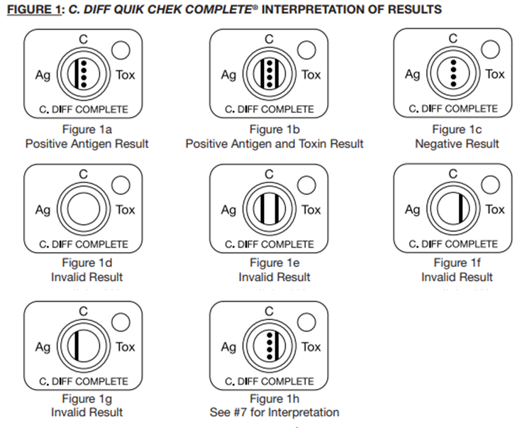

**1a.) Positive Antigen (“Ag”), Negative Toxin (“Tox”):** A positive antigen result may be interpreted at any time between the addition of Substrate and the 10-minute read time. For a positive antigen result, the blue “Ag” line and the dotted blue control line below “C” are visible (Figure 1a). The lines may appear faint to dark in intensity. An obvious partial line is interpreted as a positive result. Do not interpret membrane discoloration as a positive result. A positive “Ag” result indicates the presence of C. difficile but may not indicate the presence of an active infection. No test line is visible on the “Tox” side of the Reaction Window. The test will reflex to a C. difficile real time PCR test. See below for resulting example:

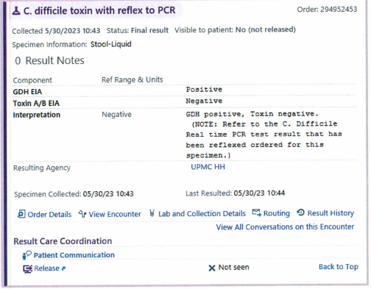

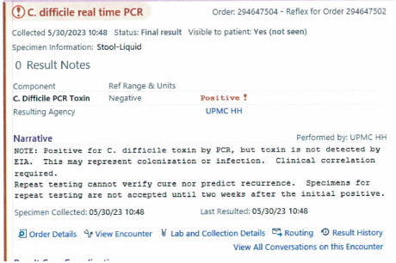 

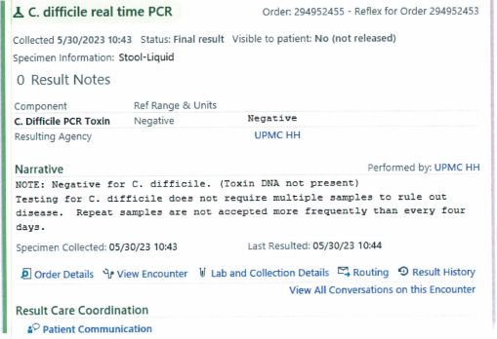

**1b.) Positive Antigen and Toxin (“Tox”) Result:** If the antigen result is positive (i.e., a blue “Ag” line and a dotted blue control below “C” are visible), proceed to the interpretation of the toxin result. A positive toxin result may be interpreted at any time between the addition of Substrate and the 10-minute read time. For a positive toxin result, a blue “Tox” line is visible (Figure 1b). The line may appear faint to dark in intensity. An obvious partial line is interpreted as a positive result. Do not interpret membrane discoloration as a positive result. A positive result indicates the presence of C. difficile toxin. See below for resulting example:

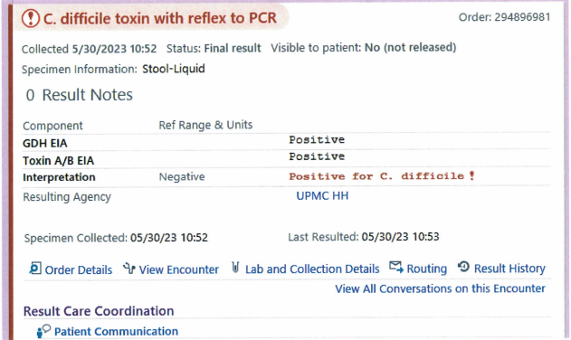

**1c.) Negative Result:** A test cannot be interpreted as negative or invalid until 10 minutes following the addition of Substrate. A single blue dotted line is visible in the middle of the Reaction Window, below the “C” and no test lines are visible on the “Ag” side or the “Tox” side of the Reaction Window, (Figure 1c). A negative result in the antigen portion indicates C. difficile antigen is either absent in the specimen or is below the detection limit of the test. A negative result in the toxin portion indicates C. difficile toxin is either absent in the specimen or is below the detection limit of the test. See below for resulting example:

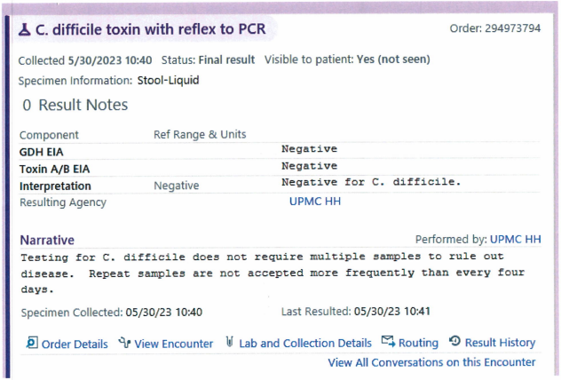

**1d,1e,1f,1g.) Invalid Result:** No lines are visible in the Reaction Window (Figure 1d). The test result is invalid if a blue dotted line is not present below the “C” at the completion of the reaction period regardless of any other lines present. Repeat test once, if repeat is still invalid request a new sample. See below for resulting example:

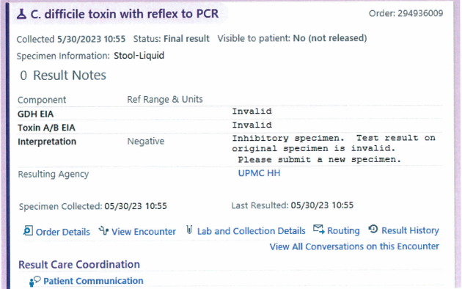

**1h.) Negative Antigen (“Ag”), Positive Toxin (“Tox”):** A low percentage of specimens may test negative for antigen but positive for toxin. These samples should be considered indeterminate and should be retested with a new specimen. (Figure 1h). Result the test as indeterminate and request another sample. See below for resulting example:

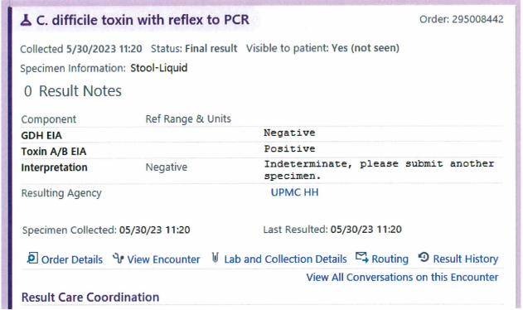

**PROCEDURAL NOTES/LIMITATIONS:**

1. The C. DIFF QUIK CHEK COMPLETE® test is used to detect C. difficile antigen and toxin(s) in fecal specimens. The test confirms the presence of toxin in feces and this information should be taken under consideration by the physician in light of the clinical history and physical examination of the patient. The C. DIFF QUIK CHEK COMPLETE® test will detect levels of toxin A at ≥0.63 ng/mL, toxin B at ≥0.16 ng/mL, and glutamate dehydrogenase at ≥0.8 ng/mL.
2. Fecal specimens are extremely complex. Optimal results with the C. DIFF QUIK CHEK COMPLETE® test are obtained with specimens that are less than 24 hours old. Most undiluted specimens can be stored between 2°C and 8°C for 72 hours before significant degradation of the toxin is noted. If specimens are not assayed within this time period, they may be frozen and thawed. However, repeated freezing and thawing may result in loss in the immunoreactivity of antigen and toxins A and B.
3. Some specimens may give weak reactions. This may be due to a number of factors such as the presence of low levels of antigen and/or toxin, the presence of binding substances, or inactivating enzymes in the feces. The lines may appear faint to dark in intensity. These specimens should be reported as positive if any blue line, even a partial line is observed. An obvious partial blue line is interpreted as a positive result
4. Fecal specimens preserved in 10% Formalin, merthiolate formalin, sodium acetate formalin, or polyvinyl alcohol cannot be used.
5. The C. DIFF QUIK CHEK COMPLETE® test is qualitative. The intensity of the color should not be interpreted quantitatively.
6. Some isolates of C. sordellii may react in the C. DIFF QUIK CHEK COMPLETE® test due to the production of immunologically related toxins (1).
7. Colonization rates of up to 50% have been reported in infants. A high rate has also been reported in cystic fibrosis patients (1,3). Results may appear positive in these groups, but should be viewed in conjunction with the potential to be a colonized carrier.
8. The only non-C. difficile organism to react in the toxin portion of the C. DIFF QUIK CHEK COMPLETE® test was Clostridium sordellii VPI 9048. This strain produces toxins HT and LT, which are homologous to toxins A and B, respectively.
9. No data exists on the effects of colonic washes, barium enemas, laxatives, or bowel preparations on the performance of the C. DIFF QUIK CHEK COMPLETE® test. All of these procedures can result in extensive dilution or the presence of additives that may affect test performance.

**REFERENCES:**

1. C. DIFF QUIK CHEK COMPLETE insert. Alere Catalog No 30525C 4/2016
2. Clinical Practice Guidelines for Clostridium difficile Infection in Adults and Children: 2017 Update by the Infectious Diseases Society of America (IDSA) and Society for Healthcare Epidemiology of America (SHEA). Clin Infect Dis. 2018;XX(00):1–48