SCOPE: This procedure applies to UPMC-Hanover Laboratory

PURPOSE:
The Aeroscout MobileView Temperature system is a wireless monitoring system that will alert the user when a device being monitored is out of specification, so that the product integrity inside the unit being monitored can be maintained. In order to verify system functionality, a Daily report is sent from MVnotifications@upmc.edu @0830AM. This report is reviewed daily by lab technical staff.

REAGENTS/SUPPLIES:
- MobileView IT HAN Lab- Daily Temps report sent via email to all users on the
HAN-LABMOBILEVIEW email distribution list.

PROCEDURE: Daily Temperature Report

Step | Action
1. | From OUTLOOK - UPMC email  Open “HAN-Lab- Daily Temps” report- by preview  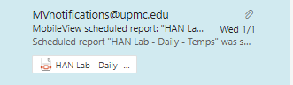
2. | Report looks like this:  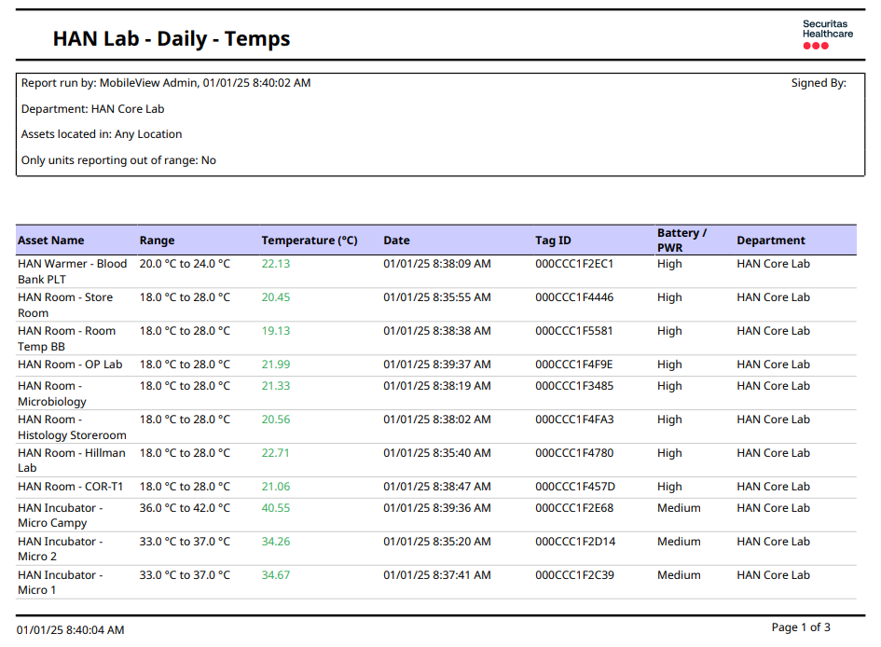  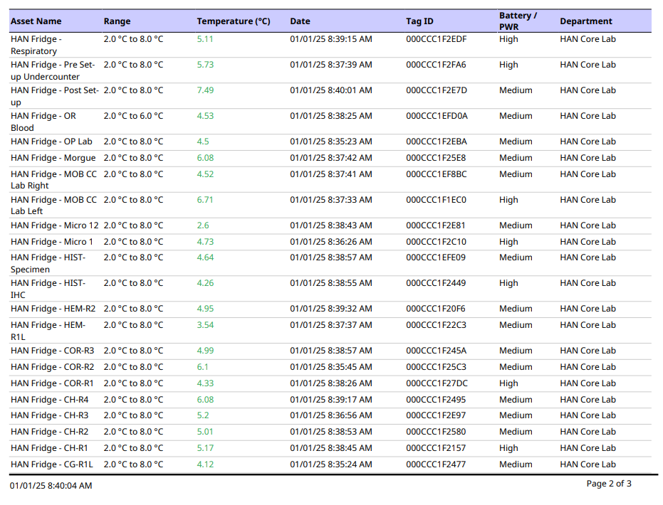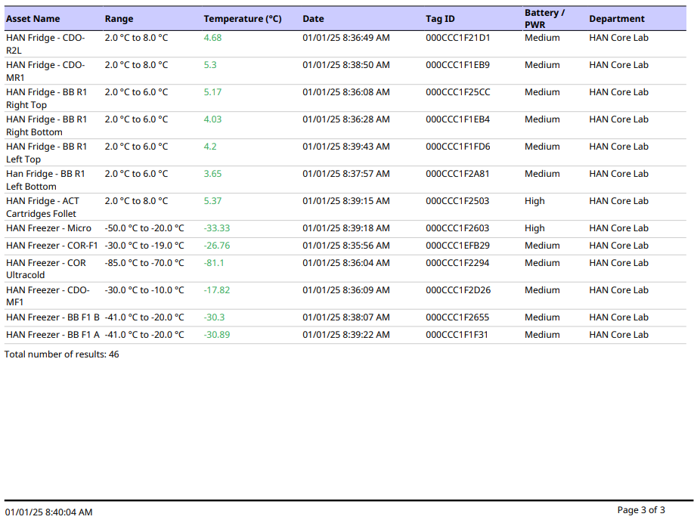
3. | Scroll through the list- verifying all of the temperature are colored green.  - If not- check to see the issue, document outliers in MobileView action alerts.  - Will not return to green until temperature returns to normal range.  - Continue to monitor unit’s temperature and process if critical range alert occurs.
4. | At bottom of list- verify the number of units reporting are the current number of units (tags) in use in the laboratory. (48 is normal – currently 46 since 2 units out of service in microbiology)  - If number does not correlate- then farther investigation is needed to see what unit is missing and why- document on Functionality Record Log.
5. | Complete form MobileView Functionality Record- located on clipboard in Urinalysis Department.  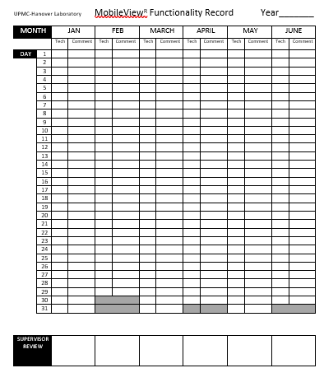

Document History
Date of Origination and Document Control Number | January 1 2025 | MobileView replaces VersaTrak electronic temperature monitory system. 10/2023  Jan 1, 2015
 |  | Prepared by: Marilee Klunk, MT(ASCP).
Revision History/ Biennial Review:
Revision History/ Biennial Review:
Revision History/ Biennial Review:
Revision History/ Biennial Review:
Revision History/ Biennial Review:
Revision History/ Biennial Review:
Revision History/ Biennial Review:

Keywords:

Mobileview Temperature

