SCOPE: This procedure applies to UPMC-Hanover Laboratory

PURPOSE:
The Aeroscout MobileView Temperature system is a wireless monitoring system that will alert the user when a device being monitored is out of specification, so that the product integrity inside the unit being monitored can be maintained. An email notification will be sent to all users. Different status alerts may require different steps by the technologist making the corrective action.

REAGENTS/SUPPLIES:
- 2x 1.5 V alkaline AA batteries-in Storeroom (Energizer)

PROCEDURE: About the Meter (Tag)

Step | Action
1 | The tag has a local alarm which will sound if the configure temperature values are out of range. The alarm can be muted by pressing the main button   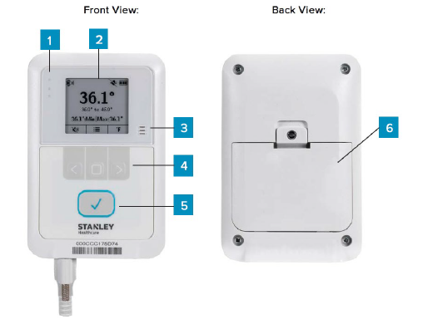  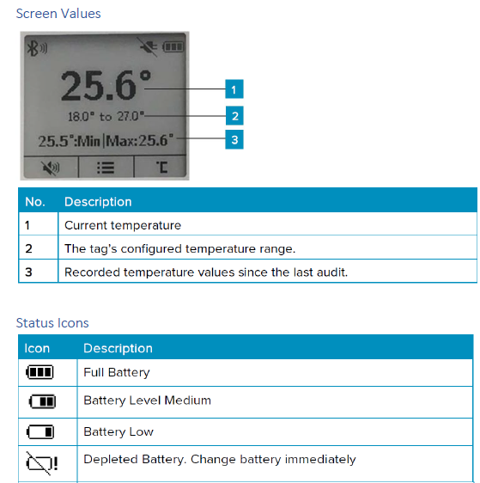
2. | Access MobileView via internet browser- the web  - Go TO MOBILEVIEW WEB access page https://mobileview.upmc.edu/.  - use your UPMC login and password    2. Select the 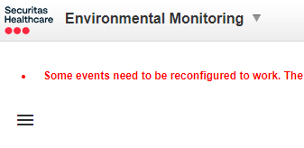  And chose the HAN Laboratory option  3 Select the  to see the alarms

Procedure: Alert –Temperature / Humidity

Step | Action
1. | TEMPERATURE ALERT: Out of specification either high or low  An email notification will be sent to all lab users:  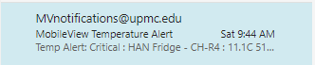  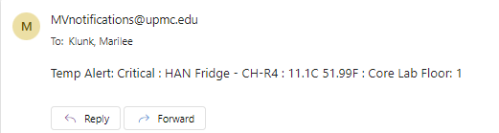
2. | A screen similar to this will appear: 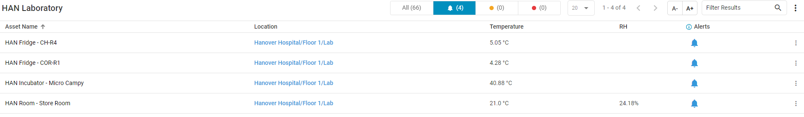  - Select the meter to document by clicking on the bell on the line with the meter’s name.
3. | A list of all alerts that have not been documented or dismissed will show  **EACH of the alerts MUST be documented and dismissed  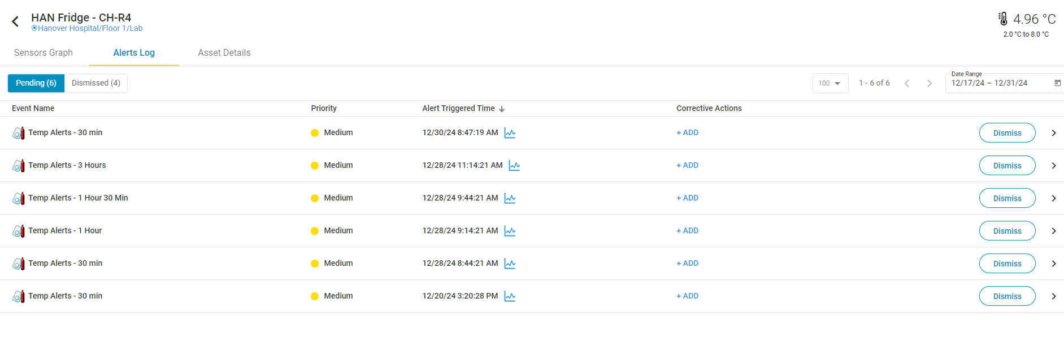
4. | Select the +ADD or the > karot by dismiss to open the Corrective action section  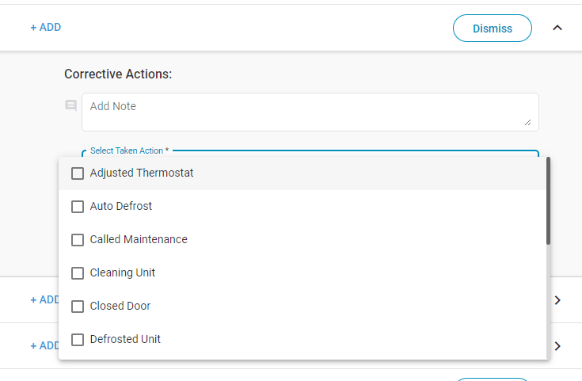
5. | 1. Scroll through drop down menu to select corrective action taken.  - Some require additional note to be added.  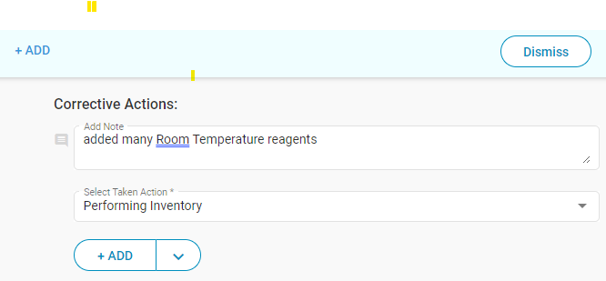  - Select Add drop down menu - select Add and dismiss.  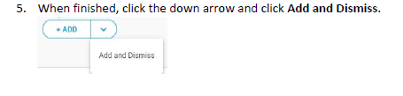  - Continue process until all alerts are cleared for that meter.  Notes:  When completed the meter “dismissed”tab should look like this:  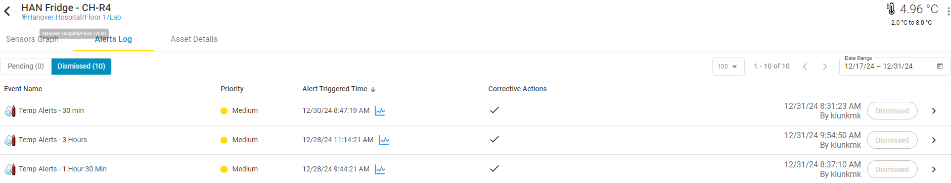  If it still has +ADD, then the corrective action was not recorded- and must be added again.- just select the +ADD to redo the action.  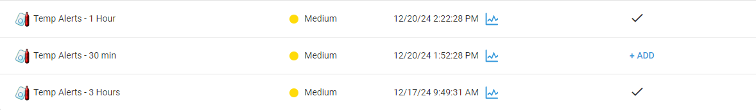

PROCEDURE: Battery Alert

Step | Action
1 | LOW BATTERY ALERT:
2 | - Open battery location #6  - Replace the batteries-  - (Place date on batteries)  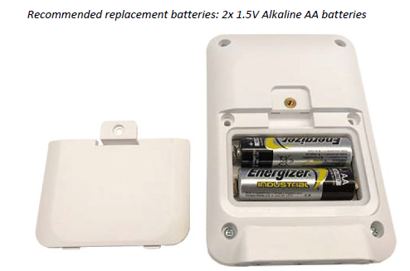  Memory is retained on meter during battery replacement

PROCEDURE: OUT of SIGHT

Step | Action
1 | OUT OF SIGHT:  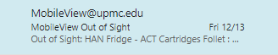  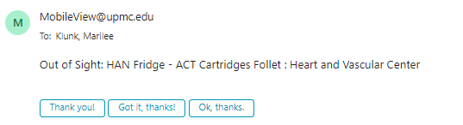
2 | This alarm signifies the loss of the network signal. It is responded to by UPMC- Mobileview IT .
3 | Once the signal has been re-established- all of the meters will have to have a documented reason and dismal added to the alert. (follow the procedure for the Temperature error as listed above.)
4 | During network connectivity failures, data is stored on the meter. Once connectivity is restored, data is automatically synchronized with MobileView within 24 hrs or can be manually synced from the meter.

PROCEDURE: Fail Safe Alert

Step | Action
1 | A Failsafe Alert Delay is the total length of time out of range before this equipment is a critical issue and product needs to be moved or the issue resolved quickly.  Note: The Failsafe Alert will be sent even if an alarm is acknowledged as long as the device is still out of range.  - IF the failsafe alert alarms. Note what has been done previously.  - Note where the product has been moved. Disable the monitor to prevent continuous alarms by placing a ticket with IT MobileViewSupport.  - Notify supervisor of changes.  - Notify laboratory of changes in communication book.
2. | The Email notification looks similar to the first Temp outlier: Watch for the word “Critical” in the notification.  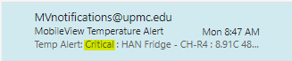  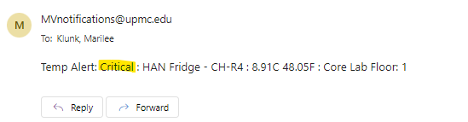  - Temperature MUST return to normal range before Critical Alert can be returned to normal.  - Documentation – dismiss all alerts to document what has been done to clear the alert.

References:
WWW.SecuritasHealthcare.com

Document History
Date of Origination and Document Control Number | January 1 2025 | MobileView replaces VersaTrak electronic temperature system on October, 2023
 |  | Prepared by: Marilee Klunk, MT(ASCP).
Revision History/ Biennial Review:
Revision History/ Biennial Review:
Revision History/ Biennial Review:
Revision History/ Biennial Review:
Revision History/ Biennial Review:
Revision History/ Biennial Review:
Revision History/ Biennial Review:

Keywords:

MobileView Temperature, Alarms, Alerts

