UPMC Hanover Laboratory MobileView^{R} TIP SHEET
How do I find the location of a temperature asset meter?
- Open MobileView: https://mobileview.upmc.edu
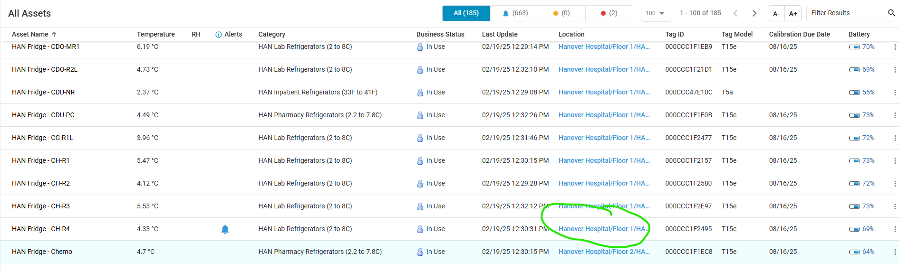
- Click on blue hyperlink under location- circled in green above
- Map of asset location in the hospital- will show with location indicated by arrow (below in pink),
to give approximate location of asset meter. (based off of WiFi location)

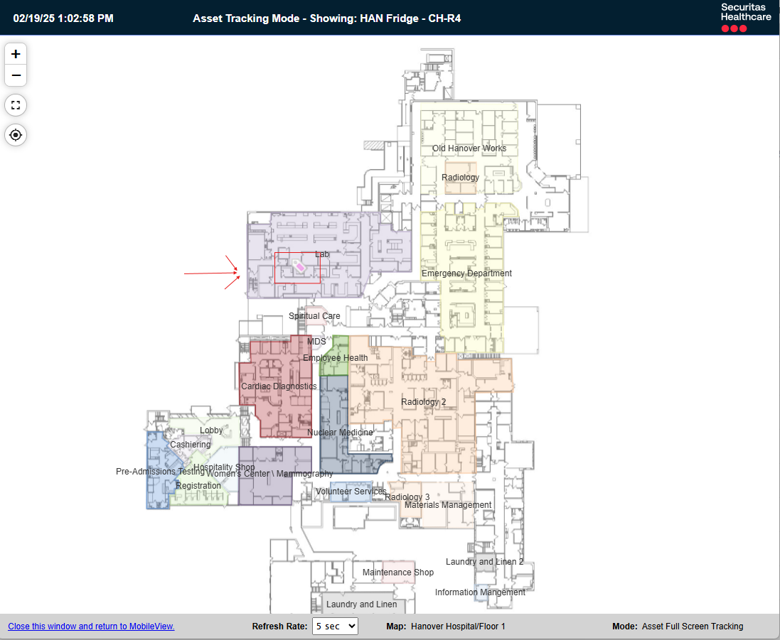

2/19/2025 mkk

