Table of Contents
I. Quality Assurance Policy: 2
A. Introduction 2
B. Purpose: 2
II. Internal Quality Assurance 2
A. Policy 2
B. Daily/Batch Indicators 2
C. Daily Control Review 2
D. Sectional Quarterly Control Review 2
III. External Quality Assurance 3
A. Policy: 3
B. Goals: 3
C. Proficiency Program(s): 4
IV. Quarterly Indicators: 4
B. QA Markers Meeting 5

Quality Assurance Policy:

Introduction

GENETWORx is committed to providing the highest possible quality of service to our clients. As such, the following Quality Assurance (QA) and Continuous Quality Improvement Plan has been established.

Purpose:

The QA program is designed to optimize performance and render accurate diagnoses through continual analysis of our practice as well as ensure continuous monitoring of patient safety. Continuous Quality Indicators are established to help achieve the goal, and are described below.

Internal Quality Assurance

Policy

GENETWORx is committed to providing the highest possible quality of service to our clients. As such, the following Internal Quality Assurance and Continuous Quality Improvement Plan has been established.

Daily/Batch Indicators

For each assay, internal quality control indicators will be included with each batch of assays.

For Qualitative tests, a minimum of one positive control and one negative control will be assessed

For Quantitative tests, positive controls (at a minimum of two concentrations within the reference range) and a negative control will be assessed.

Daily Control Review

Quality control indicators must be reviewed by trained personnel and assessed as consistent with previous known results (ie positive or negative) before sample results can be signed out.

Qualitative Quality Control results are captured daily on the control review sheet for the assay. Unacceptable results are subject to investigation and a QC deviation report. (Quality Manual Attachment 10 QC Deviation Report).

Quantitative Controls are charted and monitored using Westgard Rules of QA Monitoring

Sectional Quarterly Control Review

QC deviation reports are compiled and reported on a quarterly basis on the QA Markers Datasheet for the section

External Quality Assurance

Policy:

GENETWORx is committed to providing the highest possible quality of service to our clients. As such, the following External Quality Assurance and Continuous Quality Improvement Plan has been established for the Molecular Department.

The cycle of External Quality Control is demonstrated in Figure 1. Unlike Internal Quality Control, which uses known controls with immediate results, external quality control is performed using unknown specimens with results obtained later. Testing is performed periodically; the frequency of testing depending on the discipline. Finally, both accuracy and imprecision are assessed in the external program.
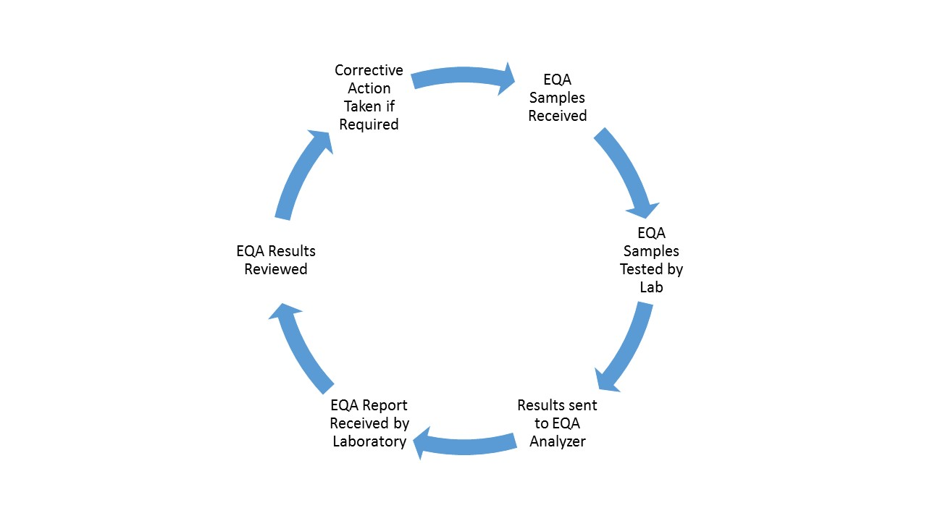
Figure 1. External Quality Assurance Cycle. External Quality Assurance (EQA) Samples are received in the laboratory. The Samples are tested by the laboratory and the results are sent to an EQA analyzer. The EQA analyzer sends the report back to the laboratory and the results are reviewed by the Laboratory managers and the Lab Director. The results and any corrective actions that taken are then reviewed by management at quarterly Quality Assurance meetings.

Goals:
The Goals of the External Quality program are to:

Provide a measure for individual laboratory quality

To supplement internal quality control procedures

Provide a measure of the “state of the art” for a test

To obtain consensus values when true values are unknown

To investigate factors in performance (methods, staff etc)

To act as an educational stimulus to improvement

Proficiency Program(s):

GENETWORx participates in the External Quality Assessment Program through the College of American pathologists (CAP) proficiency program. Additional proficiency programs as required by states (such as Pennsylvania or New York) may be required for certain disciplines.

The specifics of the GENETWORx proficiency testing program are outlined in SOP 603.013.

Quarterly Indicators:
On a quarterly basis, each section Lab Supervisor will report on the appropriate monitors/indicators using the following table format. Thresholds will be determined, and are subject to change, by the QA Committee in conjunction with the Laboratory Director.
The Markers are separated into three analytic phases

Pre-analytical variables refer to any and all procedures that occur during sample collection, prior to sample analysis. This involves patient identification, physical sample collection, sample transportation to the testing site and sample preparation. These may include the following; however not all variables are applicable to all tests:

Total Vials received

Improper collection material

Grossly leaking specimens

One Patient Identifier

Missing Test Request

Incorrect Test Ordered

Incomplete Requisition (ie no signature)

Improper Shipment of sample rendering samples insufficient

Incorrect Registration

Hemolyzed Specimen

Analytical Variables occur during actual testing of the specimen.

Molecular total vials (cases) by test type, e.g.,

Positive rates for Molecular Analytes are captured and compared with historical rates.

Test rate (% of total cases):

Test Insufficiency Rate:

Insufficient cases (# of insufficient cases/total number of cases)

Repeated cases (# of repeated cases/total number of cases)

Discrepancies/Incidents (reported as % of total cases.)

Incident reports

QC Deviation Reports

Post-Analytical Variables occur following sample testing. These may include

Erroneous validation of analytical data, failure in reporting/addressing the report, excessive turn-around-time, improper data entry and manual transcription error, failure/delay in reporting critical values.

Amendments/Addendums

May be due to Pre-analytical or Analytical variable that was not detected prior to sample sign out.

Turn Around Time. Monitor the average TAT for all tests

QA Markers Meeting

On a quarterly basis, the QA markers from all departments are reviewed with Senior Laboratory Managers and Supervisors and the Chief Executive Officer to review the performance of the QA markers, Proficiency testing, and any corrective actions pertaining to the markers.
Revision History
Revision Number | Reason for Revision | Author | Effective Date
0 | Change company name and SOP number, reformat Quality System, Add CEO signature Line, clarification of Internal and External Quality Assurance programs. | Sarah Jacobs-Helber | Upon Lab Director Signature

Review & Approval History
Printed Name | Signature | Date
Sarah Jacobs-Helber, PhD HCLD(ABB), Laboratory Director
William Miller, HTL, MBA Chief Executive Officer

Reviewed by:
Printed Name | Signature | Date

