**CASE STUDY 4**

**Initial Data:**

BP, a 49-year-old female, arrived at the emergency department of her local hospital. Her chief complaint was fatigue that had worsened since she had left the hospital 2 weeks ago following treatment for anemia of unknown origin. During this hospitalization, she had received 2 units of Red Blood Cells Leukocytes Reduced (LR_RBCs). There were no unexpected serologic findings during the pretransfusion testing.

**ABO and RH Typing:**

|  |  |  |  |  |
| --- | --- | --- | --- | --- |
| **Forward (Cell) Typing** | | | **Reverse (Serum) Typing** | |
| **Anti-A** | **Anti-B** | **Anti-D** | **A1 Cells** | **B Cells** |
| **0** | **0** | **4+** | **4+** | **4+** |

1. **How would you interpret BP’s ABO type?**
   1. Group O.
   2. Group A.
   3. Group B.
   4. Group AB.
2. **What is BP’s Rh type?**
   1. D+.
   2. D-.
   3. Weak D+.
   4. Cannot determine with the data provided.

**Antibody Detection Test (Screening) Test 1 [Polyethylene Glycol (PEG) Indirect Antiglobulin Test (IAT)]**

|  |  |  |  |  |  |  |  |  |  |  |  |  |  |  |  |  |  |  |  |  |  |  |
| --- | --- | --- | --- | --- | --- | --- | --- | --- | --- | --- | --- | --- | --- | --- | --- | --- | --- | --- | --- | --- | --- | --- |
|  | **RH** | | | | | | **MNS** | | | | **P** | **Lewis** | | **Kell** | | **Duffy** | | **Kidd** | | **PEG** | | |
|  | **D** | **C** | **E** | **c** | **e** | **f** | M | N | S | s | **P1** | Lea | Leb | K | k | Fya | Fyb | Jka | Jkb | **IS** | **37C** | **IAT** |
| **1** | + | + | 0 | 0 | + | 0 | + | + | + | + | 0 | + | 0 | 0 | + | 0 | + | 0 | + | **0** | **NH** | **0√** |
| **2** | + | 0 | + | + | 0 | 0 | + | 0 | + | 0 | + | 0 | + | 0 | + | + | + | + | 0 | **0** | **NH** | **2+** |
| **3** | 0 | 0 | 0 | + | + | + | 0 | + | 0 | + | + | 0 | + | + | + | + | 0 | 0 | + | **0** | **NH** | **2+** |

1. **What can be concluded from the results of the initial antibody detection test?**
   1. A single-specificity alloantibody.
   2. Multiple alloantibodies.
   3. One or more warm-reactive autoantibodies.
   4. Insufficient data to form a hypothesis.

An antibody identification panel was tested at the same phases as the antibody detection test. An autocontrol (patient cells) was included in the testing.

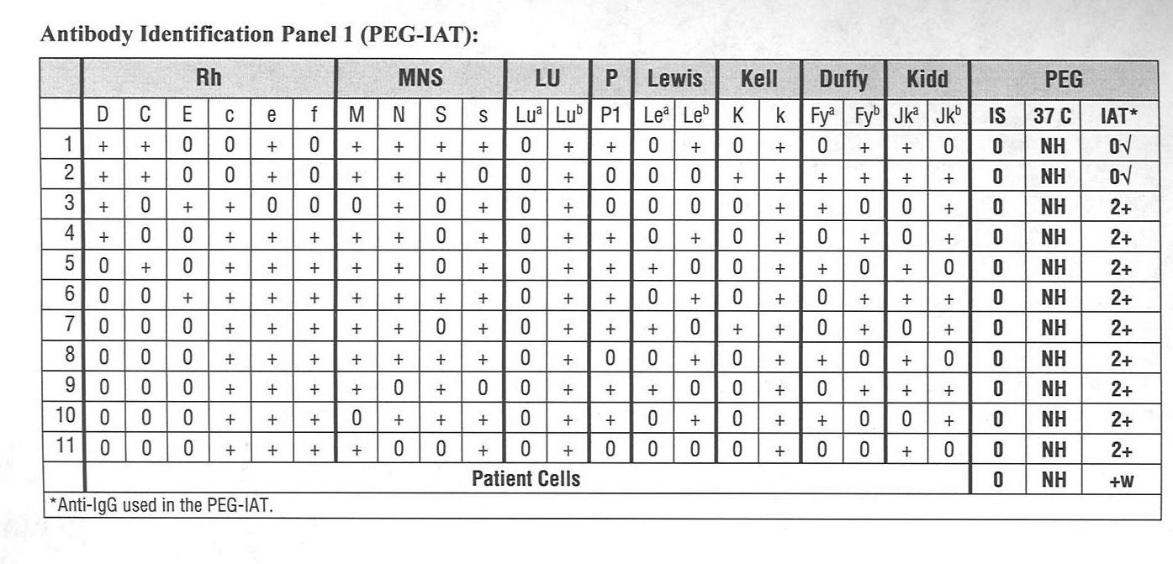

**Laboratory Protocol:**

The following antibodies can be initially ruled out **ONLY** if the patient’s serum is **NOT** reactive with the panel cells that have a double dose of the antigen: **anti-C, -c,-E, -e, -M, -N, -S, -s, -Fya, -Fyb, -Jka, and -Jkb.**

Other antibodies listed on the antigen matrix can be initially ruled out if the patient’s serum is **NOT** reactive with the panel cells that are positive for the corresponding antigen. Keep in mind that weakly reactive antibodies may not be reactive with all antigen-positive cells.

If any of the following antibodies are **NOT** ruled out using the initial screen and panel results, additional cells must be tested to provide data for rule-out decisions: **anti-D, -C, -c, -E, -e, -M, -N, -S, -s, -Lea, -Leb, -K, -k, -Fya, -Fyb, -Jka, -Jkb, and -P1.**

1. **Which of the following is MOST consistent with the results of Antibody Identification Panel 1?**
   1. A single-specificity alloantibody.
   2. Multiple alloantibodies.
   3. One or more warm-reactive autoantibodies.
   4. A cold agglutinin.
2. **Given the results of Antibody Detection Test 1 and Antibody Identification Panel 1, which of the following antibodies CANNOT be ruled out?**
   1. Anti-c.
   2. Anti-E.
   3. Anti-Fya.
   4. All of the above.
3. **Which of the following tests would be the BEST to perform next?**
   1. Patient phenotyping.
   2. Crossmatch.
   3. Selected cell panel.
   4. Enzyme panel.

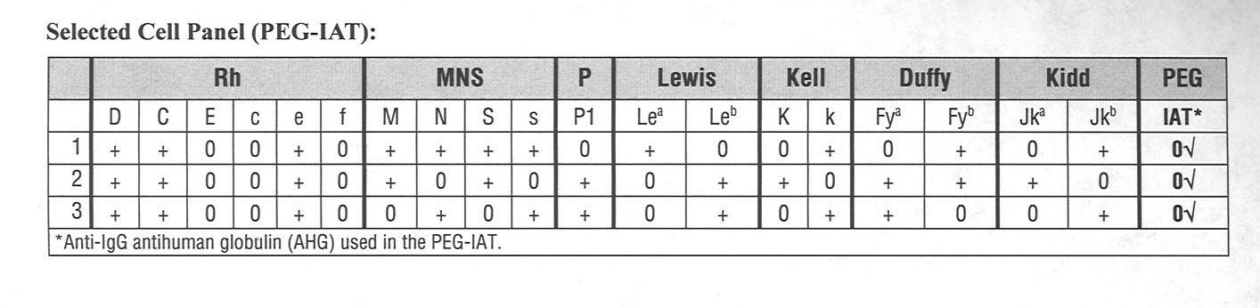

1. **Given the results of Antibody Detection Test 1, Antibody Identification Panel 1, and the Selected Cell Panel, which of the following is the MOST LIKELY alloantibody solution?**
   1. Anti-c only.
   2. Anti-c but cannot rule out anti-E.
   3. Anti-c and anti-Fya.
   4. None of the above.
2. **Given the serologic data generated thus far, which of the following tests would be the BEST next step?**
   1. Crossmatch.
   2. Direct antiglobulin test.
   3. Enzyme panel.
   4. No additional testing is necessary.

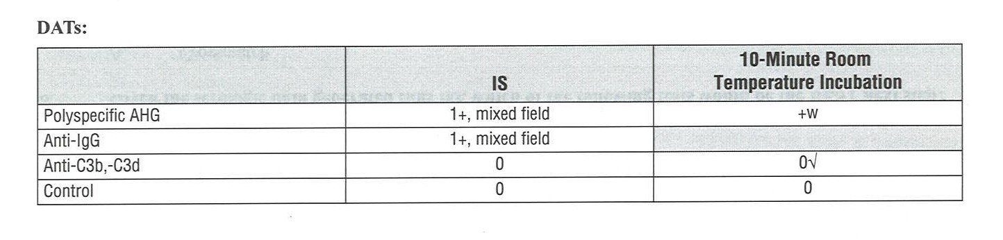

1. **What can be concluded from the results of the DAT profile?**
   1. The cells are coated with IgG.
   2. The cells are coated with complement.
   3. Both of the above.
   4. None of the above.
2. **What is the MOST LIKELY explanation for the mixed-field reactions in the direct antiglobulin testing?**
   1. The AHG was contaminated.
   2. Inadequate cell washing.
   3. The patient has a mixed cell population (transfused and autologous cells).
   4. Technical error.

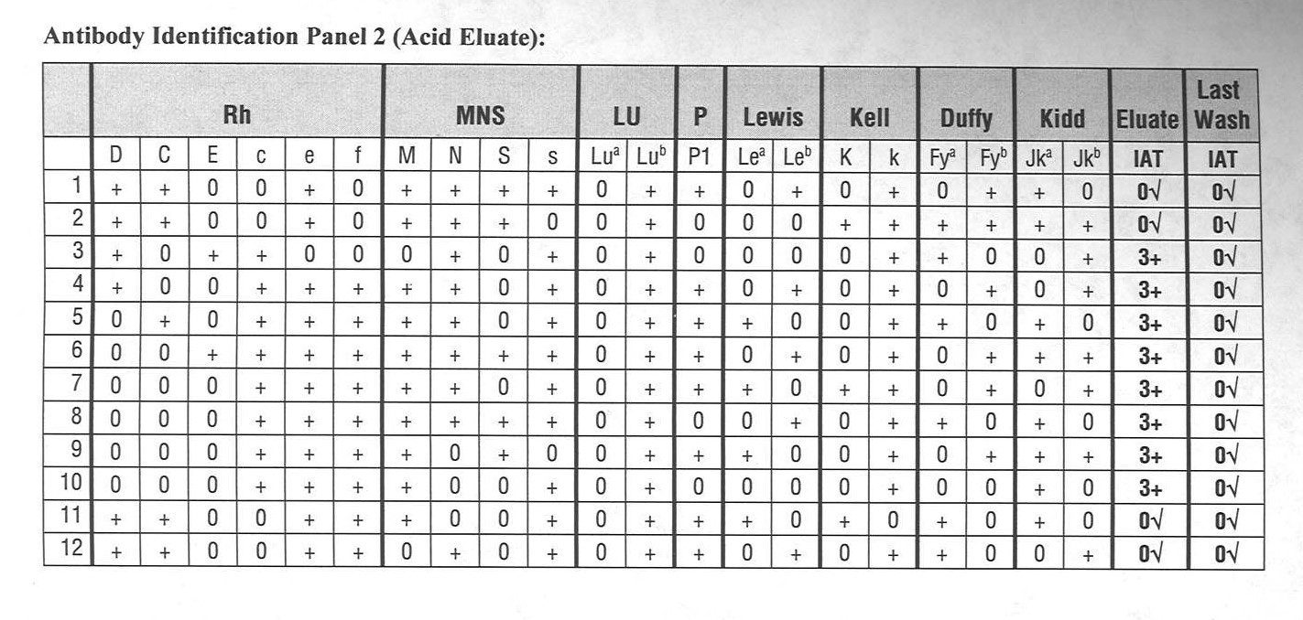

1. **What additional testing could provide data to support the transfusion reaction hypothesis?**
   1. Chloroquine diphosphate treatment.
   2. Elution studies.
   3. Red cell phenotyping.
   4. None of the above.
2. **What can be concluded from the results of the eluate panel?**
   1. Anti-c was bound to the red cells.
   2. Anti-E has been ruled out.
   3. There is no evidence to support a transfusion reaction hypothesis.
   4. Both anti-c and anti-E are bound to the red cells.

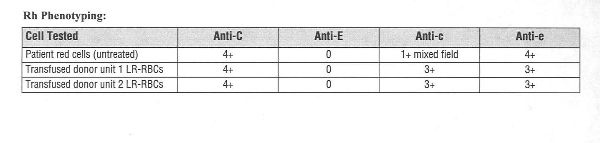

1. **What can be concluded from the phenotyping results?**
   1. The patient is likely c-negative.
   2. The transfusion reaction hypothesis is supported by these data.
   3. Anti-c is implicated in the positive DAT result.
   4. All of the above.
2. **Which of the following laboratory tests would support the clinical diagnosis of a delayed hemolytic transfusion reaction?**
   1. Comparison of pretransfusion DAT and posttransfusion DAT results.
   2. Haptoglobin.
   3. Bilirubin.
   4. All of the above.

**Case Note:**

A question that would potentially arise from this case would be whether there was an error in the pretransfusion testing. Although it is possible that there was a technical error, it is likely that the delayed reaction was not due to error. It may be that the anti-c was from a previous transfusion but no longer detectable when the pretransfusion testing was performed. Another possible scenario would be that the anti-c was a primary immune response. Repeating the pretransfusion testing (antibody detection and crossmatch) would be warranted.

Employee Name: ____________________________

Competency Score: __________________________

Date: ______________________________________