1. **PRINCIPLE**

The ability of certain bacteria to produce β-lactamases, enzymes that inactivate β-lactam antibiotics, has long been recognized as clinically significant. These organisms are resistant to β-lactam antibiotics, such as penicillin and cephalosporins, therefore alternate antibiotic therapy is required.

The BD BBL Cefinase disc test has been developed as a rapid qualitative test for the detection of β-lactamase production in aerobic and anaerobic bacteria. The Cefinase disc is impregnated with a chromogenic cephalosporin, nitrocefin. The nitrocefin compound exhibits a rapid color change from yellow to red as the amine bond in the β-lactam ring is hydrolyzed by a β-lactamase. When a bacterium produces this enzyme in significant quantities, the yellow-colored disc turns red in the area where the isolate is smeared. Both aerobic and anaerobic β-lactamase-producing bacteria produce this color change. Organisms that are β-lactamase negative do not alter the pale yellow color of nitrocefin within the time limits of the test. The Cefinase disc test is used for the predictive development of resistance in isolated colonies of *Neisseria gonorrhoeae*, *Staphylococcus* species, *Haemophilus influenzae*, enterococci and anaerobic bacteria.

1. **SPECIMEN COLLECTION, TRANSPORT, AND HANDLING**
   1. This procedure is not to be used directly with clinical specimens or other sources containing mixed microbial flora. The bacteria to be tested must first be isolated as separate colonies by streaking the specimen onto appropriate culture media.
2. **MATERIALS**
   1. **Supplies**
      1. Cefinase disc impregnated with nitrocefin
      2. Sterile disc dispenser
      3. Precleaned glass slides
      4. Distilled water
      5. Transfer pipette
      6. Sterile inoculation loop or applicator stick
      7. Isolated colonies to be tested
3. **STORAGE AND STABILITY**
   1. Unopened cefinase cartridges are stable until the labeled expiration date if stored at -20 to 8°C.
   2. Opened cefinase cartridges are stable for 60 days if stored at -20 to 8°C in a glass, air tight container containing a desiccant.
4. **QUALITY CONTROL**
   1. The Quality control should be tested in the same manner as patient samples. Refer to Section VI for the procedure steps.
   2. **Control reference cultures should be run with each new lot and each new shipment of cefinase cartridges.** See the table below for expected results:

|  |  |
| --- | --- |
| **Test Strain** | **Expected Results** |
| Staphylococcus aureus ATCC 29213 | Positive |
| Haemophilus influenzae ATCC 10211 | Negative |

1. **PROCEDURE**
   1. Let the cefinase discs warm up to room temperature prior to use.
   2. Using a single disc dispenser, dispense one disc from the cartridge onto a microscope slide.
   3. Moisten the disc with one drop of distilled water.
   4. Using a sterile loop or applicator stick, remove several well-isolate colonies and smear them onto the disc surface.
   5. Examine the reaction area for appearance of a color change in 5 to 60 minutes.
2. I**NTERPRETATION**
   * + 1. A positive reaction will show a yellow to red color change in the area where the culture was applied. Positive reactions may take up to 60 minutes to develop for some Staphylococci sp.
       2. A negative reaction will show no color change on the disc.
       3. Expected results:

|  |  |  |
| --- | --- | --- |
| **Organism** | **Result** | **Approx. Reaction Time** |
| ***Staphylococcus aureus*** | Positive | 1 hour |
| ***Haemophilus influenzae*** | Positive | 1 min |
| ***Neisseria gonorrhoeae*** | Positive | 1 min |
| **Anaerobic bacteria** | Positive | 30 min |

1. **REPORTING RESULTS**
   1. **Resulting in Epic Beaker**
      1. Select result entry and enter the specimen number.
         1. Verify patient information matches patient information of the organism being tested.
      2. Click on “Edit”
      3. Select the “Workup” tab
      4. Click on the “Component” tab
      5. Type in “B-L”. Press Enter. The B-Lactamase (Cefinase) test will autopopulate.

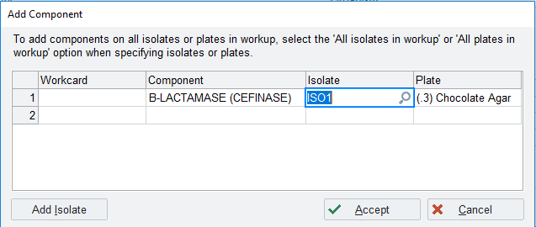

* + 1. Fill out the information corresponding to the appropriate isolate number and plate. Click Accept.
    2. Enter a result of positive or negative under the correct date testing was performed.

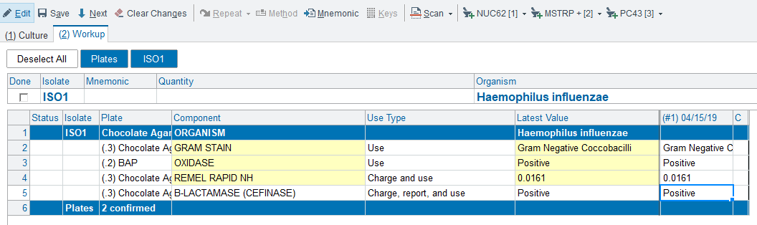

* + 1. Prelim or final verify results as appropriate. The B-Lactamase (cefinase) result will automatically report under the organism.

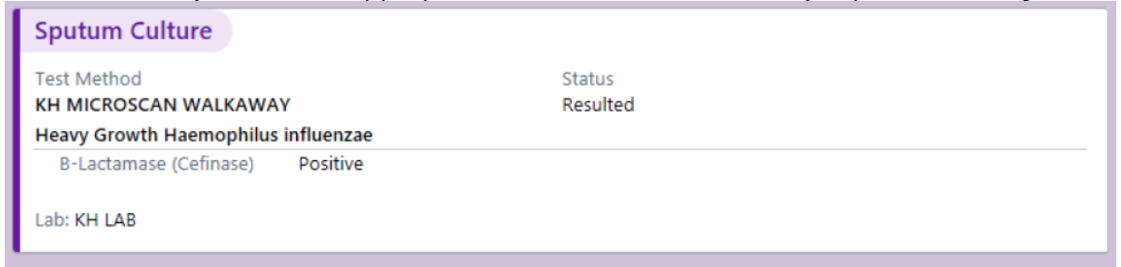

1. **CRITICAL DETERMINANTS** 
   1. Colonies selected for testing must be pure.
   2. Do not oversaturate the disc with water.
   3. The efficacy of this test in predicting the β-lactamase activity of microorganisms other than *Neisseria gonorrhoeae, Staphylococcus species, Haemophilus influenzae, Moraxella catarralis*, enterococci and certain anaerobic bacteria is unproven.
   4. Resistance to β-lactam antibiotics has been on rare occasions reported in some of the above organisms without the production of β-lactamases. In these cases, resistance mechanisms such as permeability barriers have been postulated. Therefore, the β-lactamase test should be used as a rapid supplement and not a replacement for conventional susceptibility testing. For some strains of staphylococci, particularly S. epidermidis, an inducible β-lactamase has been described that might result in a false-negative β-lactamase reaction with a strain which is resistant to penicillin or ampicillin.
   5. Unusual results should be brought to the attention of the Microbiology Supervisor and/or Medical Director.
2. **REFERENCES**
   1. BD BBL Paper Discs for the Detection of β-lactamase Enzymes: Cefinase Disc. Product Insert