New versions and major revisions must be approved and staff must be notified or trained (as applicable) prior to effective date.
Name Of Manual/Dept or location | Serology
Supersedes
Reason For New Version | New procedure for new analyzer and new test
Written by/date | Jana Wedrall, MT 11/06/2020
Approved by/date (Med Dir) | Nancy Smith, MD 11/19/2020
Revised by/date:
Reason for revision:
Approved by/date (Lab Med Dir) |  | Effective date:
Revised by/date:
Reason for revision:
Approved by/date (Lab Med Dir) |  | Effective date:
Revised by/date:
Reason for revision:
Approved by/date (Lab Med Dir) |  | Effective date:
Revised by/date:
Reason for revision:
Approved by/date (Lab Med Dir) |  | Effective date:
Reviewed by/date:
Reviewed by/date:
Reviewed by/date:
Reviewed by/date:
Reviewed by/date:
Retired by/date:
Reason for removal:
Removed to:
Distributed to :

RELATED DOCUMENTS

DOCUMENT NUMBER | DOCUMENT NAME
SER.2075.F1 | Abbott ID Now COVID-19 Verification Form
SER.2075.F2 | Abbott ID Now COVID-19 External Quality Control Form
SER.2075.F3 | Abbott ID Now COVID-19 Patient Record
SER.2075.F4 | Abbott ID Now Daily Cleaning Log

PURPOSE
This procedure is intended to provide instructional guidance for performance of the COVID-19 molecular assay on the
Abbott ID NOW platform.
SCOPE
This procedure applies to all medical technologists working in the laboratory and Northern Louisiana Medical Center.

PRINCIPLE
ID NOW™ COVID-19 is an automated assay that utilizes isothermal nucleic acid amplification technology for the qualitative detection of SARS-CoV-2 viral nucleic acids. It is comprised of a Sample Receiver, containing elution/lysis buffer, a Test Base, comprising two sealed reaction tubes, each containing a lyophilized pellet, a Transfer Cartridge for transfer of the eluted sample to the Test Base, and the ID NOW™ Instrument.
The reaction tubes in the Test Base contain the reagents required for amplification of SARS-CoV-2, as well as an internal control. The templates (similar to primers) designed to target SARS-CoV-2 RNA amplify a unique region of the RdRp segment. Fluorescently-labeled molecular beacons are used to specifically identify each of the amplified RNA targets.
To perform the assay, the Sample Receiver and Test Base are inserted into the ID NOW™ Instrument. The sample is added to the Sample Receiver and transferred via the Transfer Cartridge to the Test Base, initiating target amplification. Heating, mixing and detection are provided by the instrument.

SPECIMEN
Use freshly collected nasopharyngeal specimens for optimal test performance. Inadequate specimen collection or
improper sample handling may yield erroneous results. Follow Standard Precautions when handling clinical
specimens, all of which may contain potentially infectious materials. Standard Precautions include hand hygiene
and the use of personal protective equipment (PPE), such as laboratory coats or gowns, gloves, and eye
protection.

Collection of Nasopharyngeal Swab
Use sterile rayon, foam, polyester or flocked flexible-shaft NP swabs to collect a nasopharyngeal sample. To collect a nasopharyngeal swab sample, carefully insert the swab into the nostril exhibiting the most visible drainage, or the nostril that is most congested if drainage is not visible. Pass the swab directly backwards without tipping the swab head up or down. The nasal passage runs parallel to the floor, not parallel to the bridge of the nose. Using gentle rotation, insert the swab into the anterior nare parallel to the palate advancing the swab into the nasopharynx, leave in place for a few seconds, and then slowly rotate the swab as it is being withdrawn. To ensure proper collection, the swab should be passed a distance that is halfway of that from the nose to the tip of the ear. This is about half the length of the swab. DO NOT USE FORCE while inserting the swab. The swab should travel smoothly with minimal resistance; if resistance is encountered, withdraw the swab a little bit without taking it out of the nostril. Then elevate the back of the swab and move it forward into the nasopharynx.
Transport of Specimen
For best performance, nasopharyngeal swabs should be tested as soon as possible after collection. If
immediate testing is not possible, and to maintain best performance, it is highly recommended the
nasopharyngeal swab is placed in a clean, unused tube labeled with patient information, and capped tightly at
room temperature (15-30°C) for up to one (1) hour prior to testing. Ensure the swab fits securely within the tube
and the cap is tightly closed.
SUPPLIES
Test Bases
Sample Receivers
Transfer Cartridges
Patient Swabs
Positive and Negative Control Swabs
ID NOW Instrument

QUALITY CONTROL
ID NOW™ COVID-19 has built-in procedural controls. The result of the Procedural Control is displayed on the screen and is automatically stored in the instrument with each test result. This can be reviewed later by selecting Review Memory on the instrument.

Procedural Controls:
ID NOW™ COVID-19 contains an internal control that has been designed to control for sample inhibition and assay reagent function. In positive samples where target amplification is strong, the internal control is ignored and the target amplification serves as the ‘control’ to confirm that the clinical sample was not inhibitory and that assay reagent performance was robust. At a very low frequency, clinical samples can contain inhibitors that may generate invalid results. Procedural Control Valid displayed on the instrument screen indicates that the assay reagents maintained their functional integrity and the sample did not significantly inhibit assay performance.

External Positive and Negative Controls:
Good laboratory practice suggests the use of positive and negative controls to ensure that test reagents are working and that the test is correctly performed. ID NOW™ COVID-19 kits contain a Positive Control Swab and Sterile Swabs that can be used as a Negative Control Swab. These swabs will monitor the entire assay. Test these swabs once with each new shipment received and once for each untrained operator.

Control Swab Procedure
Positive and Negative Controls should be tested following the Run QC Test instructions on the ID NOW™ Instrument. A Positive Control Swab is included in the kit. Use a sterile swab provided in the kit as the Negative Control Swab.

For QC testing, select Run QC Test on the Home screen, and follow the displayed instructions. Refer to Running a QC Test in the ID NOW™ Instrument User Manual for further details.
1 Touch ‘Run QC Test’ | 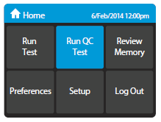
2 Touch ‘COVID-19’ | 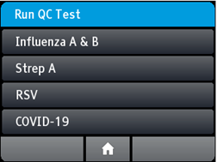
3 Select the QC Test to be Run | 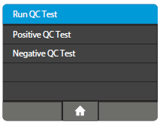
4 Confirm Test  Confirm the test type to match the QC sample intended for testing by touching ‘OK’ and following the on screen prompts to complete testing.  The user has the option to enter an ID for the QC Sample being run.  Note: The QC test is run in the same manner as a Nasopharyngeal Swab Patient Test. See the To Perform a Test section above for step by step instructions for nasopharyngeal swab samples. | 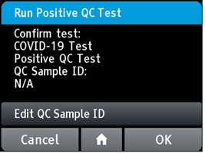

Note: The ID NOW™ Instrument reports QC results as Pass or Fail.

If the correct control results are not obtained, do not perform patient tests or report patient results. Contact Technical Support during normal business hours before testing patient specimens.

PATIENT TEST PROCEDURE
Before testing with ID NOW™ COVID-19:
• Put on a clean pair of gloves.
- Allow all samples to reach room temperature.
• Allow all test pieces to reach room temperature.
• Check that a reagent pellet is visible at the bottom of each of the reaction tubes prior to inserting the Test Base in the ID NOW™ Instrument. Do not use the Test Base if a pellet is not visible at the bottom of each reaction tube.
STEP 1
Turn on the ID NOW™ Instrument - press the power button on the side of the instrument.

Note: If the unit is unattended for one hour, the instrument will go to a black screen power save mode. Touch the screen to return the unit to active display operation.
Enter User ID  Press after entry. |  |  | 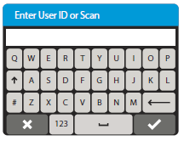
Touch ‘Run Test’  This will begin the test process. |  |  | 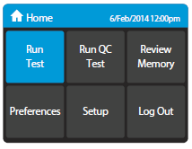
Touch ‘COVID-19 Test’  This starts a COVID-19 test. |  |  | 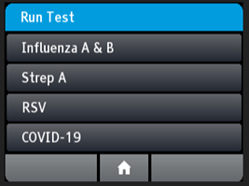
Enter Patient ID using on screen keyboard or barcode scanner.  Touch .  Verify that the ID was entered correctly, then touch to confirm entry. |  |  | 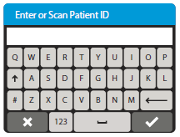
Step 2 | 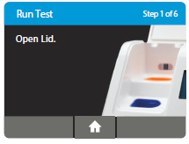 |  |  | 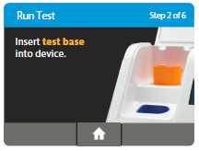
  Open the Lid and Insert Orange Test Base into Orange Test Base holder
  Caution: Do not apply excessive force. Excessive force could damage the instrument.
Confirm that the correct test is displayed on the screen.  Touch ‘OK’ to proceed. |  |  |  | 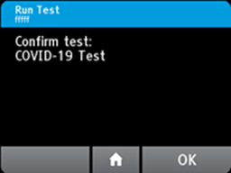
  Caution: Once the Test Base has been placed in the holder, the user will have 10 minutes to confirm the test. If the test is not confirmed within 10 minutes, the instrument will time out and the Test Base must be removed and discarded.
  If the incorrect Test Base has been inserted, remove and dispose of the incorrect Test Base. Close the lid. The instrument will then run a self-test before proceeding to the Home screen. Press Run Test and restart the test using the correct Test Base.
Insert Blue Sample Receiver into the Blue Sample Receiver holder  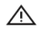Caution: Do not apply excessive force. Excessive force could damage the instrument.  Caution: Once the Sample Receiver has been placed in the holder, the user will have 10 minutes to start the test (Steps 3 through 5). If the test is not started within 10 minutes, the instrument will time out and all test pieces (Test Base and Sample Receiver) must be removed and discarded. The instrument will proceed to the Home screen. Press Run Test and restart the test using a new Test Base and Sample Receiver. |  |  |  | 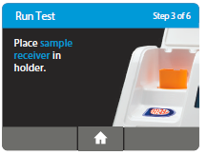
  Step 3
 |  |  |  | 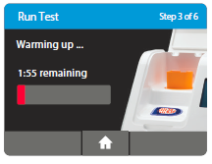
  Wait for the Sample Receiver to Warm Up. Do not remove the Sample Receiver from the instrument once the Warm Up begins.
  Caution: DO NOT REMOVE THE FOIL SEAL UNTIL PROMPTED BY THE INSTRUMENT. DO NOT close the lid or insert the sample until prompted by the instrument.
Step 4
Direct Nasopharyngeal Swab Test Procedure
 |  |  |  | 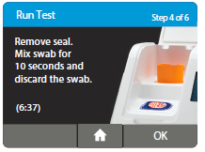
  When prompted, remove the foil seal and place the patient swab to be tested into the Sample Receiver.
 |  |  |  | 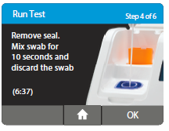
  Mix the swab in the liquid for 10 seconds. This helps remove the sample from the swab. Lift the swab out of the liquid and press the swab head against the side of the Sample Receiver to remove excess liquid. Once the swab is removed, touch ‘OK’ to proceed.
  Discard the swab into a biohazard waste container.
  Caution: To ensure that the Sample Receiver remains in the instrument while removing the foil seal, place two fingers along the outer edge of the Sample
  Receiver to hold it in place. If the Sample Receiver spills
  after warm up, cancel the test by pressing the Home button. Remove and discard the test pieces (Sample Receiver and Test Base) and clean the instrument. Press Run Test to start a new test using a new Test Base and
  Sample Receiver.
Step 5a  Press the White Transfer Cartridge into the Blue Sample Receiver  Listen for a click.  When the Transfer Cartridge is properly attached to the Sample Receiver, the orange indicator on the Transfer Cartridge will rise. If the orange indicator does not rise, continue pushing onto the Sample Receiver until it does. |  |  |  | 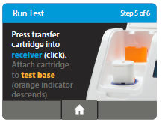
 |  |  |  | 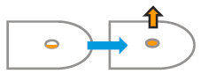
  Caution: The orange indicator should be observed closely. If the orange indicator does not fully rise, the Transfer Cartridge may not collect enough sample.
Step 5b
 |  |  |  | 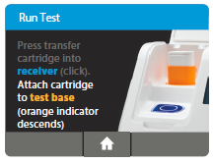
  Lift and then connect the Transfer Cartridge to the Test Base
  When the Transfer Cartridge is properly attached to the Test Base, the orange indicator on the Transfer Cartridge will descend. If the orange indicator does not descend, continue pushing onto the Test Base until it does.
 |  |  |  | 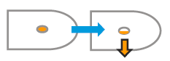
  Caution: If the orange indicator does not fully descend, not enough sample will be dispensed. This may potentially result in invalid or false test results.
Step 6
 |  | 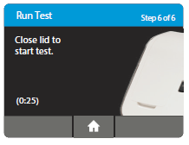 |  | 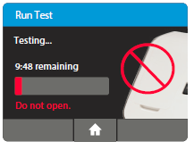
  Close the Lid.
  DO NOT OPEN THE LID until the Test Complete message appears on the screen.
  Note: The test will be cancelled if the lid is opened.
Caution: This screen will be displayed for up to 30 seconds once the Transfer Cartridge is detected. If the instrument does not detect that the lid has been closed by then, it will time out and all test pieces (Sample Receiver, Test Base, and Transfer Cartridge) must be removed and discarded. The instrument will proceed to the Home screen. Collect a new sample from the patient. Press Run Test and restart the test using a new Test Base and Sample Receiver.
Caution: DO NOT OPEN THE LID. The test will be cancelled and all test pieces (Sample Receiver, Test Base, and Transfer Cartridge) must be removed and discarded. A test result will not be reported or saved in the instrument memory.

When amplification and detection is complete, the instrument will automatically save the data before advancing to the results screen. |  |  |  | 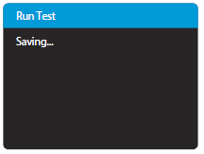
  Caution: The test is not saved until the completed result is displayed. Do not open the lid until the results are displayed.
 |  |  |  | 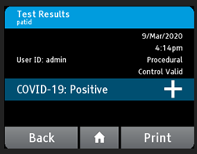
  The Test Results screen displays either a Negative or Positive result for a successfully completed test. If a test error occurs, the display will read ‘Invalid’. Refer to the Result Interpretation Section for Interpretation of Results.
  Press Print to print test results, press New Test to run another test, Press Home to return to the Home screen
 |  |  |  | 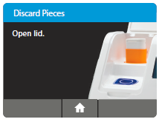
  After printing, or if New Test or Home are selected, the instrument will prompt to open the lid and discard the used test pieces.
  Remove test pieces by lifting the Transfer Cartridge attached to the Test Base, and clicking it into the Sample Receiver, by pressing into the Sample Receiver.
  Caution: Do not try to remove the Sample Receiver by any other method as there is a risk of spilling the patient sample.
 |  |  |  | 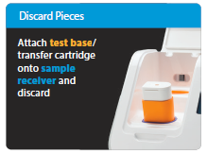
  All test pieces will be connected and can now be removed from the instrument and disposed of according to federal, state and local regulations.
  Caution: DO NOT disassemble the Transfer Cartridge and the Test Base before disposal.
 |  |  |  | 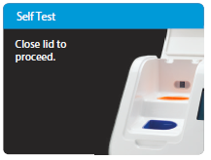
  Close the lid. The instrument will then run a Self-Test before showing the Home screen or Enter Patient ID screen, depending on the previous selection.
  Remove and dispose of gloves.

REPORTING RESULTS
When the test is complete, the results are clearly displayed on the instrument screen.

Instrument Display | Interpretation of Results and Follow-up Actions
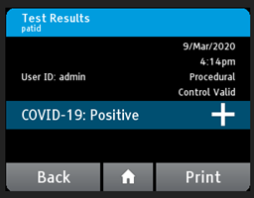 | COVID-19 Positive  Positive results do not rule out bacterial infection or co-infection with other viruses.
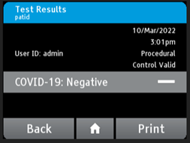 | COVID-19 Negative  Negative results should be treated as presumptive and, if inconsistent with clinical signs and symptoms or necessary for patient management, should be tested with an alternative molecular assay.  A negative result does not rule out co-infections with other pathogens.
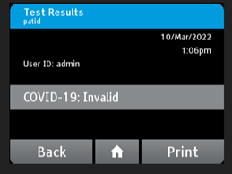 | The presence or absence of COVID-19 Viral RNAs cannot be determined.  Repeat testing of the sample using new test components. If repeated Invalid results are obtained, results should be confirmed by another method prior to reporting the results.

If an Invalid result is received, one additional test may be run using the same Sample Receiver. The instructions below should be followed:
- Remove the connected Test Base and Transfer Cartridge from the instrument and connect the Test Base portion to an open, UNUSED Sample Receiver. The connected Test Base and Transfer Cartridge MUST be attached to a Sample Receiver prior to disposal. The Sample Receiver from a new Transfer Cartridge package may be used for this.
- Remove the blue Sample Receiver separately and carefully from the instrument. The Sample Receiver should be retained and kept upright to avoid spilling the liquid contents.
- From the Home Screen, start a new test. Follow the screen prompts; however, when asked to insert the Sample Receiver, reuse the Sample Receiver and DO NOT re-elute the swab.
MAINTENANCE
The ID NOW™ is maintenance-free and has no serviceable parts. In the case of instrument failure or damage,
contact Abbott Technical Support at 800-257-9525 or ts.scr@abbott.com
The ID NOW™ can be cleaned using 70% ethanol, 70 % isopropanol, or 10% bleach solution, on a damp, lint free
cloth. 70% ethanol and isopropanol wipes are acceptable for use on the ID NOW™. Do not spray or pour solution
directly onto instrument when cleaning. Ensure no excess liquid is used when cleaning as it may damage the
instrument.
Abbott recommends that the exterior instrument surfaces and the surfaces visible under the open lid be cleaned daily.
Clean the surrounding bench area. Clean instrument and surrounding areas immediately after possible patient
sample contamination.
- Do not disassemble the instrument for cleaning
- Do not immerse in water or cleaning solutions
- Do not clean with soap or other solutions

NOTES / LIMITATIONS
For in vitro diagnostic use.
- This test has not been FDA cleared or approved; this test has been authorized by FDA under an EUA for use by laboratories certified under the Clinical Laboratory Improvement Amendments of 1988 (CLIA), 42 U.S.C. . §263a, to perform moderate complexity/high complexity tests and at the Point of Care (POC), i.e., in patient care settings operating under a CLIA Certificate of Waiver, Certificate of Compliance, or Certificate of Accreditation.
- This test has been authorized only for the detection of nucleic acid from SARS-CoV-2, not for any other viruses or pathogens.
- This test is only authorized for the duration of the declaration that circumstances exist justifying the authorization of emergency use of in vitro diagnostic tests for detection and/or diagnosis of COVID-19 under Section 564(b)(1) of the Act, 21 U.S.C. § 360bbb-3(b)(1), unless the authorization is terminated or revoked sooner.
- Leave test pieces sealed in their foil pouches until just before use.
- Do not tamper with test pieces prior to or after use.
- Do not use kit past its expiration date.
- Do not mix components from different kit lots or from other ID NOW™ assays.
- Solutions used to make the positive control swab are inactivated using standard methods. However, patient samples, controls, and test pieces should be handled as though they could transmit disease. Observe established precautions against microbial hazards during use and disposal.
- If any assay components are dropped, cracked, found to be damaged or opened when received, DO NOT USE and discard. Do not use scissors or sharp objects to open foil pouches as damage to test pieces can occur.
- Do not open the Sample Receiver before placing in the instrument. It will prohibit the Elution Buffer from reaching temperature and may impact test performance.
- If the Sample Receiver is spilled while opening, clean the instrument per instructions provided in the instrument User Manual and cancel test. Repeat test with a new Sample Receiver.
- All test pieces must be removed from the instrument according to removal instructions displayed on the instrument and disposed of according to country and local requirements. Pieces must not be separated once they are assembled.
- All test pieces are single use items. Do not use with multiple specimens.
- Once reacted, the Test Base contains large amounts of amplified target (Amplicon). Do not disassemble the Test Base and Transfer Cartridge. In the case of a positive sample, this could lead to amplicon leakage and potential ID NOW™ COVID-19 false positive test results.
- At a low frequency, clinical samples can contain inhibitors that may generate invalid results. Site to site invalid rates may vary.
- Due to the high sensitivity of the assays run on the instrument, contamination of the work area with previous positive samples may cause false positive results. Handle samples according to standard laboratory practices. Clean instruments and surrounding surfaces according to instructions provided in the cleaning section of the instrument User Manual. Refer to Section 1.6, Maintenance & Cleaning, for further information.
17. The performance of the ID NOW™ COVID-19 test was evaluated using the procedures provided in this product
insert only. Modifications to these procedures may alter the performance of the test.
18. Negative results should be treated as presumptive and tested with an alternative FDA authorized molecular
assay, if necessary for clinical management, including infection control.
19. False negative results may occur if a specimen is improperly collected, transported or handled. False negative
results may also occur if amplification inhibitors are present in the specimen or if inadequate levels of viruses are
present in the specimen. Negative results should be considered in the context of a patient’s recent exposures,
history and the presence of clinical signs and symptoms consistent with COVID-19.
20. As with any molecular test, mutations within the target regions of the Abbott ID NOW™ COVID-19 test could affect
primer and/or probe binding resulting in failure to detect the presence of the virus.
21. The test cannot rule out diseases caused by other bacterial or viral pathogens.
22. ID NOW™ COVID-19 is intended for testing a swab directly without elution in viral transport media as dilution will
result in decreased detection of low positive samples that are near the limit of detection of the test.
23. Swab samples eluted in VTM are not appropriate for use in this test.

REFERENCES
Manual of Clinical Microbiology, 11th Edition, Vol. 1, ASM. (2015) pg. 279.
Abbott ID user’s manual
Abbott ID COVID-19 package insert

