* ASAP List-

Let’s you keep appointment on the schedule, while adding the same appointment on a recall list- that will allow you to move if an earlier appointment is available.

This can be done in the patient’s appointment screen under time. (If you do not see that button it is enabled by item key- 4245) ONLY IN BROWSER

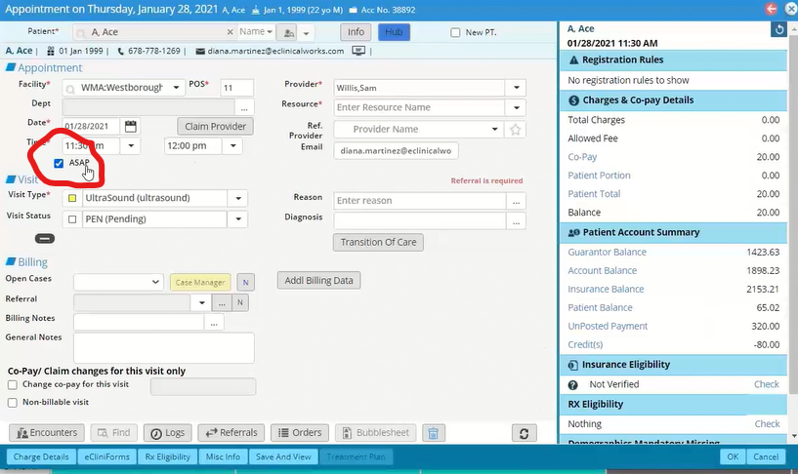

You can also Right click on the appointment. You can also remove from the ASAP this way as well-It toggles. When you remove this way it takes it off of the ASAP list, it does not move the appointment.

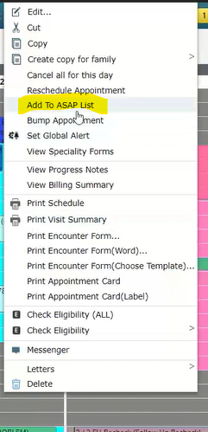

You will go to the “Bump List” and there will be a tab file named ASAP List.

It works just like the Bump List.

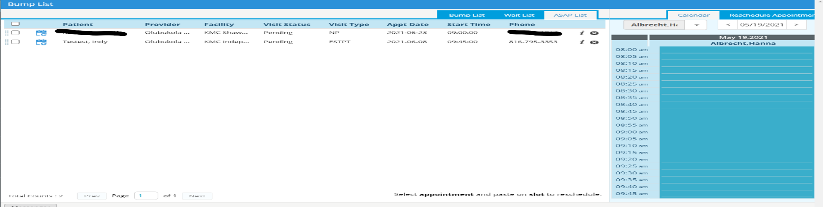

You can manually search by date and drag the appointment or you can click the reschedule icon.

It will ask you if you want to search with the visit type rule.

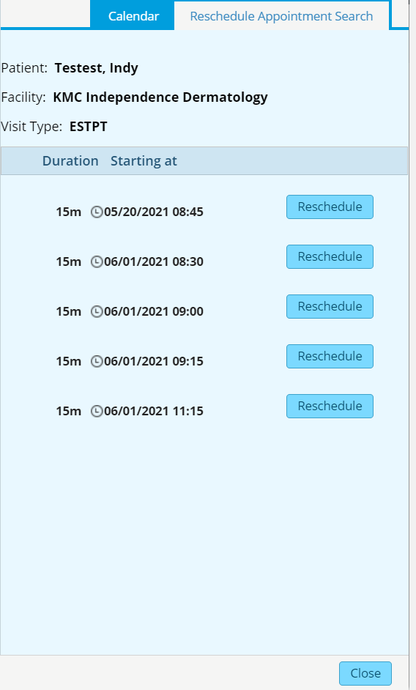

If you Click Yes and it will show you a list of availabilities with that visit type rule. If you Click No it will let you schedule for next available without visit type rules. Meaning- a different provider, NP vs Est, etc. So be careful if you click NO.

Select the date that works and Click BOOK. It will move appointment from the original appointment to the new appointment.

It will be tracked in appointment log.

