Adding BP Templates 2022
- Select Menu
- Search Templates
- Select M: Templates
- Search BP
- Star all BP templates (6 total)

- . 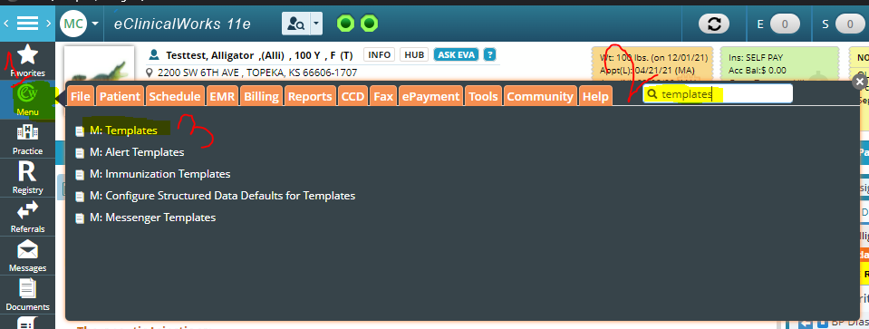
- .
- 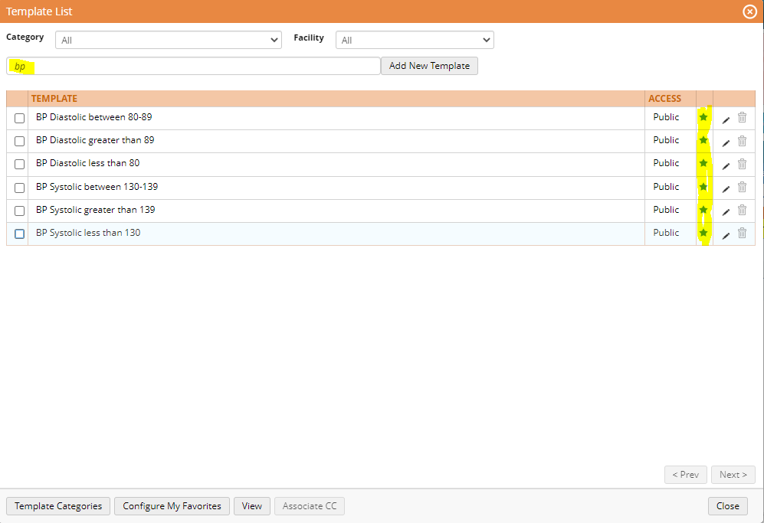
Adding template to encounter for ALL encounter (two templates per encounter)
- In encounter right panel – select templates tab
- Search BP
- Add appropriate Systolic and Diastolic templates (two templates need to be added per encounter)
- Templates will show up in the Billing Information section of encounter under Procedure Codes
- .


 
