**Posting Unposted Payments**

* Click on Billing 🡪Payments

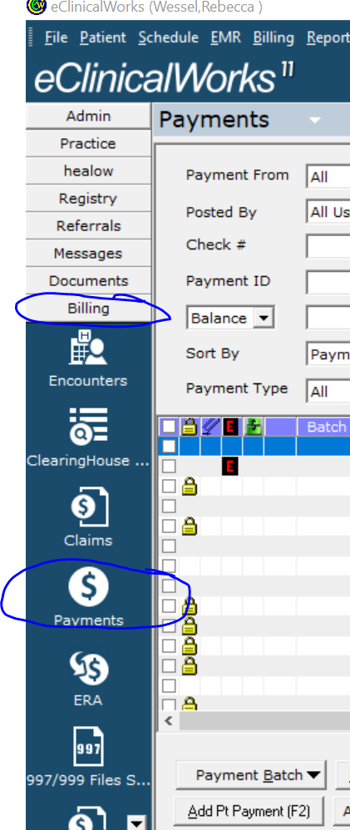

* Status = All Unposted Patient Payments (All Dates)
* Facility = Facility you are working
* Select Lookup

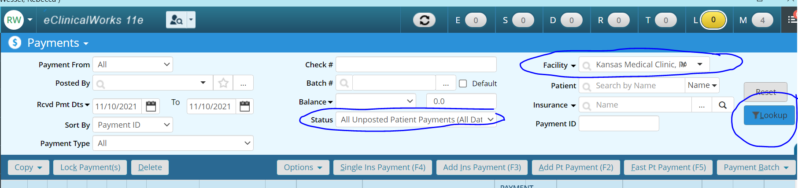

* Select payment to post
  + For GI, only work those with staff names, not FOA, _____
* Look to see if portal payment in memo
  + Billing will post portal payments,
  + Do NOT do anything with portal payments!

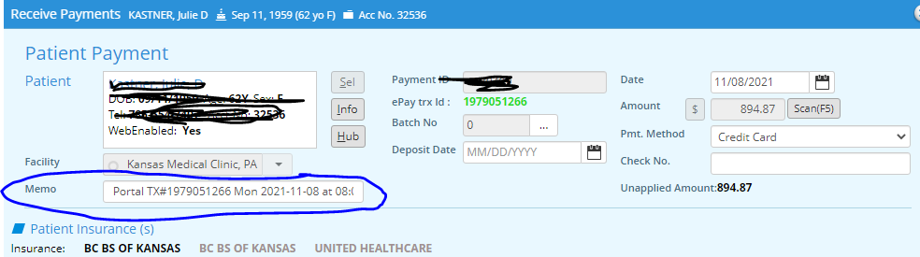

* Click on claims
  + If see claim with ID is 0, but paying for a balance on account
    - Delete the 0 ID

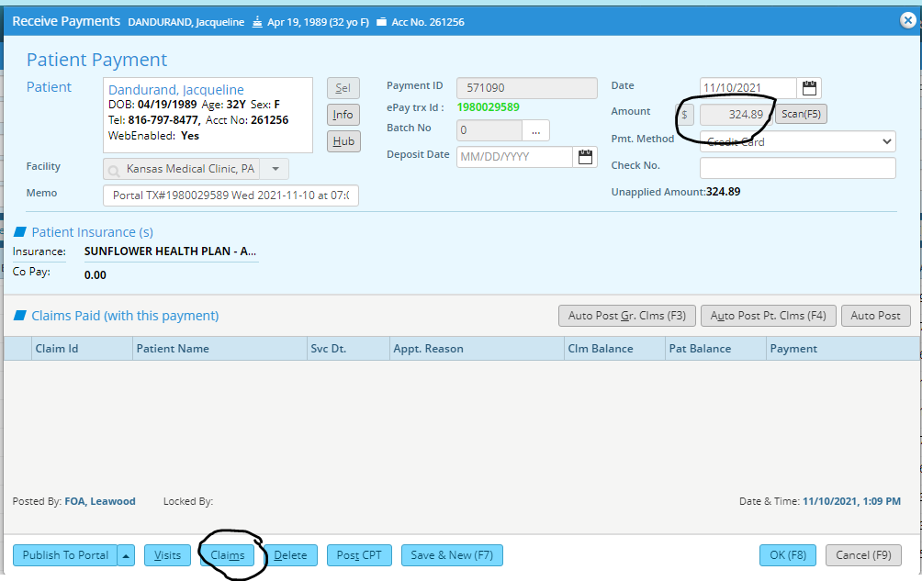

* Proceed with posting payment
  + Identify claims for amount,
  + Check mark boxes you want to apply payment
  + Click OK

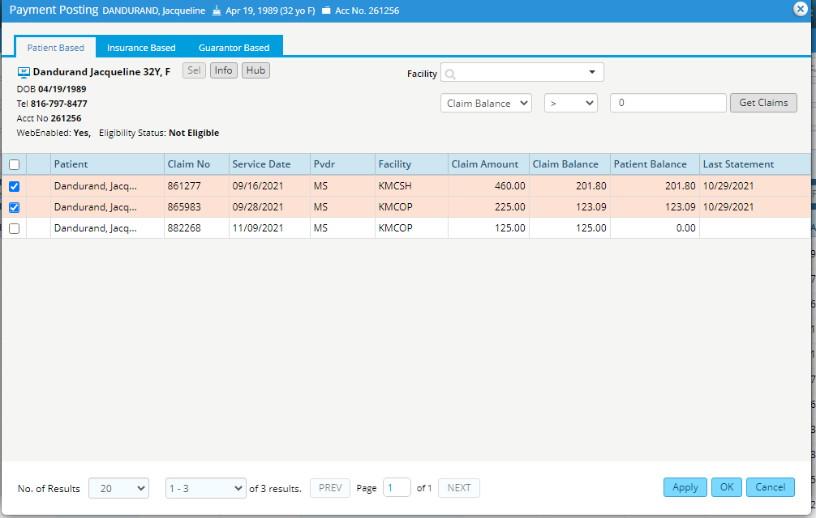

* Back to Patient payment screen
  + Type in Payment on the Claim ID
  + OK
* Screen before typing in payment amount
* 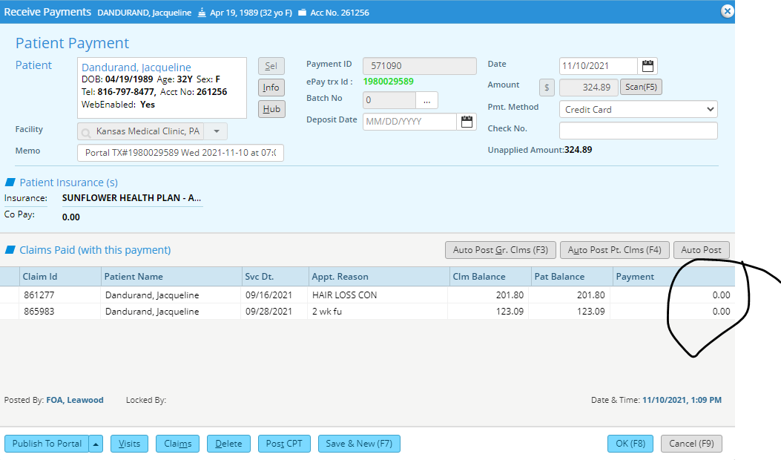
* Screen after typing in amounts

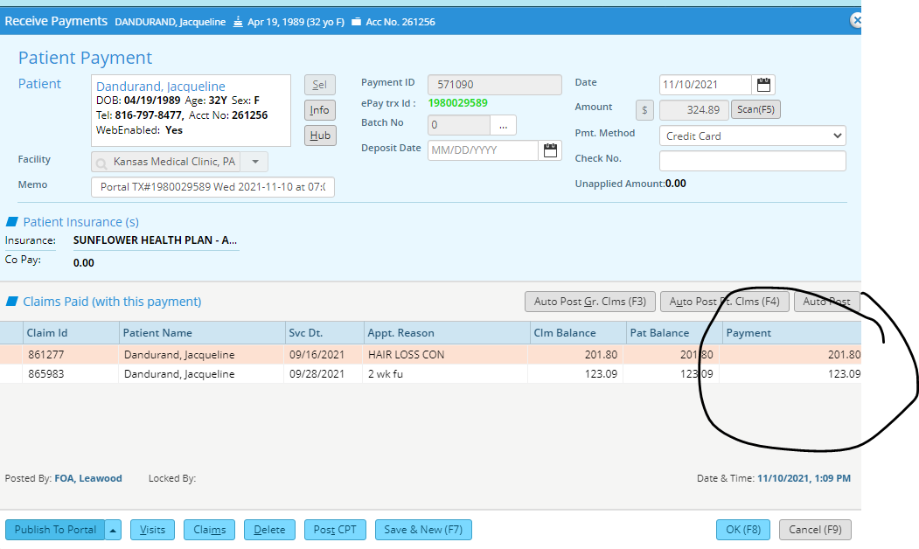

* Copayments need to be posted
* When go into claim screen, tells the last statement sent
  + Some claims they have not received a statement on