COVID WORKFLOW

A rack is brought down from accessioning.

Order NTC Elution Plate QC

Work Centers

Instruments -> Order Quality Control

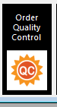 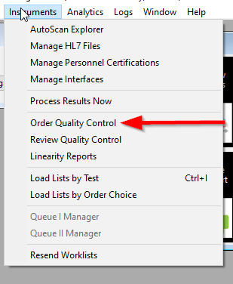

Select the proper NTC Elution and the proper Studio.

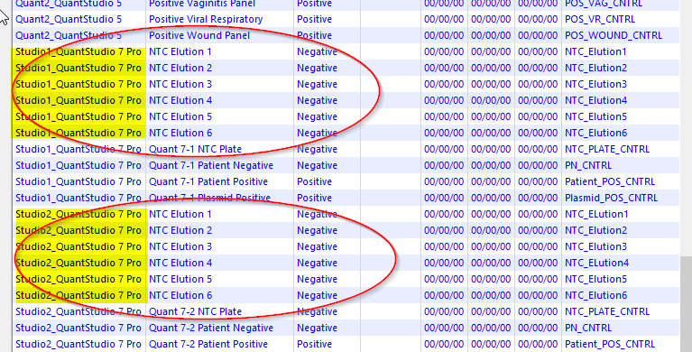

Select the proper QC and Press Select

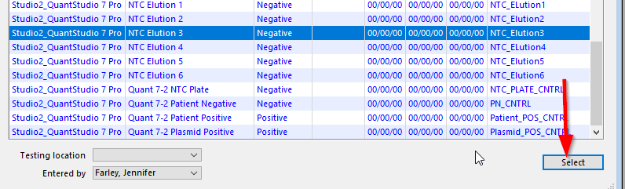

The rack is then scanned into the Load List by Order Choice

Quick Link on Work Centers

Instruments -> Load list by order choice

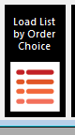 or 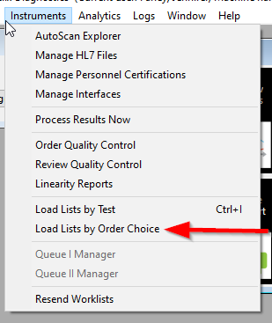

Open Load List by Order Choice

Change the Status folder to the right one, Extract-1 or Extract-2

Change the Last position to 96

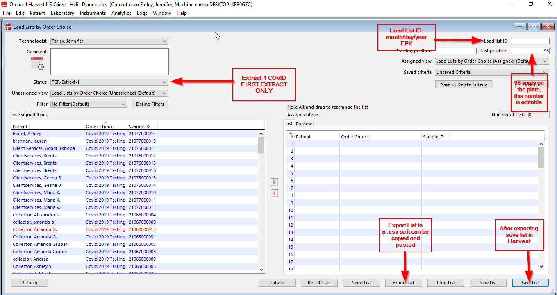

To add samples to the load list scan the barcode and press the arrow

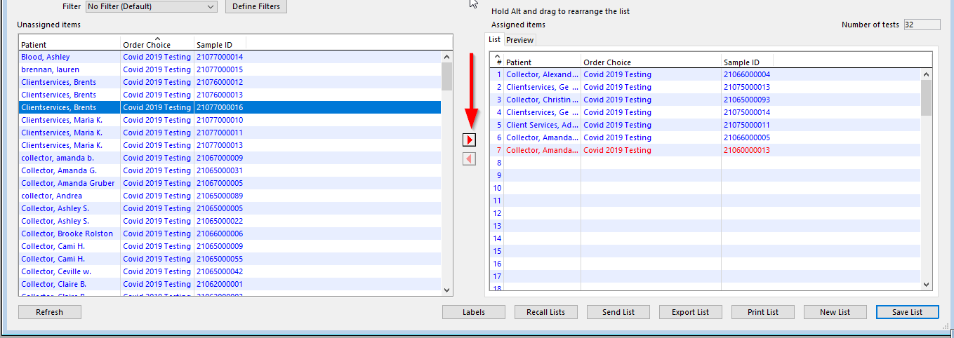

Export the list to the Z:

Save the list in Harvest

When saving entering the Load List ID will pop up

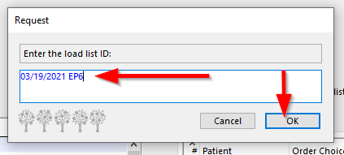

Copy and paste the sample IDs into the KingFisher BindIT Software to make the plate map.

Load wash plates and sample plate into the King Fisher

Press start on King Fisher

Transfer the sample ids into the Analysis software and make your 384 well plate map

Plate is made

Plate is loaded onto the Quant Studio

QC for PLATE is ordered Harvest

Order Quality Control

Quick Link on Work Centers

Instruments -> Load list by order choice

 or 

Select the right QC for the instrument

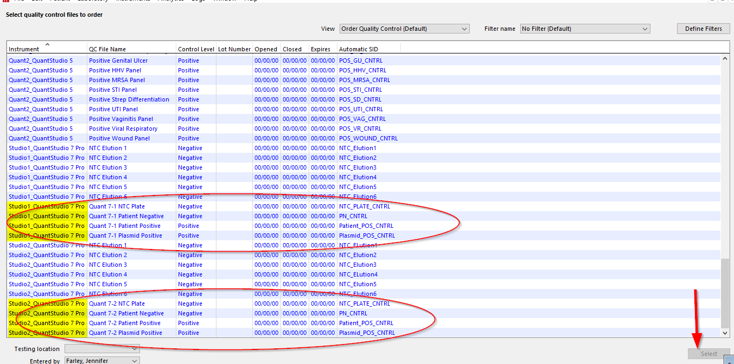

Data is then opened in the Thermo Fisher analysis software

Data is then reviewed on the Thermo Fisher analysis software

Once data is reviewed the data is then exported and saved as a .csv file

A COPY of the .CSV is dropped to the interface computer

Network -> \\HARVEST-PCR-INT

* Orchard

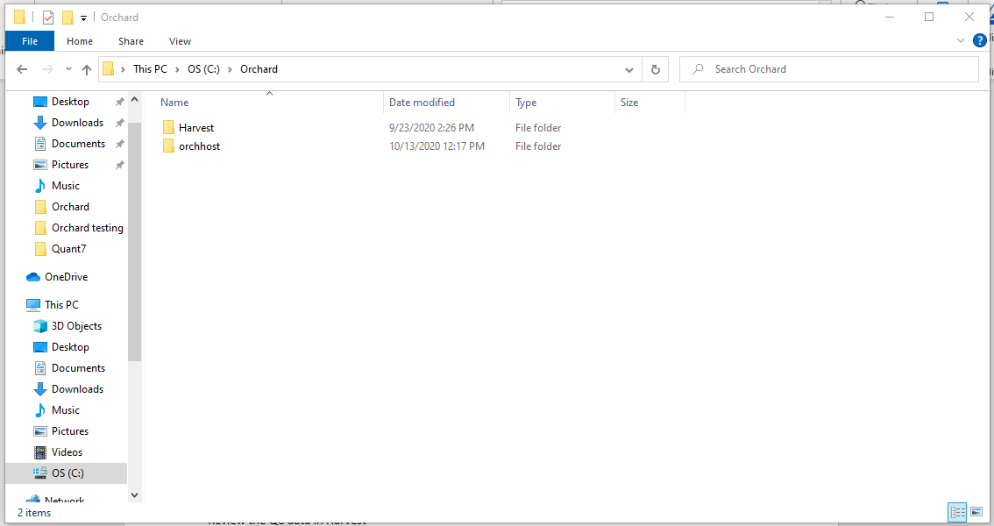

* Orchhost

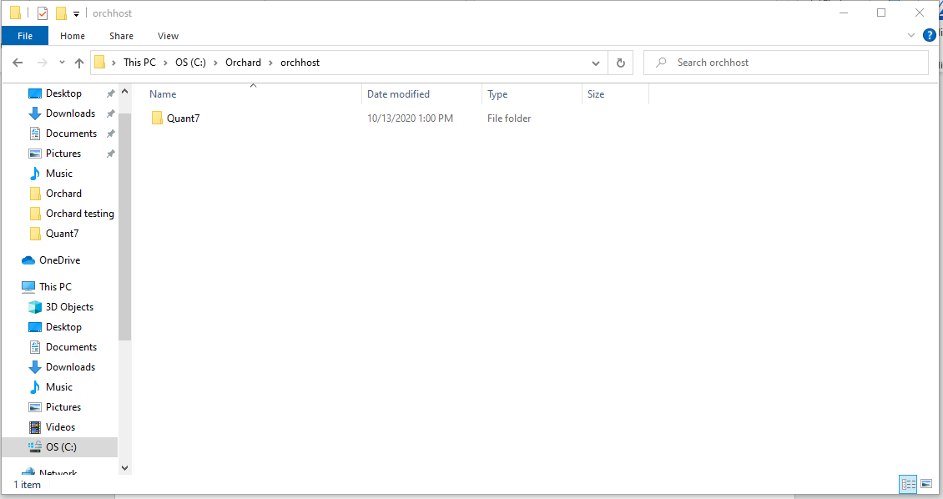

* Quant 7 or Quant 5

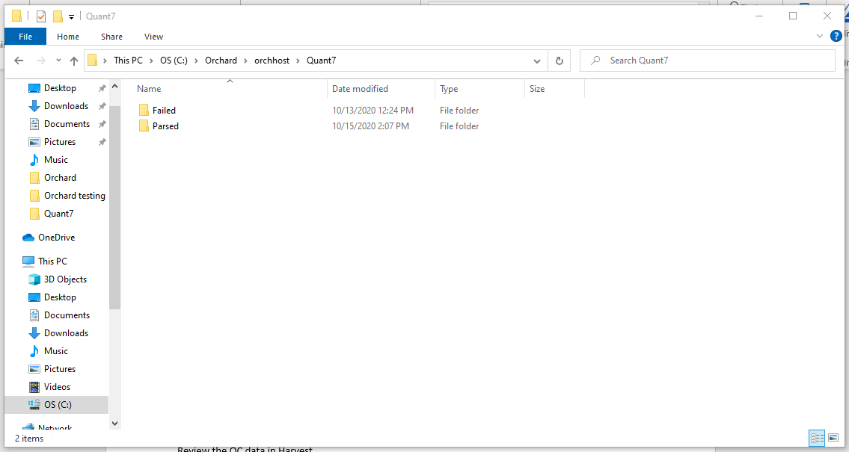

* Drop a COPY of the .csv

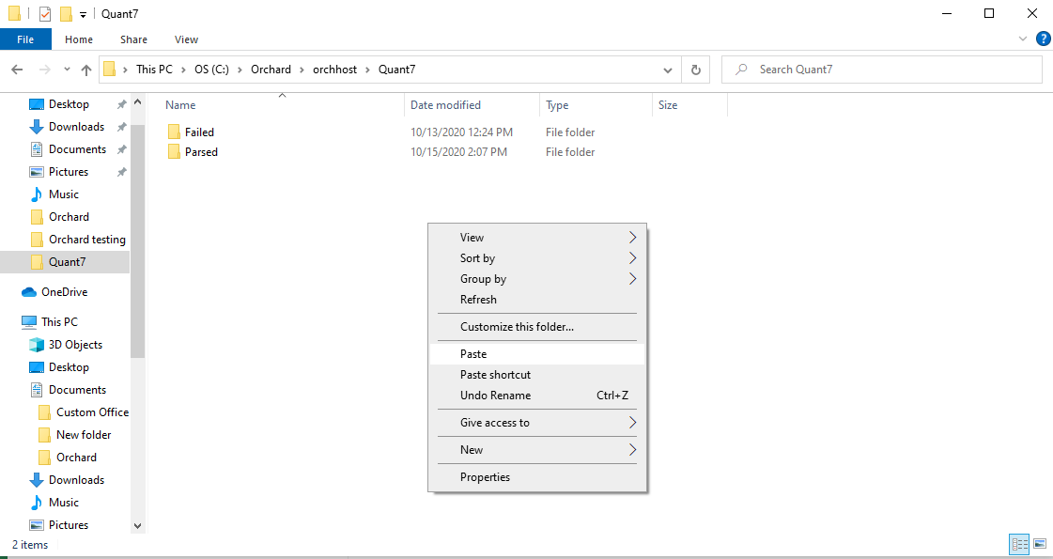

**ONCE DATA IS PARSED THE EXTRACT-1 WILL PARSE INTO THE PCR-qPCR-1 FOLDER**

Review the QC data in Harvest

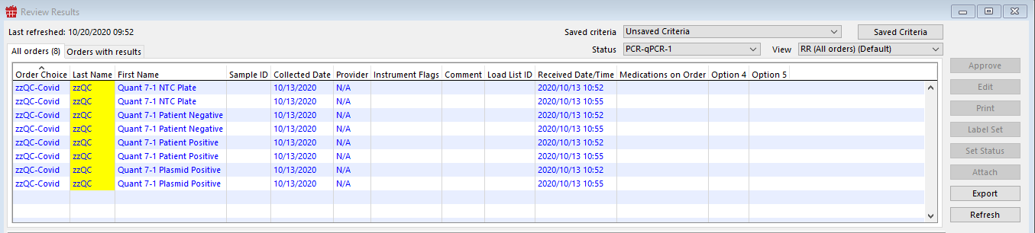

Add a Comment to the QC file

Select the QC order choice

Click Comment

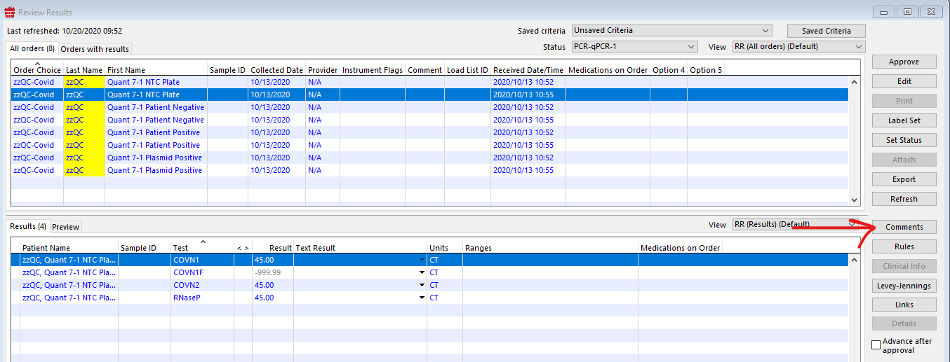

Enter Comment for plate QC. /pcrqc

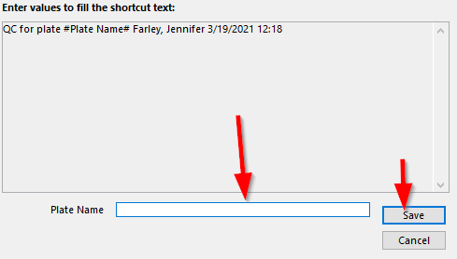

Approve the QC

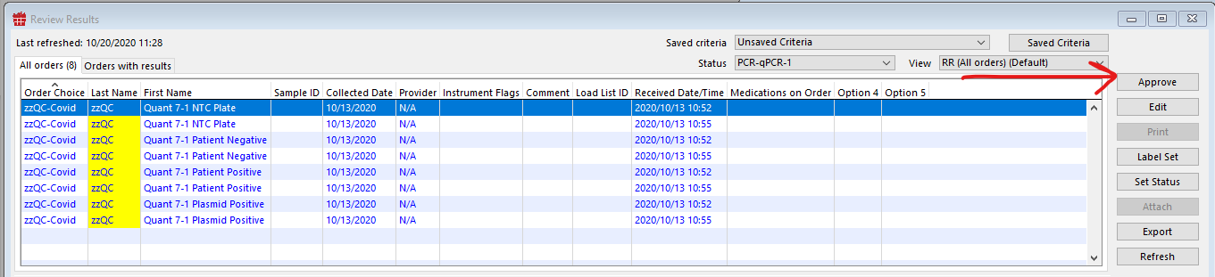

Click orders with results tab

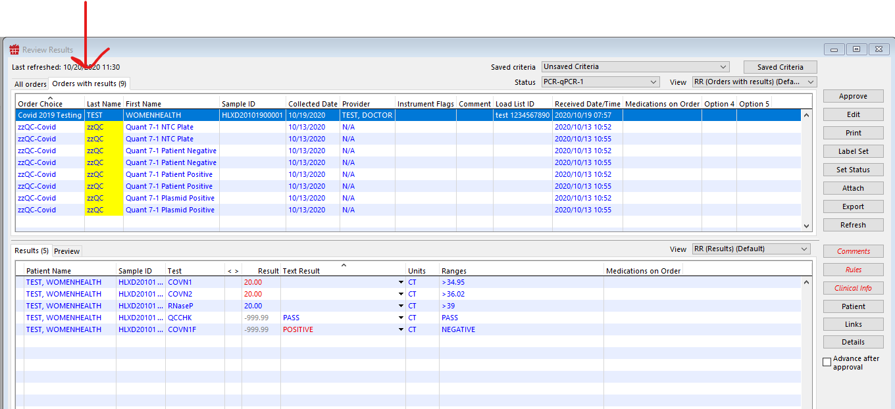

Review your HLX numbers and approve the COVID tests

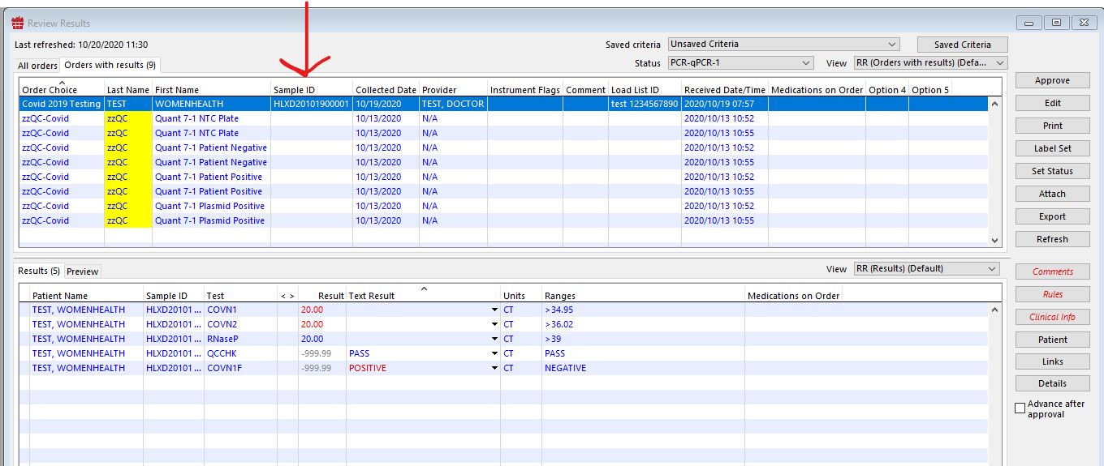

Make sure the COVN1F says positive or negative and correlates with the respective CT values

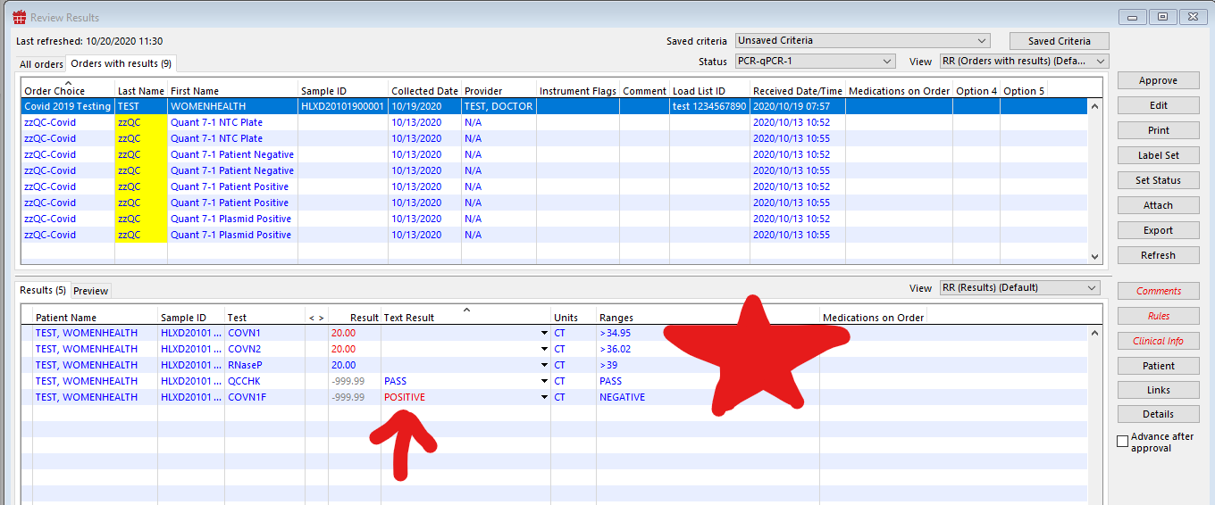

Approve the results one by one

If there are any discrepancies in the analysis or any that need management approval do the following:

Highlight the order choice and set the status to the PCR MANAGEMENT folder

