Non COVID ORCHARD

When Order Choices are released from COPIA they are put in the qPCR Extract 1 Non COVID folder

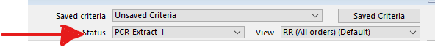

The non COVID samples are then extracted

Go to Instruments tab

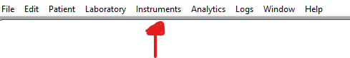

Click Load Lists by order choice

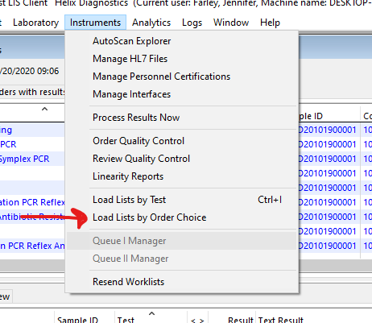

Check the status to PCR EXTRACT 1 NON COVID Status

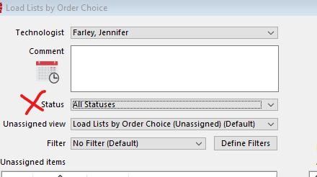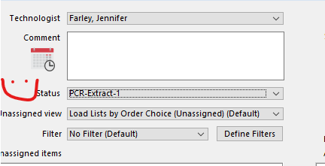

Check starting position, make sure it says 1

Check last position, make sure it says 96

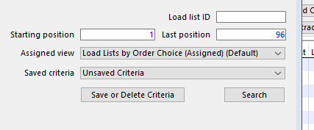

Scan the sample and double click to add it to the Load list

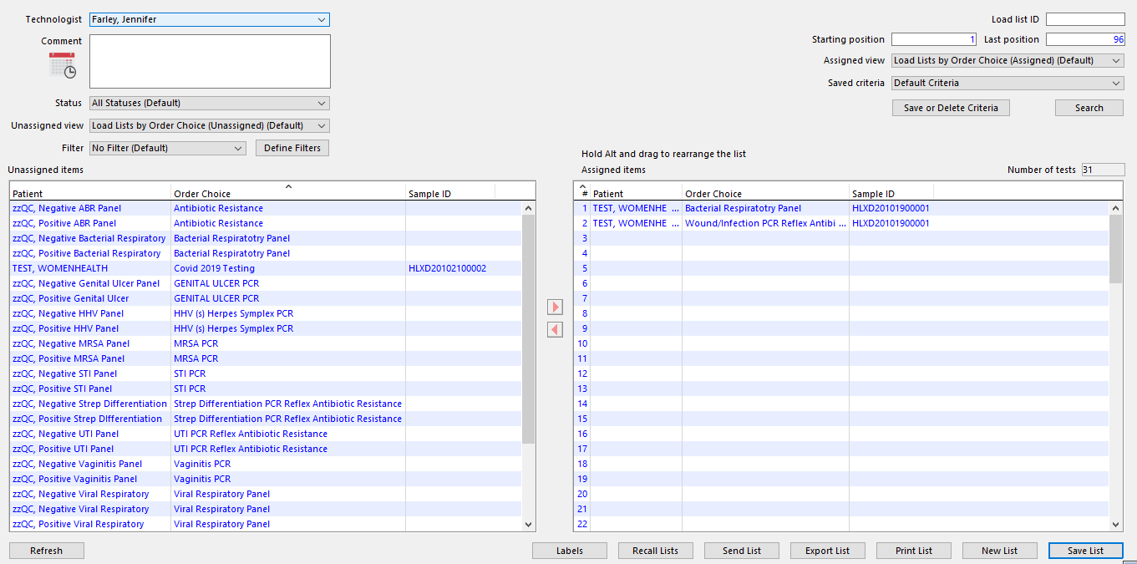

Save list in Harvest

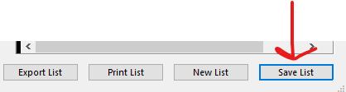

Export List

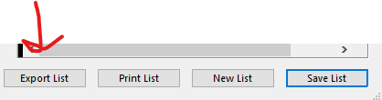

Save the load list to an export folder

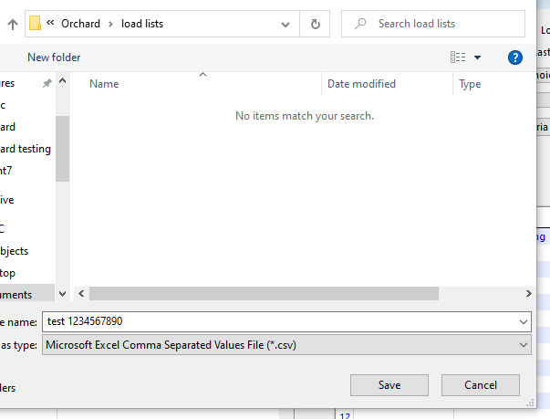

Open the CSV file of the load list that was extracted

Copy and paste the sample IDs into the KingFisher BindIT Software to make the plate map

Load wash plates and sample plate into the King Fisher

Press start on King Fisher

Once run is completed, take the elution plate to the nano drop and test

Transfer the sample ids into the Analysis software and make your 384 well plate map

Plate is made

Plate is loaded onto the Quant Studio

QC is ordered Harvest

Order Quality Control (quick link in Work Center or follow below)

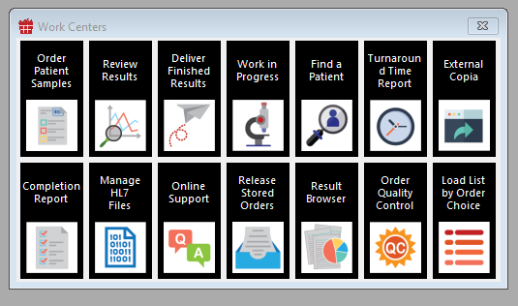

Click Instruments

Click Quality Control

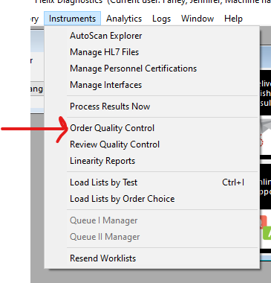

Select the Negative and Positive QC for the panels that you are running

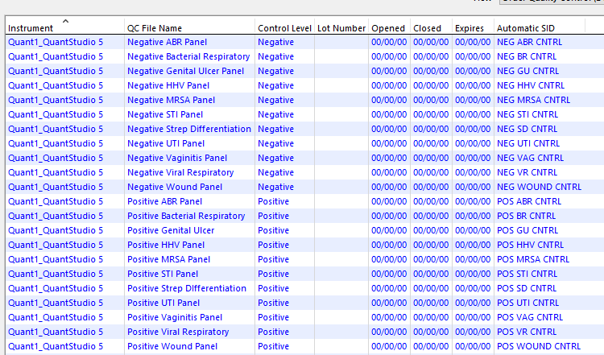

Press Select

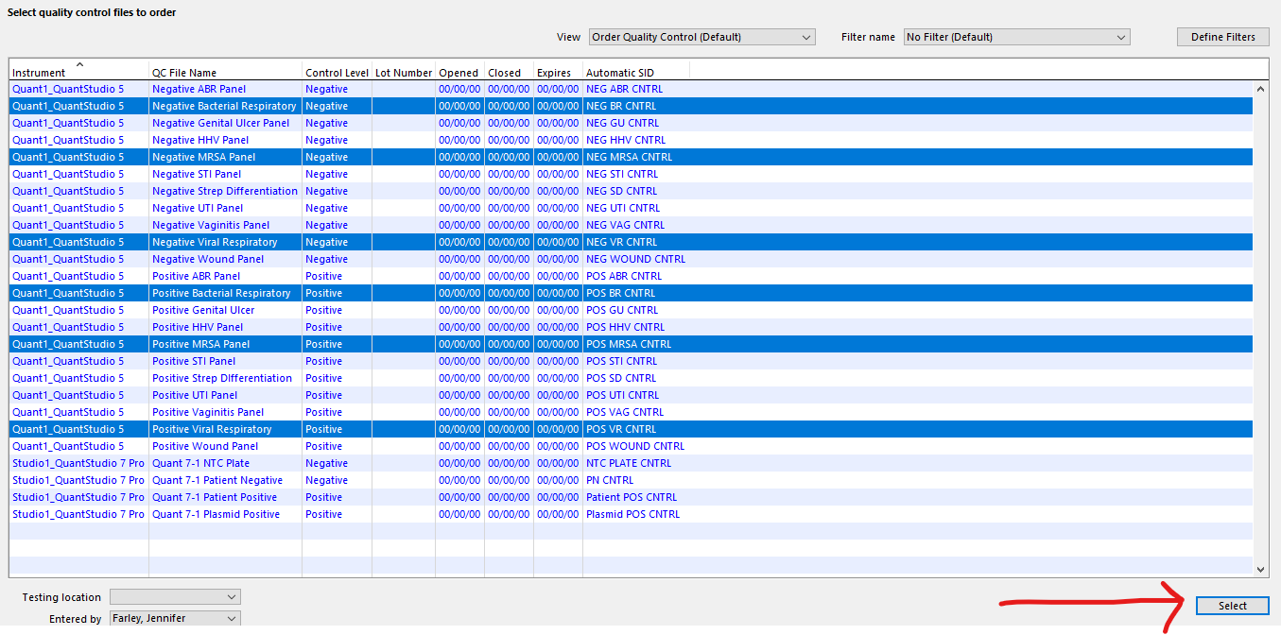

Data is then opened in the Quant Studio analysis software

Data is then reviewed on the Quant Studio analysis software

Once data is reviewed the data is then exported and saved as a .csv file

The .CSV file is then COPIED and placed in the QUANT 5 folder on the interface computer

* C:

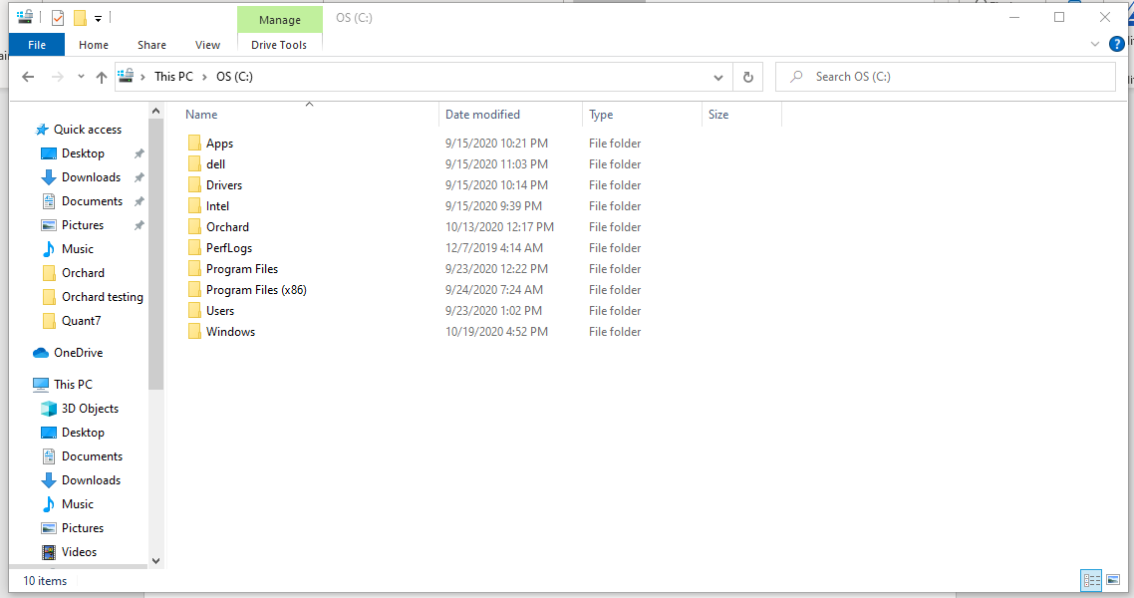

* Orchard

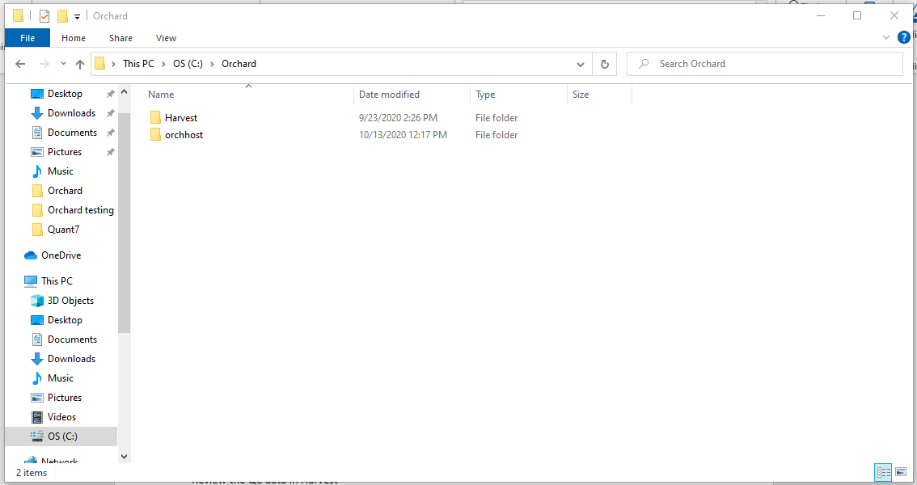

* Orchhost

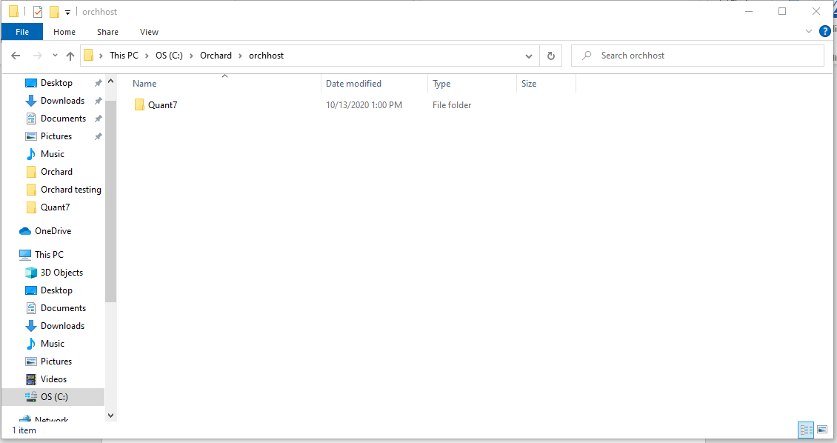.

* Quant 5

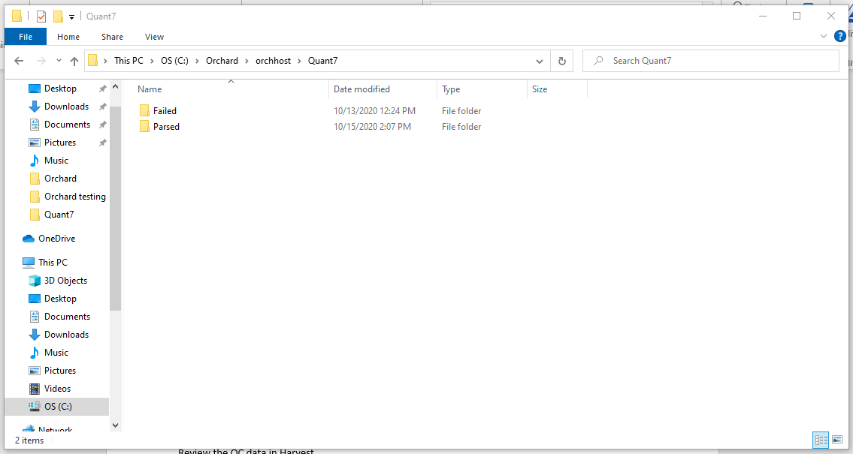

* Drop a COPY of the .csv

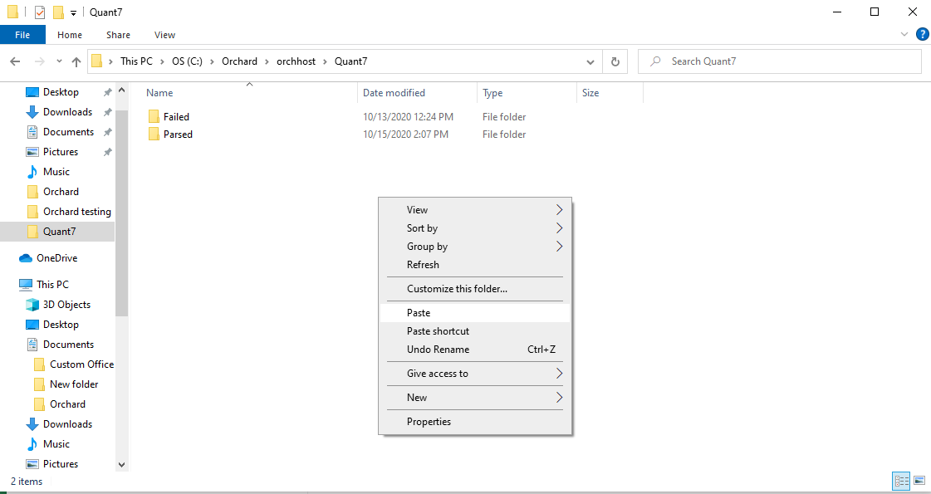

Review the QC one by one

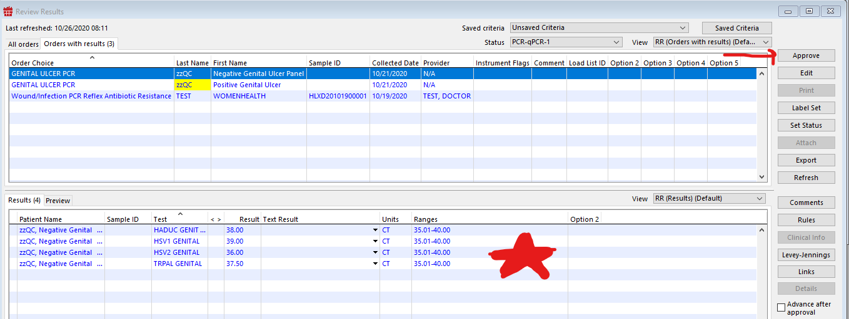

\*Blue means the QC is in range, Red or Bold Red the QC is out of range\*

Click Comment

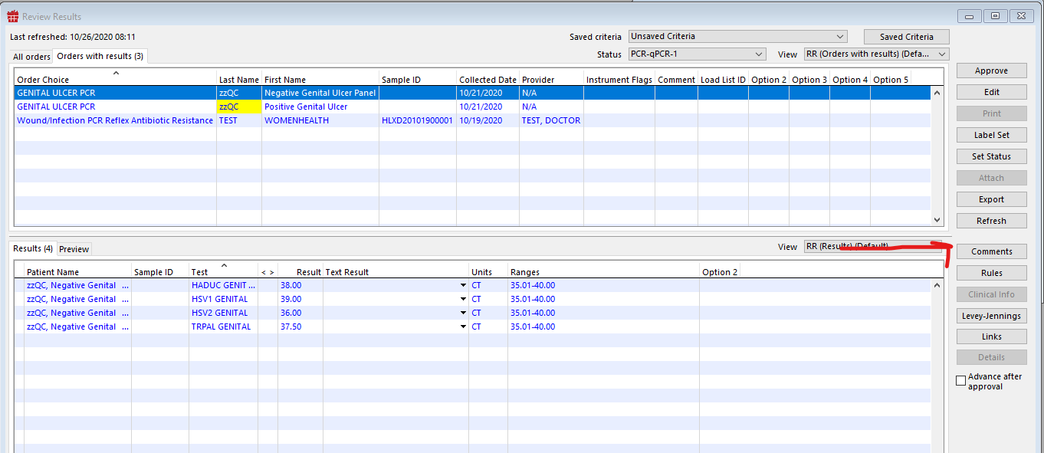

Enter your QC comment /pcrQC and press save

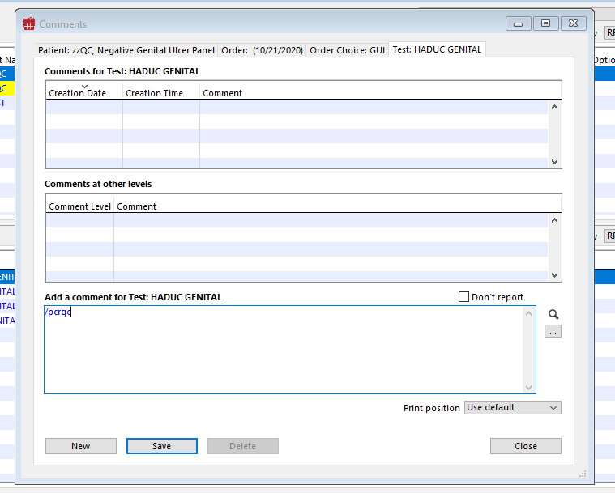

Enter the plate name

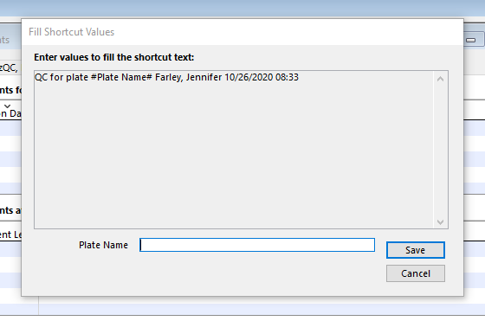

Press save

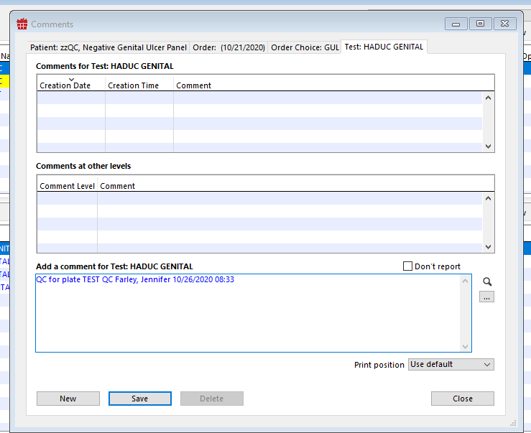

Press Save then Close

Switch to the PCR-qPCR-1 Non COVID folder, Orders with results, review the sample ids and respective CT values approve the results one by one

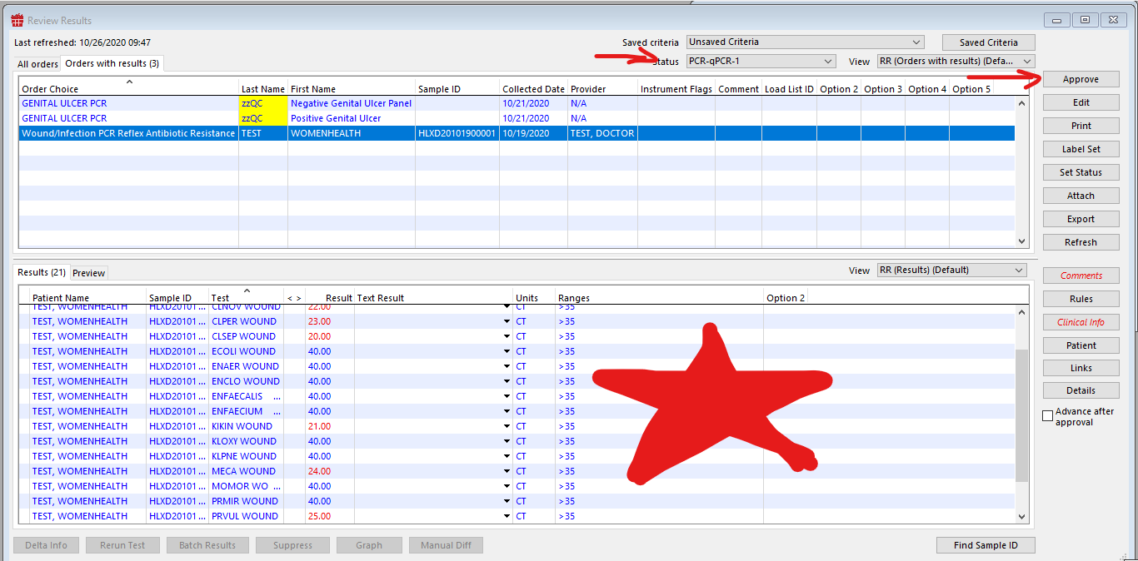

If something requires an ABR, an ABR automatically orders when the pathogens test POSITIVE that require an ABR