**Quality Assessment Plan**

|  |  |
| --- | --- |
| Title:  Ridgeline Medical Laboratory Quality Assessment Plan | Distribution: RMC Clinical Laboratories |
| Approved: _________________________________________________  Martin Mangan D.O. Date  CLIA Laboratory Director  Approved: ___________________________________________________  Keri Martin PA-C Date  Technical Consultant  Clinical Consultant  Approved: ____________________________________________________  Ashley Oltmanns Date  Staff Supervisor |  |

# Quality Assessment Plan

* 1. The objective of the Ridgeline Medical Laboratory Quality Assessment Plan is to provide high quality analytical data which is accurate, reliable, and appropriate for its intended purpose. The Quality Assessment Plan will enable personnel to establish written procedures to be followed for a comprehensive program of quality assurance as required by the Clinical Laboratory Improvement Amendments (CLIA). See Idaho Bureau of Clinical Laboratories website for CLIA regulations.
  2. This document supersedes all previous Quality Assurance Plans. Any preceding ones are to be archived.

# Goals of the Quality Assessment Plan

* 1. To improve the overall quality and efficiency of the laboratory service
  2. To evaluate the effectiveness of the laboratory's policies and procedures
  3. To allow a means of identification of problems and corrections
  4. To assure the accurate, reliable, and prompt reporting of test results
  5. To assure the adequacy and competency of staff.

# Quality Assessment (Staff Supervisor/Clinical Consultant)

* 1. Conducts reviews of quality control records for each clinical laboratory at least annually. A sampling of patient test records/quality control records will be retrieved and checked for:
     1. accuracy of laboratory-supplied information
     2. the efficiency of storage of reports
     3. the time it takes to retrieve the reports.
  2. Utilizes the Outcome-Oriented Survey (*Appendix 1*) to assess overall quality assurance of each division.

# Managers -- Staff Supervisor/Clinical Consultant

* 1. Responsible for ensuring the overall quality assurance of clinical laboratory operations, including:

1. reviewing data and identifying problems
2. recommending corrective action
3. prioritizing identified areas of concern
4. implementing a monitoring plan
5. implementing alternative corrective action if the solution identified for problems is ineffective
6. documenting all quality assessment activities.

# Terminology

* **Acceptance Criteria/Limits:** specified limits placed on characteristics of a quality control item as defined in required methods. These limits are either statistically defined by historical method performance or by specific method requirements.
* **Accuracy:** degree of agreement between an observed value and an accepted reference value. Accuracy includes a combination of random error (precision) and systematic error (bias) components due to sampling and analytical operations
* **Analyst:** designated individual who performs the analytical methods and associated techniques and who is responsible for applying required laboratory practices and other pertinent quality controls to meet the required level of quality.
* **Assessment:** evaluation process used to measure or establish the performance, effectiveness, and conformance of an organization and/or its systems to defined criteria.
* **Audit:** systematic evaluation to determine the conformance to quantitative and qualitative specifications of some operational function or activity.
* **Blank:** sample that has not been exposed to the analyzed sample stream in order to monitor contamination during sampling, transport, storage or analysis. The blank is subjected to the usual analytical and measurement process to establish a zero baseline or background value.
* **Blind Sample:** sample for analysis with a composition known to the submitter. The analyst/laboratory may know the identity of the sample but not its composition. It is used to test the analyst’s or laboratory’s proficiency in the execution of the measurement process.
* **Calibration:** determination, by measurement or comparison with a standard, of the correct value of each scale reading on a meter, instrument, or other device. The levels of the applied calibration standard should bracket the range of planned or expected sample measurements.
* **Confirmation:** verification of the identity of a component through the use of an approach with a different scientific principle from the original method.
* **Corrective Action:** action taken to eliminate the causes of an existing nonconformity, defect or other undesirable situation in order to prevent recurrence.
* **Deficiency:** unauthorized deviation from acceptable procedures or practices, or a defect in an item.
* **Document Control:** act of ensuring that documents (and revisions thereto) are proposed, reviewed for accuracy, approved for release by authorized personnel, distributed properly and controlled to ensure use of the correct version at the location where the prescribed activity is performed.
* **Precision:** degree to which a set of observations or measurements of the same property, obtained under similar conditions, conform to themselves
* **Proficiency Test (PT) Sample:** a sample, the composition of which is unknown to the analyst and is provided to test whether the analyst/laboratory can produce analytical results within specified acceptance criteria.
* **Quality Control Sample:** sample used to assess the performance of all or a portion of the measurement system.
* **Reference Material:** material or substance, one or more properties of which are sufficiently well established, to be used for the calibration of

an apparatus, the assessment of a measurement method, or for assigning values to materials.

* **Sensitivity:** capability of a method or instrument to discriminate between measurement responses representing different levels (e.g., concentrations) of a variable of interest.

# Personnel Assessment

* 1. Job descriptions are reviewed annually and revised as needed.
  2. A copy of the employee's credentials (i.e., diploma or transcripts) indicating degree obtained, certificate, license or other documentation relevant to the position will be maintained
  3. Personnel must meet or exceed CLIA regulations. The staff supervisor/clinical consultant will ensure that personnel are supervised and competent *(Appendix S-5&6).*
  4. All employees are evaluated twice within the first year of employment and annually thereafter.
  5. The first employee competency assessment must occur before the employee is allowed to report patient results.
  6. The second assessment may be done at the employee's six month evaluation.
  7. If an employee needs assistance or improvement, corrective actions are documented, and the employee is re-assessed within six months.
  8. Staff Supervisor/Clinical Consultant are responsible for initial training, the six- month and annual competency for all personnel who perform laboratory testing. This is recorded on the "Employee Competency Checklist" and is maintained in each division (*Appendix S-6*).
  9. Records of medical contact information, health exposures, incidents or accidents are maintained by the laboratory OSHA safety officer and stored on his computer. Exposures are documented in the patient’s medical chart.
  10. Additional training and continuing education for Ridgeline Medical Laboratory employees is available from external agencies, e.g., https://**www.cdc.gov/labtraining** (Centers for Disease Control and Prevention) and others.

# Records

* 1. Sample/specimen information is recorded in a written or typed log or a computer-based laboratory information system.
  2. All quality assessment (QA) activities are documented.
  3. The staff supervisor/clinical consultant will review test requisitions, worksheets, patient logs, or other records to ensure the following information is included.

1. Suitable identifiers of the authorized person requesting the test or the name and address of the laboratory submitting the specimen and, if applicable, a contact person to enable the reporting of imminent life threatening laboratory results
2. Patient's name or other identifier and mechanism/number that links the specimen to that patient
3. Gender and age (or date of birth) of the patient
4. Test(s) requested (They should be pertinent to the diagnosis and/or treatment of the patient.)
5. Specimen source
6. Date of collection and, if applicable, the time of specimen collection
7. Date and time the specimen was received into the laboratory
8. Identity of the laboratory personnel who performed the test(s) and date results are reported
9. Condition and disposition of unsatisfactory specimens.
   1. Lack of pertinent information and/or inconsistencies on the form or patient specimen are verified by the health care provider via phone or fax or reported unsatisfactory. If the specimen can be tested, it will not be reported until all required information is provided by the client/submitter of the specimen and record.
   2. Employees must ensure:
10. the test results are consistent with related data (age, sex, diagnosis, and other tests ordered).
11. the test reports are legible, error free, and reported within the established time as reflected in the turn-around-times recorded in the Laboratory

Reference Manual.

1. that alert (panic) values are reported and there is documentation of reported alert values.
   1. Records retention (see *Appendix S-11* for a more detailed list)

Most records are maintained for a minimum of two years to include:

* analytic systems records
* test requisitions and authorizations
* maintenance and function checks
* calibration and calibration verification procedures
* proficiency testing records
* quality control/assessment records
* test procedures for at least 2 years after a procedure has been discontinued and must include the dates of initial use and discontinuance
* patient test records including instrument printouts if applicable
* test reports - retain or be able to retrieve a copy of the original report (including preliminary, final, and corrected reports)
* employee competency records

NOTE: If the laboratory ceases operation, it must make provisions to ensure that all records are maintained and available for at least 2 years.

* 1. Records destruction
* Records may be appropriately destroyed once they have exceeded the retention time for the specific records.

# Laboratory Equipment and Instrumentation

* 1. Laboratory equipment, standard devices/materials of known accuracy, computer hardware and software, instruments and test system status are monitored as preventive maintenance.

1. Maintenance and function checks as specified by the manufacturer, as well as frequency, are documented for each test system within each section.
2. Calibration verification must be performed at least with the frequency recommended by the manufacturer or at least once every six months and when any of the following occur:
   1. A complete change of reagents for a procedure is introduced, unless the laboratory can demonstrate that changing reagent lot number

does not affect the range used to report patient test results and control values are not adversely affected by reagent lot number changes.

* 1. When controls begin to reflect an unusual trend or are outside acceptable limits and other means of assessing and correcting unacceptable control values fail to identify and correct the problem.
  2. There is major preventive maintenance or replacement of critical parts that may influence test performance.
  3. The laboratory’s established schedule for verifying the reportable range for patient test results requires more frequent calibrations.

1. All records of preventive maintenance are documented in the equipment maintenance log provided by the manufacture or a suitable ledger that is maintained by the section personnel. It will contain:
   1. the identity of the piece of equipment (and its software, if applicable),
   2. manufacturer’s name, type ID, and serial number or other unique identification,
   3. manufacturer's instructions, if available,
   4. the dates, results and copies of reports and certificates or all calibrations, adjustments, and acceptance criteria,
   5. the maintenance plan, where appropriate, and maintenance performed to date,
   6. documentation of any damage, malfunction, modification or repair to the equipment.
2. All records of corrective action taken or minor troubleshooting and repair performed must be documented in the individual unit’s equipment maintenance log or a suitable ledger maintained by the testing personnel.
3. Equipment preventive maintenance, records of corrective action taken, and function checks documented in the previously mentioned maintenance log or ledger will be reviewed by the staff supervisor or clinical supervisor or the Director.

# Laboratory Reagents

* 1. Reagents are defined as any chemical substance used to dissolve, digest, extract, react with or otherwise interact with any sample or analytical component of the sample.
  2. Reagents used in the will be of the appropriate quality for their intended use.
  3. All reagents prepared by laboratory shall be marked with date of preparation and expiration date.
  4. All reagents purchased from a commercial vendor will be marked with the date of receipt.
  5. All reagents will be marked with date opened.
  6. All reagents will be labeled with the expiration date.
  7. All reagents shall be stored according to manufacturer’s instructions.
  8. All reagents shall be labeled to indicate content, and when appropriate titer or concentration.
  9. Reagent shelf life will be observed and must not be used when they have exceeded their expiration date, have deteriorated, or are of substandard quality.
  10. Components of reagent kits of different lot number are not interchangeable unless specified by the manufacturer.

# Specimen Criteria and Reporting

* 1. Submission and handling

1. All specimens submitted for testing must be done according to the Ridgeline Medical Laboratory Standard Operation Procedure (SOP) Manual. All specimens must have a written or electronic request for patient testing from an authorized person or agency/client.
2. All samples/specimens are stored according to established methods. Unsatisfactory/unacceptable specimens will be reviewed by the section supervisors by way of the monthly report. The division manager will review the section's unsatisfactory specimen criteria to determine whether the criteria have been compromised.
   1. Specimen rejection

The Laboratory Director has established criteria for the rejection of specimens in the laboratory. The staff supervisor will inform employees of these criteria which can be found in the Laboratory Reference Manual. The use and appropriateness of the criteria will be reviewed as problems are

identified by personnel.

* 1. Referral of specimens

1. The laboratory refers a specimen for further testing or confirmation to Expres Labs or Quest Laboratories.
   1. Turn-around-time for reporting test results

Please see SOP Manual for established turn-around-times (TATs) for the respective test procedures. Staff/supervisor/clinical consultant will verify that results were reported within the established time frames and such is indicated on the Monthly QA Audit Form *(Appendix S-22)*.

# Procedures

A written procedure manual selected and/or developed and optimized for all specimen processing, tests, assays, and examinations performed by the laboratory must be available to, and followed by, laboratory personnel in advance of performing testing. Procedures will be equivalent to or exceed requirements recognized by regulating agencies, state, and/or federal regulations and will follow the CLIA Approved Guideline. The “New Method Validation” policy will be followed (*Appendix S-23*). Procedure manuals are maintained in each Ridgeline Medical Laboratory clinical laboratory to include the criteria listed below as applicable.

* 1. Requirements for the following are found in the SOP Manual and procedure manuals for each test performed.

1. patient preparation
2. specimen:
   * collection
   * labeling
   * storage
   * preservation
   * transportation
   * processing
   * referral
   * acceptance and rejection
3. Step-by-step performance of testing procedures (analytical methodology/ principles) including limitations of procedures, reagents, and calculation explanations and interpretation of results.
4. Referral of specimens, including procedures for specimen submission, handling, and positive identification and optimum integrity of a patient’s specimen from the time of collection or receipt through completion of testing and reporting of results
5. Procedures for microscopic examination, including the detection of inadequately prepared slides
6. Preparation of slides, solutions, calibrators, controls, reagents, stains, and other materials used in testing
7. Handling procedures including reportable ranges, tests outside of reportable ranges, and criteria or panic values
8. Calibration and calibration verification procedures
9. Reportable range for test results.
10. Control procedures
11. Corrective/remedial action guidelines when calibration, control results or test systems fail to meet the laboratory’s criteria for acceptability
12. Limitations in the test methodology, including interfering substances.
13. Reference intervals (normal values).
14. Protocol for entering results in the patient record and reporting results including reporting imminent life-threatening test results or panic/alert values.
15. Pertinent literature references
    1. These procedures must be approved, dated and signed at least annually by the laboratory director, and any changes in the procedures must be approved, signed and dated by the laboratory director or designated technical supervisor before use. Procedures must be re-approved, signed and dated if the directorship of the laboratory changes.
    2. The laboratory must maintain a copy of each procedure with the dates of initial use and discontinuance for a period of two years for clinical procedures.

# Corrective Actions

* 1. Corrective action policies and procedures must be available and followed as necessary to maintain the laboratory's operation for testing patient specimens in a manner that ensures accurate and reliable patient test results and reports.
  2. The laboratory must document all corrective actions taken, including actions taken when any of the following occur:

1. Test systems do not meet the laboratory's verified or established performance specifications, which include but are not limited to
   1. Equipment or methodologies that perform outside of established operating parameters or performance specifications;
   2. Patient test values that are outside of the laboratory's reportable range of test results for the test system; and
   3. When the laboratory determines that the reference intervals (normal values) for a test procedure are inappropriate for the laboratory's patient population.
2. Results of control or calibration materials, or both, fail to meet the laboratory's established criteria for acceptability. All patient test results obtained in the unacceptable test run and since the last acceptable test run must be evaluated to determine if patient test results have been adversely affected. The laboratory must take the corrective action(s) necessary to ensure the reporting of accurate and reliable patient test results.
3. The criteria for proper storage of reagents and specimens are not met.

# Quality Control (QC) Assessment

* 1. QC is performed and documented for each procedure as recommended by the manufacturer and as described by the division procedure manual.
  2. QC is evaluated with each patient run to determine if the patient run is acceptable.
  3. QC data is charted each day of business or monthly, depending on the manufacturers’ directions, and observed for accuracy and precision of test procedures.

1. When problems occur, corrective action is taken and documented on the corrective action form *(see Apendix S-26).*

* 1. Calibrations are performed according to manufacturer's recommendations. Instruments that are internally calibrated by the manufacturer have their calibrations verified at least every six months.
  2. Preventive maintenance is performed according to manufacturer's recommendations for all instruments and equipment.
  3. Temperatures of room, refrigerators, incubators, and other temperature dependent equipment are recorded each day of business. Humidity checks, where applicable, are also recorded.

.

* 1. Remedial/Corrective actions are taken when:

1. test methods fail,
2. test equipment fails,
3. media/reagents fail,
4. patient results are outside the reportable range,
5. a population reference range is inappropriate,
6. controls are out of range,
7. calibration is unacceptable,
8. established time frames cannot be met,
9. reported results are incorrect.

Remedial/Corrective actions are outlined in the Procedure Manuals. When any of the above situations occur, any staff discussion(s) and remedial action(s) will be documented on the Corrective Action Logs. These logs are reviewed monthly by the technical supervisor and include any review of the effectiveness of corrective actions taken to resolve problems, revision of policies and procedures necessary to prevent recurrence of problems, and discussion of general laboratory systems assessment reviews with the appropriate staff. This review is recorded and monitored via the Monthly QA Audit Form.

# Proficiency Testing (PT) Assessment

* 1. Active, successful participation in approved external PT programs that cover all analyses/procedures performed is required for testing for which certification is maintained. All testing personnel must participate in PT on a regular rotation within their respective areas of responsibility. The INL clinical laboratories are enrolled in a PT program in order to:

1. ensure the competency of employees in their areas of testing and includes direct supervisory observation**.**
   1. The retesting of previously analyzed specimens, internal blind samples, reference proficiency test samples or external PT samples that have already been reported to approved PT programs may be used to assess the performance levels of each staff member responsible for performing and supervising testing.
2. ensure an ongoing mechanism to monitor, assess, and correct any problem identified in the testing procedure.
   1. If no external PT is available, a mechanism to semi-annually document and determine accuracy and reliability of analytic results on patient samples is required.
   2. A PT program shall be defined for each specialty and subspecialty evaluated in the laboratory.
   3. PT is performed for all regulated analytes, and the reports are signed and submitted to the PT agency within the allotted time frame.
   4. Participation in a particular PT program must be continued for one year before changing to a new one.
   5. Release is authorized of all necessary data from PT programs to certifying agencies.
   6. PT samples are handled like patient specimens.
   7. PT results are not discussed between inter-laboratory personnel or with personnel at the branch labs until after the date the laboratory must report the PT results to the program provider.
   8. PT samples (or portions) are **not** sent to any other laboratory for analysis.
   9. All steps of proficiency testing are documented.
   10. Receipt of PT results
3. The staff supervisor must:
   1. have each analyst (as necessary) review, sign and date the results.
   2. have the laboratory director review, sign and date the results.
   3. retain these **signed** PT results in their divisions to be available for CLIA inspections.
4. In the event that the PT performance indicates:
   1. an unacceptable response for an analyte
   2. an unsatisfactory response for a specialty/subspecialty
   3. any Exception Reason Code,

the Missed Analyte Investigation section of the Proficiency Testing Performance Report *(Appendix S-24)* must be completed by the division supervisor within ten working days. Copies must be submitted to the Quality Management Division and the laboratory director who both review all PT results.

1. **Communication Problems and Complaints**
   1. Communication problems
2. An assessment of any problem occurring due to a breakdown in communication between the laboratory and the health care provider is investigated and documented.
3. Remedial/corrective action is documented.
4. The staff supervisor/clinical consultant will review the complaints, corrective actions and documents.
   1. Complaints
5. Complaints/ problems received by any employee from staff, patients, or health care providers are documented in telephone logs, or complaint logs.
6. The remedial/corrective action is documented for all valid complaints.
7. When corrective actions are necessary to decrease problems with a procedure (pre-analytical, analytical, or post-analytical), the effectiveness of them are reviewed by the staff supervisor.

# Facilities and Safety

* 1. The Ridgeline Medical Laboratory clinical laboratories consists of one laboratory facility.
  2. To assist in assuring quality testing and results, each dispensary must be kept clean by using the appropriate disinfectants (i.e., 10% bleach solution, etc.) and chemical spill kits when necessary.
  3. Refer to the “Ridgeline Medical Laboratory” for safety information.

# Appendices

S-2

**S-1 Outcome-Oriented Survey**

|  |  |
| --- | --- |
| **Quality Control Records** | |
| 1 -- Corrective/Remedial Action log |  |
| 2 – Calibration and calibration verification records (e.g., parallel studies, linearity) |  |
| 3 – Statistical limits |  |
| 4 – Instrument Maintenance logs |  |
| 5 -- Comments |  |
|  |  |
|  |  |
| **Proficiency testing (PT) reports, including:** | |
| 1 – test runs with PT results |  |
| 2 – Direct printouts |  |
| 3 – Attestation statements |  |
| 4 – Remedial/Corrective actions for unsatisfactory results |  |
| 5 -- Comments |  |
|  |  |
|  |  |
| **Quality system assessment plan and documentation:** | |
| 1 – Quality assessment plan in place |  |
| 2 – Documentation staff reviewed the manual |  |
| 3 – Documentation of complaints/problems |  |
| 4 -- Comments |  |
|  |  |
|  |  |
| **For All systems, review documentation of ongoing assessment activities** |  |
| 1 – Review of corrective/remedial actions – monthly QA Audits |  |
| 2 – Complaint documents |  |
| 3 – Revision of policies and procedures to prevent recurrence of problems |  |
| 4 – Discussion or assessment reviews with staff |  |
| 5 -- Comments |  |
|  |  |
|  |  |
| **Safety Information:** | |
| 1 – Copy of safety manual |  |
| 2 – SDS’s |  |
| 3 -- Comments |  |
|  |  |
|  |  |
| **Patient Testing Records** | |
| 1 -- Requisition |  |
| 2 – Work records (direct printouts) |  |
| 3 – Patient test reports |  |
|  |  |
| **Technical Consultant (initial)** |  |
|  |  |
|  |  |
|  |  |
|  |  |
|  |  |
|  |  |
|  |  |

**S-5 Employee Training Report**

|  |  |  |
| --- | --- | --- |
| Name:  S#  Title: | | |
| **Test/Machine** | **Date Training Completed** | **Comments:** |
| Phlebotomy |  |
| Rapid Strep |  |
| Urinalysis Dipstick Automated Reader |  |
| Piccolo Xpress Chemistry Analyzer |  |
| Cell-Dyn Emerald Hematology analyzer |  |
|  |  |
|  |  |
|  |  |

**S-6 Employee Competency Checklist**

|  |  |  |  |
| --- | --- | --- | --- |
| **INL Clinical Laboratories: CFA, WCB, MFC** | | | |
| **This form certifies that the employee named below** has the skills, knowledge and awareness to perform testing on: Emerald Cell-Dyn hematology analyzer (moderate complex); Piccolo Xpress chemistry analyzer (waived); Urine Dipstick Automated Reader (waived); Rapid Strep screen (waived); Glucose meter (waived); Other:  Employee Name: _____________________________________________________________  Competency Assessment performed at: 🞏 Annual 🞏 6 months 🞏 Other | | | |
|  | | | |
|  | **Meets Standards?** |  | **Meets Standards?** |
| **Specimen** |  | **Troubleshooting** |  |
| Collection | Y / N / NA | Specimen Referral | Y / N / NA |
| Identification | Y / N / NA | Instrument Calibration | Y / N / NA |
| Processing | Y / N / NA | Instrument Maintenance | Y / N / NA |
| Rejection Criteria | Y / N / NA | Problem Identification | Y / N / NA |
| **Reagents** |  | **Package Insert/Written Procedure** |  |
| Storage | Y / N / NA | Reviewed | Y / N / NA |
| Stability | Y / N / NA | Interpretation of Results | Y / N / NA |
| Preparation | Y / N / NA | **Proficiency Testing** |  |
| Disposal | Y / N / NA | Scheduling | Y / N / NA |
| **Quality Control** |  | Handling | Y / N / NA |
| Materials Used | Y / N / NA | Testing | Y / N / NA |
| Frequency | Y / N / NA | Reporting | Y / N / NA |
| Documentation | Y / N / NA | Evaluation | Y / N / NA |
| Corrective Action | Y / N / NA |  |  |
| By signing below, the assessor and employee certify that the following evaluations were completed: 1) direct observation of test performance; 2) monitoring or recording and reporting or results; 3) review of intermediate test results or worksheets, QC, P)T and PM records; 4) direct observation of instrument maintenance and function checks; 5) assessment of test performance through external proficiency testing: and 6) assessment of problem solving skills. | | | |
| Employee Signature:________________________________________Date:__________  Assessed By: ______________________________________________Date:__________ (Must meet requirements for Technical Consultant/Supervisor) | | | |

**S-11 INL Clinical Laboratories Record Retention Times**

|  |  |
| --- | --- |
| **Record Retention Times** | |
| Certification Files | 6 years |
| Clinical Chemistry Reports | 2 years |
| Laboratory Testing Protocols | 2 years post-retirement of protocol |
| Proficiency Testing | 2 years |
| Testing Personnel Qualification and Competency Evaluations | 2 years |
| Other Laboratory Test Reports (e.g. Rapid Strep, Urine Dipstick ,etc.) | 2 years |

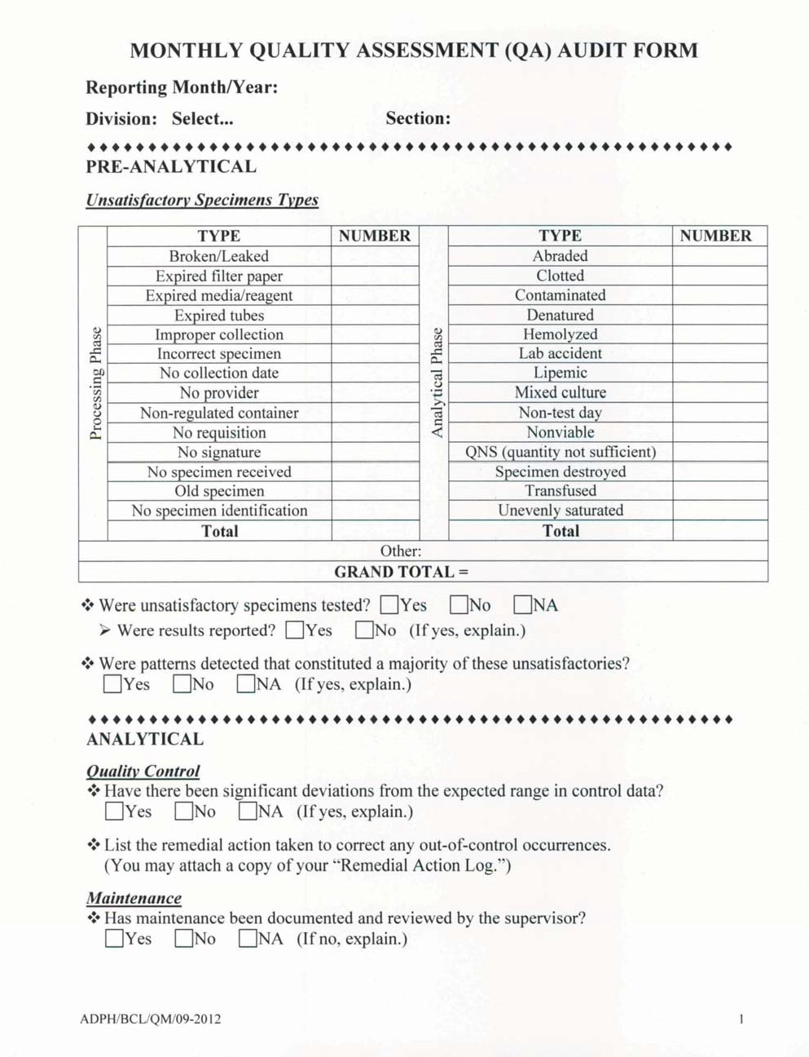**nthly QA Audit Form**

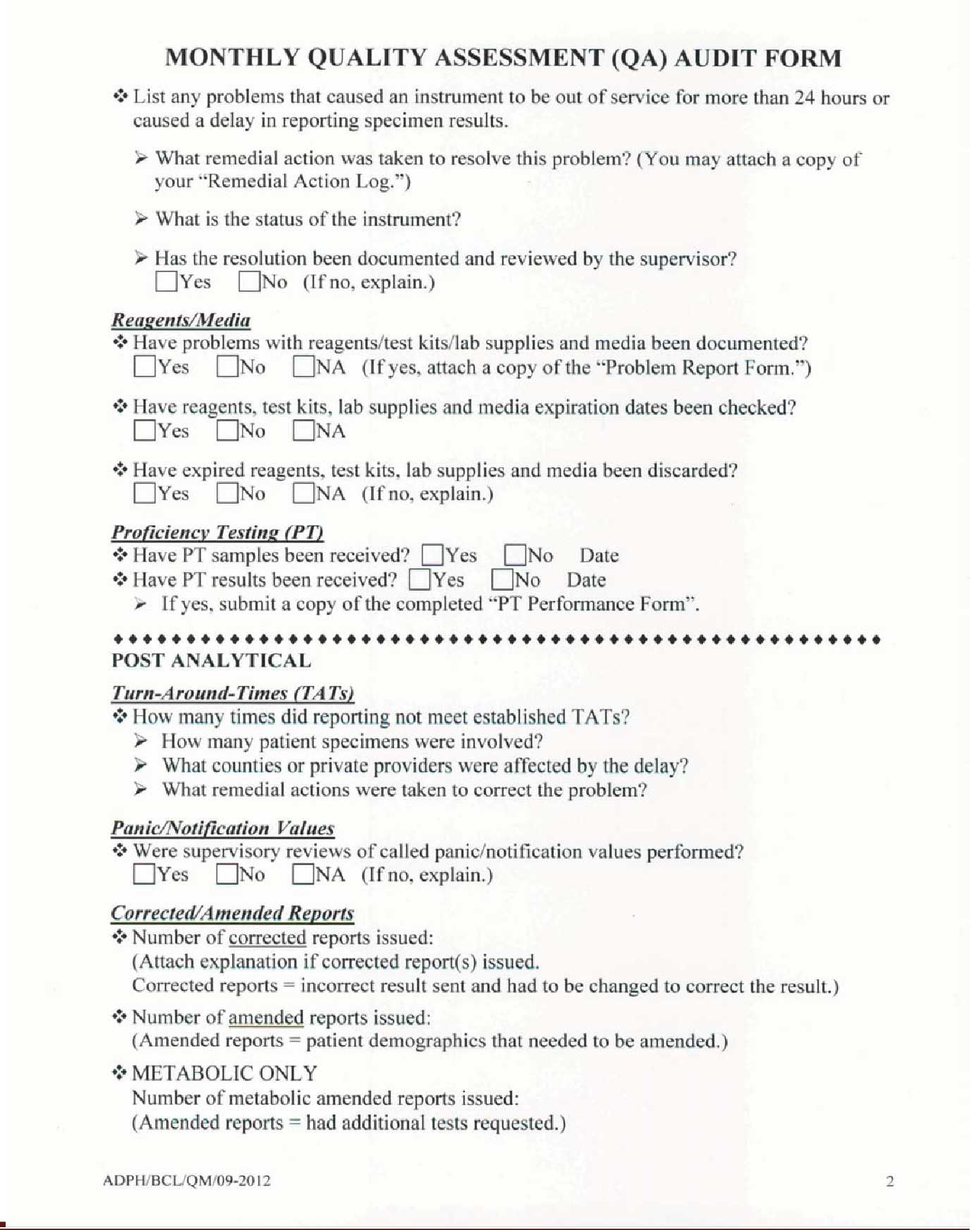

Appendices

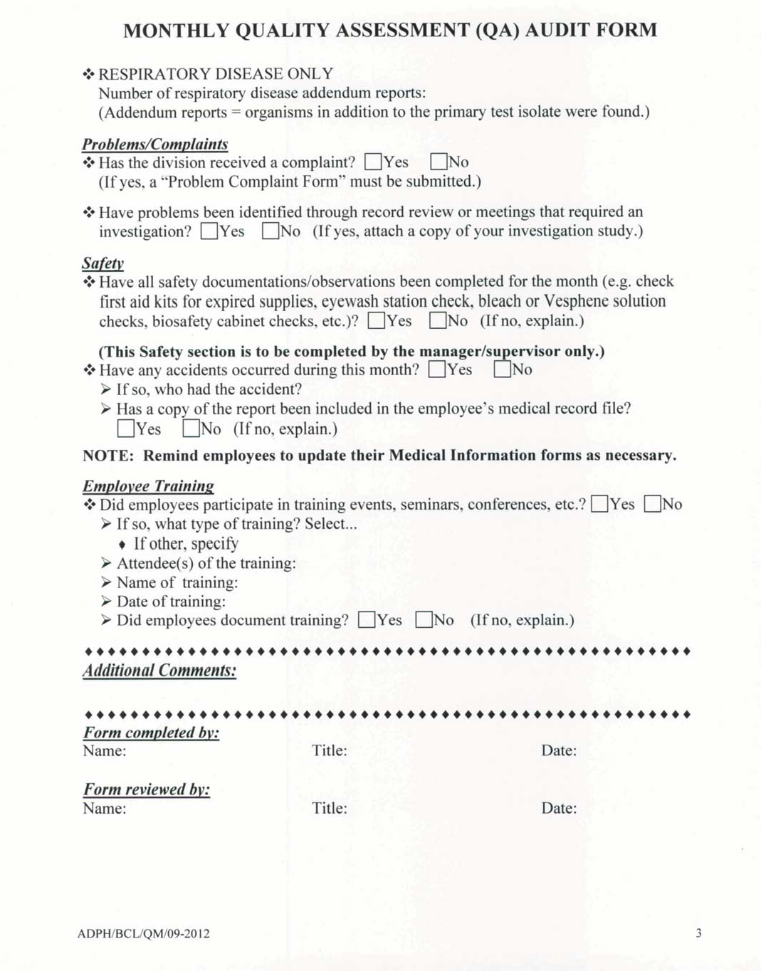

**S-23 New Method Validation**

For new procedures being incorporated, the instructions for performing the test(s) are placed in the procedure manual. The appropriate accuracy and precision studies have been performed and documented as required. Quality control is established. Documentation is made that training has been completed for appropriate testing personnel. Personnel are documented as competent before testing is performed and patient results are reported.

**S-24 Proficiency Testing Performance Report**

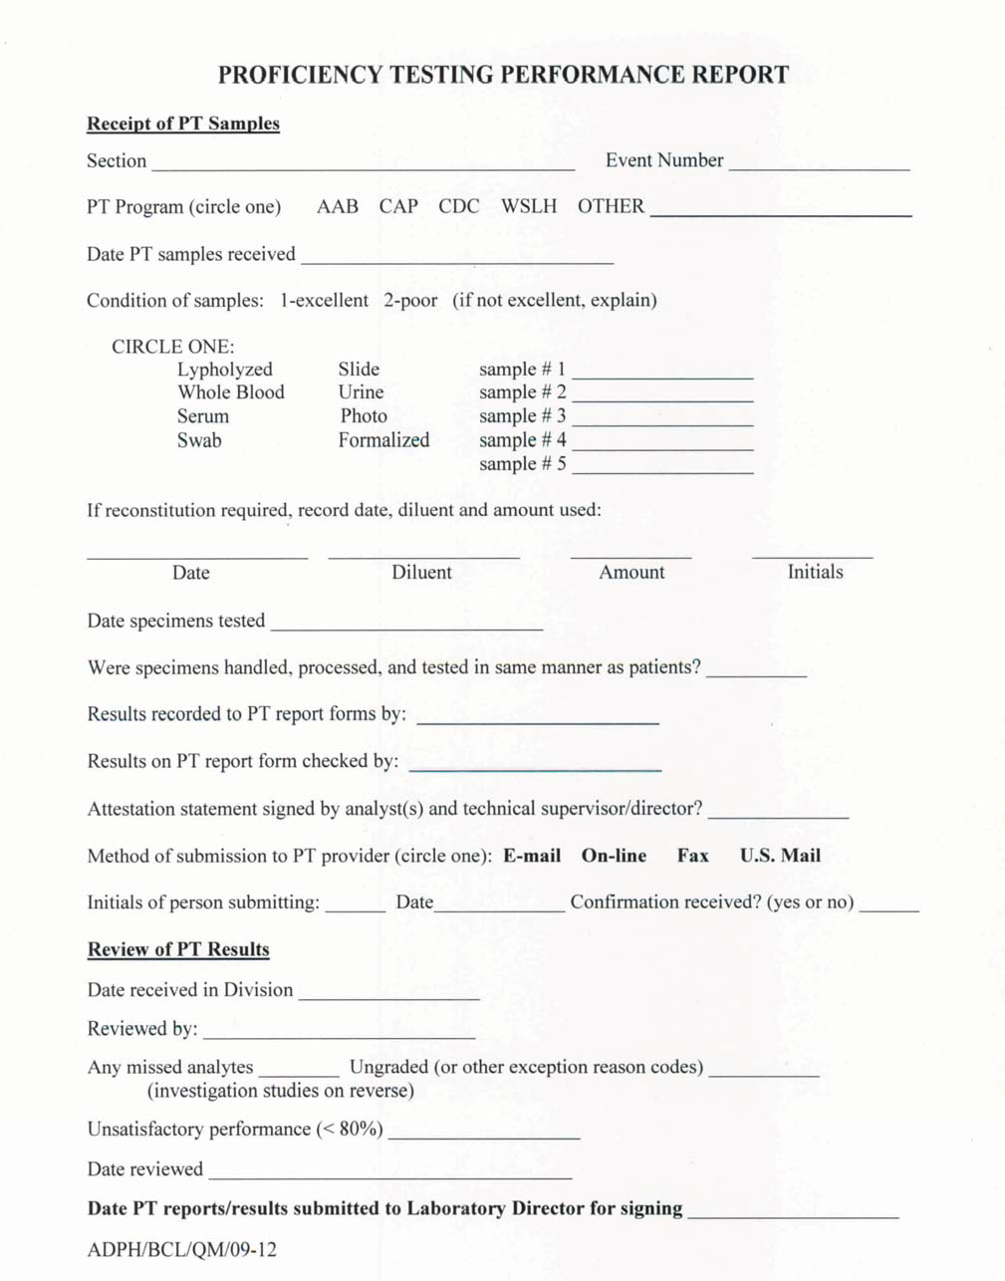

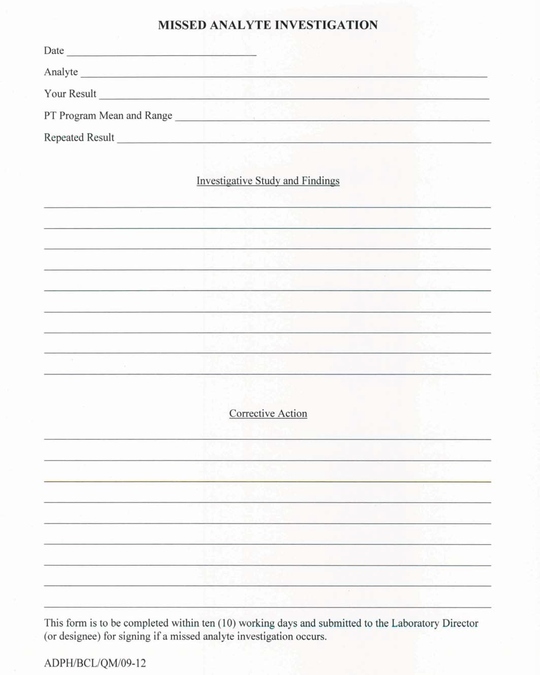

**S-25 Documentation of Communication and /or Complaints**

