**Proper Use of Spill Kits**

A spill kit can be used to contain a chemical or biological (blood, body fluid) spills and cleaned up if the spill is small or to keep contianed while waiting for the proper response team. In order to effectively deal with a spill, it is important to know what is in the spill kits and the steps to take to contain and/or clean the spill.

**Spill Kit contents**:

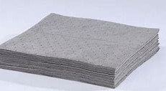

Chemical absorbent pads (6)

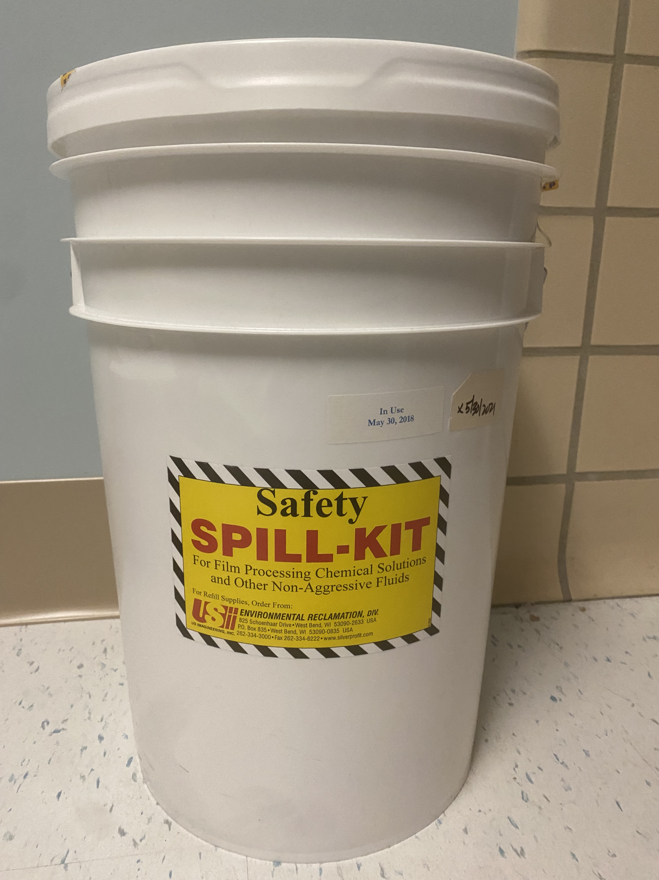

Spill Kit container

Half-mask respirator : To be used with vapor and gas filters. Gases and vapors from liquids and sovents will be absorbed by the filters to protect the respitory tract

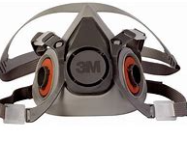

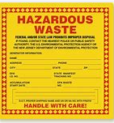

Hazardous waste stickers (3)

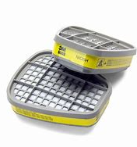

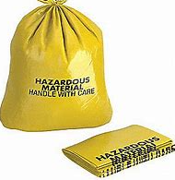

2 Cartridges for half mask respirator

Yellow Caution bags

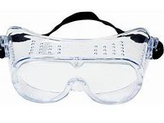

Anti-fog goggles (1 pair)

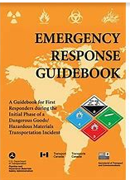

Emergency response guidebook

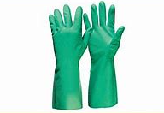

Gloves (1 pair)

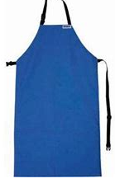

Vinyl apron (1)

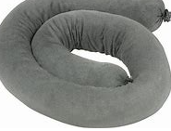

Chemical absorbent socks (3)

**Spill Kit Directions:**

1. Assess the area, notify nearby people of the spill and evacuate the area. Restrict access to the area.
2. Open the spill kit
3. Don PPE (gloves, face mask, goggles or face mask and fluid resistant lab coat or gown).
4. For a Chemical spill, print out the SDS (safety Data sheet)
5. Open the Spill kit and locate the Emergency Response Guidebook to determine appropriate spill containment items to use.

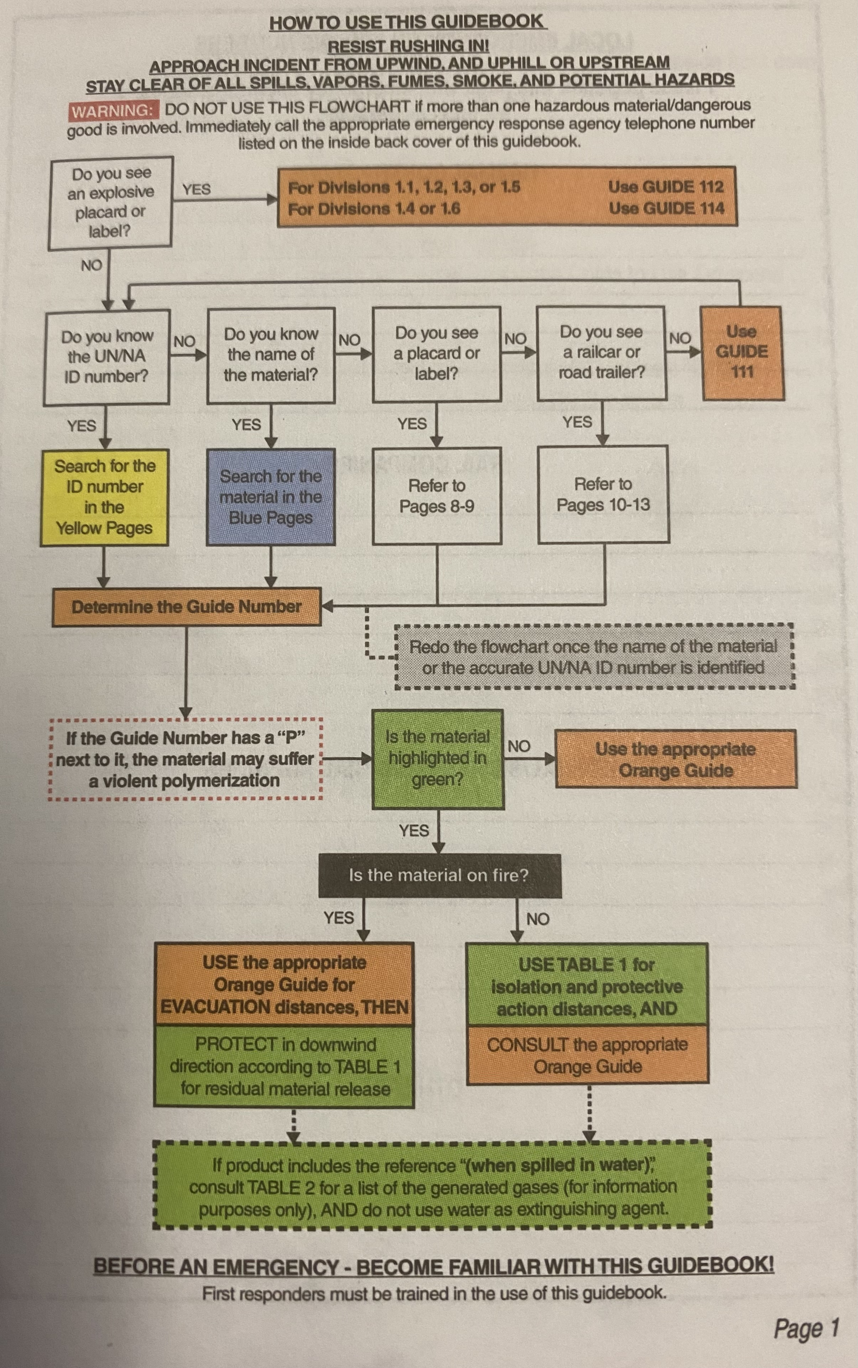

Open the guidebook to page 1 for instructions on using the book to identify the chemical and necessary precautions to take.

1. Contain the spill using the chemical absorbent socks
2. Use the chemical absorbent pads to absorb free liquid
3. For a small spill, clean the area.
4. The contaminated items should be put into the yellow hazard bags. Close the bags with the provided ties. Place a hazardous waste sticker on the bag.
5. Place the hazardous waste bag in the spill kit bucket.
6. For larger spills, wait for environmental services to respond.
7. Notify the safety officer to replenish the spill kit

**Half-Mask respirator instructions:**

Assembling the respirator:

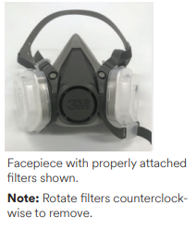

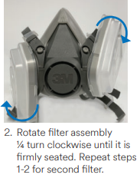

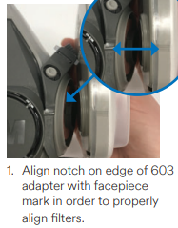

Donning the respirator:

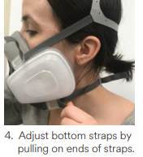

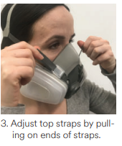

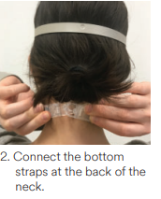

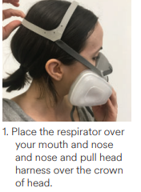

References:

3M quick start guide for 3M Half face piece reusable respirators and particulate filter assembly

