**Accessing Safety Data Sheets using Salute Safety Data (SDS) Program**

1. Go to the Hospital intranet.
2. Click on the white arrow in the blue box in the upper left hand corner and choose Bridgeport hospital.

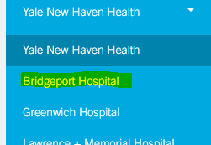

1. Click on resources at the top of the page 
2. Scroll down and find Salute Safety ***Data Sheets (SDS) Program*** under Applications and open the application.
3. When you open the application, you will need to enter your hospital email then click next

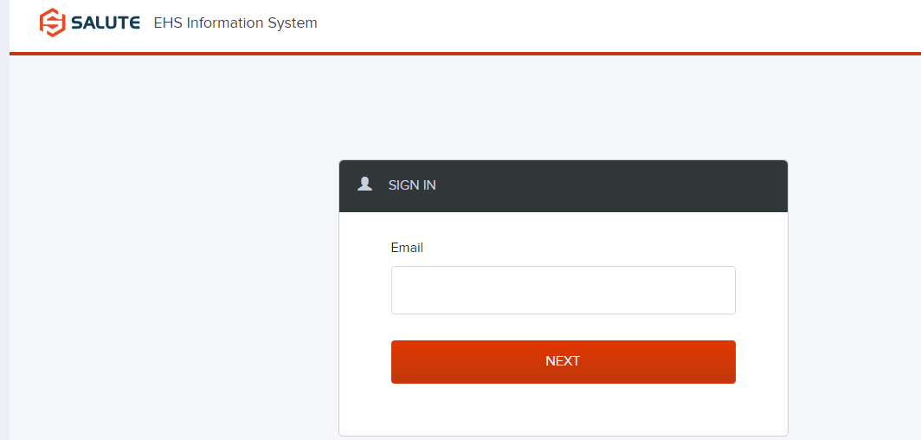

1. The Salute SDS Program will open. Make sure that the header is Chemical Safety, if not, Click on Chemical safety in the choices on the left side of the page.

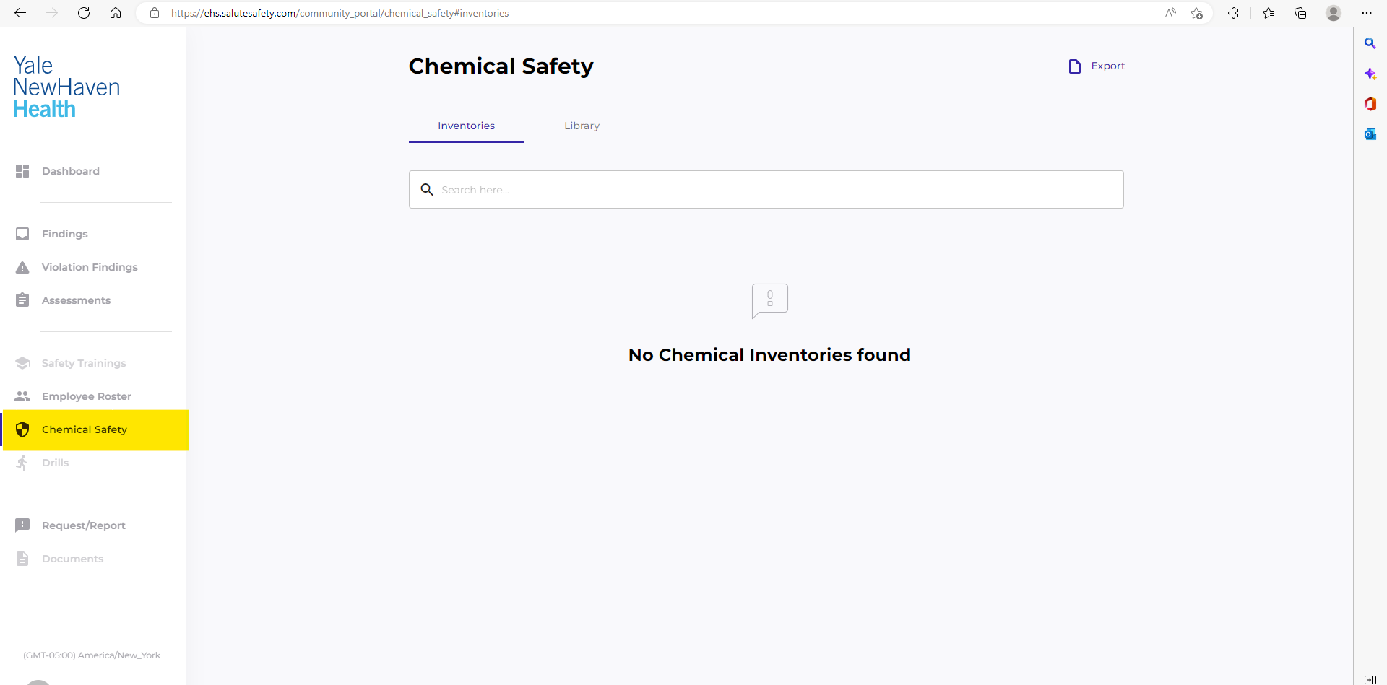

1. Click on Library at the top of the Chemical Safety page. Enter the chemical you need in the search bar

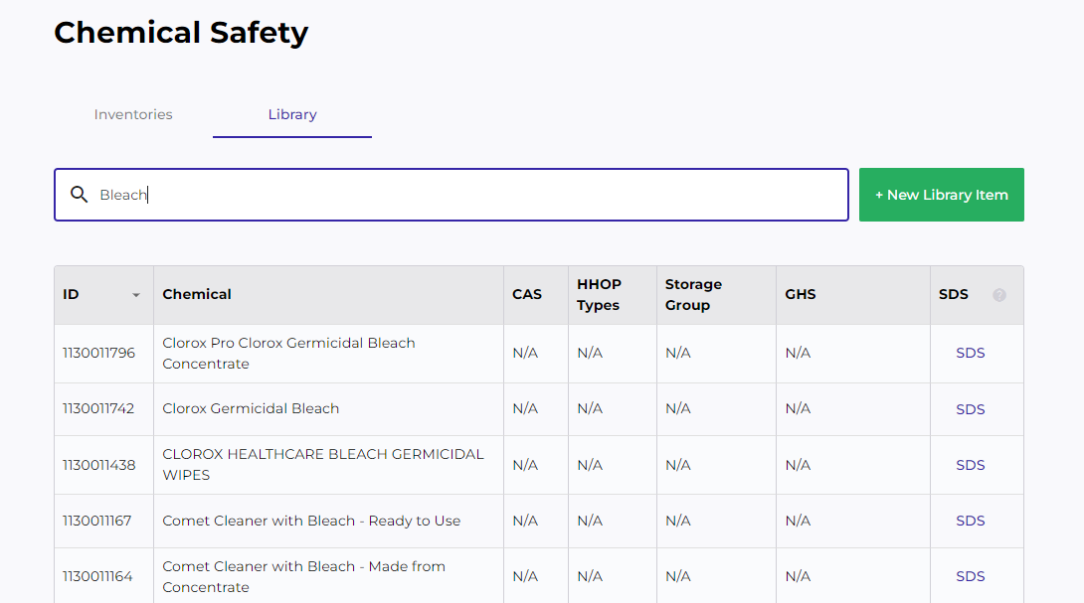

1. Click on SDS. The following window will open. Click on Open file to open the Safety Data Sheet

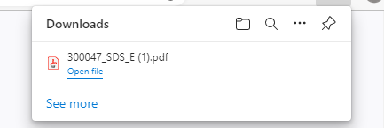

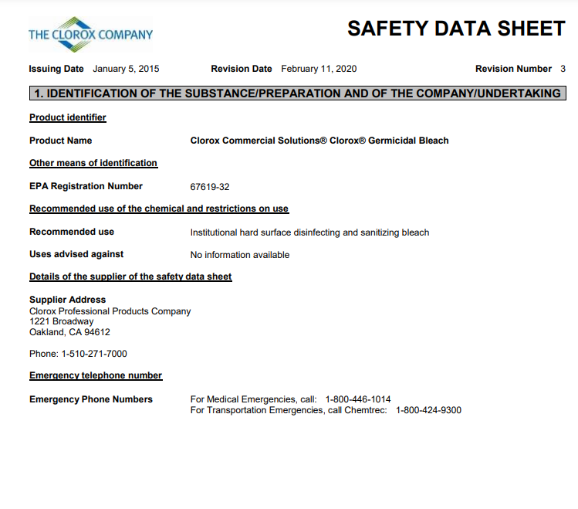

1. To Print the SDS,click on the printer icon at the top of the page

