HEMATOLOGY
MINUTES
MARCH

DATE: 3/16/2023
PRESENT:
Day Shift: Louise, Dan, Virginia, Isamar, VJ, Emma
Evening Shift: Sharon, Kwame, Souman Duc

- IT Requests (IRMA’s)
- Coag QC to be interfaced with Beaker. This will allow for a more efficient way to manage the QC- Has been completed. Will begin using Beaker for coag QC in the next couple weeks.
- FSINT/CSINT: Fluid MD and CSF MD interps: Add a radio button in the differential section of fluids/CSF to add MD interpretations, similar to the way we currently add fluid counts and differentials to the fluids- Currently being tested in non-prod.
- Hemoglobin Electrophoresis: Electrophoresis is being sent to Yale (started 2/17/2023). The request is to re-direct HBSC to a Yale number- Went into production 3/15/2023.
- Request for a Zebra Label printer: will be interfaced with Beaker so that we can print out labels for our Fluid and Manual slides.- still waiting for printer.

- Instrument and testing News:
- Fluid Validation for CSF on the DxU will be done 4/10 and 4/11
- 8100- Currently testing the 8100 to receive Hematology and Coag specimens.(will not spin the coag) more to come on that…
- XN: We are enrolling in BCQM (Beyond are quality management) for the XN. New way to manage QC and Cal verifications. I will send out the link and the instructions for the learning module. We will go live with this after everyone has completed the learning module.
- Hematology will be taking over Mono testing-probably in April,
- Beaker upgrade: the next Beaker upgrade is scheduled for late July. Testing will begin 5/1/2023 and go through 6/30/2023.
- New Cytocentrifuge on order.
- Redraws and Corrections; If you need to choose other as a reason for a redraw or a corrected result, please make sure you put the reason in the comment section.
- Critical PTT’s: All Critical PTT results must be called for each occurrence.

FY2023 PIP Measures 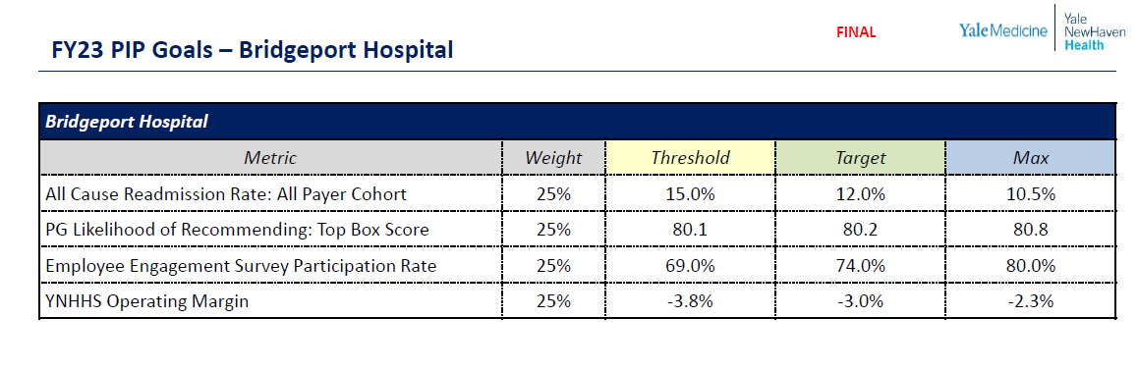
Our fiscal year 2023 metrics:
- Press Ganey “Likely to Recommend”: Reflects patients’ perception of how well we were able to meet their needs by capturing the percentage who chose the most favorable score for the Press Ganey survey question “Likelihood to Recommend.” It includes all survey responses from both inpatient and outpatient settings.
- All cause readmissions rate: Reflects our ability to prevent unplanned readmissions through high quality care delivery, effective care coordination and inter-disciplinary collaboration across our Health System. This measure includes all patients, payers, and reasons for readmission (with some exclusions per CMS methodology).
- Glint employee engagement survey participation rate: The greater the number of employees who complete the survey, the more representative the feedback. It is important to hear from as many employees as possible to inform action plans and decisions that will enhance the work environment. The participation rate is the percentage of unique employees at each organization who complete the survey, out of all employees at that organization who are eligible to take it.
- YNHHS operating margin: Indicates our ability as a System to self-fund additional or expanded services from regular business operations by reflecting how much income remains after we cover our expenses. It includes operating revenue and expenses that are System-centralized but does not include non-operating revenue such as investments.
PIP timing and eligibility:
- The FY 2023 PIP measurement period is October 1, 2022, through September 30, 2023.
- Payout will occur in December 2023 (date to be announced).
- To be eligible to participate in PIP, employees must work a minimum of 1,000 hours in fiscal year 2023 and be active employees on the date of payout.

A copy of the minutes will filed on the p drive P:\Laboratory\Hematology\MONTHLY MEETING MINUTES

