Bridgeport Hospital Lab Safety Committee
February Meeting Minutes

Date: 4/19/2022  Time: 11:00  Location: Microsoft Teams  Recorder: Kathy |  |  |  |  |  | 
ATTENDANCE
 |  |  | JR |  | Mario Vega |  |  |  | Eric Demerchant
 |  |  | Kathy Castillo |  | Karen Zmijewski
 |  |  | Jocelyn Clerveau |  | Aziza Ezzaki
 |  |  | Laura Buhlman |  | Ann Parisi
 |  |  |  | Discussion |  |  |  | Outcome/Follow-up
Injuries |  |  |  | No Injuries since last meeting
Action plan follow-up |  |  |  | No injuries related to cutting tissue reported in Febraury
Ergonomic Evaluation |  |  |  | Ergonomic assessment completed on 3/8/2023.Work stations are ergonomically adjustable but employees are not using chairs/and or djusting their workstaions properly |  |  |  | We will be setting up some in-services to go over proper adjustment of chairs and workstations.
Fire Response Plan |  |  |  | Please remember to take the fire response quiz on MTS
Emergency Stickers for Phones |  |  |  | All phones must have emergency stickers by 5/1/2023. The stickers will have either 155(in hospital) or 911 (outpatient/drawstations) with the location of the phone written on the sticker  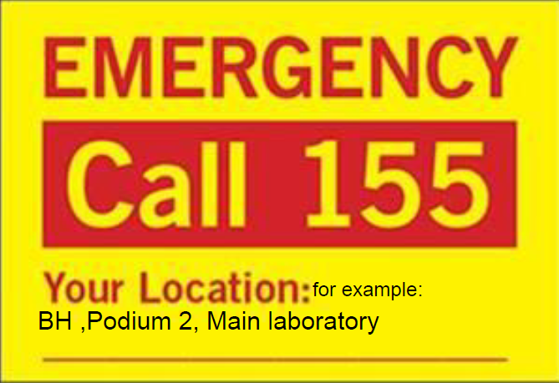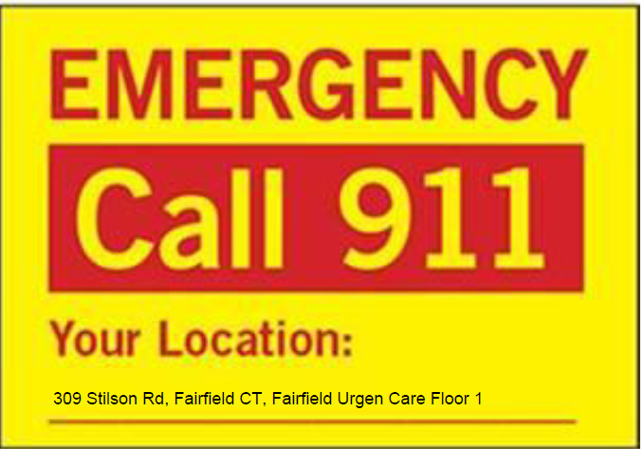 |  |  |  | Stickers are on order
Risk management |  |  |  | BH property insurance carrier toured BH on 8/24/2022 and passed along a list of 7 loss control recommendations for Histology. Most of the items on the list are no longer applicable. |  |  |  | We will set up a meeting with Risk management, facilities and EVS
Lab Coats |  |  |  | Fluid resistant Lab coats have been purchased for everyone who was sized. They should be ready for distribution in a week or two. If you have not been sized, please see the safety member in your department.
Safety Concerns |  |  |  | During a fire alarm, employees were unable to open badge access door to the main lab hallway |  |  |  | A handle was placed on the door leading into the hallway . Still needs to be tested.
Future Meetings
Date/Time  4/19/202 |  |  | Event  Safety Meeting |  |  |  |  | Location  Microsoft Teams

