Laboratory Technologist meeting
May 25,2023

Present: JR, Lisa, Laura, Martin, Pragna, Jay, Nick, Terrie, Judy

- To accommodate workload (see below chart) and to meet TAT expectations of AM draws, effective June 5, 2023, the EXL1 QC & maintenance will be done at 8 am daily& EXL 2 at 8 pm daily.
If anyone needs a maintenance or QC refresher let Laura or JR know by email prior to 6/5.

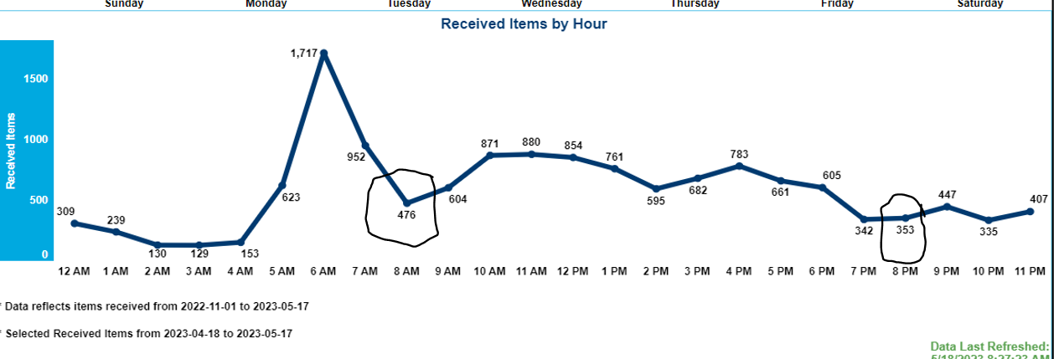
- JR reviewed Beaker QC rules and when to accept, reject & exclude QC values:
- Accept all QC results that are “green”.
- Accept 1st yellow (1st result outside 2s) be aware and communicate to co-workers to be alert.

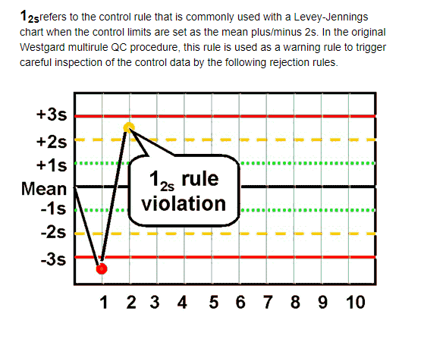

- Reject any Red Result 1-3s - Recalibrate and rerun QC
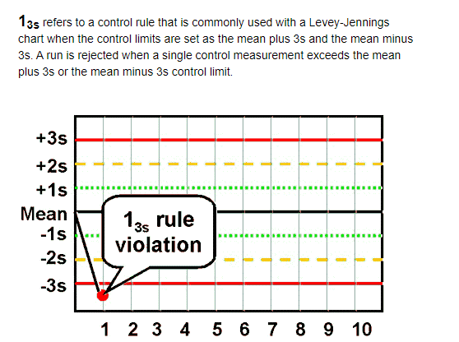

- Reject any 2-2s or 2 Yellow result in a row. Recalibrate and re-run QC

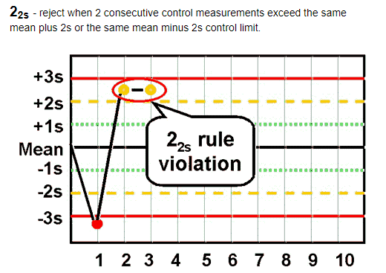
- Exclude only results that are clearly due to switching QC reagents or results are due to QNS of QC material.
If analyzer issues are identified, all shift personnel must troubleshoot and contact service if necessary.

- All personnel must take their lunch/dinner & breaks.

- Please submit PTO requests in writing to Laura. As Interim Manager access to ESS has not been fully transitioned and prior requests made may be stuck in Will’s inbox. Do not assume PTO is approved until you get confirmation. Do not buy airplane tickets or book hotels without confirmation from interim manager.

- Safety Committee participation – Starting in June, At least one staff member must be present at monthly safety meetings. The Zoom/Teams meetings are usually the 3rd Wednesday of every month at 11 am. If anyone is interested in representing the Milford Campus regularly let Laura know by 6/5. If no one volunteers, meeting attendance will be assigned.

- ALL staff needs to wear appropriate PPE when handling patient samples and cell phone use is also prohibited when in the work areas. The only cellphone that should be used in the lab are the MHB only.

- The “warm handoff” of OR and Pathology samples became effective May 22nd. Jocelyne & Eric developed a checklist and were onsite to train Heather. Since then, Heather has been training Milford staff. If you do not have a training checklist completed see Heather as soon as possible to complete this.

*Note: use a PINK highlighter to highlight the required information. Pink identifies the Milford samples from other locations when received at BH.

- Attendance and Punctuality
All staff is expected to report to work & clock in and leave on-time. The YNHHS point system is applicable to all staff and will be enforced.

- Lisa discussed the Emergency Release Process and the quiz which will be assigned to staff regularly. Lisa also discussed the Transfusion Reaction Workup Procedure. This procedure is currently being revised and will also have a quiz assigned to all staff. Please review established procedures and processes. On June 6th Grifols will be setting up the Eflexis which is a fully automated Blood Bank instrument. Staff will be trained in June and July with a tentative go-live of 8/8/2023.

- New validations

a. The new Grifols Eflexis will be implemented. This will help free up the “Blood Bank Tech” who will now be available to help in the core lab.

b. The validation of the new Sysmex analyzers is almost complete. The WAM middleware will be used with the new analyzers. To transition to the new workflow, all staff will be scheduled to be onsite at BH for training. More info on the schedule to train will follow.

c. A New Cepheid analyzer was installed on 5/22. Currently all Cepheid tests are being re-validated on the new instrument in addition to the C. Diff PCR assay & EIA test which will go live in the upcoming month. All personnel will require training.

d. 3 new drugs (methadone, THC& oxycodone) have been validated on the EXL’s and will go live soon. All testing personnel will require training.

e. Procalcitonins are also being re-validated on the e411’s and will be re introduced to testing soon. All personnel will require training.

On the lighter side, there will be a lab picnic on July 29th at Unity Park in Trumbull. All staff & families are invited, and it is a great opportunity to socialize and get to know your BH peers. Mark your calendars, more info to follow. Please RSVP by emailing Tanya Graham.

