Bridgeport Hospital Lab Safety Committee
August Meeting Minutes

Date: 8/16/2023  Time: 11:00  Location: Microsoft Teams  Recorder: Kathy |  |  |  |  |  | 
ATTENDANCE
 |  |  | JR |  | Kirsta Chila |  |  |  | Mario Vega
 |  |  | Kathy Castillo |  | Aziza Ezzaki |  |  |  | Renatta Van Ettan
 |  |  | Jocelyn clerveau |  | Ann Parisi |  |  |  | Sharon Geniston
 |  |  | Eric Domerchant |  | Cindy Roberts |  |  |  | Will Jones
 |  |  |  | Discussion |  |  |  | Outcome/Follow-up
Injuries |  |  |  | 2 injuries since last meeting:  Possible Histoplasmosis exposure while processing a BAL  A dry ice burn when using a scoop left in the dry-ice container w/no glove. |  |  |  | OH to follow employee-very minimal risk;Manual fluids will be processed in the BSC.  Burn was ok by the next day, reminder that gloves should be worn when deailing with dry-ice. Scoops should not be left in the dry-ice bin.
Action plan follow-up |  |  |  | No injuries related to cutting tissue reported in July |  |  |  | Monthly follow-up
Active Shooter Drill |  |  |  | Each department should identify areas of refuge and evacuation routes from an active shooter. The lab will work on a written policy describing what to do and where to hide.See reference sheet below.  Please review Active shooter Training in LMS: Search “Active shooter” in health stream and Launch video  Edren asked if the doors to the lab hallway will automatically lock-up and shut during an active shotter. |  |  |  | Send Kathy departmental plans. Would like a policy in place for the active shooter drill so that Security can evaluate the plan.  The active shooter training is specific to YNHH but has tips pertaining to everyone  JR to follow up
PPE  Compliance |  |  |  | Schedule for secret PPE observation:Schedule for secret PPE observation:Schedule for secret PPE observation:  Sept: Chemistry Oct: Micro Nov: BB Dec: AP  Please document here: P:\Laboratory\Secret Shopper – PPE |  |  |  | Results will be shared monthly in Huddle.  Compliance at BC has improved over the year.
CP |  |  |  | There was a leak in CP near the Chemistry entrance. The water was from a sink in the OR. |  |  |  | Infection control came down and assessed that there was no infectious disease risk from the water.
Fire response Quiz |  |  |  | Employees who have not completed the BHBC and/or BHMC fire response plans should do so as soon as possible. (Employees who work at both campuses must complete both quizzes) |  |  |  | Kathy will send list of employees who need to complete the Quiz to managers.
Safety Concerns |  |  |  | NONE
Bi-Hazard bins |  |  |  | Reminder that the large Bio-hazrd Bin capacity is at ½ full. Please do not overfill the bins, they are heavy and employees are getting injured. Once a bin is ½ full call SERV. They are available 24/7. There are extra bins in the chemistry closet and in micro. |  |  |  | EVS has been coming up every day and removing the bins,
Noise Meter |  |  |  | BC campus has completed noise metering for 2023. Kathy will send the noise meter to MC to complete.
Future Meetings
Date/Time  9/20/2023 |  |  | Event  Safety Meeting |  |  |  |  | Location  Microsoft Teams

Active Shooter Reference card:

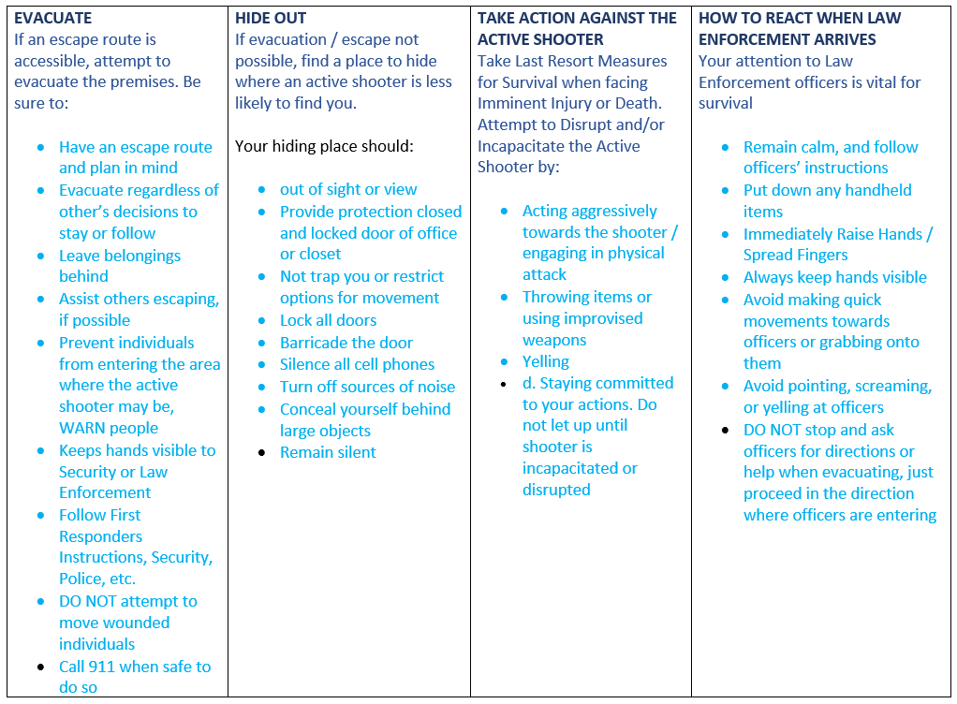
Stay calm
Have a plan
Run Hide Fight
Call 9-1-1

