Bridgeport Hospital Lab Safety Committee
September Meeting Minutes

Date: 9/22/2023  Time: 11:00  Location: Microsoft Teams  Recorder: Kathy |  |  |  |  |  | 
ATTENDANCE
 |  |  | JR |  | Renatta Van Ettan |  |  |  | Laura Buhlman
 |  |  | Kathy Castillo |  | Tanya Graham
 |  |  | Edren Walker |  | Ann Parisi
 |  |  | Aziza Ezzaki |  | Cindy Roberts
 |  |  |  | Discussion |  |  |  | Outcome/Follow-up
InjIN
Action plan follow-up |  |  |  | No injuries related to cutting tissue reported in July |  |  |  | Monthly follow-up
Injuries |  |  |  | No Injuries since last Meeting
Active Shooter Drill |  |  |  | BH Main Lab is scheduled for an Active shooter drill on Tuesday 9/26/203 at 10:30am and 4pm. Please see preliminary plan at the end of the notes.
PPE  Compliance |  |  |  | Schedule for secret PPE observation:Schedule for secret PPE observation:Schedule for secret PPE observation:  Sept: Chemistry Oct: Micro Nov: BB Dec: AP  Please document here: P:\Laboratory\Secret Shopper – PPE |  |  |  | Results will be shared monthly in Huddle.  Compliance at BC has improved over the year.
CO2 tank in Micro |  |  |  | There was a CO2 leak in Micro. |  |  |  | The leak has been fixed. No harm to employees
Fire response Quiz |  |  |  | Employees who have not completed the BHBC and/or BHMC fire response plans should do so as soon as possible. (Employees who work at both campuses must complete both quizzes) |  |  |  | Kathy will send list of employees who need to complete the Quiz to managers.
Safety Concerns |  |  |  | NONE
Noise Meter |  |  |  | BC campus has completed noise metering for 2023. Kathy will send the noise meter to MC to complete.
Future Meetings
Date/Time  10/18/2023 |  |  | Event  Safety Meeting |  |  |  |  | Location  Microsoft Teams

ACTIVE SHOOTER PLAN- BH LABORATORY
The safety committee modified a plan written by Renatta Van Etten for AP to draft a preliminary active shooter plan which will be evaluated when we have our active shooter drill on Tuesday 9/26/2023.
The plan is set up based on Run, Hide and Fight
RUN(EVACUATE):
Cytology: There are stairs leading to the main lobby outside of the cytology suite. The door is locked from the stairway side and is only accessible as an exit door.
Histology: There are two exits available to histology for evacuation. One exit is in the grossing area and one exit is right outside the histology laboratory in front of Blood bank.
Pathology: There are three exits available to histology. One exit is next to cytology, one exit is outside of blood bank, and the third exit is in the grossing area of histology.
Main Lab: There are stairs outside the admin hallway that lead to the Ambulance area outside. Get to Histology through the door in the back of Chemistry and evacuate using the exit in the grossing area or the exit stairs in the hallway between Histology and BB. Evacuate through BB using the door in the back of hematology and use the exit stairs in the hallway.
Blood Bank: Exit using stairs between BB and Histology or Exit through Hematology and follow Main Lab evacuation options.
Microbiology: Exit using the door in the back of Micro and if safe, exit the building through Surgease or use the exit stairs in the Surgease hallway , go down to the first floor and exit to the ER employee parking garage.

HIDE(SHELTER IN PLACE)
Cytology: The cytology suite has a keypad door lock. The door can be further reinforced with the soft cubicle walls found in the main office area. The cytology laboratory is lockable and can be reinforced with chairs and the workbench which can be moved with effort. Dr.’s office is kept locked and would not be available during emergency. The cytology office has glass doors and would also not serve as sufficient cover during emergency.
Histology: Histology has a badge access door. It is connected to the central lab and to pathology offices. The door can be reinforced with chairs and garbage cans. The microtomy area is internal to the lab and staff should hide under the benches as needed. The grossing area is also internal and has access to an egress if fleeing is possible. There is an internal connecting door with pathology for additional shelter areas.
Pathology: The doors to pathology are keypad locked and require access code for entry. There are numerous offices available that can be locked and secured in the pathology office. The conference room also locks and can be secured with tables from inside. Doors can be reinforced with shelving units available throughout the offices. There is an internal connection to histology for additional shelter areas.
Main Lab: Option during day shift M-F: Manager offices can be locked, and doors re-enforced using office furniture.
Other options:
- Lab is badge access, doors can be blocked with tables, chairs, or other larger objects. Many benches have spaces underneath where employees can hide.
- The break rooms can be used, and doors reinforced using available furniture.
- There is a door in the back of chemistry to the histology area, the back door can be reinforced from inside histology.
- There is an internal door from histology to pathology. Pathologist offices can be used to shelter in place.
- There is a door in the back of Hematology to Blood bank.

Blood Bank:
- Manager’s office- reinforce door using furniture
- Break room- reinforce door using furniture/fridge
- Exit BB into Main Lab and follow shelter in place options
Microbiology:
- Micro has 2 doors; one is badge access, and one is locked. Doors can be reinforced using furniture.
- Rooms with doors can be used and doors reinforced with furniture or other large objects.

FIGHT
Fighting is a last resort option when fleeing and sheltering in place are no longer viable. Some items that can be used as weapons include:
- Fire extinguishers
- Caustic chemicals such as bleach, xylene, alcohol, and formaldehyde can be used.
- Any hard objects that can be thrown
- Scalpels/blades
- Scissors

Miscellaneous:
- Cell phones should be silenced. Communicate Via text.
- Tugs should be cancelled if not in the Main lab/ they should be turned off if in the lab, so they are not used.
- Managers can use teams Shifts to identify employees working.

Active Shooter Reference card:

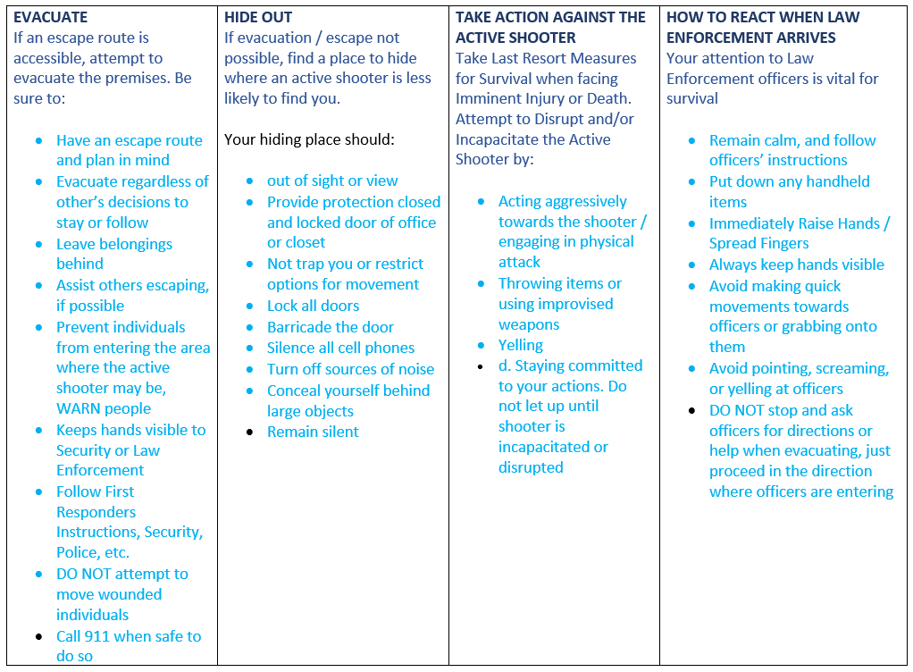
Stay calm
Have a plan
Run Hide Fight
Call 9-1-1

