MCBH Lab meeting 10/16/2023

Present: JR, Will, Belinda, Heather, Pragna, Judy, Martin, Wendy, Paulette, Laura

1. Call out coverage:
   1. Patient care comes first
   2. Volunteers to stay but if we can’t find coverage, you will have to stay in order of least seniority.
   3. Bringing in volunteers from Bridgeport to augment Phlebotomy staffing
      1. Fei, Vallen
      2. Outreach phlebotomy
2. Schedule
   1. November
      1. Rauf- training should be completed in November
      2. Not complete-need the following shifts filled: sign up in TEAMS

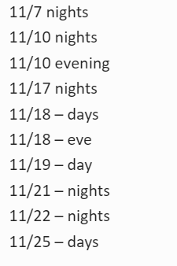

* 1. On-call sign ups
     1. Night sign ups – OPEN TO EVERYONE trained in all sections.
  2. December schedule will be deleted- do not go by that schedule, it will change.
     1. Goal is to have: 1 month in advance. November to be finalized soon.

1. Holiday Rotation
   1. New rotation schedule for 2023 and 2024
      1. Techs
      2. Phlebotomy- to follow
   2. Techs

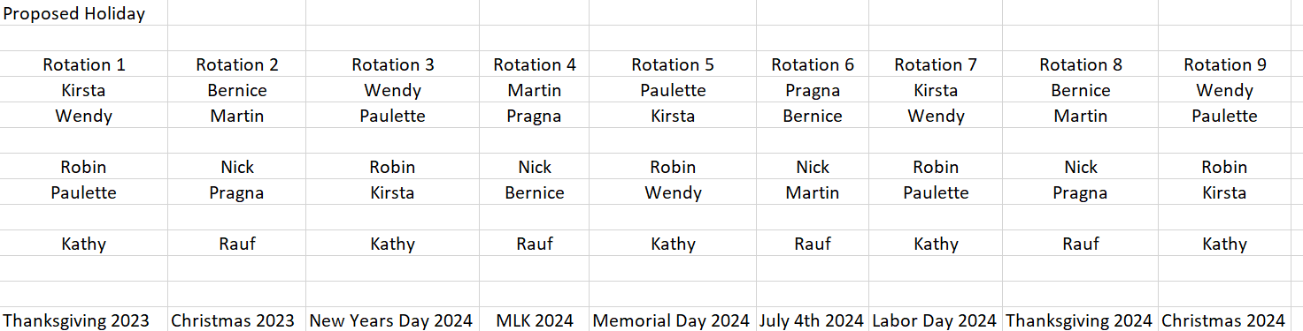

1. Weekend Rotation Techs
   1. Every other to start in December
   2. Hospital policy
2. Technical competency –To staff lab appropriately, all staff are to be trained and maintain competency in all sections.
   1. Blood Bank Rotation
      1. Pragna
      2. Bernice
      3. Wendy
   2. Bridgeport Rotation-As there have been BH techs onsite at MC to cover holes, MC staff will be rotating to BH as needed.
3. Technologists & MLT’s: Give Laura your completed CEU log by 10/27. The requirement is $ ceu’s for techs & 2 for MLT’s. Everyone was emailed a log sheet to be filled out.