Bridgeport Hospital Lab Safety Committee
January 2024 Meeting Minutes

Date: 1/17/2024  Time: 11:00am  Location: Microsoft Teams  Recorder: Kathy |  |  |  |  | 
ATTENDANCE
 |  |  | Kathy Castillo | Laura Buhlman
 |  |  | Ann Parisi | Edren Walker
 |  |  | Aziza Ezzaki
 |  |  | Lisa Krause
 |  |  | Discussion |  |  |  | Outcome/Follow-up
Injuries |  |  | I injury reported: blood splash to face while aliquoting in send outs. No protective eyewear, shield. |  |  |  | Face shields and plexiglass shields are available in the send-out area
Lab Coats |  |  | Laundry will be putting the clean lab coats on a rack in the send out area (old Immunology Lab) |  |  |  | Please pick up your lab coats
PPE  Compliance |  |  | January PPE and Electronic device compliance  See chart for BC |  |  |  | We will continue to monitor PPE and electronic device compliance in 2024
Fire response Quiz |  |  | The quiz been assigned to all employees to be completed by 3/31/2024
Safety Concerns |  |  | MC lab coats are not being returned from Laundry |  |  |  | Laura is ordering new lab coats and will bring to Laundry for barcoding.
Future Meetings
Date/Time  11:00am |  |  | Event  Safety Meeting |  |  |  | Location  Microsoft Teams

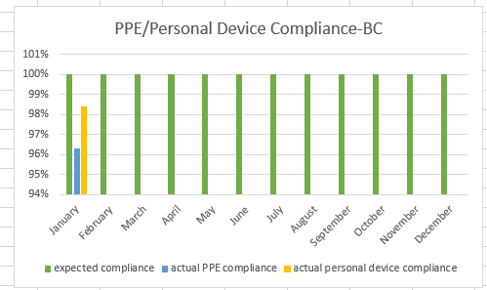
PPE compliance: 96.3%
Personal electronic device: 98.4%

