Bridgeport Hospital Lab Safety Committee
MARCH 2024 Meeting Minutes

Date: 3/20/2024  Time: 11:00am  Location: Microsoft Teams  Recorder: Kathy |  |  |  |  | 
ATTENDANCE
 |  |  | Kathy Castillo | Laura Buhlman
 |  |  | JR | Eric Domerchant
 |  |  | Laura Buhlman | Ann Parisi
 |  |  | Cindy Roberts
 |  |  | Discussion |  |  |  | Outcome/Follow-up
Injuries |  |  | 2 Injuries reported:  - Thumb injury due to moving a cold heavy weighted tissue mold  - Splash to cheek area from Strep swab |  |  |  | Improper use of hood.
Lab Coats |  |  | Laundry will be putting the clean lab coats on a rack in the send out area (old Immunology Lab) |  |  |  | Please pick up your lab coats
PPE  Compliance |  |  | February Compliance  BC: PPE= 98.2% personal electronics= 96.9% ( earbuds)  MC: PPE= 59% 9 (ordered new lab coats for staff) PED= 100% |  |  |  | New lab coats were ordered at MC and some have been received. MC will be giving out warnings for PPE non-compliance
Fire response Quiz |  |  | The quiz been assigned to all employees to be completed by 3/31/2024 |  |  |  | Kathy will send a list of employees who still need to complete the quiz
Armed intruder  Training |  |  | 2 training sessions yesterday for those that missed the training in September.
Director Walkthrough |  |  | Director safety walk-throughs need to be completed ASAP |  |  |  | Will put the forms on the P-drive
Upcoming regulatory |  |  | Spill kit inventory and evaluation: MC- March/BC- June  Noise Metering- Begin in June
Future Meetings
Date/Time  4/17/2024  11:00am |  |  | Event  Safety Meeting |  |  |  | Location  Microsoft Teams

February PPE/PED compliance

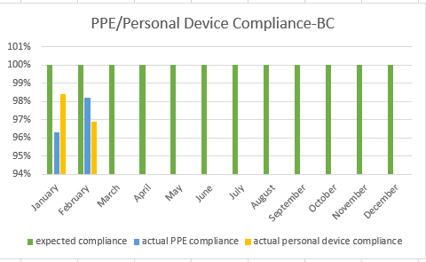
PPE compliance: 98.2%
Personal electronic device: 96.9%

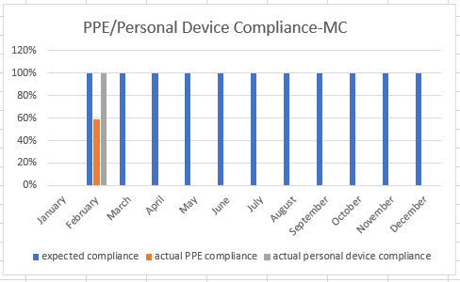
PPE compliance: 59%
Personal electronic device: 100%

