Bridgeport Hospital Lab Safety Committee
APRIL 2024 Meeting Minutes

Date: 4/19/2024  Time: 11:00am  Location: Microsoft Teams  Recorder: Kathy |  |  |  |  | 
ATTENDANCE
 |  |  | Kathy Castillo | Aziza Ezzaki
 |  |  | Laura Buhlman | Jocelyn Clerveau
 |  |  | Ann Parisi | Edren Walker
 |  |  | JR | Eric Demerchant
 |  |  | Discussion |  |  |  | Outcome/Follow-up
Injuries |  |  | 1 injury reported:  Cover of the 8100 hit employee on the head. |  |  |  | The cover of the 8100 does not stay open unless being held open, employee was re-educated.
Xylene spill in Histology |  |  | Xylene spill in Histology on 4/9/2024. Facility alert was initiated by the Histo lab and the lab evacuated. Staff followed Spill policy by initiating a facility alert. A tube from the xylene waste came lose spilling Xylene on the floor. |  |  |  | -Staff is being re-trained in waste disposal on the tissue processor.  - re-structuring the lead of the container so it’s more secure.  -Use a spill catch container when emptying waste.
Lab Coats |  |  | Lab Coats must be picked up from the rack in the send-out area
PPE  Compliance |  |  | March compliance  BC: PPE= 97.5% personal electronics= 95.7% ( earbuds)
Fire response Quiz |  |  | The quiz been assigned to all employees to be completed by 3/31/2024 |  |  |  | A few employees still need to complete the fire response quiz
SDS |  |  | Need to review how to access SDS sheets with staff |  |  |  | Will re-assign accessing SDS sheets in MTS training.
Director Walkthrough |  |  | Director safety walk-throughs need to be completed ASAP |  |  |  | Will put the forms on the P-drive
Upcoming regulatory |  |  | Spill kit inventory and evaluation: MC- March/BC- June  Noise Metering- Begin in June
Future Meetings
Date/Time  11/15/2024  11:00am |  |  | Event  Safety Meeting |  |  |  | Location  Microsoft Teams

March PPE/PED compliance

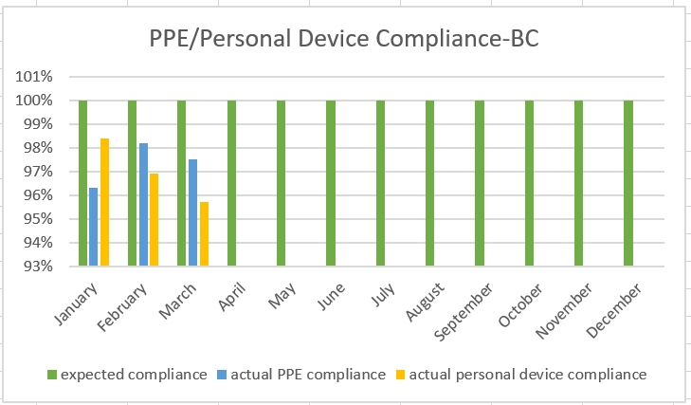

PPE Compliance- 97.5%
Personal Device compliance-95.7%

