Bridgeport Hospital Lab Safety Committee
July 2024 Meeting Minutes

Date: 7/24/2024  Time: 1:00pm  Location: Microsoft Teams  Recorder: Kathy |  |  |  |  | 
ATTENDANCE
 |  |  | Kathy Castillo | Aziza Ezzaki
 |  |  | Laura Buhlman | Cindy Roberts
 |  |  | Ann Parisi
 |  |  | Edren Walker
 |  |  | Discussion |  |  |  | Outcome/Follow-up
Injuries |  |  | 1 injury reported:  Roche reagent PreClean M splashed on employee's face. |  |  |  | Wear proper PPE when working on instruments.
Spill Kit Inventory |  |  | Spill kits must be inventoried and evaluated for effectiveness. Please complete ASAP. File can be found on the P drive(see below)  P:\Laboratory\!CAP Regulatory\Safety\SPILL KIT INVENTORY
Noise Metering |  |  | Please perform noise metering in your respective departments by the end of September. See Kathy for the noise meter. Document results on the P drive:  P:\Laboratory\!CAP Regulatory\Safety\! NOISE LEVEL CHECKS\2024 |  |  |  | CP/Send-out areas have been completed.
Fire response Quiz |  |  | The quiz was assigned to all employees to be completed by 3/31/2024. |  |  |  | A few employees still need to complete the fire response quiz
Risk Assessments |  |  | All Risk Assessments must be reviewed and updated if warranted. Will need to update and move micro risk assessments to the Core Lab.
Safety Manual Update |  |  | Safety Committee to start annual review of the safety manual |  |  |  | Will begin reviewing in the next month.
Future Meetings
Date/Time  08/27/2024  11:00am |  |  | Event  Safety Meeting |  |  |  | Location  Microsoft Teams

March PPE/PED compliance

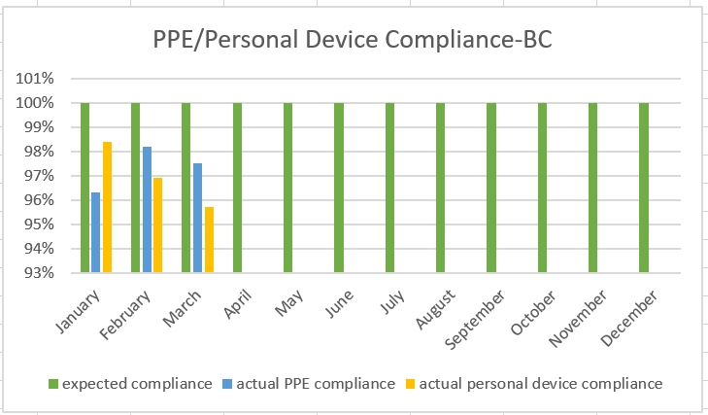

PPE Compliance- 97.5%
Personal Device compliance-95.7%

