HEMATOLOGY
MINUTES
September 2024
DATE: 9/5/2024
PRESENT:
Day Shift: Louise, Emma, Dan, Lisa , Susan, Hiram
Evening Shift: Kwame, Sharon, Souman, Duc

- YNHHS
- Employee Engagement survey: 9/9/2024 to 9/22/2024
- Part of the PIP payout- Please complete.
- JR is looking for volunteers to work on the YNHHS Laboratory Newsletter.

- UPDATES:
- Hematology
- UB Student (Nadia) starts on 9/10/2024 and will be in Hematology for 7 weeks.
- We have the following projects starting:
- Validation of a New TEG 6s Cartridge: Susan
- Beaker upgrade testing: Dan, Emma, Hiram
- Validation of Spun Hematocrit Centrifuge: Louise
- The Hemolysis tolerance level for coag tests has been changed to ≤ 4+ (was < 4+)
- “Do Not Spin” has been added to the TEG labels.
- Night Shift will begin performing SP-50 maintenance on 10/1/2024.
- Shutdown 2 takes 45 minutes which holds up results, so it makes sense to do the maintenance during less busy times.
- The blood Parasite procedure and resulting of parasites is currently being updated to remove “refer to Microbiology for ID” and add % parasitemia and binax now components to the results.
- The pH buffer chart for Malaria has been added to the P-drive (P:\Laboratory\Hematology - BH 38020\Maintenance Charts and QC charts\2024 CHARTS\MISC 2024)
- Please call EVS (336-7378) to remove Methanol waste when there are 2 full containers.
- Please complete the BSC and Centrifuge training by the endo of the month (9/30/2024)

BSC
- https://www.train.org/connecticut/course/1041976/

Centrifuge
- https://www.train.org/connecticut/course/1073746/

- Outpatient Redraws: New Workflow
- Lab staff alerts Customer Service via the Add Follow up task in Beaker.
- Click on Add follow-up task

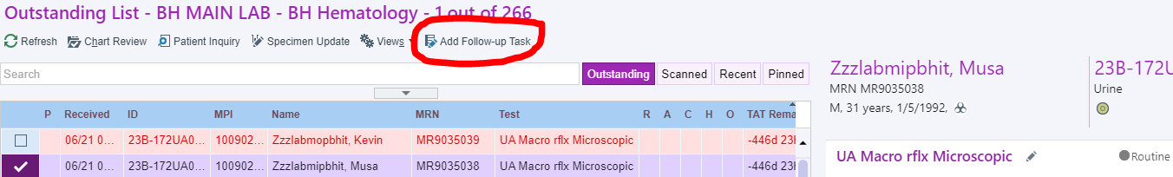
- A pop-up box will appear. Click +ADD and (CSR) Call physician for test cancellation
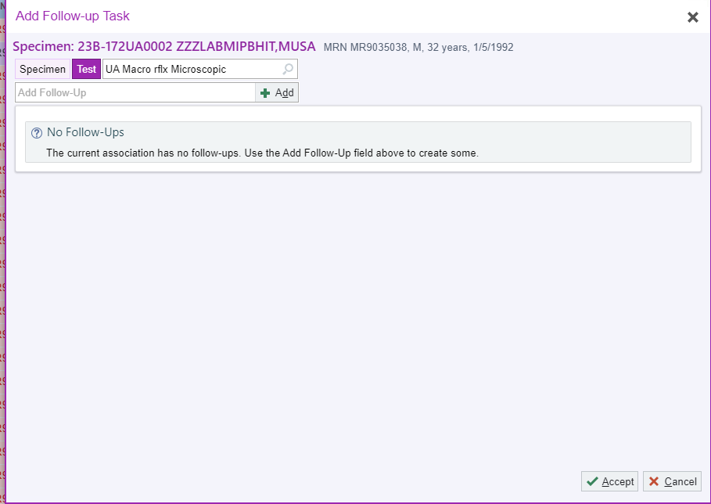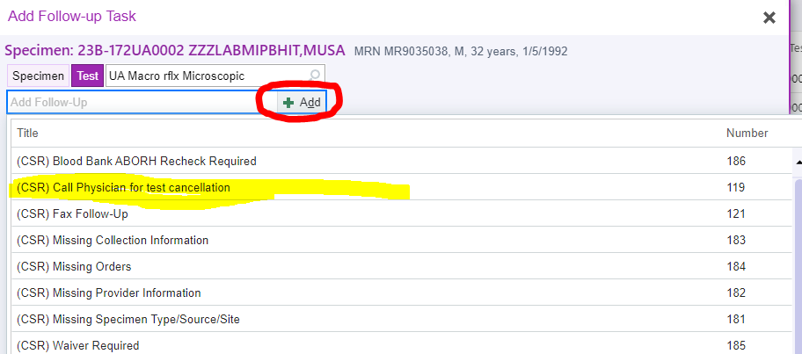
- Add comment (reason for redraw) and click on accept
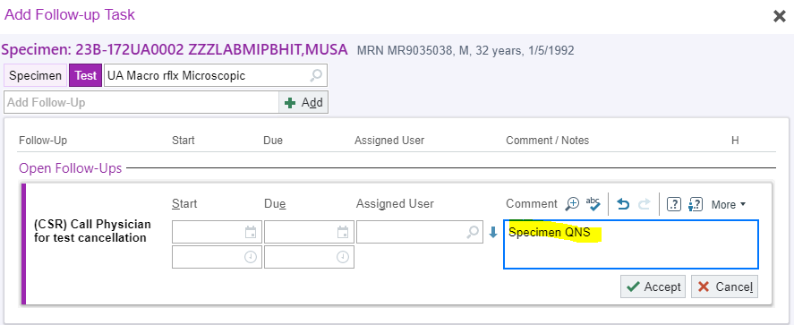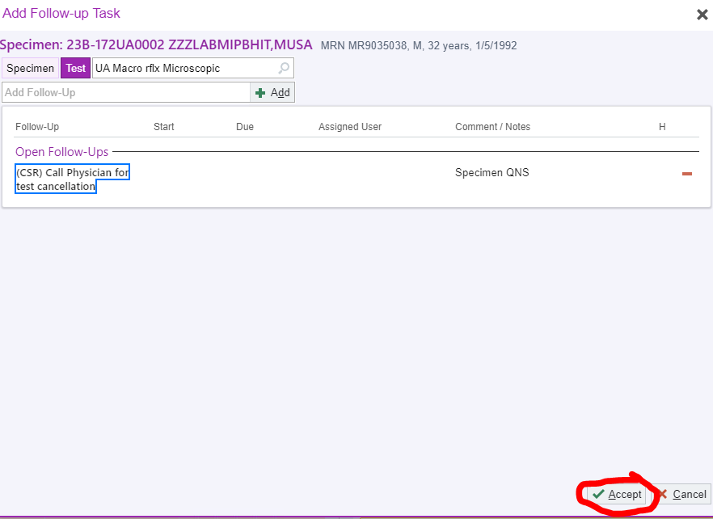
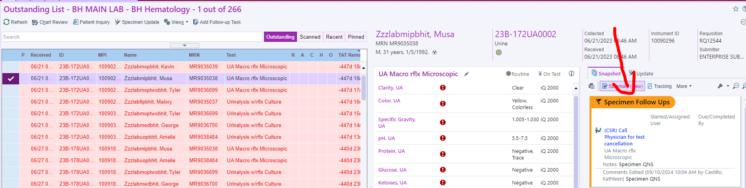
- Once the follow-up task has been added, order a redraw for the specimen

- Micro
- Verigenes will be moved to Hematology on 9/12/2024
- RVP and EP will be sent to Yale while the instruments are validated.
- For positive Cepheid, RVP and EP, please note what is positive on the tube.
- Cepheid Maintenance:
- Weekly maintenance: Evening Shift
- Monthly maintenance: Day shift
- Quarterly maintenance: Hiram
- Please remember to document gram stains and C-diff EIA on the P-drive

- MISC
- Monthly/Bi-Monthly QC:
- Day shift: Cepheid, Plt Mapping, Binax Now
- Evening Shift: Verigene (RVP and EP), Teg Trauma
- Night Shift: Mono, Teg Global Hemostasis

- Additional Info not discussed in Meeting-
- Please review the Critical call policy – If you are unable to communicate a critical value after 3 attempts, you MUST notify the pathologist on call.
- The follow-up Worklist is everyone’s responsibility. If you see a critical result in the follow up worklist from a previous shift, DO NOT ignore it- call the result.
- There was a critical ANC in the follow-up worklist from Wednesday evening until Monday morning
- Caresphere flags and alerts and slide reviews vs Manual diffs
- Please pay attention to the alerts and flags in caresphere. When you are scanning a slide and see anything abnormal. Bands, Meta’s, atypical lymph’s, etc., RBC morphology (schistocytes, hypo, target cells ) or the automated diff and the cellavison diff don’t match, you MUST perform a manual diff. If in doubt, do the diff.
- Also, when scanning WBC’s, you must classify the cells before confirming the scan.

- The alert below requires a manual differential not a scan/perform diff if indicated. A few techs are just reviewing the smear and not doing a differential.
